Using the php programming language

PHP is classed as middleware. Its main use is to interface with a relational database residing on a company’s server. FoxServ is a package that allows you to configure your computer as a php-enabled server.

Downloading, Installing and Running FoxServ

- Go to www.foxserv.net and download v2.1 and save
- Install FoxServ v2.1. It may tell you that you don’t have sufficient space on your drive – ignore it.
- You should see a traffic light (on green) on your task bar and have a shortcut to FoxServ. Click on this and you should see the following control panel:
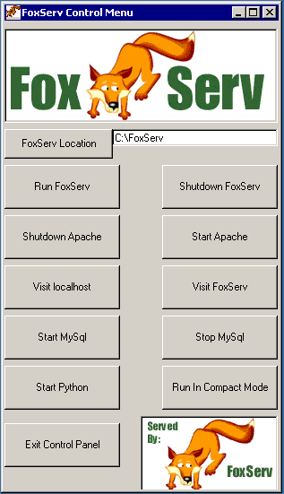

- Click on Run FoxServ and then minimize the DOS screen that appears
- Click on Visit localhost. You should see the screen:

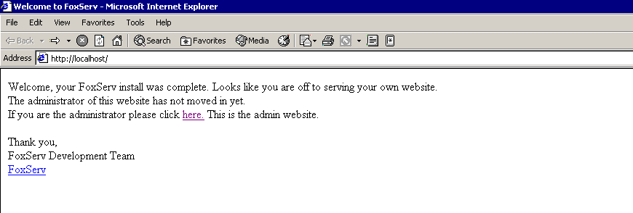

- Click on here and you should see the screen:

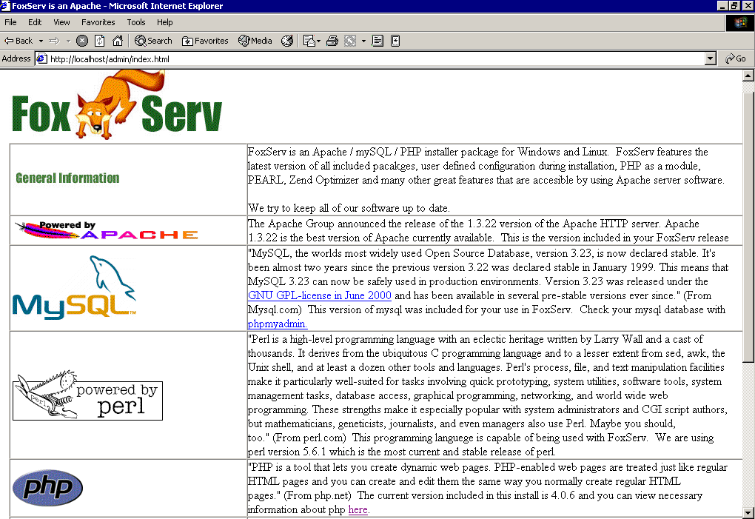

- Go to php and click on here. You should see the following screen:

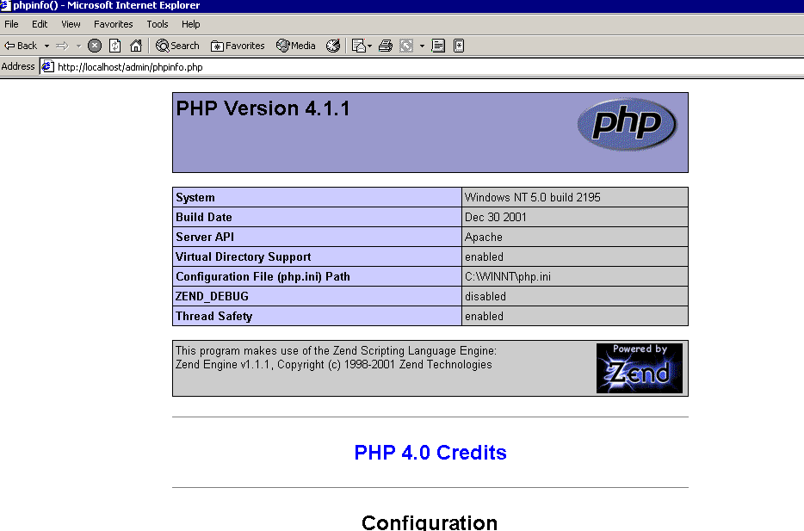

- If you see this screen then your PC is acting as a PHP-enabled server (and you’re more than half-way there!)
- Open C: drive and you should have a folder called Foxserv. Within this there should be a folder called www which is referred to as the root directory. All your php files must have the extension .php and reside in this folder. They can be in a sub-directory, called, for example php_progs.
- To run a program, go to http://localhost/php_progs/. Assuming you’ve placed them in a sub-directory called php_progs, you should see a list of your files.
- To run a program, enter its name eg. http://localhost/programs/adder.php
- php programs can call themselves or write to another web page.

