CASESTUDY
The City Streets Clothing Company - Creators of Fine Fashions

The City Streets Clothing Company designs and manufactures a range of clothing for both men and women in their Melbourne factory. To produce a garment a three-stage process is followed. This is shown in Figure 1.

Figure 1

Designing. The designer starts by placing cloth over a standard sized dressmaker's dummy and works out the shapes of each part of the garment. These shapes are used to make the 'cutting pattern'.  Grading. The cutting pattern is entered into a computer using a drawing tablet and stored for later use. Using tables of standard human measurements, the computer calculates and then draws sets of 'graded patterns' to fit a range of human sizes. Each of these is drawn at full size. At the same time the computer produces data sheets showing costing and material usage. The graded patterns are then used to make hard plastic templates.  Making. An expert in pattern laying uses the graded pattern templates and works out the best way to lay them on the material to minimise waste. This layout is used as a cutting guide. The material is cut and stitched together to make the garment. | 
 | 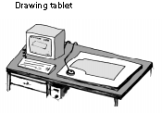 | 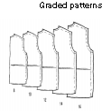
 |  | 
The grading stage involves the use of a computer. Depending on the type of garment being designed, the computer may have to perform up to one million floating point instructions in order to produce the graded patterns. City Streets have two computers that can be used for this task.

Question 1
Figure 2 shows three block diagrams of different computer systems that could be used by City Streets' designers for the operations described above. Choose the system (A, B or C) that is best able to carry out these operations. Justify your answer.

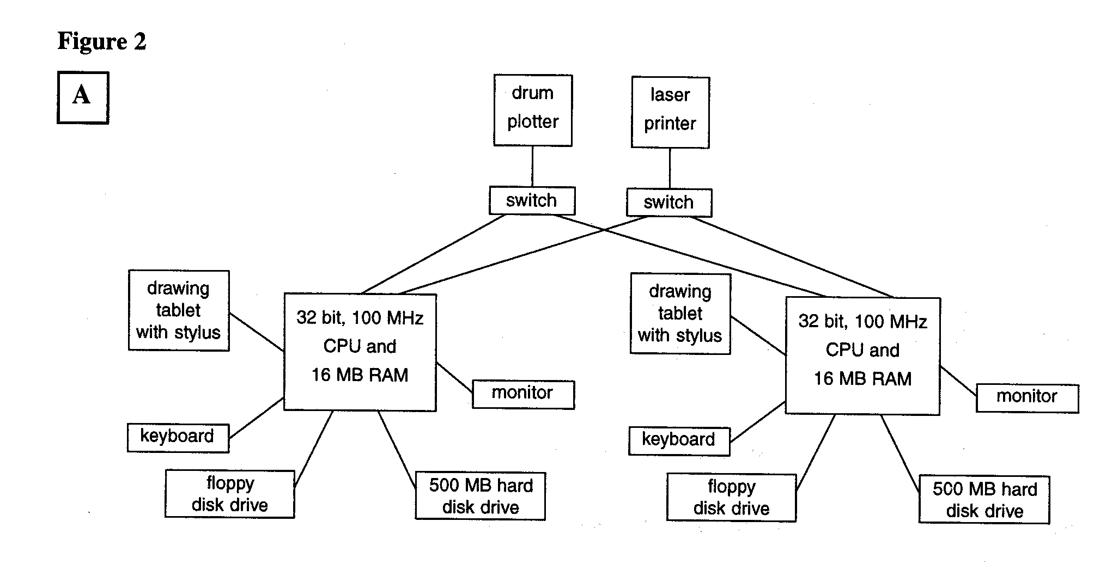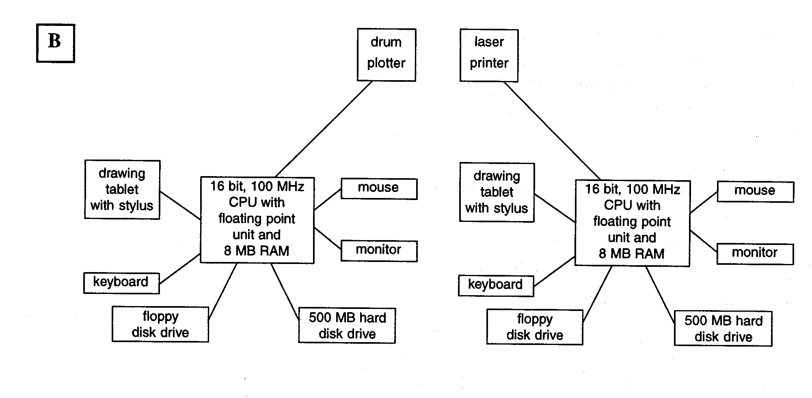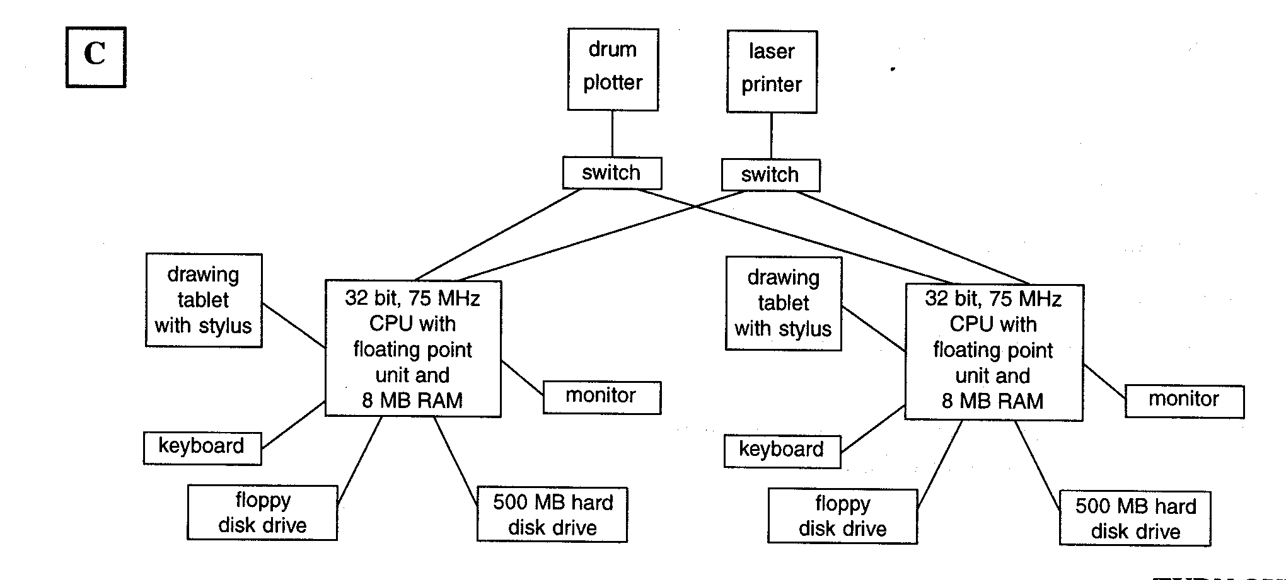

Question 2
The following five features might be found in an operating system.
- user interface
- device drivers
- multi-user support
- network filing system
- file manager

These features may or may not be essential to the operating system that runs on the City Streets' computers. For each of the features listed, state whether or not it is essential and explain why or why not.

City Streets has recently noticed a reduction in sales. Market research has shown that
- City Streets' prices are not competitive compared to other clothing companies
- City Streets does not produce as broad a range of garments as other companies.

Management have therefore decided to update their design procedures by using computer-based design tools rather than the traditional method currently employed. One software product on the market is a program called el, (electronic Layout). It has the following features and capabilities.

For the design process, eL
- provides a database containing basic patterns that fit a wide range of human shapes
- provides specifications for a huge range of fabrics, including available colours and textures, and costing data allows the designer to draw clothing on screen
- allows designers to access each other's garment files so that they can share the design process
- animates the design on a virtual catwalk, allowing the designer to see the clothes in various postures; for example sitting or walking
- generates the cutting pattern from the design.

For the grading process, eL
- grades the cutting pattern
- can draw the graded pattern if necessary
- can produce costing data if necessary.

For the making process, eL
- generates the pattern layout to make optimum use of material
- can create a LOGI (laser operating and guidance instructions) file for use on automatic cutting machines.

However, because eL is very expensive, management is considering buying cheap off-the-shelf hardware to run eL. One off-the-shelf model has the following specifications.

- 350 MHz processor
- 32 MB RAM
- 4 GB hard disk drive
- 15 " colour monitor
- 4 MB 1280 X 1024 SVGA video card
- 40 X speed Ultra Fast CDROM drive
- PCI 32-bit sound card
- 1.44 MB floppy disk drive
- midi tower case
- 104 enhanced keyboard
- ergonomic 2 button mouse and pad

Question 3
Comment on the appropriateness of this of-the-shelf computer given eL's features and capabilities.

Assume City Streets purchases eL. This package will produce a file of LOGI instructions. Any LOGI-compatible cutting machine can use this file. Therefore the garments can be manufactured anywhere in the world. Smart Cut Tailors (SCT) of Lapen, in SE Asia, have recently installed a new cutting and sewing system. As a result, SCT is looking for business opportunities, and has offered to cut and manufacture garments for the City Streets Clothing Company very cheaply.
The City Streets Clothing Company wishes to investigate the possibility of transferring LOGI files to SCT via the Internet. LOGI files need to provide very detailed instructions to the cutting and sewing machines. These files can be several megabytes in size.
The City Streets Clothing Company also needs access to the Internet so that they can get on-line assistance from the manufacturers of their new garment design and pattern-making system and download new information about fabrics and fashions.

Question 4
Assume City Streets Clothing Company purchases eL and a number of off-the-shelf computers. They will need access to the Internet to transfer LOGI files to SCT quickly and securely: Describe any other equipment, hardware and software that will be required, taking into account
- hardware specifications
- features required by the software.

Assume the City Streets Clothing Company purchased the necessary equipment. In order to test the new equipment they sent a simple test pattern to SCT. This test pattern consisted of LOGI instructions to draw a square. Rather than risk damaging the cutting and sewing machines, the test pattern should draw the square on the computer screen at SCT. The City Streets Clothing Company made several attempts to transmit the test pattern, with the following results.

First attempt: SCT reported that no pattern data arrived. Both the City Streets Clothing Company and SCT carefully checked all the connections between their computers and the communications equipment. They found that all devices were connected correctly.

Second attempt: SCT reported that some data arrived, but absolutely nothing appeared on the computer screen at SCT. One of the SCT engineers examined the data and declared, 'This does not look like a set of LOGI instructions'. The City Streets Clothing Company engineers assured SCT that they had sent a LOGI file.

Third attempt: SCT reported that a LOGI file arrived but, instead of drawing a square on the screen, the resulting figure looked like the diagram shown below.

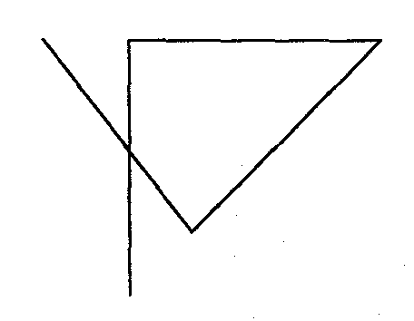

Question 5
For each of these three attempts, suggest a reason for the problem. Justify your answer in each case.

The LOGI language includes the following six simple instructions.

Command | Parameter | Description
HOME |  | moves the laser cutting head to the centre of the cloth
L1 |  | turns laser on
LO |  | turns laser off
BYE |  | checks that the laser cutting head is off and moves it to  the edge of the cutting table where it is out of the way
RT | angle | turns the laser cutter right by angle degrees
FD | length | moves the laser cutter forward by length units

When all the problems with the test pattern had been corrected, the first real garment pattern was sent from City Streets Clothing Company to SCT. This pattern caused the laser cutter to attempt to cut all the shapes about 25 times too big.

Further investigation revealed that SCT had downloaded their cutting software from an American web site. This American version expected the FD length units to be in inches, whereas the metric version of the software installed by the City Streets Clothing Company uses millimetres in the instructions. SCT cannot afford to buy the metric version of the software so they need to write a program to convert the measurements in the LOGI files from millimetres to inches.

The following instructions are available for manipulating LOGI files.

Instruction | Effect
OPEN filename | opens a LOGI file called filename
READ filename | reads next data item from file, for example
FD, Ll, 90 or 300
WRITE filename | writes current data item to file called filename
CLOSE filename | closes file called filename

Other standard programming control structures such as looping and branching may be used.
Sample LOGI file to draw and cut out a square:
HOME L1 FD 300 RT 90 FD 300 RT 90 FD 300 RT 90 FD 300 RT 90 LO BYE

Question 6
Write an algorithm that will read all LOGI instructions, check for those that include a length measurement, change this length from millimetres to inches by dividing by 25.4 and write each instruction to an output file.

Question 7
When City Streets did their market research, a close analysis of the old system showed that one reason that prices were too high was a large wastage of material. This occurred because the pattern template layouts were done manually. Therefore one of the aims of the new system is to reduce this wastage. Another aim is to make the design process quicker so that a greater range of garments can be produced in the same length of time. a. Describe the records that could have been kept when using the old system. b. Indicate what records could be kept after the new system is introduced. c. How would these two sets of records be used to check whether these aims for introducing the new system are being achieved?

Question 8

Part A

Answer either Part A or Part B

Joe, one of the young fashion designers, is very pleased with his designs for the winter season and believes that they will be very popular. He is looking forward to seeing the first production of all the garments. Naturally, he became very concerned when he heard from other workers that the company was going to send his designs electronically to another country to be manufactured.

Describe three different issues that Joe might be concerned about. Outline two other possible concerns for the company and society in general, resulting from this use of information technology.

OR

Part B

Company officials have been to visit the overseas factory where all their garments are to be made. Production is very efficient with the entire manufacturing process being computer controlled. When the garments have been cut out, the pieces are put on a coat hanger with a barcode attached. As workers receive each coat hanger they scan the barcode and when they have finished their part they scan it again. From this, the company can find out who is doing poor work, who works too slowly, and who leaves their work space. The company officials think this is excellent but the union representative is concerned.

Describe three different issues that the union representative might be concerned about. Outline two other possible concerns for the company and society in general.
1999 Information Systems CAT 3: Written examination

GENERAL COMMENTS

Areas of strength and weakness

The examination paper consisted of 8 questions. Each question was marked on a scale of 0 to 5 (not shown, very low, low, medium, high, very high), so the maximum possible score on the paper was 40. Once again the overall standard of responses to this examination was good. The raw score mean mark was 25.7 out of 40 (or a little over 64%). This was comparable with the 1998 mean of around 63%. The assessors were generally pleased with the standard of the students' responses. Again it was gratifying to note that almost all students carefully related their answers to the case study. The assessors rarely had to mark an answer down because it failed to include reference to the case study.

It was pleasing to discover that the number of students who sat the Information Systems examination increased significantly, compared to 1998. The approximate numbers were 1950 in 1998 and 2250 in 1999.

While Question 6 was still found to be the most difficult question on the paper, the assessors were pleased to find that the standard of answers to this type of question has improved considerably compared with previous years, to the extent that students found it equivalent in difficulty to Question 7. As usual, the assessors were very disappointed with the standard of the answers to Question 7. The Exam Setting Panel considers that questions relating to strategies for evaluating information systems are generally very straightforward. As a consequence it is difficult to understand why students continue to answer these questions so poorly.

Students found all questions, apart from Questions 6 and 7, to be of roughly equal difficulty.

There was little if any evidence to suggest that candidates ran out of time to complete the paper. In fact Question 8 proved to be the easiest on the paper.

As usual, a number of candidates didn't read the questions properly - especially such words as justify, explain and describe. However, this trend was less prevalent than in previous years - the vast majority of students attempted to justify, explain or describe, as instructed. Once again Question 7 appeared to be the most frequently misread question (see specific comments under Question 7). Teachers are urged to impress on their students how important it is to read the question carefully after completing their answer, to make sure the answer covers all aspects of the question.

In some questions the Exam Setting Panel will continue to give candidates clear directions about the number of points to be raised in the answer. However, in other questions the student's ability to determine how many items are necessary is considered to be an important part of the answer.

What happens if the student is asked for three points but gives four and one of them is wrong? If one of the four points is plain wrong, for example, suppose a student said in answer to a question on back-up that backup is unnecessary, and then went on to outline three perfectly valid points about backup, an assessor could hardly be expected to give the student full marks for the question (although they could give four marks out of five). However, if the fourth point is simply irrelevant to the answer, for example, the student suggests that backup should be carried out using long file names, the assessor will ignore this information and award full marks if the other points deserve it.

SPECIFIC INFORMATION

How criteria are used in the explanation

The Setting Panel refers to the criteria constantly while they are setting the paper. However, the criteria are not used specifically by the assessors when they mark the candidates' answers. Each assessor receives a set of guidelines which specify possible answers and a marking scheme. The assessors are also instructed to use their discretion in cases where the candidate gives an unexpected answer. If a candidate provides an answer to a question which, in the opinion of the assessor, deserves full marks, it will receive full marks, even though the Setting Panel may not have anticipated that particular answer.

The Information Systems examiners take the view that the circumstances outlined above reflect an ambiguity in the question. It would be unfair to penalise a candidate for giving a good (although unexpected) answer to such a question. The fault lies with the question, not with the candidate. Question by question details

Question 1
Figure 2 shows three block diagrams of different computer systems that could be used by City Streets designers for the operations described above. Choose the system (A, B or C) that is best able to carry out these operations. Justify your answer.
System A is probably the best answer, but the main purpose of the diagrams is to provide source material for the justification. Students did not score any marks for mentioning equipment that was common to all three systems, they were expected to focus on the differences between the systems. Points that may be made in the justification:

- for both computers to be able to perform this task they both need to be able to draw the patterns 'at full size' and print costing and material usage figures, so both need access to both printer and plotter (this rules out alternative B - unless the student makes specific reference to the need to connect printer and plotter to both computers)
- a 100MHz 32 bit processor with 16MB RAM is likely to outperform either of the other processors, in spite of the inclusion of a floating point unit in the others (students who indicated that the FPU is essential - and therefore ruled out alternative A - could still earn full marks for this answer)
- it is likely that the 100MHz 32 bit processor will incorporate a FPU (maths coprocessor) -few students raised this point
- a 75MHz 32 bit processor is likely to outperform a 100MHz 16 bit processor
- 8MB RAM is inadequate
- 500MB hard disk is inadequate
- the mouse is a 'red herring' - while a mouse may be useful it is not required -the "drawing tablet with stylus" is used for the entry of graphical data. Mention of the mouse was ignored by the assessors, and students who used this as their sole or main argument in favour of alternative B did not score well

This question was a little more difficult than the usual "pipe opener", however, students generally handled it reasonably well, with only a handful scoring zero.

It was unfortunate that the word "switch" in two of the diagrams could be interpreted ambiguously. The assessors recognised that students might be more familiar with the term "switch " meaning "switching hub " than "printer switch ". Students were given credit whichever way they interpreted "switch ". If they chose the "switching hub" interpretation their answer to question 2 was marked accordingly.

Question 2
The following five features might be found in an operating system: user interface
- device drivers
- multi-user support
- .network filing system
- file manager

These features may or may not be essential to the operating system that runs on the City Streets' computers. For each of the features listed, state whether or not it is essential and explain why or why not.

User Interface - essential, any system where the user has to interact with the system needs a user interface. In this case the user needs to be able to (at least) enter cutting patterns.

Device Drivers - essential, each hardware component connected to the system (for example, keyboard, screen, printer, plotter, drawing tablet, disk drives) needs a device driver - a program that allows the hardware to interact with the processor.

Multi-User Support - not essential, the two existing computers each appear to be stand-alone PCs, each with a single user (only one keyboard and screen each) so it is not likely that they will need multi-user OS features. (Even if students assume that the switches in Question 1 are switching hubs, and therefore the computers are connected by a network, these computers do not need multi-user support.)

Network Filing System - not essential, there is no evidence of a network in the existing system. (If students assume that the switches in Question 1 are switching hubs then they may legitimately argue for a network filing system.)

File Manager - essential, the cutting pattern is entered, and needs to be "stored for later use" therefore there will need to be a file manager to allow patterns to be stored and kept separate.

There were five parts to this question. To achieve 5 marks all five parts needed to be addressed.

This question revealed several common misconceptions. For many students 'user interface' meant 'graphical user interface'. Device drivers were only required for devices that were added after the system was initially installed -not for all devices.

Like the word 'switch', 'multi-user support' is unfortunately another fuzzy term When setting the paper the Panel expected students to respond in terms of operating systems, like UNIX, that support multiple simultaneous users. However, the assessors recognised that operating systems, such as Windows 95, that allow profiles to store user preferences, could be described as having 'multi-user support'. The papers were marked accordingly.

Many students thought that a file manager' was an optional extra, such as the File Manger program in Windows 3. 1, rather than a fundamental component of any operating system

The assessors were generally pleased with the students' responses in an area which has not been handled well in past papers. In fact students found this the second-easiest question on the paper.

Question 3
Comment on the appropriateness of this off-the-shelf computer given eL's features and capabilities.

Probably the most important point that needs to be made is the lack of a network card "eL allows designers to access each other's garment files so that they can share the design process" this would not be possible without a network. The assessors were very disappointed that only a small handful of students mentioned this problem. (It was still possible to earn full marks without mentioning the lack of a network card.)

Many, if not most, students commented on each of the specifications listed. The Setting Panel expected students to comment only on those specifications that were either inadequate or 'over the top'.

Points that could be made include:
- 350MHz processor - adequate
- 32MB RAM - inadequate or barely adequate given the need for network support and programs with significant graphics and animation processing needs. 64MB would be a practical minimum, and 128MB would allow the rest of the system to function efficiently.
- 4 GB hdd - adequate, especially if common data and programs are stored on network servers
- 15' colour monitor - inadequate for this sort of design application, a 21' (or at least a 17') monitor is required
- 4 MB 1280 X 1024 SVGA video card - adequate as it can support "true colour" (3 byte or 16 million colours) at this maximum resolution - monitor must also be capable of displaying this video output. However, video cards that support higher resolutions are now available, for example, a 16MB video card would help to improve the speed and smoothness of the virtual catwalk animation.
- 40X speed Ultra Fast CDROM drive - not required, but handy for installing software and transferring large design files (together with the sound card it could be used to play soothing music to the highly strung designers - to keep them calm)
- PC1 32-bit sound card - not necessary, unless the virtual catwalk is to be animated with musical accompaniment
- 1.44 MB fdd - may be useful but not essential for this type of application---abetter storage medium would be a removable medium with larger capacity -eg. ZIP drive
- midi tower case - adequate (though students did make something of this, in relation to the desk space occupied by the computer). Some students confused 'midi' meaning between 'mini' and 'maxi' with MIDI meaning musical instrument digital interface.
- 104 enhanced keyboard - probably should have said 104-key - adequate
- ergonomic 2 button mouse and pad - given that this type of application cries out for a GUI a mouse will be almost essential

The purpose of this question is to ascertain the student's level of understanding of these common PC hardware specifications. Students received 5 marks if they commented 'knowledgeably' about at least five of these specifications. Mention of the need for a network card made it easier to obtain full marks. What constitutes a 'knowledgeable comment'? Well, "350MHz processor - adequate " is not a 'knowledgeable comment'. "15 inch colour monitor - inadequate for this sort of design application" is a 'knowledgeable comment' - but only just There were many other ways of earning marks in this question, for example, a few students commented on the lack of a suitable device for backing up data. It was quite common for students to be uncritical, and indicate that all the specifications were fine, or to be super-critical and find fault with everything.

Question 4
Assume City Streets Clothing Company purchases eL and a number of off-the-shelf computers. They will need access to the Internet to transfer LOGI files to SCT quickly and securely.
Describe any other equipment, hardware and software, that will be required, taking into account
- hardware specifications
- features required by the software

Hardware Specifications
To gain access to the Internet CS will (at the very least) need a modem connected to one of their computers, via a serial port. (Some students offered other - better - alternatives such as network access via a proxy server and an ISDN line or cable modem. In fact ISDN was mentioned frequently.)

If the single modem option is taken then the modem should have speed of 56 000 bps. This gives a data transfer rate of about 5600 bytes per second - at optimum rates a 1 MB LOG1 file could be transferred in about 3 minutes. (Hardly any students attempted a calculation like this, however, in those few cases it was helpful in obtaining full marks for the question.)

Software Features Required
The CS computer will require communications software, such as "Dial-up Networking" to make the connection to the Internet (via a Service Provider) with the appropriate protocol.
It will need a means of transferring LOGI files to garment manufacturers. For this they could use an ftp (File Transfer Protocol) program or email.
CS will also need a Web browser (such as Netscape Navigator or Internet Explorer) to gain access to the on-line assistance offered by the manufacturer of their new garment design and pattern-making system, and information about fabrics and fashions.
Other additional software could include encryption software or antivirus software. Mention of the need for an ISP was helpful in obtaining full marks.

Question 5
For each of these three attempts, suggest a reason for the problem. Justify your answer in each case.

First Attempt:
The question indicates that "no pattern data arrived".

Assuming this means no data of any sort arrived the most likely explanation is that CS sent the data to the wrong address. Another possibility is that the communications protocols used by the two systems are totally incompatible. Therefore the SCT system simply doesn't recognise that data has arrived from CS.

Second Attempt:
The most likely explanation for this problem is that CS sent the wrong file - it wasn't a LOGI file. Other explanations include the possibility that CS and SCT may be using protocols that are similar enough to allow data to be transmitted but with a different format. For example, one system might be using a 7-bit code whereas the other may be using an 8-bit code, or one system may be using even parity whereas the other system is using no parity. Thus the data appears to have been "scrambled". Or perhaps the file may have been corrupted before transmission.

Third Attempt:
A small amount of data corruption may have occurred and not been detected by the communication software's error checking mechanism- It appears that the second RT 90 instruction got converted to RT 135. (The binary version of 90 is 0 10 110 10 while 135 is 10000 111 - it's hard to see how this change could have happened by chance!) Or perhaps an error occurred in the original LOGI file before it was transmitted.

A handful of people read this question to be asking for a single reason to explain the failure of all three attempts, or tried to make one explanation fit all three attempts. However, the vast majority of students coped well with this question.

Question 6
Write an algorithm that will read all LOGI instructions, check for those that include a length measurement, change this length from millimetres to inches by dividing by 25.4 and write each instruction to an output file.

OPEN infile.logi
OPEN outfile.logi
READ infile.logi INTO inst_var
WHILE NOT endOfFile infile.logi
WRITE outfile.logi, inst_var
IF inst_var = 'FD' THEN
READ infile.logi INTO length_var
WRITE outfile.logi, length-var / 25.4
END IF
READ infile.logi INTO inst_var
END WHILE
CLOSE infile.logi
CLOSE outfile.logi

Marks were awarded for each of the following five essential features:
Algorithm expressed in an appropriate form
OPEN and CLOSE files
Loop until there is no more data in the file
READ data (instructions) from the file and WRITE data to a file (most students READ filename - which was OK but it would have been much better if there was a variable name as well, so that the assessors could be sure that the algorithm was reading data from the file.)

IF the current data item is 'FD' the next data item will be a length so needs to be divided by 25.4 (it should then have been written to the output file)

Of course there are many possible variations on this theme. For example, it is possible to modify the original file (in situ) rather than writing a new output file.

Quite a number of students tried to write a LOGI interpreter rather than a text handling program to convert length measurements. (These students still scored some mark£)

The assessors were concerned that very few students understood the need to read the data items into a variable

Question 7
When City Streets did their market research, a close analysis of the old system showed that one of the reasons that prices were too high was a large wastage of material. This occurred because the pattern template layouts were done manually. Therefore one of the aims of introducing the new system is to reduce this wastage.

Another aim is to make the design process quicker so that a greater range of garments can be produced in the same length of time.
- Describe the records that could have been kept when using the old system.
- Indicate what records could be kept after the new system is introduced.
- How would these two sets of records be used to cheek whether these aims for introducing the new system are being achieved?

In order to determine whether wastage has been reduced by introducing the new system CS could carry out the following measurements for each batch of garments with the old system an the new system:
- weigh the cloth before cutting out the patterns, weigh the waste cloth after cutting out the patterns
- divide the weight of waste cloth by the weight of cloth before pattern cutting to give the percentage waste.

For each different pattern the percentage waste after introduction of the new system can then be compared with the percentage waste before introduction, to see if there has been a reduction.

In order to determine if the design process is quicker with the new system a record of the total time taken from the start of the design process to the finished design would have to be measured both before and after the introduction of the new system. The total times obtained from these measurements for similar designs could then be compared to see if the time is indeed less after the introduction of the new system.

To obtain full marks students needed to indicate what to measure before, what to measure after, how these measurements should be compared, for each of the two aims. This gives a total of six elements to be covered.

It was perfectly acceptable to detail what should be measured when using the old system, then say the same measurements should be taken with the new system On the face of it this seemed to be a very easy question - perhaps it's too easy, because students found it to be just as difficult as Question 6. The assessors are at a loss to understand why students find it so difficult to score well on this type of question. We can only urge students to read the question very carefully, and answer what is asked.

Question 8 - Answer either Part A or Part B

Part A

Joe, one of the young fashion designers, is very pleased with his designs for the winter season and believes that they will be very popular. He is looking forward to seeing the first production of all the garments. Naturally he became very concerned when he heard from other workers that the company was going to send his designs electronically to another country to be manufactured.

Describe three different issues that Joe might be concerned about. Outline two other possible concerns for the company and society in general, resulting from this use of information technology. Joe's designs could be intercepted as they are being transmitted from CS to SCT and copied by an unknown manufacturer unless the LOG1 files are encrypted before transmission. Joe is therefore likely to lose out on commission or royalty payments for his designs.

Unless Joe travels to Lapen he will not see the finished version of his garments until they are sent back to CS.

He will not be able to go to the factory to see whether the garments are being made correctly, or to the right quality.

What guarantee does Joe have that SCT will not sell his designs to other manufacturers?

What guarantee does Joe have that SCT will not manufacture more garments than they send back to CS, and sell the rest on the international market without him knowing?

Joe heard about these new arrangements from other workers, not directly from management.

CS may be concerned about privacy and security of information (in the form of their designs). If these designs are intercepted and copied will they be able to prosecute the offenders (if they can identify them)? For example, copyright legislation is different in other countries.

Garments manufactured and sold by CS will no longer be able to carry the 'Australian made' logo.

Society would be concerned about the fact that the garment production jobs are-effectively being shipped offshore.

Part B

Company officials have been to visit the overseas factory where all their garments are to be made. Production is very efficient with the entire manufacturing process being computer controlled. When the garments have been cut out, the pieces are put on a coat hanger with a barcode attached. As workers receive each coat hanger they scan the barcode and when they have finished their part they scan it again. From this, the company can find out who is doing poor work, who works too slowly, and who leaves their work space. The company officials think this is excellent but the union representative is concerned.

Describe three different issues that the union representative might be concerned about. Outline two other possible concerns for the company and society in general.

Work moving offshore - electronic communications makes international cooperation more feasible.

Quality control - "big brother is watching you" - monitoring and timing the workers

This may be considered an invasion of privacy - the technology is being used to spy on the employees - the employees are likely to feel intimidated

It also gives the company the means to pay workers for "piece work" - a rate per garment

On the other hand this technology will allow employees to be rewarded for working efficiently

The company is concerned because another company is exploiting its labour force

Can the company afford not to take advantage of this opportunity - it may be unable to compete with companies that carry out their manufacturing offshore

The company may be concerned about the likely union reaction to the introduction of this technology

Members of society may worry that the quality of the garments will be sacrificed in the drive for greater speed of production

In 1999 this question specifically asked for five points to be raised ~ three from the individual's point of view, and two from the company society's point of view. To satisfy this requirement students needed to raise five essentially different points for full marks.

While the wording of the question implies that the issues to be raised should be negative issues (or concerns), the Setting Panel has always believed that students should be encouraged to view issues from both sides. After all an issue that is a concern for one side, for example, management, may be a benefit for the other side, for example, workers. To gain full marks students needed to raise three issues for Joe the union rep and two for company and society in general. However, these latter two could be one each for the company and society or both for one of these groups.

