Advice for Teachers from VCAA

Units 3 and 4: Information Systems
Information Systems focuses on the design of information systems, the development of software from given design specifications and the interaction of individuals, organisations and society with both systems and software.
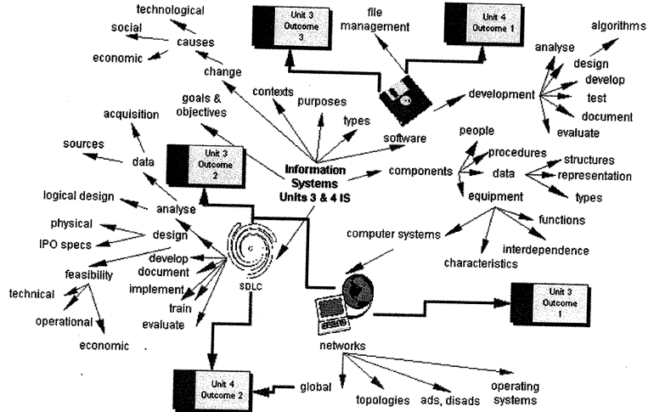

Diagram 4. Overview of VCE Information Systems
For Outcome 1 students create a poster or presentation file that visually represents the relationships between components of a networked information system; that is, the people, equipment and key data sources. The components must be annotated to indicate the roles of the people and the functions of the equipment. Analysis of the operations of the system is required, including the purpose and functions of the network topology, the network operating system, hardware such as network cards, cabling types and bandwidth, and communications protocols.
Outcome 2 requires students to analyse an existing information system and justify the design of a new or modified networked information system focusing on the analysis, design and development phases of the systems development life cycle (SDLC). Students must demonstrate knowledge of some system design tools to represent both the logical and physical models of an information system.
The logical design describes the functions required of a system. It identifies what is to be done; not how it will be done. This design is not concerned with hardware and software requirements but rather with what processes need to be performed. Context diagrams and data flow diagrams (DFDs, level 0 and 1) and data dictionaries are useful tools in representing the logical design of a system. Students must be able to create DFDs and interpret data dictionaries.
A physical design describes how the processing will be performed; for example, whether data is input by a person or read by a bar code reader, whether a file is electronic or print. Tools to represent the physical design include system flow charts and structure charts. For the assessment task, students document only the logical design of the new system. However, the outcome requires they also be able to interpret structure charts and system flow charts.

For Outcome 3 students develop a software module. They do not develop a whole software application but one module only. To achieve this outcome, students interpret flow charts, pseudocode, and Nassi-Schneidermann (N-S) diagrams. They write algorithms using one of those three methods. For this outcome and Outcome 1, Unit 4 students use a programming language to create a software application. The software application need not be as sophisticated as would be required in actual use in an organisation. The purpose of each response is to serve as a model of a real situation. The programming language must be selected from a list provided annually by the Victorian Curriculum and Assessment Authority in the VCE Bulletin. When appropriate, this list will be updated to include new programming languages.
Outcome 3, Unit 3 requires students to explain how their program takes into account a legal obligation or an ethical responsibility. To do this, students will need an overview of legal obligations of programmers including relevant amendments to the Copyright Act Copyright Amendment (Digital Agenda) Act 2000. A paraphrased summary of the main provisions is adequate. Students do not need to know every clause.
For Outcome 1, Unit 4 students apply a problem-solving methodology to produce purpose-designed software in response to a design brief, and a written report. The scenario described in the design brief should include a statement of the information system objectives and the needs of end-users. It should take into account the outcome requirement that students explain in writing how the software they developed may cause conflict between the organisation and an end-user.
This outcome has two assessment tasks. The first task is an information technology solution that includes internal documentation but not user documentation. The second task comprises user documentation and an explanation of how purposed-designed software may cause conflict between the programmers who develop the solution and the people who use the solution. This task can be undertaken as a test or a written report. This outcome contributes 60 marks to school-assessed coursework for the unit, but students score a separate mark for each task. The information technology solution is worth 45 marks and the user documentation and explanation is worth 15 marks.
Outcome 2, Unit 4 explores information systems that operate in a global environment. For the purposes of the study design this relates to organisations that use the Internet to make e-commerce transactions or to communicate with remote parties (for example, suppliers, customers, branches of a business). The outcome requires the study of a change in an information system that addresses one of these global factors. Students' responses to the associated assessment task (a written report or test) address the development, implementation and evaluation phases of the SDLC and strategies to coordinate these. Project management tools and techniques are useful strategies. Students are not expected to develop skills in creating PERT charts or Gantt charts. They are, however, expected to be able to interpret these and explain why they might be used.
When developing a course, a thematic approach can be taken, whereby all outcomes focus on the one information system. Another option is for each outcome to have a different information system setting or students might study one information system in Unit 3 and another in Unit 4. In Unit 3, the mark contribution of Outcome 1 (20 marks) to school assessment suggests this outcome should be undertaken first. This task is relatively small yet provides a useful introduction to the VCE assessment process for the students.
While assessment is based on the student's ability to demonstrate each outcome for the school-assessed coursework, the aspects of Outcome 3 in Unit 3 and Outcome 1 in Unit 4 that require creation of a solution and/or output are not examinable in the final examination.

Unit 3 Information Systems

Outcome 1 | Examples of learning activities
Explain the functions of, and the relationships between, the components of a networked information system used in an organisation. | - explain the relationship between RAM, processor speed, and bus width  - comment on the notion that transaction processing, management information systems, and decision support systems are not separate entities but are integrated  - investigate the functions and skills required of the people involved with information systems  - investigate the school network, identify whether it has a star or bus topology, comment on the merits and problems with this topology

Detailed example: Represent a Network
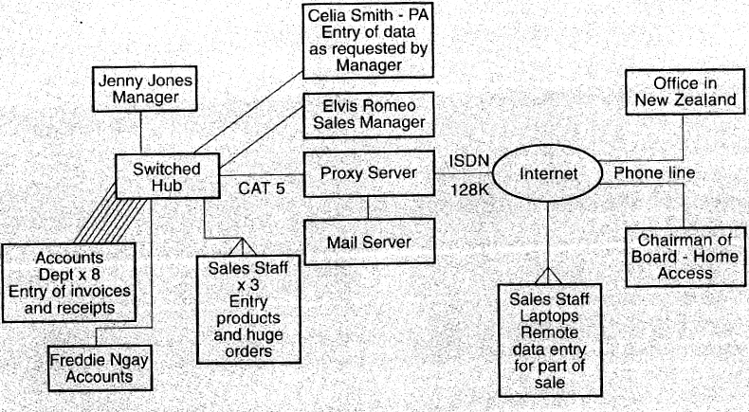
Network based on extended star topology

Dressed Floors Co sells carpets. For residential sales, staff measure and quote on site and record their orders through laptops. Industrial carpets are measured on-site then the order is processed at the office. The diagram represents the company information system. Annotate the diagram to :

• suggest why Jenny and Elvis need to be involved with the system
• state the functions of the equipment components
• explain the purpose of the Extended Star topology and why it is suitable for this network,
• explain the suitability of the coaxial cable and the ISDN access used in this network
• explain why the system needs Windows NT and TCP/IP

Outcome 2
Analyse an information system and explain and justify a detailed design for a new or modified networked information system. | Examples of learning activities  - investigate how information systems are used in a range of organisational settings using methods such as observation (visits), guest speakers, videos, case studies in print and on the Internet  - discuss concepts such as organisational aims and system goals and objectives with a view to understanding the relationship between them  - investigate user needs using a range of methods such as surveys (paper-based, electronic), interviews, email, mailing lists, video conferencing  - assess the feasibility of a proposed new information system for the school canteen, complete an incomplete data flow diagram, which has a list of processes  - a legal firm has all their archive files stored on a 200Gb tape array; a new goal for the firm's information system is quick access to the archives; explain whether and how a 300Gb disk drive could assist in meeting the system objectives  - design an information system for a medical practice

Detailed Example

Design an information system
Dr Johnson has been in practice over thirty years. Dr Albright graduated in 1990 and recently joined the practice. On an average day each doctor sees about 25-30 patients. There are about 5000 parents with the clinic. The gross income of the practice is $75,000 a month. This income must cover office expenses and staff salaries: office manager, receptionist and two nurses. Other expenses include: rent electricity, supplies, malpractice insurance, conferences, etc. The doctors think the practice information system is efficient but this is only because the two staff work much unpaid overtime.

Current practices
Mrs Long, the practice manager, writes up a patient invoice while the patient waits. If the patient pays on the spot, Long writes out a receipt. If the patient pays by credit card, Long writes the credit form out and transfers the credit card details to the form by using a hand-operated credit card machine. If a patient doesn't pay on the day, Long gives them an invoice and places a copy of the invoice in the patients file. If the patient then pays by mail, Long writes a receipt and posts it to them. If the patient calls in, the normal procedure applies. At the end of each month, Long prepares a profit report for the doctors. The profit report is often late as Long can't keep up with the paperwork.

Ms Carr, the receptionist finds patient files in the filing cabinets and places them in the doctors' pigeonholes ready for the doctors to collect before seeing each patient. She collects about six patient files in advance for each doctor. When patients have been seen, the doctors leave the patient files on the front desk and Carr returns them to the fling cabinet. Sometimes files mount up an the desk if the surgery is busy and Carr stays back after work to file them all.

Business concerns
Lang is about to retire. Carr doesn’t want Longs job. Albright doesn’t want to do the paperwork either as it will take her away from her patients. She is also worried about the salary costs of the practice and wants to cut overtime so suggests a computerised information system.

Albright wants the doctors to be able to update patient records (medical history and fees) on PC terminals in their examination rooms.

Design a new information system. Steps include.

- identifying two problems with the current system
- identifying three data sources and two methods of acquiring data about the current system
- stating a goal and two objectives of the new system
- drawing a context diagram and a data flow diagram for the new system
- describing the hardware and software specifications for the new system
- for one of the system objectives, describing two hardware or software alternatives and evaluating their operational feasibility
- listing the criteria you will use to evaluate the performance of the system

Outcome 3
Produce a software module, in response to a system design, and verify its performance against the design specifications. | Examples of learning activities  - desk check a given piece of pseudocode and find the errors  - discuss concepts such as debugging, testing, validation and evaluation  - compare two representation techniques for program design such as a flow chart and N-S diagram  - give examples of the programming control structures of sequence, decision, loops in a flow chart and in pseudocode  - discuss the purpose of internal documentation and where the remarks/ comments should be placed in the program code  - design a test table and test data to check a program module designed to calculate a theatre ticket price for adult customers but giving 15% discount to those over 60  - discuss the ethics of borrowing a program module from another programmer's code such as copying some JavaScript from a web page on the Internet  - produce a software module for a new car park ticketing system

Parkiteer Car Park opens from 6.00 am nil midnight has 150 spaces and charges $8.00 per hour with a maximum charge of $20.00. Ten per cent GST must be added. Fees are calculated to the next hour; no part hours are allowed. On entering the car park, a customer gets a ticket with a unique number from a time clock that stamps the entry time on the ticket. When the customer returns for their car, a clerk inserts the ticket into the time clock to get the current time, then calculates the fee with a calculator. The clerk keeps the ticket. At the end of each week, the tickets are used to produce a weekly revenue report that states total revenue earned and total GST payable to the government.

A new system will be introduced. On entering the car park the customer's ticket will be printed by a computer controlled system that includes the time, date, and a unique ID on the ticket. When the customer returns, their ticket will be inserted into a card reader and a computer will calculate the parking fee including GST, display the fee on a screen and print a receipt.

There are four processes: calculation of parking fee, printing of the receipt, updating of revenue file, printing of revenue report. Your task is to design a prototype module that calculates rate parking fee. A friend advises you that he has code for a similar system that was written by Frank Ferrari.

You will:

- write an algorithm as pseudocode or flow chart
- draw up a data table that shows: data item, description, format, data type
- produce a documented working module
- test the module
- compare the module you developed with the algorithm; explain how the actual capabilities of the program compare with the intended capabilities
- if your friend had offered you Ferrari's code would you have accepted ? Explain your response.

Modification: design the module using the keyboard for data input. Your code will be used in the final system. Only the input method will be different in the real system.

Unit 4 Information Systems

Outcome 1 | Examples of learning activities
Apply the principles of software development to produce purpose-designed software that takes into account the information system objectives and the needs of the end-users. | Examples of learning activities  - debate the comparative value of online help, multimedia tutorials, printed manuals, and onscreen help files as forms of user documentation  - read short case studies and identify appropriate test data  - compare and contrast software developed to the same design specifications  - write user documentation and incorporate screen dumps where appropriate  - discuss the structure and merits of serial, sequential and random (direct) access files  - design develop and test software to enable a business to conduct its sales by e-commerce

Detailed Example

Design, Develop & Test Software
Anklebyters Videos is a retailer of children’s videos. The firm has their produce catalogue displayed on a website. Potential customers can download an order form that they fill in and fax back to Anklebyters Videos. The stock clerk fills the order, calculates the total cost and posts it to the customer with an invoice. Invoices are often miscalculated so the firm is losing revenue.

Anklebyters Videos wants to make the process more accurate and more efficient by ending the fax service and selling only online and automatically calculating the price due. This new system must collect the customers order data, delivery and contact details, and credit card details. It should calculate the total price of the order, save the order in a file and print out an invoice.

You are to create a prototype of the software application required to achieve the system objectives. For the prototype, assume the firm has a catalogue of five products and will accept VISA and Bankcard.

Sample product data: Catholic Wriggles $25, Chewy Outer Boot $35, Ice Drops $30, Bung It On $28, Tooleybuck $25.

Anklebyters Videos Co. Ltd, GPO Box 456, Melbourne,Vic 8000. Phone 9344 7891

Constraints

In practice, a firm will check a customer's credit card PIN against the credit card company's database to validate it. For the prototype create a customer record file of five customers. The file will contain the customer name and credit card PIN. Assume the PIN Is four digits.

Your tasks

- Write an algorithm to represent your prototype design. Include representation of the processes, a screen layout diagram, an invoice layout diagram.
- Complete the data table pro forma
- Determine the data structure.
- Determine validation techniques
- Design a test table to test your software application.
- Code and document your program.
- Write appropriate user documentation
- Prepare a written report that explains how your software application could cause conflict between Anklebyters Videos and a customer.

Outcome 2
Propose and justify development, implementation and evaluation strategies for introducing to an organisation an information system that will operate in a global environment. | Examples of learning activities  - discuss which email messages should be encrypted and whether all emails should be filed  - use the Internet to investigate the validity of customer fears about the safety of credit card data transmitted over the Internet  - debate the proposition that introducing software to a network requires more planning than introducing hardware to a network  - compare two strategies for managing change and debate their appropriateness in different situations  - read a short case study describing proposed changes to an information system; design a plan to manage the implementation of the system  - discuss ways of protecting data stored on a network from unauthorised access and theft  - discuss how staff absentee rates can be an indicator of system performance

Detailed Example
Implementing a new system.

The Victoria Hospital (VH) wants to develop a new information system to overcome a nursing shortage because a recent survey found a 30 per cent shortfall of nurses. VH held focus discussion groups and discovered that nurses wanted better rosters, more communication with management, changes to work practices, and educational opportunities

VH will provide ten computers and four Internet Kiosks for exclusive nursing staff use. The kiosks will give staff free Internet access and the computers will give updates from hospital management through the hospital's intranet system. All nurses will have email accounts and nurses on night duty can sort out problem such as payroll from the ward computer instead of coming in during office hours. Nurses can also apply for jobs at a hospital over the Internet and study VH sponsored courses over the Internet.

VH employs 800 nurses and has vacancies for 150 nurses. It currently has a network with a PIII 800Mh 128M, RAM PC file server running Windows 2000, Windows NT, SGA monitor, 2 x80 Gb HDD mirrored disks and 16 similar configuration PCs attached each with 64Mg RAM. The network is run by a Network Manager and is currently used for processing and managing financial data, patient data and document processing.

VH provided these specifications for the new system to be installed in the hospital.

- file server similar to current one but with 2 x 60 Gb mirrored disks
- five PCs to be similar to current network computers attached to the file server
- four Internet kiosks with Windows keyboards, joystick. SGA monitor, 20 Gb HDD, ISDN access
- two additional 60 Gb HDDs, mirrored disks
- Windows NT IE7, MS Office with Outlook
- dedicated phone line.
You are to:
- state the purpose of the new system
- evaluate the appropriateness of the components suggested by MGH
- describe the techniques you will use to test the system components and the whole system
- select a changeover method and justify your choice
- describe the documentation needed to support this new system and explain its purpose
- identify who will need training, what type of training they will need and when
- state what procedures must be developed to ensure only nurses can use the network
- describe the procedures required to ensure records are kept of all emails sent to management
- explain how you will evaluate the performance of the system and when you will do this
- explain how you will coordinate the development, implementation and evaluation of the system
- explain one way the hospital and the nurses will be affected by the new system.

