Information Processing and Management
Written examination — November

Introduction

The format of the examination paper will be different from past practices. Students will now be presented with a Question and Answer Book that contains both the questions and space for responses.
Options may exist within some questions.
The examination paper will address all criteria and students will be examined against each criterion. The examination will comprise different types of questions of varying mark values and each outcome will be addressed and the value of the question(s) pertaining to each outcome reflects its contribution to a unit.

Sample questions

The purpose of the following sample questions is to show some different formats in which questions may be asked or to indicate how new content may be treated in the examination. The samples do not represent a total examination paper.

Question I
The management hierarchy of a typical organisation may be represented in the following way.

General manager

Section manager

Operational staff

In a medium-sized organisation, the Accounts department information system produces the following reports.
A:. a daily transaction report of receipts and payments
B:. Monthly profit and loss statements
C:. an annual budget forecast for the next five years
In the boxes provided above, indicate which of the identified reports each management level is likely to require.
1 mark

Question 2
Provide one example of when recording customer complaints would be an appropriate way of evaluating a solution to an information problem.
1 mark

Question 3
Provide one example of an electronic data entry method that is appropriate to use in a stock recording system.

1 mark

Question 4
Provide one limitation of using surveys as a method of determining the effectiveness of an information system.

I mark

Question 5
Listed are three examples of types of information systems. Select one and describe its purpose and provide an example of a typical capability of the system software component.
i. personnel system
ii document management system
iii. point of sale system

2 marks

Question 6
Listed are four statements, which either describe a problem or describe a solution. For each statement indicate if it is a problem’ or a ‘solution’.
i. When a customer calls and orders an item that is not in stock, the sales assistant cannot find out when an item is expected to be back in stock.

ii. The Information Technology department is providing end users with the technical support they need.

iii. The local tennis club is losing revenue because it does not keep accurate records of its members.

iv. The secretary in the Accounts department needs a zip drive for all his data.
2 marks
Question 7

Explain why it is important to keep an off-site backup of financial records.

2 marks
Question 8
List two factors that affect the value of information produced by an organisation.

2 marks

Question 9
Typically the phases of an information system life cycle include designing, analysing, planning, maintaining, evaluating, decommissioning/retiring, implementing.
List these phases in the sequence in which they are most likely to occur in the information systems life cycle.

(more lines would be available for this answer
4 marks

Question 10
Answer either Alterative A OR Alternative B. Both questions are of equal value.

Alternative A
The following Performance Evaluation and Review Technique (PERT) chart has been developed to assist in the management of a project. Examine the chart and answer the related questions.

TASK B
TASK A 3 hrs
TASK C TASK E TASK F
1 day 3_{1/2} hrs 3 hrs 1 day
TASK D
4 hrs
Critical path

a. Why is TASK B not on the critical path?

- What happens to the overall timeline if TASK D takes an extra 2 hours?

c.What do the lines indicate?

3 marks

OR

Alternative B
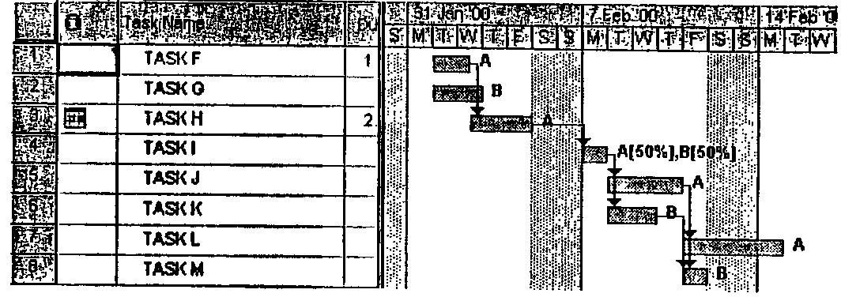
Below is a GANTT chart for the process to complete a project.

(Note: Weekends are non-working days.]

a. If TASK K takes three days longer than planned, what impact will this have on the end date?

- List two tasks that can take extra time without affecting the end date.

1+2=3 marks

Question 11
The following diagram represents a process for developing a solution to an information systems problem.
Overall organisational goals
established

Sub-system is broken down into parts
Sub-system is broken down into parts
Sub-system is broken down into parts

a. Name the design strategy shown above.

. State one disadvantage of this strategy.

c. State one advantage of this strategy.

3 marks

Questions 12
Listed are items that could be included in a flowchart. Select the appropriate items and draw a flowchart that indicates how you would test that a solution produces accurate output.
Compare manually determined and computer-generated values
Enter data
Check rules

Create sample data

Stop
Start
Manually determine correct results
Correct rules

Check manual results
Rules are correct

Manual and actual outcomes match

Is data created typical?

5 marks

Question 13
Readmore Books is a small retail hook shop with two full-time and three part-time employees. They want to purchase a computer system to develop an electronic publication for uploading to their Internet Service Provider. Some of the components likely to be required me listed. Select three of these components and for each recommend the appropriate specifications and justify your choice.
i. modem
ii. CPU
iii. RAM- 64K
iv. hard disk drive
v. application software

6 marks

Question 14

The following diagram shows the floor layout at High Tech Retail. Security devices are required at the three numbered points. From the alternative devices listed below, select one device for each numbered location and justify the selection.

Secure
Storage
area
Exit
2
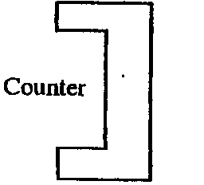

Counter
1

Entry
One way barrier
3

i. rotating video camera
ii. number lock
iii. card reader
- x-ray scanner to monitor stock

6 marks
Question 15
Company B wants to allow clients to use a  program that will show the interest earned on investments at varying rates. | Company D operates a lending facility and  wants its clients to be able to query/search for relevant information, | Company F wants to target young computer  users to buy its  products online, | Company Z wants to run an automatic  presentation at a food fair to advertise its products to people passing by.

Select and identify one of the above companies and answer tlse following questions.

a. What output will need to be created?

b. What data would need to be acquired?

c. What software will be needed to process the data?

d. What hardware will be required to produce the information?

e. How would you evaluate that the solution was meeting the company’s needs?

2+2+2+2+2= 10 marks

Question 16

Dual Days is an organisation that provides people who look like well-known identities for the entertainment industry, Its database contains a wide range of personal details for each member including a digital image. Currently one user name and the word 'password’ as the password is used by all staff. Any changes to the files are verbally authorised by the manager before being made on the network by any of the 10 staff members. Last week it was discovered that one of the images had been altered without authorisation and the manager was unable to track who made the change.
Explain and justify an appropriate security strategy for Dual Days.

(more lines would be available for this answer)
8 marks

Question 17

A toy store with three outlets wants to establish a web site to sell toys over the Internet. The site displays a table that includes a picture of a toy, a description, country of origin and price. Customers may purchase toys using a credit card. To encourage use of the system, customers may register their personal details and be eligible for bonus points that may be redeemed on Christmas purchases. Current sales staff will be selected to

• update the web site
• respond to e-mail enquiries
• process purchases by preparing delivery dockets from the database of orders
• send out orders.

Discuss this situation with respect to two of the following.

i. privacy
ii. occupational health and safety
iii. data security and integrity
iv. training
12 marks

Question 18
With specific reference to a software type you have studied this year, explain a technique for validating data, how it operates, when it would be used and its limitations.

8 marks

