Criterion

2

“knowledge of strategies and techniques for developing and evaluating solutions to information problems experienced in organisations”

Information Processing
Is the process of transforming data into meaningful information.

Major steps associated with information processing
- Data acquisition
- Input
- Data Validation
- Data manipulation
- Storage
- Retrieval
- Output
- Communication
- Disposal of data and information that is no longer needed.

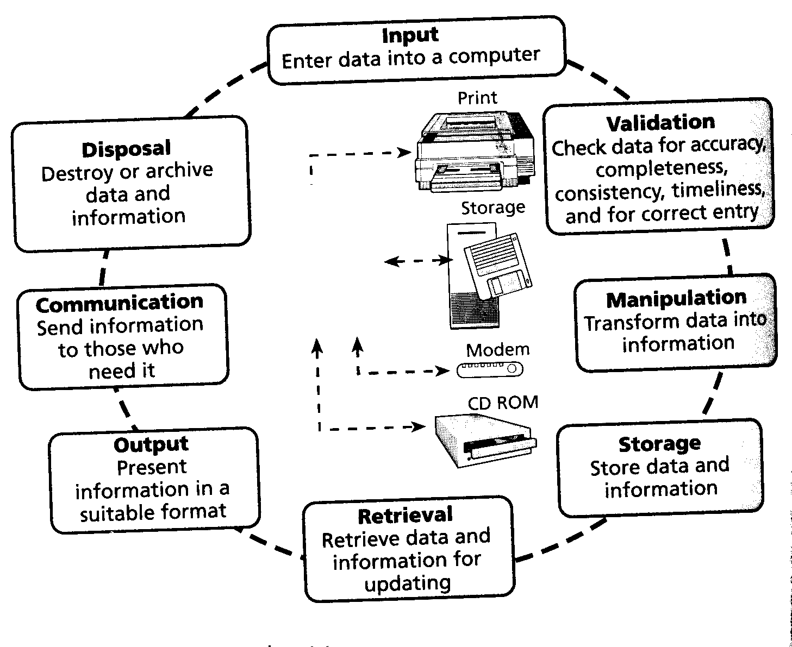

Techniques and procedures to produce information effectively and efficiently

Data Acquisition

For data to be useful for processing into information, it must have the attribute of data integrity.

“Data integrity implies that the data is from accurate, reliable and unbiased sources and that it has been entered correctly and is current.”

The three elements of data integrity are: data accuracy, reliable data entry and timeliness of data. These elements must be considered when acquiring data for information processing. There are two types of data:
- Primary data: unpublished, first hand data obtained from sources such as direct observation, surveys and sampling, interviews and forms.
- Secondary data: is published material obtained from sources such as books, the mass media, web sites and online services.

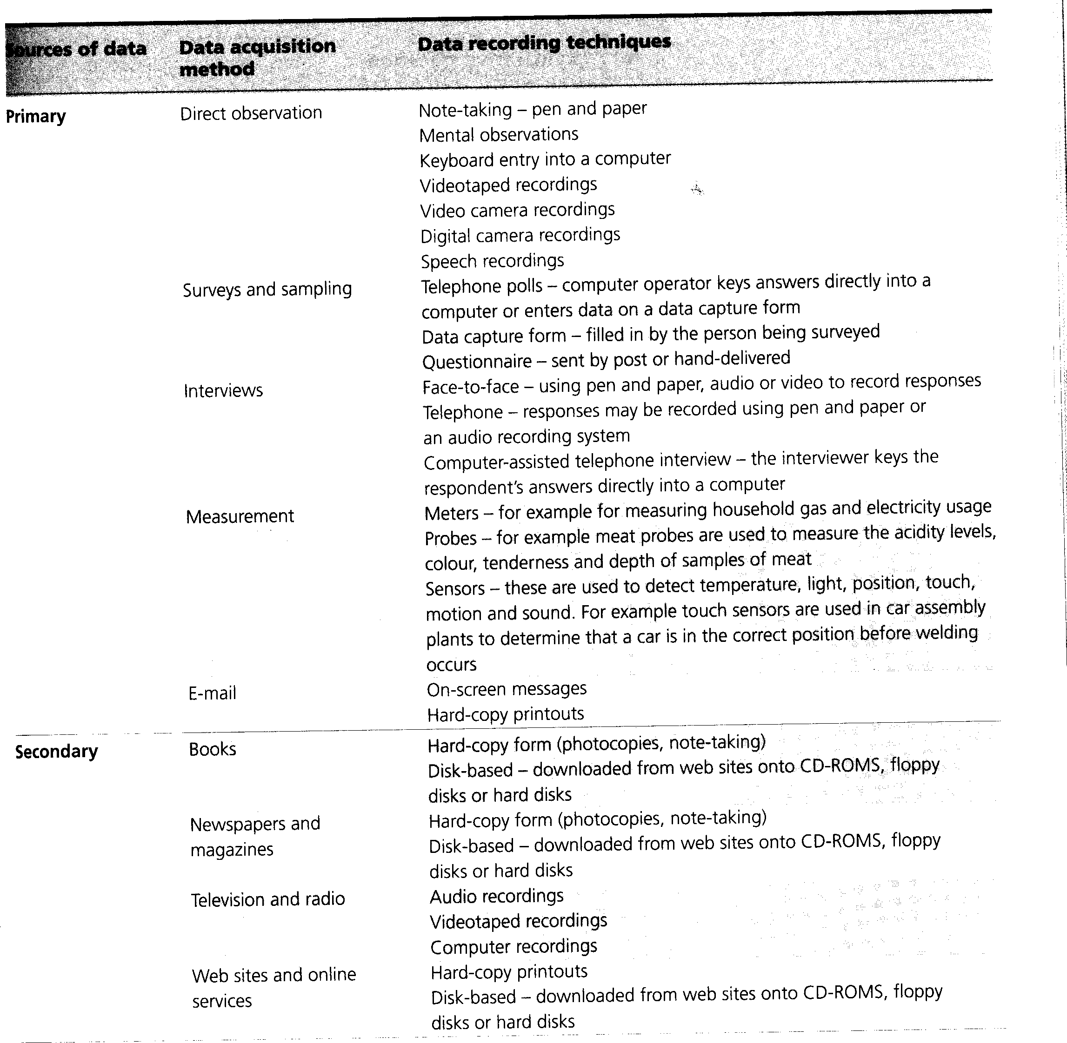
Input

Data can be entered into a computer using various techniques, for example by:
- Keyboard
- Scanning from paper
- Tracing over data such as a diagram or drawing using a stylus
- Connecting a sensor to a computer
- Touch sensitive screen
- Connecting a digital camera to a computer to input pictures that have been taken
- Speaking for a speech recognition device
- Operating an electronic keyboard connected to a sound card.

The efficiency of different data-entry techniques can be measured in terms of time, effort and money used in inputting data.

The effectiveness of different input techniques can be measured in terms of data-entry accuracy rates.

Data Validation

Data validation is the process of checking that data is complete, accurate and unbiased before it is used to produce information.
The data validation process can be undertaken using either manual or electronic (software and hardware) techniques. Some electronic techniques can be built into computer programs that are used to produce information.

Data Validation Techniques | Definition
Reasonable Checks | It is possible to check whether data entered into a computer is reasonable, although such checks do not confirm that the data entered is accurate. For example, checking a day entered is between 1-31.
Data Consistency Checks | Examining data in relation to other data is a way of detecting if data entered is valid. For example, in a travel reservation system an error message will be displayed if the departure date entered for a holiday package is later than the return date.
Range Checks | Numeric data should be checked to see that it falls within a particular range.
Data Type Checks | If data should be of a particular type, it should be tested for that. In a spreadsheet, alphabetic and numeric values will have a different alignment in the cell and this will serve as a form of data validation
Text Checks | Spelling and grammar checkers in word-processing software tools can be used to check text.
Manual Checks | - Proofreading for spelling, grammar and typographical errors etc.  - Reading back the information  - Testing data such as survey questions, which involves asking someone to read material to check that it is clear and unambiguous  - Printing drafts and checking them  - Checking secondary data details.

Manipulation
Manipulation is the process of using software to transform data into information. Examples of manipulation include:
- Searching
- Querying
- Sorting
- Drawing
- Charting
- Calculating
- Summarising and;
- Comparing.

The main types of software tools used for this data manipulation are: word processing, spreadsheets, databases, web authoring, multimedia, drawing, presentation graphics and desktop publishing.

These are suited to different types of manipulation tasks, for example:
- Word processing software is suited to formatting text and tables
- Spreadsheets are commonly used for calculating statistical data and formatting it into tables and charts
- Databases are useful for collecting data and preparing reports
- Presentation graphics software is used to produce slides for oral presentations
- And many more

The efficient manipulation of data can be determined by how well software techniques are used. For example:
- Using the SUM function in a calculation is much more efficient than adding individual cells
- Using automatic text-styling techniques is more efficient than manually applying a set of fonts and type style to text.
- Creating macros to combine a numbers of operations into one is more efficient than re-entering the steps in a frequently used function.

Using manipulation techniques effectively refers to presenting information that is clear and readable, and accurate, complete and appropriate. It also refers to the content and format of the information meeting the users needs.

Storage
Storage is the process of saving data on disk. Storage of data may need to occur prior to and after data is converted to information.
Typical storage devices include: floppy disks, cartridges, CD-ROMS and hard disk drives.

Retrieval
Retrieval is the process of recovering stored data or files for updating or manipulating. To retrieve a file from storage, a computer must be given directions in order to locate it.
The use of filenames that are meaningful, filename extensions and directories, as well as the careful labelling of disks are all necessary for the efficient retrieval of files.

Output
Is the conversion of data from machine-readable form to human-readable form. The type of output produced will depend on the nature of the data, the techniques and equipment available and the needs of the user. Computer output can take many forms, for example:
- A report is printed from a laser printer
- A building plan is produced from a plotter
- A video clip is shown on a screen
- Presentation slides are projected on a large monitor.

Communication
Communication is the transfer of information from one place to another. Organisations and individuals use communication applications such as:
- E-mail
- Videoconferencing transmissions of video, image and sound to participants in a remote location.
- Web site and online services to place information and retrieve it.
- Voice mail
- Fax transmissions

Whether one or another type of communication technique is used for a given situation will depend on factors such as the need for speed, security and confidentiality and the level of permanence of information required.

Disposal
Disposal involves the removal of unwanted files from a computer and the transferring of files that are no longer active, but are still required for legal or other reasons. These inactive files are transferred (archived) to an auxiliary storage area, such as a remote warehouse or an outside storage provider. Archiving is one aspect of records retention program that involves the classification of documents and procedures for the periodic transfer of inactive files.

Examples of solutions to problems involving the different information processing steps.

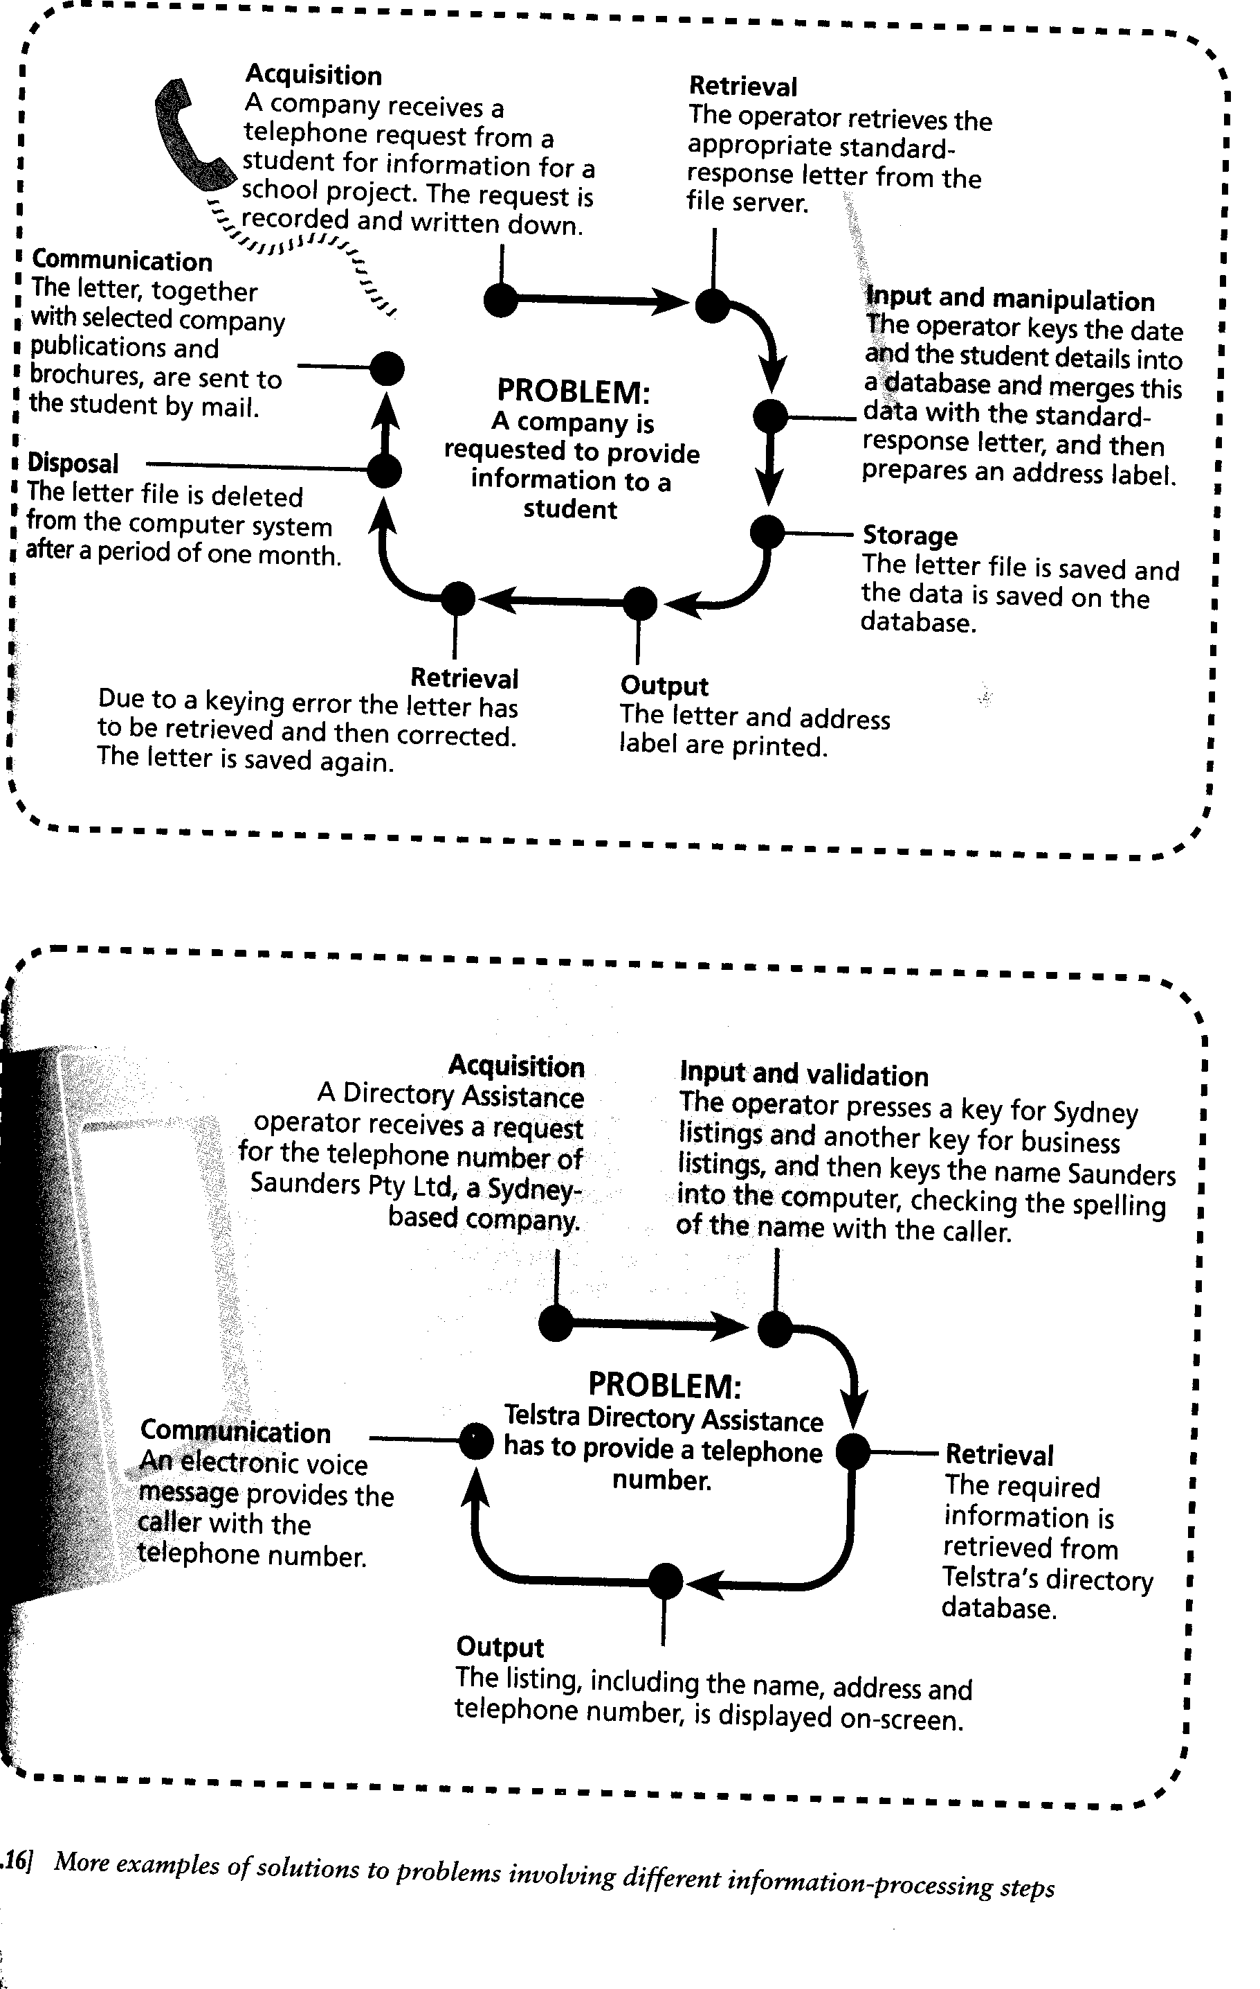

Methods of organising and validating data

Data Validation
As previously defined, data validation is the process of checking that data is complete, accurate and unbiased before it is used to produce information. There are a variety of methods of used to validate data:
- Reasonableness checks
- Data consistency checks
- Range checks
- Data type checks
- Text checks and;
- Manual checks.

Using a database software package, data validation may be performed by:
- Applying a rule eg. Postcodes must be ‘between 3000 and 3999’
- Specifying (using an input mask) that a field begins with a certain digit or character.
- Dividing fields into as many subcategories as possible.
- Ensuring that the user has entered data into a field (not null)
- Forcing the user to select data to be entered from a drop down menu.

Data Organisation
If data is organised in a logical manner it is more suitable for processing into information. The methods used to this are referred to as data structures. Data structures are organised collections of data items that are subject to certain manipulation rules.
Most application software tools hide the data structures away from the user, with significant exception, the database. Using a database the user must organise the data into fields, records and files.
- A file is a collection of data that is electronically stored.
- A record contains all the data about a single entry, such as a person in an address book.
- A field is a category of data within a record and contains a specific data item, such as a person’s telephone number or postcode.

There are two types of file structures:
- A sequential-access file is one in which the records can only be accessed one after another in order from the beginning to the end.
- A random-access file is one in which the records can be accessed directly no matter where they are in the file.

Techniques for representing designs

There are two types of approaches to describing the processes involved in a problem:
- Top-down design is an approach where the solution is divided into progressively smaller parts until there is enough detail to allow implementation to take place.
- Bottom-up design is an approach that is in a sense opposite to top-down since it examines the individual parts of the solution and puts them together to achieve a complete solution design.

There are a variety of techniques that can be used to represent designs:
Technique | Definition
IPO chart | Represents the items and processes involved in inputting data, processing data and outputting information
Structure Chart | Shows the relationship between a process and its constituent parts or sub-processes
Algorithm | Is an explicit set of instructions which when applied to a given set of input data, will produce the required output. There are different methods of representing an algorithm:  - Pseudocode  - Flowchart  - Structured English  - NS-Chart

Formats and Conventions

Formats are the overall styles used to present information and the ways in which the various elements of the presentations are arranged. For instance, letters newsletters, web pages, computer programs, financial statements are all examples of different formats.
Conventions are rules that have developed over time governing the layout and presentation of a selected format or the individual elements of that format.

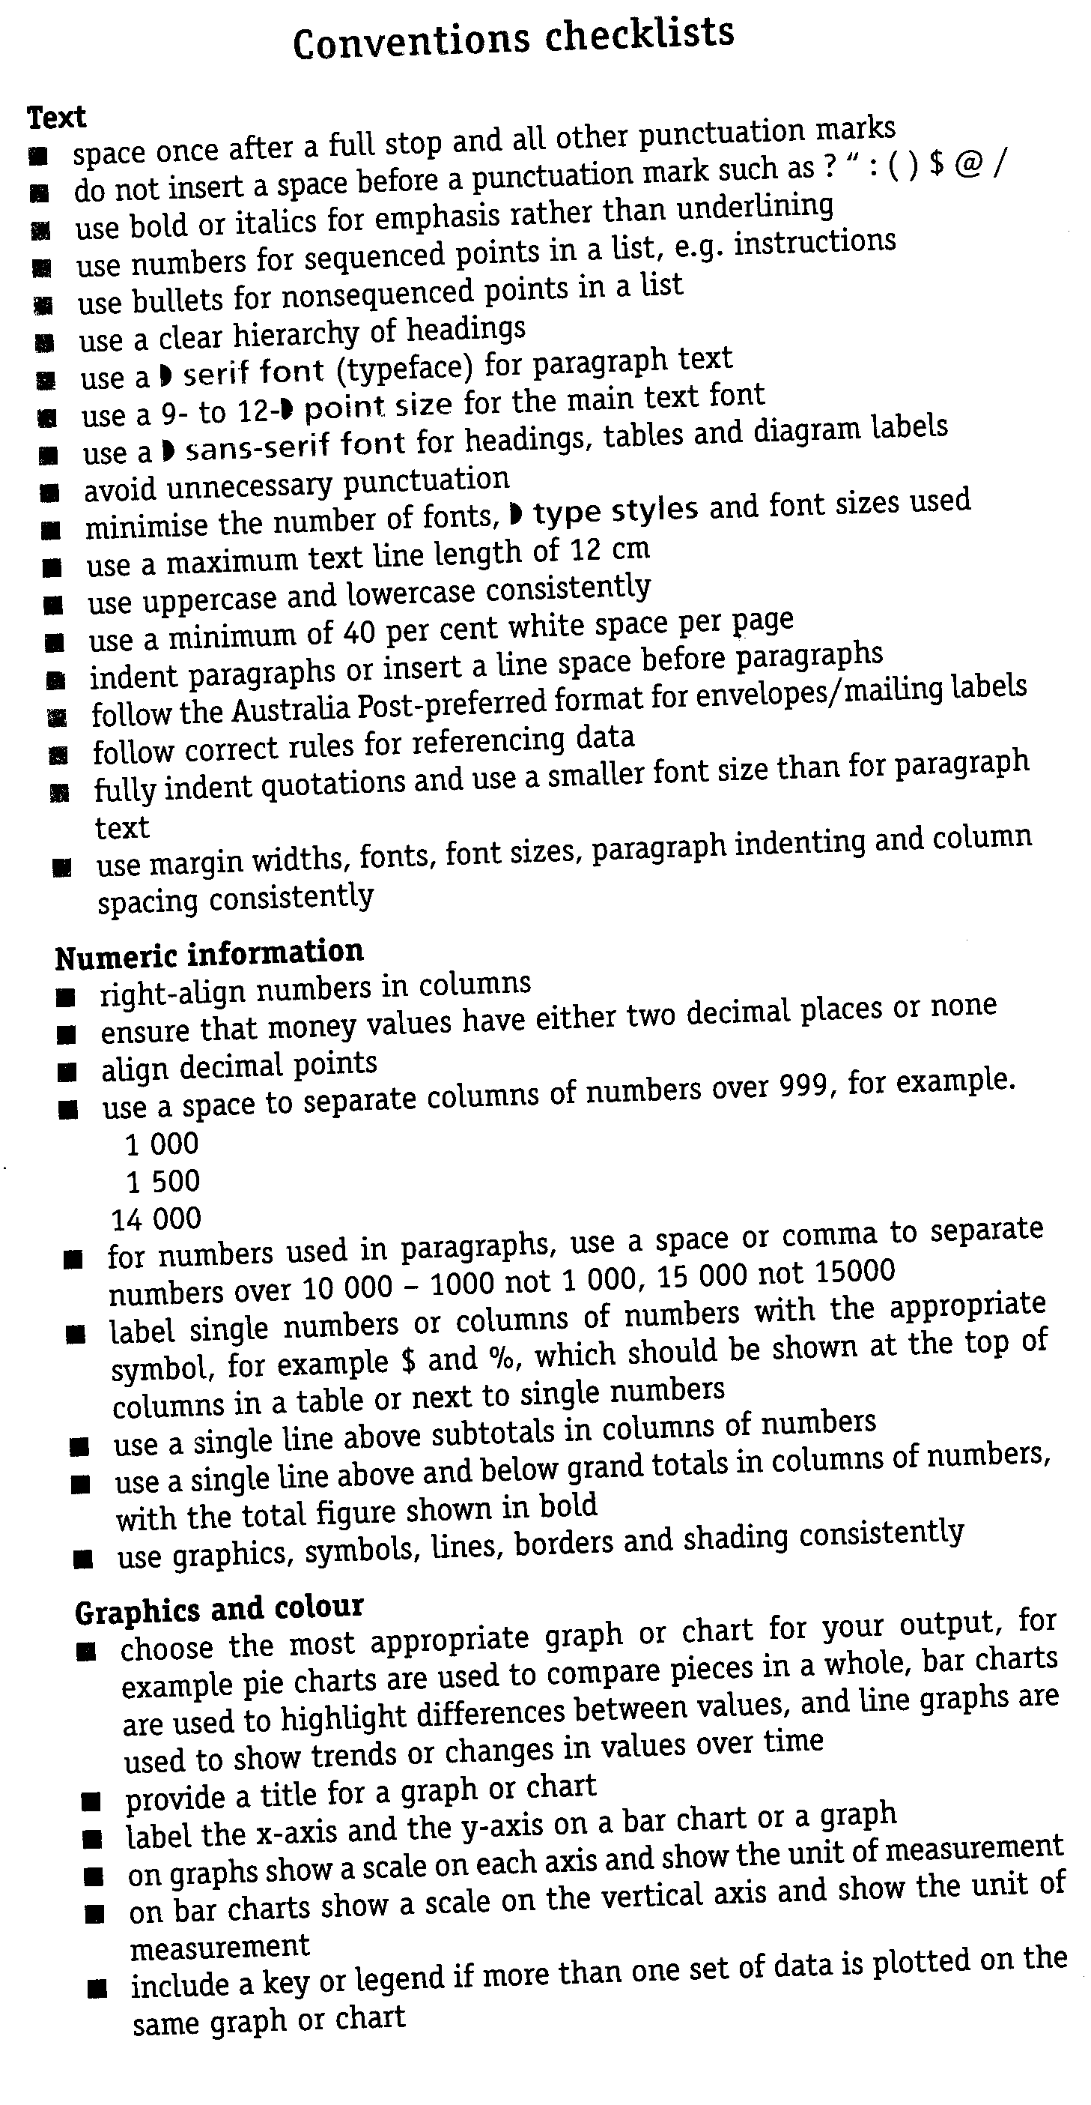
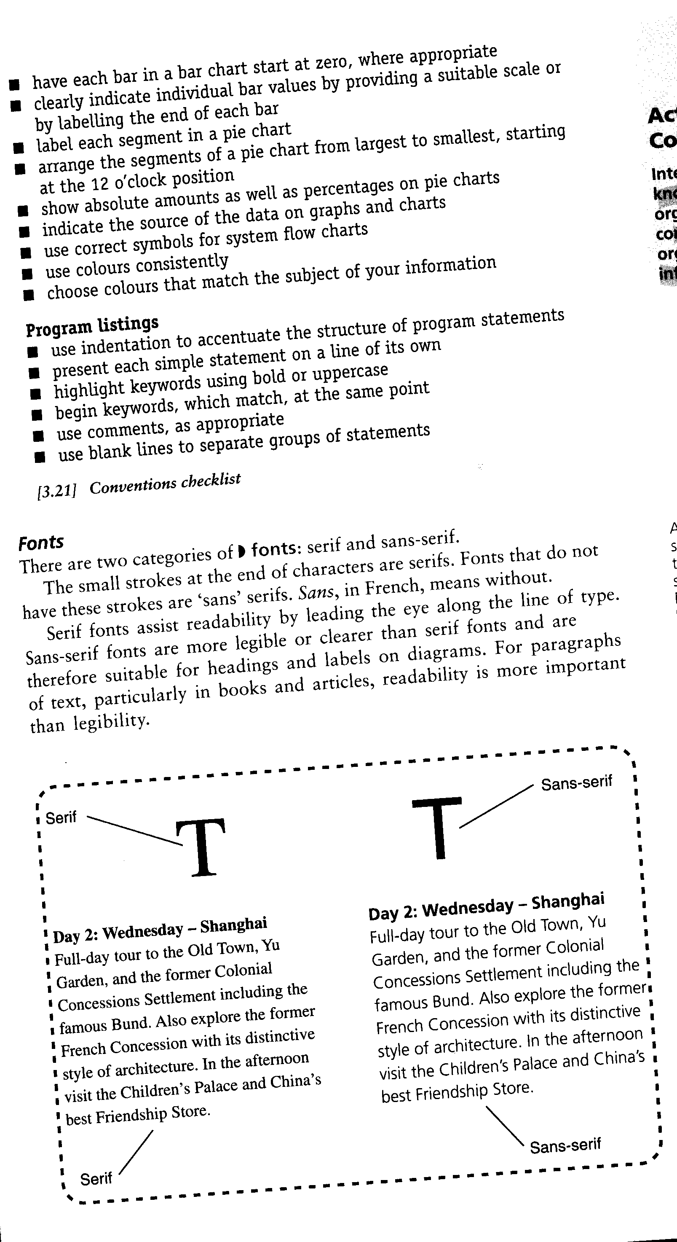
Factors affecting the suitability of information

Qualities of Good Data and Information
- Accuracy: although error free data does not guarantee accurate information, it is impossible to produce accurate information from erroneous data.
- Completeness: that all relevant data and information is provided or made available.
- Consistency: all related data in a document or file must be compatible and logical. (e.g. In a questionnaire, an answer stating ‘never married’ followed by another stating ‘divorced’ is an illogical inconsistency.
- Validity: the information needs to be verifiable, in other words, it should be capable of being confirmed (e.g. a sales manager should be able to verify the totals in a monthly sales report by adding up the orders received for the month).
- Appropriateness: is the information meaningful and relevant to the person who receives it.
- Timeliness: making the relevant information available to the right person at the right time.

A guide to designing and formatting information
- What is the purpose of your information product?
- Who is your attended audience?
- What impression do you want to convey?
- What elements are needed to enhance your information product?
- Are there any physical limits to your information product?

Nature of information used in organisations and reasons

Information helps us to make accurate and informed decisions by reducing our uncertainty about what to do. It also helps us to solve problems and perform work tasks effectively.

Senior managers, middle managers, operational managers and workers all have different information needs (shown below). While both internal and external information is used at all four levels of an organisation, the higher a manager is in an organisation the more likely it is that the external information will be needed.

- Internal information: is produced within the organisation for internal purposes.
- External information: is produced outside an organisation but is used internally.
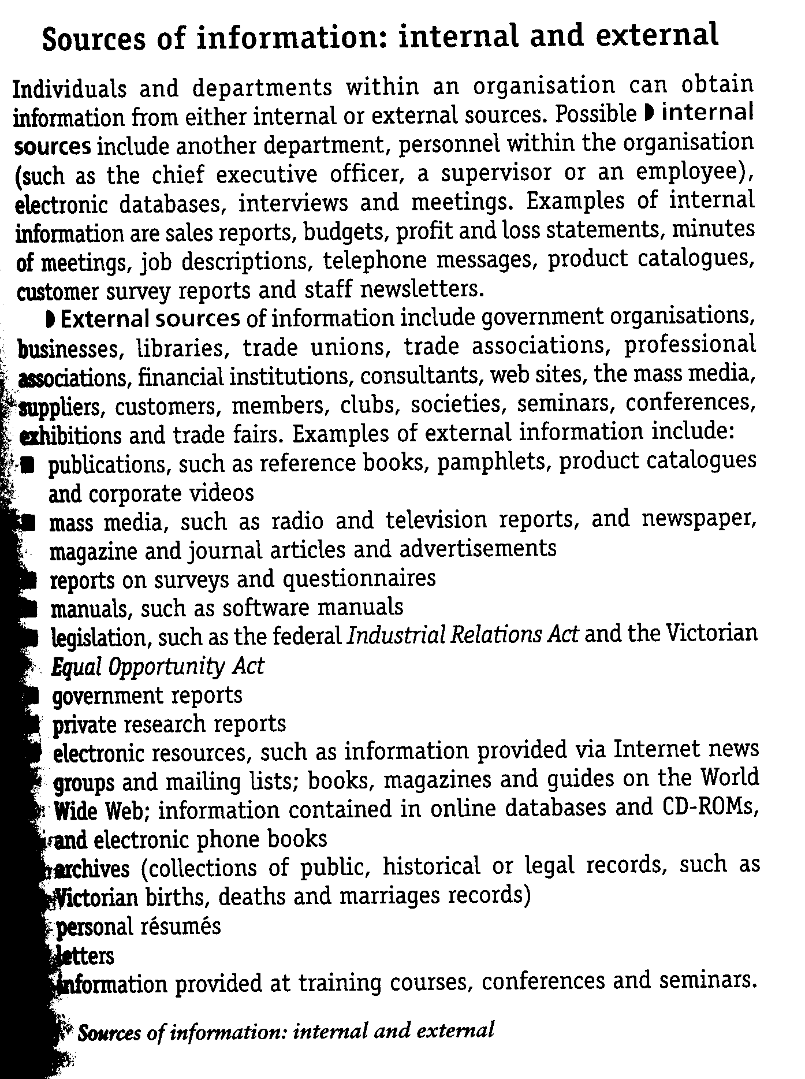

Structure of information
- Detailed information: is item-by-item information that is used at the operational level of an organisation.
- Summarised information: is the main information, such as totals and is used at the middle and senior levels of management.
- Exception information: is information that indicates situations that are outside normal, specified conditions or values
- Sampled information: is a small part of the total information that can be generated on a particular subject
- Aggregated information: is detailed information about everything on a particular subject.

Types of information
- Text
- Numbers
- Statistics
- Sounds
- Images
- Multimedia

Nature of Information
- Quantitative information: is derived from numeric data, such as a, statistical table
- Qualitative information: is derived from text, such as a written report
- Formal information: which is presented using commonly accepted formats and conventions, and uses a formal writing style. Some examples are business reports and memos, formal invitations, invoices and notices.
- Informal information: which may not use commonly accepted formats and conventions or a formal writing style. For example, e-mail messages are quite often written in a conversational style.

Reasons for using information
Organisations such as schools, sports clubs, associations, businesses and government agencies all use and generate information for a wide range of purposes. Organisations use information to:

- Inform people or other organisations about specific facts, events or decisions.
- Identify themselves or others.
- Regulate activities or behavior (e.g. fire ban notice, code of ethics etc)
- Persuade people or other organisations to act in a certain way (eg poster on safe work practices)
- Entertain people
- Express opinions about an event or activity (eg letter to the editor)

Techniques and procedures for processing and managing information
Refer to Page 3 & 4 of these notes on input methods.
Some techniques used to process and manage information are:
- Macros: a long series of often repeated key-stroes can be recorded using the macro function
- Templates: a document with a special layout, such as an application form, can be saved as a template. This allows the original layout to be preserved when a new user opens the document to enter data.
- Shortcut keys: are used to record frequently used commands such as CTRL + C for copy.

Types of documentation
Two types of documentation:
- Internal: for the operators of the system
- External: for the clients of the system

ELECTRONIC | PAPER BASED
Help menus | Quick reference cards
Cue cards | Telephone hotline lists
Internet | Comprehensive user manual
E-Mail
Telephone

Criteria for evaluating processing techniques
Some criteria for evaluating processing techniques are the data validation techniques:
- Reasonableness checks
- Data consistency checks
- Range checks
- Data type checks
- Text checks
- Manual checks (refer to page 7 of these notes)

Questions for evaluating the effectiveness of processing techniques:
- Does the information product meet the design specification?
- Does the output communicate the message it is supposed to?
Problem-Solving Methodology
The aim of the problem-solving methodology is to provide a way of focusing, in a systematic way, on the steps in information processing.
There are a number of steps that could be listed to represent the problem solving methodology:

Step 1: | Study the problem situation carefully
Step 2: | Determine the structure of required data:  - Determine the data structures to be used  - How will the data be collected?  - How will the data be validated at input time or before processing?  - How will the data be stored?  - What will the data input screens, formats or forms look like?  - How will the data be retrieved from the data store?
Step 3: | Determine the information to be output and how the information will be communicated to those who need it? Design layout forms for all output.
Step 4: | Develop a set of test data and expected results to test the accuracy of processing
Step 5: | Determine the processing required to produce the solution and represent the solution using a suitable technique. Design suitable user interface forms to enable the control of processing etc.
Step 6: | Refine and represent the steps involved in producing the output.  - Check that you designed formats for user interfaces (menu screens), data input screens and output information (report formats)
Step 7: | Construct the solution using the selected software
Step 8: | Test the functioning of the solution by comparing real output to the expected output.
Step 9: | Refine the solution
Step 10: | Run the solution and produce the desired output and communicate it.
Step 11: | Evaluate the efficiency and effectiveness of the solution and refine the solution as required.

The steps involved in the problem-solving methodology presented above can be grouped into the following parts of a formal problem-solving methodology:

- Analysis of problem situation: step 1
- Design of solution: steps 2 to 4
- Development of solution: steps 5 to 7
- Testing and refinement of solution: steps 8 to 9
- Implementation or running of the solution: step 10
- Evaluating solution to refine the solution: step 11

