Criterion

4

“Understanding of data integrity and information security protection strategies applied within organisations”

Obligations of organisations and individuals to monitor and control flow and access of information.

Obligations of organisations and individuals
Information as a product is a relatively new concept for a large number of organisations and the individuals who work in them. It is now treated as a commodity that can be tailored and packaged for sale in the marketplace. For this reason, we need a set of rules to regulate the generation, storage and resale of information.
- For an information product at the initial creative or collection stage, this would mean the author of an article or gatherer of statistics would cite all sources for their data and declare any allegiance that might bias their perspective.
- Information should be produced in an environment where old versions are not allowed to accumulate and the system regularly scans for viruses, to protect the processing software.
- Information storage should consider: password access, clearly visible data of last update or ‘valid until’ statement and secure environment to prevent spoiling by biased opinions.

Information also has a wide range of mediums through which it flows, some of which include:
- Cable – Internet connections, terminal-to-terminal via telephone lines, coaxial and fibre optic cable
- Electromagnetic signals – Internet connections and satellite-to-earth transmissions such as radio and television
- Microwave signals – building-to-building data transfer such as Internet connections
- Infra-red signals – instructions from remote television controls and remote computer mouses.
Because information can flow through each of these mediums on its way to a customer, the regulations that govern its handling can change as it moves.

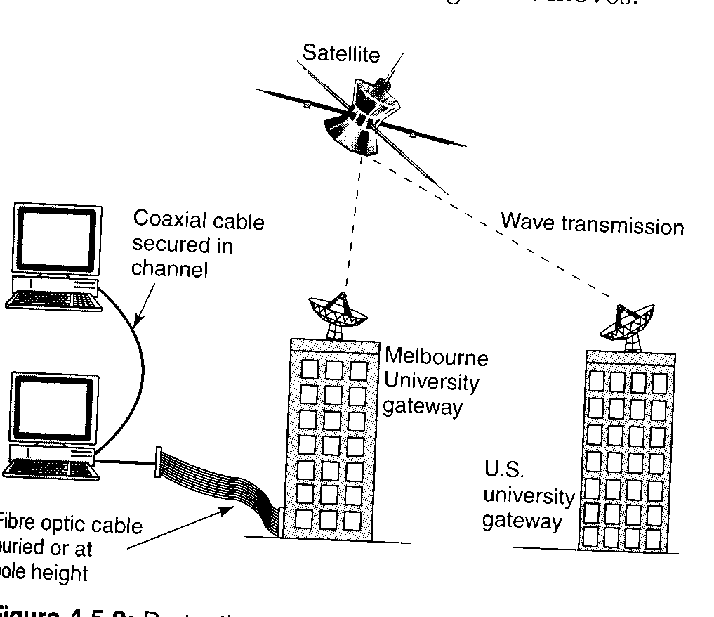

Monitoring and control of information flow
File servers often provide gateways where information flows from one medium to another. The information coming into an organisation from a fibre optic cable, for example, will probably pass through a file server before it is accessed by individual users.
The file server can have software that monitors and controls programs and data that moves around the network it manages:
- The amount of time spent on the Internet by any single employee can be monitored if a password log-on procedure is followed
- Many companied run programs that record the e-mails sent by employees
- File servers can also control the application software that is available to each user logged into the system (therefore meeting licensing agreements).
This ability to monitor and control the flow of information demands that a company’s policy is consistent with laws regarding the privacy of data.

Monitoring and control of access to information
Access to information can be controlled in two ways:
- The information itself can be coded, as with encryption
- Access to the medium can be controlled, as with a password

It is probable that a good programmer can always use the computer itself to decode an encrypted file. Controlling access to information therefore requires both strategies:
- The information must be coded/encrypted
- There must be password access to prevent unauthorized use of a terminal.
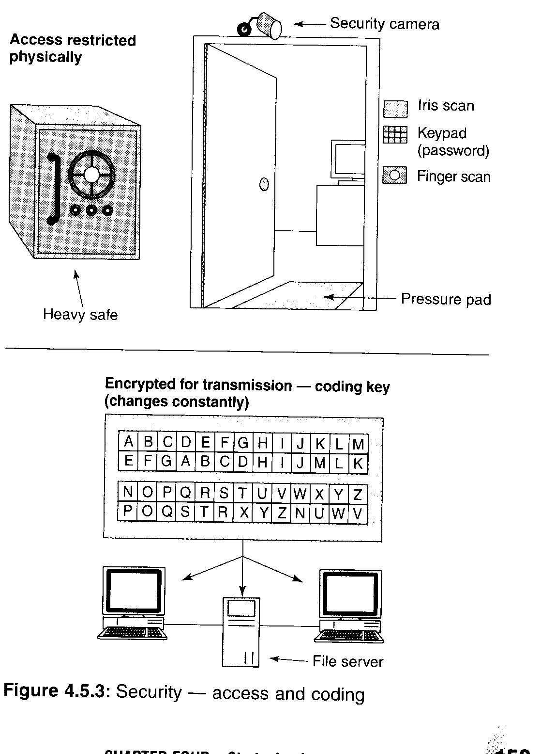
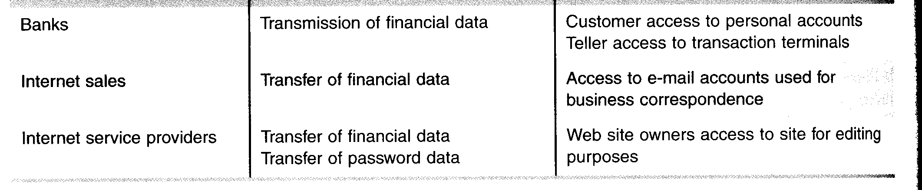
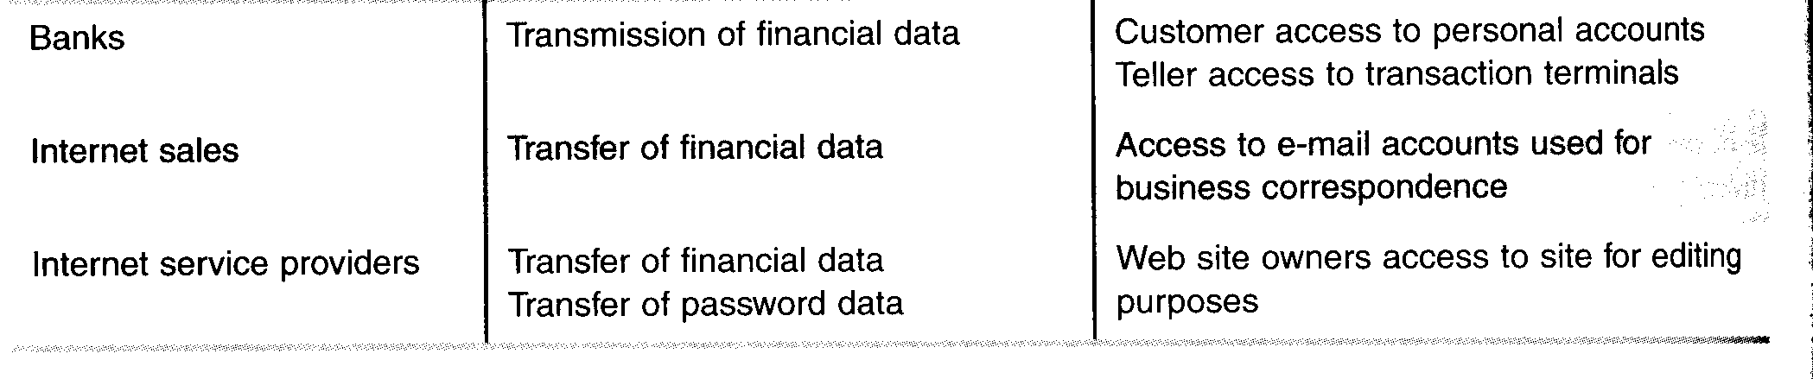
Procedures used to enhance security of information produced and communicated
Security procedures for staff handling of information are necessary because of the human tendancy to loose concentration, while performing routine tasks and forget to save a file.

Table 4.6.1 P162

Security for information received
With the widespread use of the Internet, e-mail and networking, many organisations are now responsible for the security of information they receive from outside sources. They need to have procedures for securing outside information at three points in their system:
- When entering
- While open in their system
- When exiting

Table 4.6.2 P163

Entering the system
As information comes into an information system, it needs to be directed to the right address and only to that address. It needs to be saved in its baseline, or initial form. Saving a baseline is an important concept in computing:
- If an error occurs after processing or another operator wishes to process it in a different way, then the original data is still available and easily identified.
- An example of using a baseline is shown below:

Scan fig 4.6.1 p163
- Another way of ensuring security at the entry point of a system is for the systems manager to decide that all incoming files are set to a read-only attribute. People who wish to use the files will need to save it under a different name.
- All e-mail accounts need to be password protected at log-on.
- All users need to be aware of : Trojan horses, spamming, logic and time bombs and worms when receiving e-mail.
- All computer systems need virus protection software, firewalls

Security for information produced

Backup procedures
- Screen messages instructing operators to back up work on a floppy disk when a task is completed
- Autosave
- Automatic log-out and save after 10 minutes of inactivity
- Saving and printing controlled copies of files required for proofing or by a reference group
- At the end of each day, saving all files and folders on the network to a tape, disk, cartridge etc which is then dated and locked in a secure fireproof cupboard.

File access restrictions
The features of a password policy should consider: structure or hierarchy, allocation and duration.

- It is safer to have only one master password used by the system manager
- The allocation of passwords should be performed by the system manager
- The duration of a password is really up to the individual organisation

Security for information communicated
When the information is transmitted, the security procedures will need to be appropriate to the physical nature of the medium on which the information is transmitted:
- Protecting a cable from being ‘tapped’ involves using electronic devices that detect ‘shadows’ in the circuit.
- Protecting a disk or CD-ROM from interference means ensuring that is couriered by a reliable person.
- Protecting Internet or e-mail information from contamination is tackled in a number of ways, including: encryption, passwords and e-mail watchdog groups

