Dreamweaver: A Walkthrough Tutorial

- Setting up a Site

Websites that are published on the Internet are not just random pages that are thrown together in the hope that people will be able to view them over the Web. Rather, each site is a group of pages, images, and if applicable, multimedia effects that are linked together. When is comes to creating a whole site it is important that you create a structure into which you can place all of the content for your site.

2. Preparing a structure

Before you start working in Dreamweaver, it is a good idea to decide where you want to store your pages and other content for your website.

- Go to your W:/
- Create a new folder called DreamweaverCourse

3. Creating a new site

- Open Macromedia Dreamweaver
- On the menu bar select Site > New Site
- Click on the Basic tab
- Enter a name for your site. Call you site LearningDreamweaver
- Click Next
- For the Server Technology option choose No. Click Next
- For the Editing Files option choose “Edit Local copies on my machine, then upload to server when ready (recommended). Click Next
- For Connecting to remote server option, choose None from the drop down menu. Click Next.
- You should have the final page that gives you a summary of the selections made. Click Done.
- Save your page as index.htm

- Setting up a Home Page

Every website has to have a home page. This is the one that appears when the site is first accessed. Dreamweaver needs to know what your homepage is as a reference point. To specify a home page

- Click on Site in the Site definition window

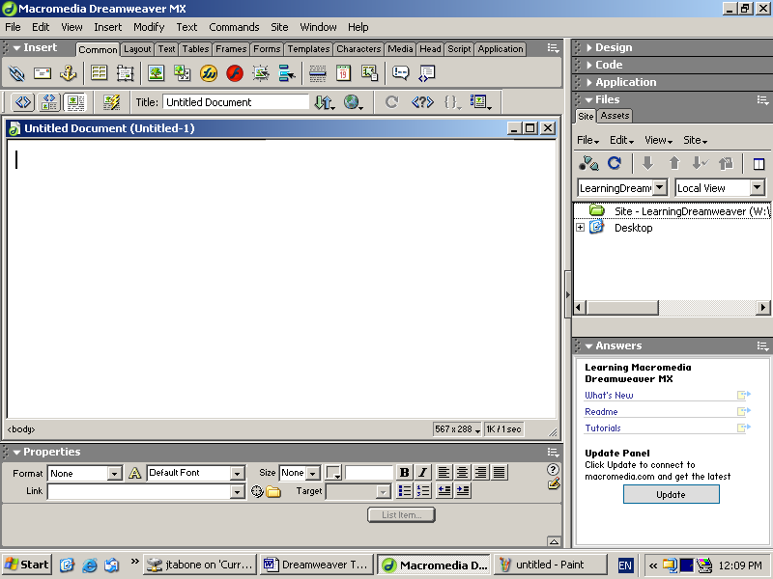
- A drop down menu appears. Click on Edit Site.
- A dialog box appears. Click on the Edit button.
- Another dialog box appears Click on the Advanced Button

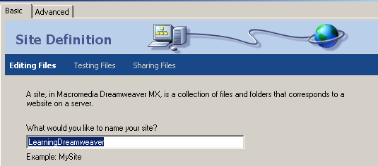

- Another dialog box appears Click on Site Map Layout
- In the Home Page section of the Site Map Layout Dialog Box, click on the folder to browse for your index.htm file. Select that file and click OK

Adding Text

Add the following text to your index.htm page

How information systems can be used to help achieve organizational goals

Organisations exist to achieve a goal or a set of goals. Most organizations share common goals which include,
a desire to maximize profits,
an emphasis on effectiveness and efficiency,
an attainment of growth and the provision of a service.

Notice: that whenever text is being added or edited, the Text properties inspector at the bottom of your screen is displayed.

- Click on the Font Drop Down List to select a font. Dreamweaver only lists the most commonly used fonts. However, you can add more fonts. From the Text Properties Inspector Font List, go to the last option “Edit Font List …”

- In the Edit Font List dialog box, click in the “Available Font” list to select a font. Choose Comic Sans MS.

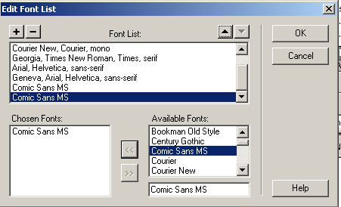
- Using the arrow buttons, click the arrows so that the chosen font is selected and added to the chosen fonts box.

4. Now change the Font of your text to Comic Sans MS.

Changing the Size of text.

  - Click on the Text Properties Inspector to access the options for changing the size of the font.
  - Select a size ranging from1 (smallest) to 7 (largest).
  - Change the Heading to Size 5 and bold
  - Change the paragraph to Size 2

Changing the colour of text

- On the menu, click Text, then Click Colour. A colour dialog box appears. Choose a dark blue and click OK.

Alignment

- Use the Text Properties Inspector Centre your heading.

Create a list

Select the following text
a desire to maximize profits,
an emphasis on effectiveness and efficiency,
an attainment of growth and the provision of a service

In the Text Properties Inspector click on the list button

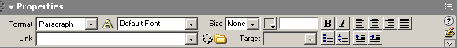

This will create a bulleted list.

To indent your list, click on the indent button

Page Properties

1. From the menu bar select Modify > Page Properties
A dialog box appears. To change the background colour click on the background arrow. This will bring the colour picker on screen. Choose the lemon colour for your background.

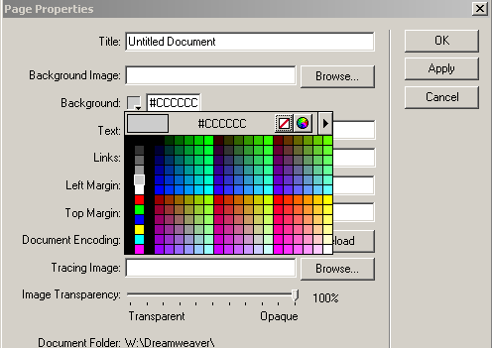

2. Alternatively you can use an image for your background.
3. Click on Modify > Page properties from the menu bar.

In the Page Properties dialog box, under Background images browse and select Background Spiral.gif

A warning on using background images – make sure your image is not too complex or gaudy. A background image should be subtle and unobtrusive, rather than flashy and too bold. The image we used is not really suitable for our webpage as it detracts rather than adds.

4. Remove the background image and return to our original colour lemon.

The page properties dialog box also allows you to change the title of the page.

5. Change the title to Index Page – How organizations use information

Working with Images

- Inserting an image

Insert the cursor at the point on the page between the heading and body of our text and click on the image button on the common tab Insert Panel

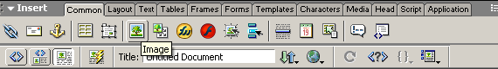

A dialog box appears. Locate the image you want to use and Click OK.

- Image Properties

When an image is selected in Dreamweaver, the Properties Inspector displays information about that image.

- Resizing Images

Select the image by clicking on it once.
Drag the midpoint resizing handles to change the size – width 119 and Height 98

- Adding Alternative text

Add Alternative text to your image. In the Alt Box type in the words Organisation Logo

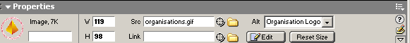

Save your work. Press the F-Key on your keyboard to activate the function keys, and then Press F12. This will allow you to see your work in a browser. Check to see if your ALT message in your image has worked.

- Creating rollover images

Click at the bottom of your page.

On the Common tab on the Insert panel, click the Rollover Image button

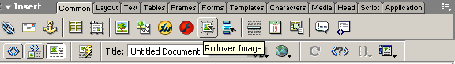

A dialog box appears.

Type in as follows:

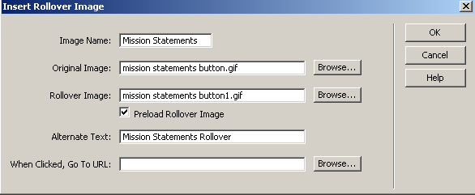

Click OK. View page in browser.

Using Hyperlinks

- Open a new blank page. In the menu bar click on File > New. Click on Basic Page and then Create.

- Type in the following

Mission Statements and Policies

Many organizations have a mission statement that summarises the vision and purpose of the organization and serves to focus all employees on what the organization aims to achieve. Goals and specific objectives are defined to work within this basic statement, and policies and procedures are put in place to achieve them.

- Format page properties, font, font size and colours.
- Click on File and save page as page2.htm.
- Open your index page.
- Click on the “Mission Statement” Rollover button we created earlier.

- In the image properties box, click on the Link folder and find and click on Page2.htm

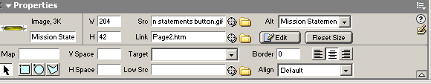

- Click Save.
- Browse your index page in an Internet browser to check if your link works.
- Add a link from your page2.htm back to the index page.

Create an email link

To create a link that allows the user to access an email address, first insert the cursor at the point where you want the link to appear. That is:

- Insert the text that will be displayed – in between the body of the text and the rollover hyperlink button
- Left align your cursor
- Click on the Email link button on the common tab on the insert panel
- In the Email Link dialog box, Text: type the following
Send your email comments
- In the Email category : type in an email address
- Save the page
- Preview in browser and test your new link

Create a Hyperlink to an external site

  - Place Cursor at the bottom of the page
  - Click on the Hyperlink button in the Common Tab on the Insert Panel
  - A dialog box appears
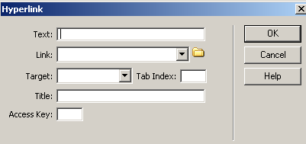

  - In the Text box type : Search Google for information on Mission Stateemnts
  - In the Link box type : http://www.google.com
  - Click OK
  - Save your page.
  - Test your link in your browser

Creating a Navigation Bar

One of the best devices for moving around a website is a navigation bar. This is a set of buttons that contain links to other main areas of the site. Once a navigation bar has been created, it can be stored and placed on as many pages as required.

- Create another new page.
- Save page as page3.htm

Type in the following:

This is page three of my website.

Create a Navigation bar

Click on your index page where you want your navigation bar to appear. Place your cursor at the very top of your page.
- Click on the Navigation bar button on the common tab.
- The following dialog box appears
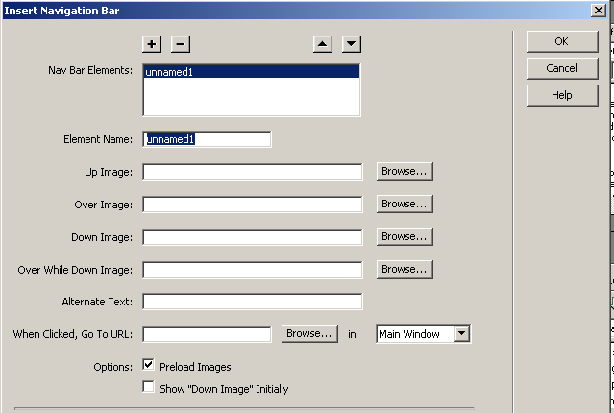

- You can create different images, for each mouse movement. Click in the box Element name and type in the word MissionStatement.
- For Up image use mission statements button1.gif
- For Over image use mission statements button.gig
- For Down image use mission statements button1.gif
- For Over while down image use mission statements button.gif
- Alternative text type in Home Button
- When click go to URL: browse for Page2.htm
- Click OK
- Use the Plus sign to create another element for your navigation bar
- Repeat the Process for index and page3.htm
- Save your work
- Test in browser.

Designing with Tables

Tables are used for formatting, such as aligning text and images. You can insert as many tables as you like on a page and tables can also be nested, that is tables placed within other tables. They are very useful to give your page the structure and look you desire.

To insert a table

- Open page3.htm
- On the common tab on the insert panel, click on the Table button. The following dialog box will appear

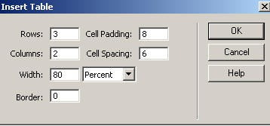
Enter the number of rows and columns that are required for the table.
Enter the Cell padding and cell spacing values. Cell padding effects how much space there is around each item in a cell and cell spacing affects how much space there is between the cells in a table.

- Click OK
- Remove the heading “This is page 3” and replace with the heading Types of Information Systems
- Add the following to your table

Management Information Systems | Management information systems software is used by large organisations to organise the files that are shared around a variety of locations
Expert Systems | Expert systems are software packages designed to be used by different professions, for example medical.
Transaction Processing Systems | Are used to keep track of financial transactions, shops, banks, etc would use this.

- Highlight table and change font and font size
- Click on the table, a thick black border should appear around the table

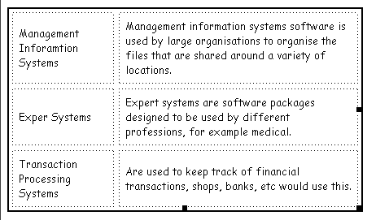
- The Table properties inspector should appear at the bottom on your screen.
- Click on Bg Color to change the colour of the table.

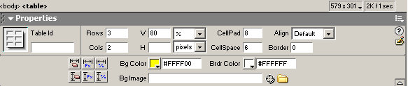

Rows and Columns in a Table

When tables are being used, particularly for complex designs, it is unlikely that the correct number of rows and columns will be specified first time around. It is possible to add or delete the number of rows and columns by selecting the table and amending the values in the Tables Properties Inspector.

Merge Cells

- Create another row, and in the second cell type in the following: Information systems enable individuals and organizations to manage their data and information and enable decision making.
- To merge the two cells, highlight the row

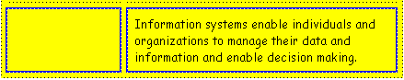

- Using the right click button on your mouse, right click. A menu should appear. Click Table > Merge Cells

Formatting Cells

- Highlight your merged cell. Click on Bg to change the background colour of the cell.

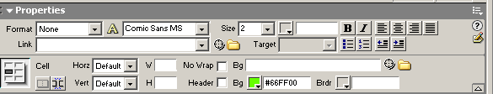

- You can add a background image to a cell, by browsing and selecting an image.

Aligning items in a table

- Click on the cell entitled “Expert Systems”. In the Vert Alignment box – choose Top

Using Layers

One of the drawbacks of web pages created in HTML is that there has not always been a facility to overlap elements on a page, such as text over an image, or several images stacked on top of each other. Layers can give us a degree of flexibility to create interesting designs.

Creating Layers

A single layer can be added to a page, or numerous ones can be included. Layers have to be inserted before content can be added to them.

1. Delete the heading Types of Information Systems

- On the Common tab on the Insert Panel, click on the Layer button
- Click and drag in the document window to draw the layer
- A layer marker will appear at the top left of the page.
- Add the following words to the layer Types of information systems. Change the font, font size and font colour

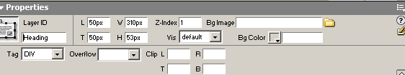

- Select the layer by clicking on its border once. This activates the Layer Properties Inspector. Give the layer a meaningful name. This is advisable is you are going to be using a lot of layers.

- Place three layers on your web page and create the following logo, using text and the images informationsystems1.jpg and informationsystems2.gif

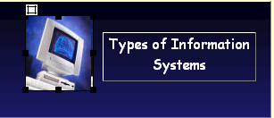

- Preview your page in your browser

Accessing the Layers Panel

At times it may be necessary to change the order of your layers. Select Window > Others > Layers from the Menu bar.
Drag layers to appropriate position.

Moving and Resizing Layers

Layers can be moved and resized in a similar way to working with images. Select a layer by clicking on its border. Click and drag as required.

- Link Types of Information Systems Page to your index page and Mission Statement page.

