- This is based on IrfanView version 3.75, but by February 2003 the available free download is now version 3.80 plus plug-ins (visit http://www.irfanview.com).

- To help you with carrying out each of the tasks in this worksheet, either use the Help Menu with Irfan View, or the Tute Web Site for IrfanView created by KR.
- TASK: Obtain 4 different images by different means (see below), and prepare them for use in printing and on the web. With each of the four, demonstrate your understanding of Irfan View by wisely using a different range of effects.
Save the images using the following file names: ‘yourname_web_01’, ‘yourname_print_01’, ‘yourname_web_02’, ‘yourname_print_02’, and so on.

(1) Acquiring Image Files.
You need to be able to capture image files from either a digital camera or a scanner (or both).

(1.1) Try getting some direct from your scanner or digital camera if it is attached to your computer:

Twain Devices
Click on the File menu, then Select TWAIN Source.
Allows you to choose from the scanners, or any other TWAIN compatible device (digital camera, TV card etc.), installed on your computer (if more than one is available).
Click the name of the device you want to use, then the Select button. To exit without making a selection, click Cancel .
Click on the File menu, click Acquire.
The program that runs your scanner, or any other TWAIN compatible device (digital camera, TV card etc.), will appear. Follow the steps given in your scanner's manual for scanning an image.
When finished, the image will be placed into IrfanView.

(1.2) On the other hand, you may already have the image files available to you electronically, so to get Irfan View working on them:
Opening Files
To open a file originally, you can double click on the file and IrfanView will open on its own. You can also use File, Open. Once you have opened, you can navigate through the files by using the left and right arrows on the toolbar. It is not necessary to open each file separately (This will only work when the files are located in the same folder.
You can also open all files at once by clicking File, Thumbnails. This will display small images of each file. You can double-click on the thumbnail to open the picture. You can click once on the thumbnail to highlight it and then hit the Delete key on your keyboard to delete a file or use the Delete File option on the File Menu.

(1.3) You may wish to turn your screen display (text, images etc) into an image that can then be manipulated using Irfan View:
Capturing Screen Images
Click on Options menu then Capture.
Select the capture area (Foreground window is useful)
Decide if you want the cursor included in the capture image, and the 'Hot Key' combination you will use. Ctrl + F11 is useful.
Saving Method - Saving as a file is useful - choose GIF for most captures (very small file size with good resolution), or JPG if there is a photograph.
Suggestion: Set a temporary destination then visit it, rename the files appropriately, and save to more suitable final destination.
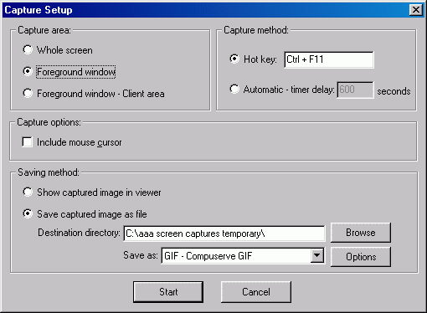

(2) Deciding What to Do with the Image Files.
You will need to change or ‘process’ the image files to make them suitable for their final destination. The following may be used as a rough guide:
Web Use, Digital Presentation Use, Slide Show or Screen Saver Use –
Size: maximum physical dimensions after cropping and other adjustments about 800wide & 600 deep (pixels) to fill the screen (or less according to the final on-screen size required).
Resolution: 72 dpi (dots per inch). (Some modern screens go beyond 100dpi, but 72 dpi is probably adequate at the moment in 2003.)
File Type: Photos should be changed to .jpg, images with solid blocks of colour or black & white change to Gif.
Printer Use.
Size: physical dimensions after cropping and adjustments to the actual size required for the finished printed product. Basic rule – to retail maximum clarity, never force an image to increase in size.
Resolution: 300-600 dpi (dots per inch). (It is almost impossible to detect any visual difference above these settings.)
File Type: Photos should be changed to .bmp or .tif or .jpg depending on your special printer and desktop publishing program’s particular requirements. Note that of these three, the .jpg will have a much smaller file size and so may be easier to transport.

(3) Making the Changes to the Images.
(3.1) Cropping.
Use the left mouse button to outline the area (selection), click on the Edit menu, then Crop.
The area outside the outline will be thrown away, only the inside will be left.
Use this to eliminate unwanted space (usually blank space) from an image. It can also center a badly composed photo.
Use with Resample (Image menu,) to eliminate background "noise", and often have the same sized image when you finish.
This action may be reversed with the Edit Menu's Undo command.
Hint: When cropping people, leave a little space in front of their face if they are facing sideways. Avoid touching the top of their heads with the crop, Similarly, along the sides either cut through the person's arms or leave space between them and the crop - avoid just touching their arms to avoid a 'cramped' look.

(3.2) Resizing – change the file size and the physical dimensions.
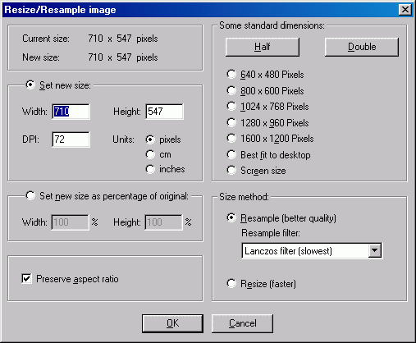
Click on the Image menu, then Resize. (Ctrl R.) A dialog allows you to choose the new size for the image.
There are several built in choices, or you can type over the old numbers. The first number is width, the second height, both in pixels (but you can also choose to use cms or inches). Leave the Preserve aspect ratio box checked; type in one number and the other will be calculated for you. There are a number of standard sizes that may prove useful. If you want to create thumbnails, use an alternative approach.
Click OK to resize the image. This action can be reversed by the Edit menu's Undo command.

(3.3) Saving and changing to your desired File Type.
Click on the File menu, select Save As (or use the Save As tool on the toolbar or simply press S.)
Saves your file to disk. Use Save in and File name to find the directory where you want the file saved.
To save as a different type, use Save as type. Click the arrow and a list of file types drops down.
Move the cursor to the one you want and click again. When you save, the file will be converted to this new type.
Clicking the Options button brings up special options for some file types. There are three tabs: JPEG/GIF, LWF, and TIFF.
Click Save to send the file to your disk drive. To exit without saving, click Cancel.
Note that Save As comes up in the last directory in which you saved a file.
Save comes up in the last directory from which you loaded an image

(3.4) Adding Special Effects – there are many to choose from.
Use the left mouse button to outline the area (selection), click on the Edit menu, then Crop.
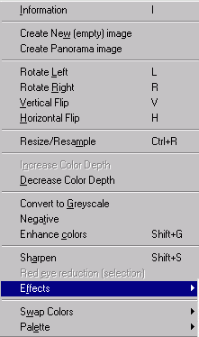
Click on the Image Menu, then point the mouse at Effects to access these options.
The 'Effects Browser' (Ctrl E) provides a useful rapid look at the effects when applied to an image of your choice. The degree of change created by the effect may be adjusted in the effects browser thus setting the default for when a particular effect is selected directly from the menu
The Effects possible are:
3D Button
Click on the Image Menu, point the mouse at Effects, and click 3D Button. Gives the image a beveled edge look, with the center raised. The size of the border can be changed using Effects Browser. This action can be reversed with the Edit menu's Undo command.
3D Blur
Click on the Blur Menu. The amount of blur (1-99) can be changed using Effects Browser. This action can be reversed with theEdit menu's Undo command.
Emboss
Click on the Image Menu, point the mouse at Effects, and click Emboss. Turns the background gray and gives the image an engraved appearance. This action can be reversed with the Edit menu's Undo command.
Oil Paint
Click on the Oil Paint Menu. The amount of change (3, 5, 7, 9) can be changed using Effects Browser. This action can be reversed with the Edit menu's Undo command.
Edge Detection
Click on the Image Menu, point the mouse at Effects, and click Edge Detection.
Finds the main lines in an image and replaces their color with the opposite color, at the same time most fill colors are darkened, making them like a background. The image takes on a "painted on velvet" appearance. This effect needs a color depth of 256 or lessto work properly. This action can be reversed with the Edit menu's Undo command. Explosion
Click on the Explosion Menu. The amount of explosion (two axes) can be changed using Effects Browser. This action can be reversed with the Edit menu's Undo command.
Pixelize
Click on the Image Menu, point the mouse at Effects, and click Pixelize. Breaks the image into a coarse version of itself, as if it were made up of oversized pixels. The amount of Pixelization (two axes) can be changed using Effects Browser. This action can be reversed with the Edit menu's Undo command.
Sharpen (only through browser)
Click on the Image Menu, point the mouse at Effects Browser, and click Sharpen. The amount of sharpen (1-99) can be changed using Effects Browser. This action can be reversed with the Edit menu's Undo command.
Red-Eye Reduction (only through browser)
Click on the Image Menu, point the mouse at Effects Browser, and click Red-Eye Reduction. The amount of Red-Eye Reduction can be changed. This action can be reversed with the Edit menu's Undo command.
Fine Rotation
Click on the Image Menu, point the mouse at Effects, and click Fine Rotation. Turns the image to the left or right. The degree of rotation can be changed using Effects Browser. The original image can be left as background or cleared. This action can be reversed with the Edit menu's Undo command.

Note: Many other ‘Special Effects’ may be achieved with programs such as Paint Shop Pro 7 – this can be so much fun it becomes almost addictive!

