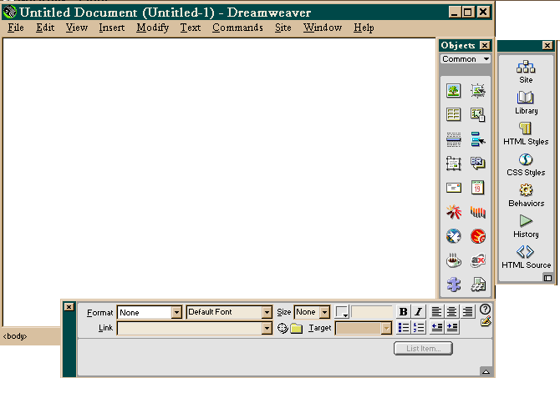
Launcher
Objects Palette
Document Window
Properties Inspector
Defining a Site.

A site is a storage location for the documents belonging to a web site. To get started in Dreamweaver, you must first create a local site. A local site requires a name and a local root folder to tell Dreamweaver where you plan to store all of the sites files.
- Dreamweaver automatically asks for you to define your site. If it doesn’t,
click on SITE > NEW SITE.
2. Type in the SITE NAME in the field name Site Name (never have spaces between words)
3. Click on the FOLDER ICON and navigate to the folder where you will store your web pages (If you do not have a folder already created, click on the NEW FOLDER button and type a name for the new folder and then select it).
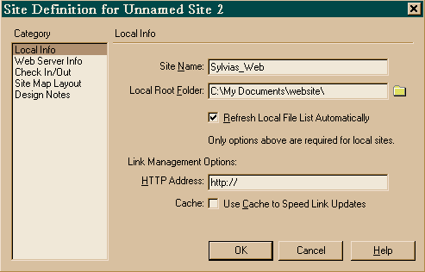
2
3

Creating New pages.

Web sites normally have more than one page. It is important that you save your pages with relevant names to the content of the pages. Always save your HOME PAGE as index.html Web page names should never have spaces in them; instead use an underscore to separate words. Always save your pages in the root site folder.

Modify Page Properties.

You can change such elements as the background colour, page title, text colour, links colour and margins. To do this, select MODIFY > PAGE PROPERTIES.

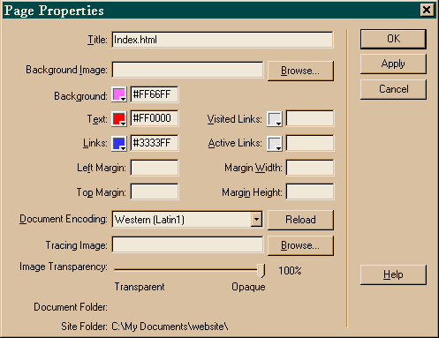

Text Properties.

Dreamweaver is a WYSIWYG interface, so when you type text you can change the properties of the text. To apply any properties to the text, you must first select that text. Then view the Properties Inspector (if it isn’t visible, go to WINDOWS> Property INSPECTOR. The Properties inspector allows you to change the Format, Font, Size, Colour, Alignment, List Properties and Indentation.

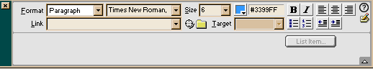

Dreamweaver Objects.

All of the objects that you can place in Dreamweaver are available from the OBJECTS palette or from the INSERT menu. The panels in the OBJECT palette are Characters, Common, Forms, Frames, Head and Invisibles. To insert an object on a page, click on the icon for the object you wish to select from the Object palette. If Dreamweaver needs further information, a dialog box will appear.

To change the OBJECT palette panels, click on the menu arrow at the top of the Objects Palette. A pop up menu will appear and you can choose Common, forms, Heads or Invisible.
Otherwise, you can also select the object from the INSERT menu.

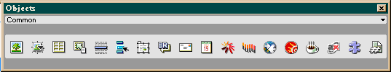

Inserting Images

It is important that when inserting images in your site that the images are stored in your root site folder. To insert an image, first click on the page where you want your image to appear. Choose INSERT> IMAGE or select the image icon form the object palete. Select the image and click OK. Click on your image and view your PROPERTY Inspector. If the inspector is not visible, choose WINDOWS> PROPERTY inspector.

Image Properties.

Sometimes there are some people who have their images turned off when browsing on the net, so it is important to have ALT tags on the images. An ALT tag is a text alternative to your image. To do this, ensure that the image is selected. In the property inspector, click in the field next to ALT and type in a text relevant to your image. You can also change the border width and alignment of the image.

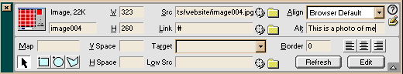

Insert Tables.

Sometimes you may require a table in your web page such as for a table of contents, or you want use a table to replicate the layout of your text and images so it is in set order. To do this, you need to select INSERT>TABLE or click on the tale button on the Objects Palette.
Type the number of rows and columns you need. (This can be adjusted later). Click on OK.
Insert text or images in the cells of the tables. To make changes on your table or to insert more columns etc, select the table and change the properties in the Properties Inspector. Always remember to name your table.

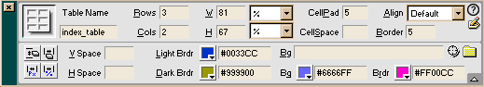

Hyperlinks.

Hyperlinks can be text, hotspots or rollovers that you can click on and be taken to another page or location in a web site.

Linking Text.

Select the text that you want to be the hyperlink.
Click on the folder icon next to the LINK field in the property inspector and select the html page you wish to link to and click on OK or SELECT.

Link with Images.

Select the image on page and view the property inspector (WINDOWS>PROPERTIES)
Click on the folder next to the LINK field and select the html page you wish to link to.

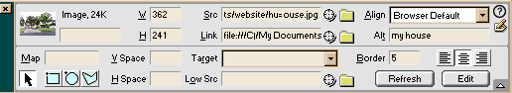

Image Hot Spots

- Select the image on you page and view the property inspector
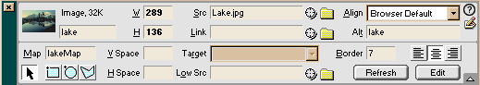

- To Hot Spot an image, select either the square, circle or Polygon hotspot tool which is located to the lower left of the property inspector under the Map Field.
- Using the Hotspot tool draw a square, circle or polygon shape on your image. Only this will be the hyperlink.
- Notice that the property inspector has now changed to the Properties of this hotspot. You can now give the hotspot a link value by clicking on the folder next to the link field and selecting a HTML page
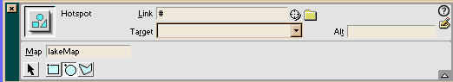
Note: Dreawmweaver automatically places a # in this field. If you are not linking to an anchor and to an HTML you will need to delete the #.
- In the ALT field type in a text alternative for the link.
- You can create multiple hotspot areas on the same image follow step 2 – 4

Creating Anchor or Bookmarks

- Insert a Name Anchor where you want the link to go to. To do this go to INSERT > INVISIBLE TAGS > NAME ANCHOR or change the view in the Object panel to INVISIBLES. Click on the anchor icon.

- In the Popup dialog box enter a name for the anchor. Click on OK

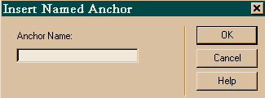

- Select the text/object you wish to link. Go to the Property Inspector and enter the # symbol in the field. You should now be able to click on the down arrow to get a selection of name anchors. Select the appropriate one. If your anchor is not there, type it in. once again, the spelling of the link must be correct.

Rollovers

- Click in your page where you want the rollover image to appear.
- Choose INSERT > ROLLOVER IMAGE or click on the rollover image on the Object Panel.
- A dialog box will appear that requires you to locate the original image and rollover image and a link to URL if required.
- Type in the name of the image.

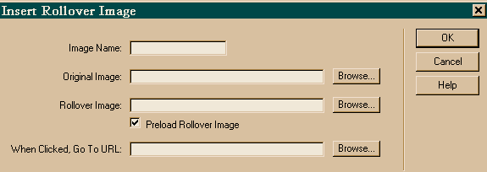

- Click the ORIGINAL IMAGE FIELD and click on the BROWSE button. Locate the original image (this is the image that will be seen when the page is loaded).
- Click inside the ROLLOVER IMAGE field and click on the BROWSE button to locate the image. This is the image that will be seen when the mouse roll’s over the original image.
- If you wish, click on the WHEN CLICKED GO TO URL: field and then click on the BROWSE button. Locate the HTML page and click on OK.

Email Links

- On the page type “Email me” or something to that effect.
- Select the text and then click on the Mail icon on the Objects Panel. Or INSERT> EMAIL LINK.
- The text “Email Me” should now appear in the text field of the INSERT EMAIL LINK dialog box.

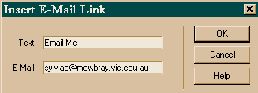
- Click in the field E-MAIL and enter the email address and then click on OK.
- Save the page and check the link in the browser.

OR

- Select the text.
- In the link field of the property Inspector type mailto:emailaddress

