
DreamWeaver Project – Camp Site 2001 3
1 Introduction 3
2 Layout diagram of the site map 3
3 Layout diagram of Home Page Camp Site 2001.htm 4
4 Layout diagram of graph.html 4
5 Layout diagram of tyred teacher.html 5
6 IPO Charts 5
7 Loading Dreamweaver 5
8 Defining the site 5
9 Editing a site 6
10 Creating an empty html file 6
11 Nominating Camp Site 2001.html as home page 6
12 Creating the Site Structure – Creating empty Files & Folders 6
13 Creating the Site Structure - Linking Files from the Home Page 7
14 Previewing In a Browser 8
15 Putting Content into Home Page Camp Site 2001.html 9
16 Adding a Table into Home Page Camp Site 2001.html 11
17 Adding Hyperlinks to Home Page Camp Site 2001.html 12
18 Putting Content into graph.html using layers 13
19 Putting Content into tyred teacher.html 15

DreamWeaver Project – Camp Site 2001

1 Introduction
- This website project consists of three pages – the home page called Home Page Camp Site 2001.html that is linked to two other pages graph.html and tyred teacher.html. All three pages are put in the folder Camp Site 2001 Root_Folder which in turn is inside another folder of your choice. All these should be in you Home or H:\ drive.

2 Layout diagram of the site map
- Layout diagram is a design tool.
- A layout diagram is a sketch showing the positions of text, images and their properties such as formats and hyperlinks or the relationship between the pages.
- Our site map(version 1) looks like this:

Home Page Camp Site 2001.html
graph.html
tyred teacher.html

- Note the two-way links in the version above.
- A second version looks like this:

Home Page Camp Site 2001.html
graph.html
tyred teacher.html
Home Page Camp Site 2001.html
Home Page Camp Site 2001.html

3 Layout diagram of Home Page Camp Site 2001.htm

4 Layout diagram of graph.html

(2) Heading(Arial, 16, bold, green, left-aligned)
(3) Paragraph text(Aria, 14, bold, black, left-aligned)
(4) Text(Format is same as paragraph text above, hyperlink in brown) |  | (5) Text(Format is same as paragraph text above, hyperlink in brown)
Notes:
- “Welcome to Camp Web Site 2001”
- “Principal's Message :”
- “It gives me great pleasure to address you all through this modern medium of communication.
This is an initiative taken by our students who had a wonderful time at the Camp and wanted everyone to know that it has been a worthy life experience. All credits must go to Vicky Smith, Reason Lee, Harry Browski, Ahmad Farad, Suzie Sugiwati. In hope you enjoy the site as much as I do"
- “The most memorable part of the camp was to see all the tyred teachers with their heads sticking out of the rings.”
- “Another high point of the Camp was the weather & activities”.
(2), (3), (4) & (5) are located in the cells of a 3 x 3 table.

Picture of green line
(1) Title(Default typeface, 16, bold, centred, blue)
Picture of autumn leaves
Picture of diamond(hyperlink) | (1) Text(default font, black) | Picture of diamond(  hyperlink)

Notes
- “Take Me Home”
- “The weather while at the camp was hot and sunny through the entire week. There were many activities - kayaking on the lake, rope and adventure courses, horse riding, flying fox, rock climbing and other activities.
However the most popular was swimming because of the hot weather.
Eating is also a popular pastime, not just at meal times because the enormous appetite cause by all the activities during the day. At night, we went out for walks, breathing the fresh cool mountain air and smelling the typical Australian bush that surround the camp site.
We were sad to leave the place when it was time to go.”

Picture of Graph on temperatures at camp
(2) Text(default font, black, vertical scroll bar)

5 Layout diagram of tyred teacher.html

Diamond picture with red curl rollover hyperlink
Text(“Take Me Home” - default font, black)
Diamond picture with red curl rollover hyperlink
Picture of tyred teachers

6 IPO Charts
- An IPO chart is problem analysis tool.
- An IPO chart shows the Input(data), Processes required on the input to produce the information and the Output
Exercise: Use the information on the web page layout diagrams to make three IPO charts, one for each web page.

7 Loading Dreamweaver
- Now that we have, we are ready to sit down in front of the computer to construct the web site according to the design of the layout diagrams.

Practical Work
- Load Dreamweaver as follows:
- Click Start, Programs, Macromedia Dreamweaver 4.
- Double click Dreamweaver 4
- A document window appears with the title Untitled Document appears.

8 Defining the site
- To define a site is to nominate a folder so that all necessary resouces such as html and picture files are accessible to a browser exactly the way you want to set it up on a web server.

Practical Work
- Start Dreamweaver
- In Site window, click Site, New Site to see Site Definition Unnamed Site 1 dialogue box.
- Type in Camp Site 2001 in SiteName box. This is a working title, not a folder.
- Click on folder icon next to the Local Root Folder box to open the Choose Local Folder dialogue box.
- Find the main folder in the your Home(H) drive you wish to store all your web sites, for example All My Web Sites.
- In the Choose Local Folder dialogue box create a new web site folder by pressing the Create Folder icon and type in Camp Site 2001 Root_Folder. Double click on this folder to transfer its name to the box Select. Press the button Select to make it the Local Root_Folder and return you to Site Definition Unnamed Site 1 dialogue box.
- Tick the Enable Cache box. After clicking box OK, a DreamWeave message appears informing you that is it creating the cache and tracking changes. After clicking OK in the message box, an empty site window appears with a left and a right panel. The left panel will show the site map and the right panel has the folders and files of the web site.

9 Editing a site
- If you make a mess of what you have done so far. You can edit it, delete it and/or create a new site.
- To take one of these actions select menu Site, Define Sites to reveal the dialogue box Define Site. Choose what you want to do and repeat the steps described in the previous section if necessary.

Practical Work
- Delete the defined site and define it again.

10 Creating an empty html file
- Dreamweaver allows you to set up the site structure without you first creating the files needed for the web site. This is done by creating folders and empty files as well as linking them according to your design. Now lets create empty file called Home Page Camp Site 2001.html.

Practical Work
- Make sure the site Camp Site 2001 is still open. If it is not, Click menu Site, Open Site and select the site to open it.
- On the right panel select the root folder Camp Site 2001 Root_Folder
- Use menu File, New to create an empty home page. After clicking on menu File, New File, an icon appears on the right panel. Type in Home Page Camp Site 2001.html. The result is shown below:

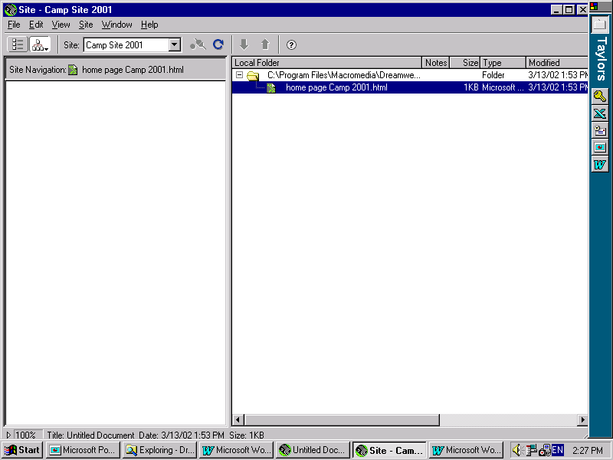

11 Nominating Camp Site 2001.html as home page
- Naming the file with the words “Home Page” does not make it the first page that a browser will open when a site is visited. You have to tell Dreamweaver that it is the home page. Now let’s make Home Page Camp Site 2001.html the real home page for a browser.

Practical Work
- Select Home Page Camp Site 2001.html and click on menu Site, Set as Home Page to nominate it as the home page.

12 Creating the Site Structure – Creating empty Files & Folders
- Our web site has three pages – the first page is the home page and two other pages. The second page contains a graph and the third page contains picture., neither page has been created.
- However we can create the structures to show the site map by creating the empty files and linking them.
- We also want to keep the second and third page in another folder.

Practical Work
- Make sure the site is open.
- First let’s create the folder called HTML. Select the root folder Camp Site 2001 Root_Folder and click on menu File, New Folder and type in “HTML” as the folder name.
- This is the result:

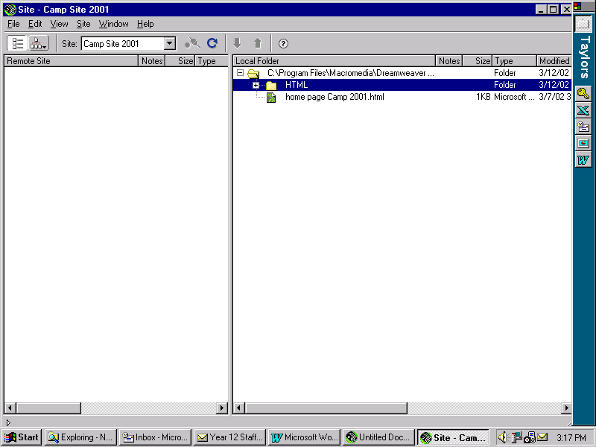

- Select the new folder HTML and click on File, New File and type in “graph.html” as file name for the second web page.
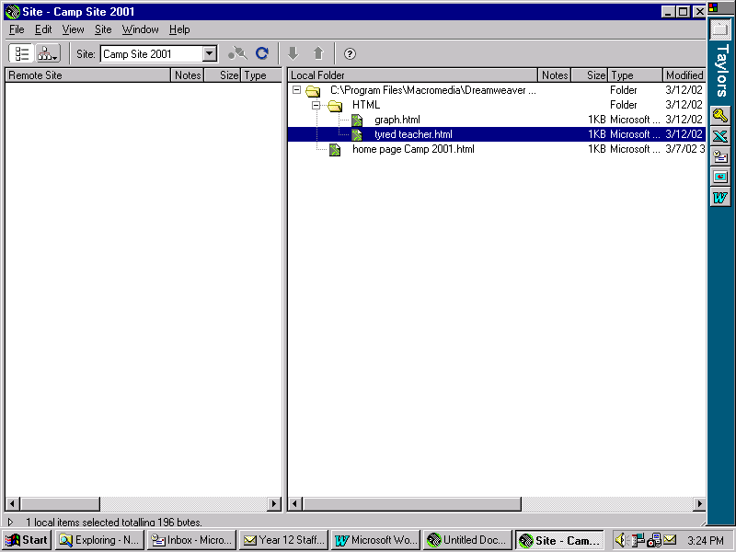
- Create the third web page tyred teacher.html in a similar way.

- You right panel of your site should look like this:

13 Creating the Site Structure - Linking Files from the Home Page

Practical Work
- Now we are going to link the empty files that we have created.
- However, let’s look at the site map so far.
- Select home page Camp 2001.html and click on the toolbar buttons Site Map, Site Map & Files to reveal the site map on the left panel.
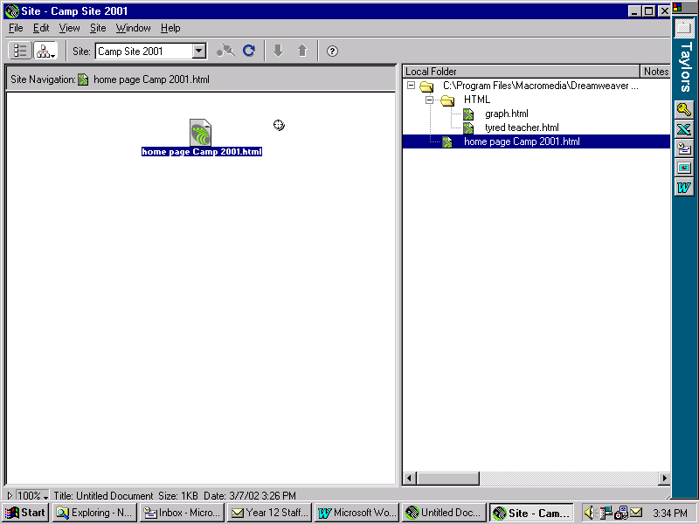
- You should looking at something similar to the picture below:

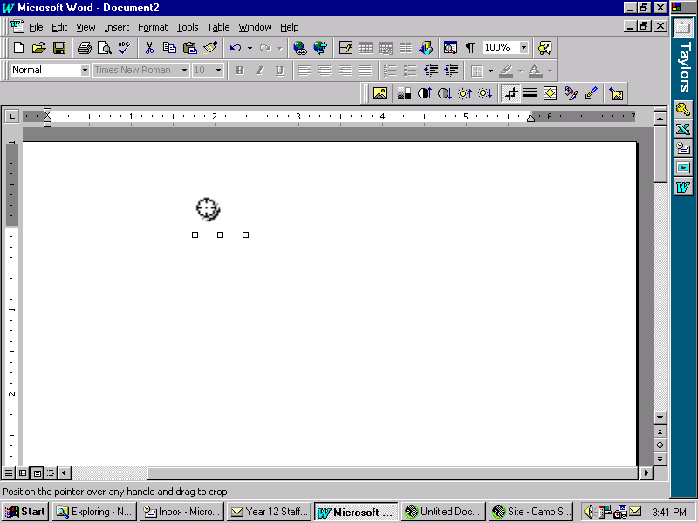
- Note that the pointer-to-file icon

appears on the right hand side of the file in the left panel. The purpose of this icon is to create the links.

- To link the home page Camp Site 2001.html to graph.html you must point to and drag the pointer-to-file icon to reveal an elastic arrow and a duplicated icon. Drag it to the graph.html until the file name is enclosed in an elongated rectangle. On releasing the mouse button, the site map will reflect the fact that a link has been created from the home page to graph.html.
- Repeat the procedure to link home page Camp Site 2001.html to tyred teachers.html. The end result is shown below.
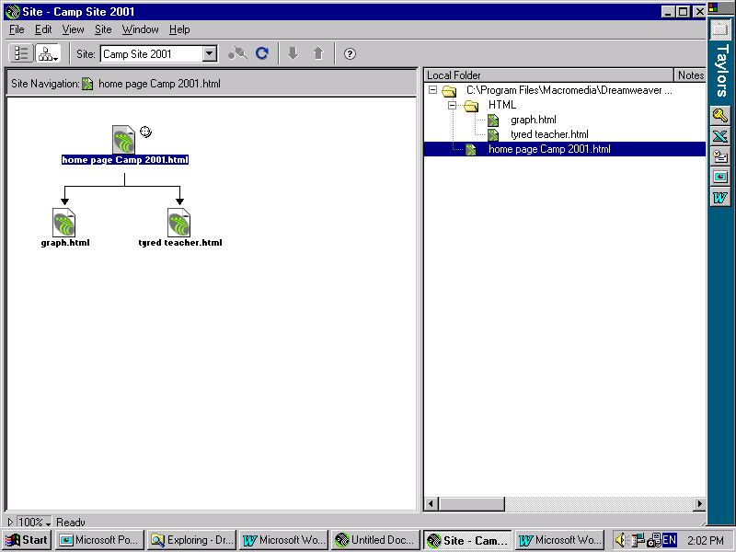

14 Previewing In a Browser
- It is a good idea to test your website as you go along. This form of testing is called informal testing.
- Now let us test our website and see that the links are working properly.

Practical Work
- Open the file Home Page Camp Site 2001.html to put it in the Document Window by using menu File, Open.
- While in the Document Window the links do not work. Links only work when Home Page Camp Site 2001.html is opened by a web browser and this is what you are going to do next.
- Now press F12 to open the default browser and view the home page.
- You should see something like the picture below with the browser in the fore ground and the corresponding document in the background:

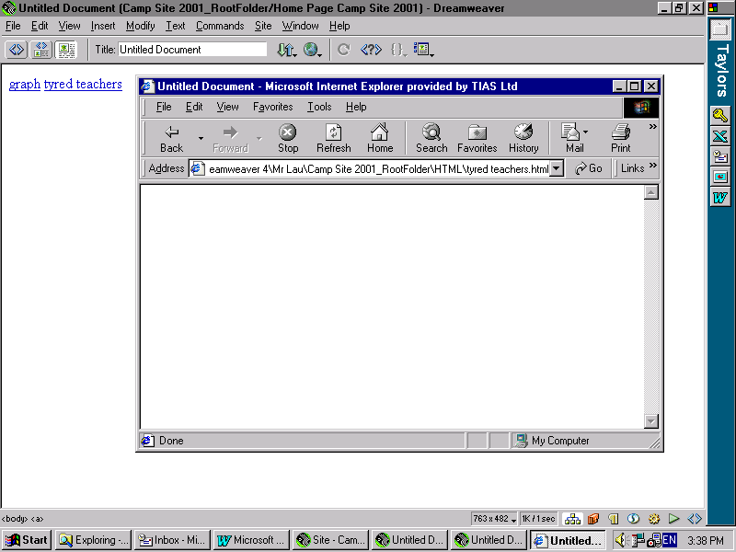
- Note that in the browser window the hypertext “graph” and “tyred teachers” are in black but in the document these are blue.
- In the browser window click on the hypertext “graph” to go to graph.html and from there back again by clicking the “Home Page Camp Site 2001” link.
- Save the page and test the other link “tyred teachers” in the home page.

15 Putting Content into Home Page Camp Site 2001.html
- So far, all the pages are devoid of content except the hypertext inserted by Dreamweaver indicating the linked pages.
- Text editing in Dreamweaver is similar to using a word processor.
- You must select the text before it is formatted. We are going to enter some text into Home Page Camp Site 2001.html.
Practical Work
- Open the site Camp Site 2001 using menu Site, Open Site
- Open Home Page Camp Site 2001.html document by double-clicking this file.
- Note graph and tyred teachers were inserted by Dreamweaver to remind you that these are the linked pages.
- Note the Properties Inspector window which can be switch on and off from menu Windows. Try it. You can also drag & drop anywhere on the screen. Try it.
- The aim of the Properties Inspector is to format text. First we must enter some text.
- Position the cursor after tyred teachers and pressed enter to initiate a new paragraph.
- Type in “Welcome to Camp Web Site 2001”.
- Let’s use the Properties Inspector to format the heading.
- To enlarge the heading, first highlight it and select Heading 1 from the format box.
- To centre the heading, click the button Align Center .
- To colour it, find the drop down list Text Colour and select a blue colour.
- You screen should look like this:
- Next we are going to put the picture of a colour line above and below the heading.
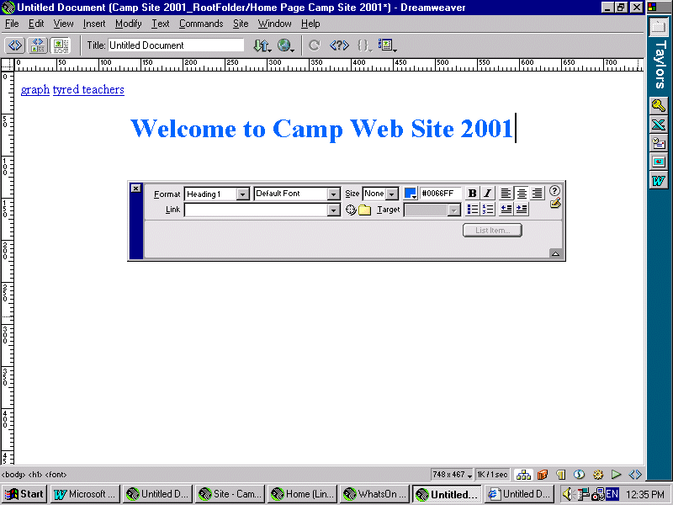
- Position the cursor before the W of Welcome and press Enter to create a blank line. Use the upward arrow to move to the blank line.
- To insert the picture of a colour line, use menu Insert, Image and browse the G:\ drive for the Clipart, Line folder and locate the file green and black stripe.gif .
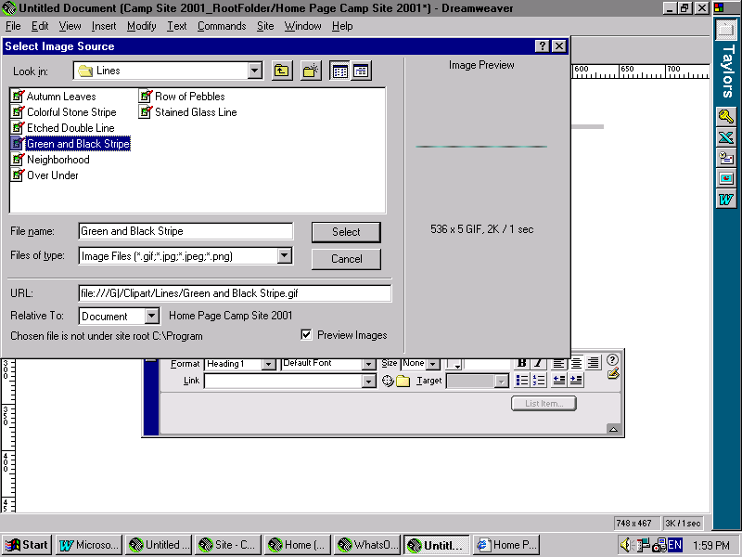
- Your screen should look something like the picture below:

- Press Select and a Save File Now message comes up. Answer Yes to open Save File As dialogue box.
- In the Save In box, select Camp Site 2001 Root_Folder.
- Before we save, let’s create a new folder called Images to holder all the pictures. To do this, click the icon Create New Folder and type in Images to replace the default name New Folder. Refer to the screen below:
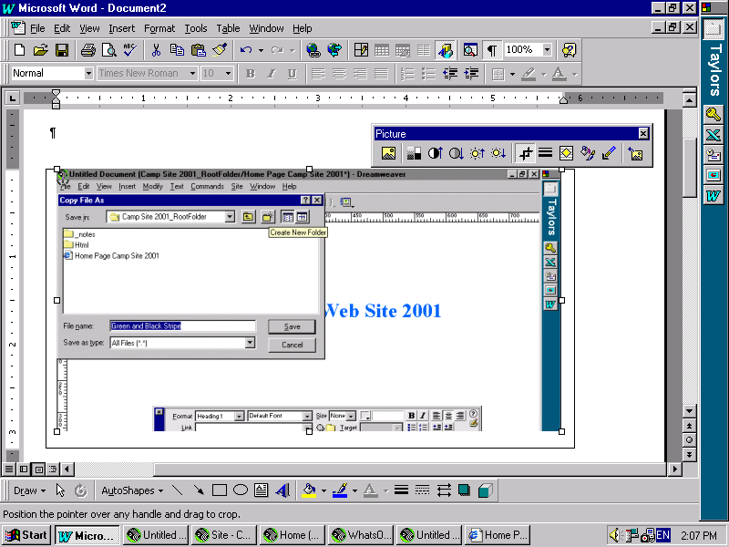

- To save the picture file, open the folder Images and select the file green and black stripe.gif. Finally press Save.
- The picture of the line is now above the heading.
- Repeat the procedure to put another line picture Autumn Leaves.gif below the heading.
- Save the page and test the page informally by pressing F12.
- The end result is shown below:

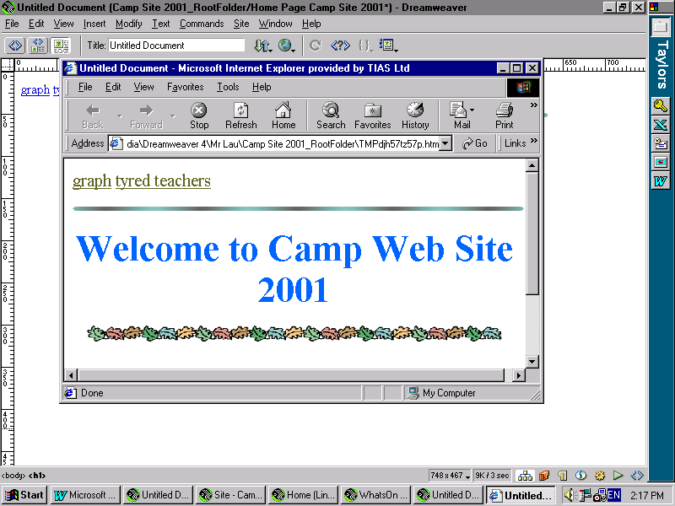

16 Adding a Table into Home Page Camp Site 2001.html
- One of the better ways of organising a page is to put text and images in a table.
Practical Work
- Now we are going to create a table. Make sure Home Page Camp Site 2001.html is still open.
- Position the cursor just below the line of Autumn Leaves
- Use menu Insert, Table to open Insert Table dialogue box.
- Type in 3 in Rows box and 3 in the Columns box. Accept the other default values.
- Let us now centre the table.
- First select the table by clicking on the outer border where a four –way arrow is invisible.
- The properties of the table should appear in the Properties Inspector. If the Properties Inspector is not visible, use menu Windows, Properties to open it.
- Click on Align box and select centre to position the table in the middle of the page horizontally.
- Let us now change the background colour of the table
- Make sure the table is still selected.
- In the Properties Inspector, in the Bg Colour box open the colour palette and select the yellow colour(#FFFFCC).
- Save and test the page informally.
- We are going to put the college principle’s message in the 3 cells of the first row. Before we type the text, we have to merge these 3 cells as follows:
- Select the cells by clicking when a left-pointing arrow appears on the left just outside the first row.
- Use menu Modify, Tables, Merge cells to combine the 3 cells as a single cell.
- Now type the following text in the first row:
“Principal’s Message :
It gives me great pleasure to address you all through this modern medium of communication.
This is an initiative taken by our students who had a wonderful time at the Camp and wanted everyone to know that it has been a worthy life experience. All credits must go to Joe Smith, Reason Lee, Harry Browski, Ahmed Farad, and Suzie Sugiwati. In hope you enjoy the site as much as I do”
- Now let us format the text using the Properties Inspector
- Select text “Principal's Message :”.
- To increase the size , use Size box and select +2
- To its colour, use Text Colour box and select the green colour (#FFFFFF).
- Similarly increase the remaining body text to +1.
- Select all the text.
- To embolden it, use button B.
- To change the font, use Default Font box and select Arial, Helvetica, sans-serif.

17 Adding Hyperlinks to Home Page Camp Site 2001.html
- The hyperlinks in Home Page Camp Site 2001.html were put there by Dreamweaver merely to remind the web developer that such links must be present in the page. It is the job of the develop to put designed hyperlinks on the pages.
- A hyperlink is text or image with embedded URL, which is executed when clicked. An URL is the address of a file located on the Internet or locally.
- Practical Work
- Let’s now create a text hyperlink.
- In the cell in row 2 column 1, type in the following text “The most memorable part of the camp was to see all the tyred teachers with their heads sticking out of the rings.”
- Use the Properties Inspector to select & format the text: Size +1, Bold, font Arial, Helvetica, sans-serif.
- Select a section of text “see all the tyred teachers”
- Select menu Modify, Make Link, find and Select the target page Home Page Camp Site 2001.html, after you have ticked the box Relative To Document as indicated in the picture below.
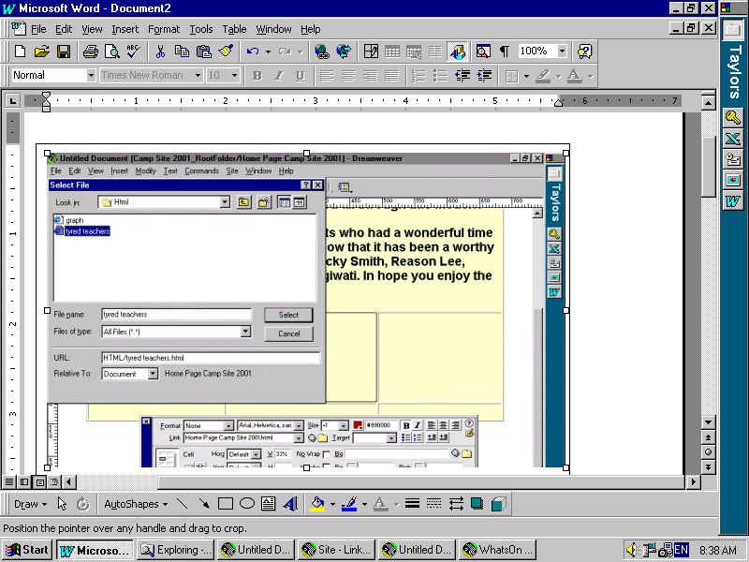
- Note the selected text is now underlined and in blue.
- From the Properties Inspector change the hypertext colour to dark red(#990000).
- Save the page and test the hyperlink by pressing F12 and click the hypertext. Check the address box that it has file name tyred teacher.html.
- Now enter some text in row 2 colum 3 and create a text link.
- Text “Another high point of the Camp was the weather & activities”
- Format the text consistent with the previous text.
- Select text “weather & activities”
- Turn it into hypertext.
- Format it consistently.
- Save the page and test the link to ensure that it would link to graph.html.

18 Putting Content into graph.html using layers
- Remember graph.html is an empty file except for a hyperlink reminder.
- Instead of using a table to set up the page, we are going to employ layers.
- A layer is a container in which text and image can be placed. It is very flexible since it can be moved around, resized and placed on top of another layer. At the same time its behaviour can be unpredictable. The browser’s view and Dreamweaver’s view may appear different. A page must be tested informally and continually.

Practical Work
- Let us create a layer to hold a temperature graph and a second layer to hold some text.
- Make sure graph.html is open. If it is not, open it by using menu File, Open and find the file.
- Open the Object Panel by using menu Window, Objects.
- Click on Object Panel, Draw Layer to reveal a hair cross.
- Use the hair cross to draw a layer in the document.
- The result is shown below.
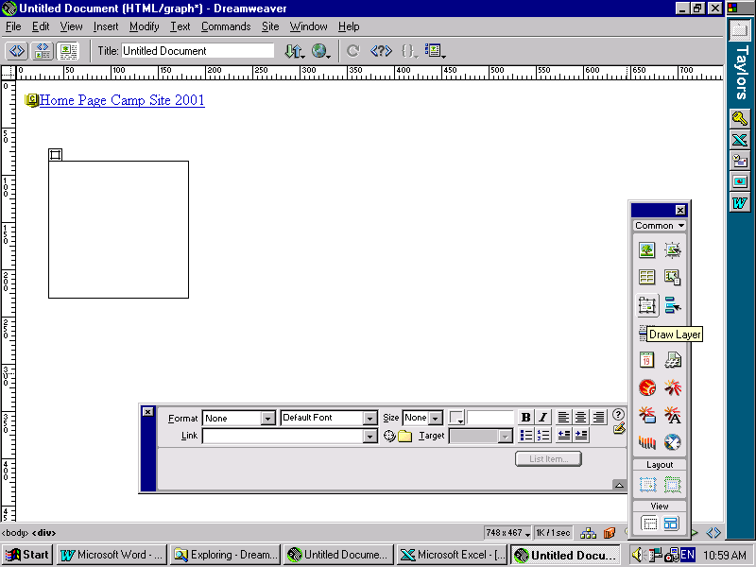

- Let’s now put the picture Graph gif24.gif insider the empty layer.
- Position the curser inside the layer.
- A layer is said to be active if the cursor is inside it, ready to receive text or image.
- To insert the picture, use Object Panel, Insert Image to open Insert Image Source window. Find the folder G:\IT Faculty\…\DreamWeaver in the Look in box.
- Find the file Graph gif24.gif and click it to place the name in the File name box.
- When you click Select the message “Would you like to save it now?” appears. Click Yes to accept it.
- In the Copy File As window, select the folder …\Camp Site 2001 Root_Folder\Images before click Save.
- Create another layer on the right hand of the first layer.
- Type in the following text
“The weather while at the camp was hot and sunny through the entire week. There were many activities - kayaking on the lake, rope and adventure courses, horse riding, flying fox, rock climbing and other activities.
However the most popular was swimming because of the hot weather.
Eating is also a popular pastime, not just at meal times because the enormous appetite cause by all the activities during the day. At night, we went out for walks, breathing the fresh cool mountain air and smelling the typical Australian bush that surround the camp site.
We were sad to leave the place when it was time to go.”
- You would have notice that as you typed, the layer gets longer to accommodate the text.
- Test the page in the browser and you will see that it looks pretty messy.
- One way of tidying it up is to restrict both the overflow and height of the layer. Let’s do it now.
- Select the layer by clicking a 4-way arrow at an edge of the layer. You know it is selected when eight resizing handles become visible.
- In the Properties Panel, select auto in the Overflow box.
- Test it in the browser and you should see a vertical scroll bar on the right hand side of the text material.
- You can adjust the height of the layer in the Properties Panel, by typing in an appropriate number in the H box.
- Your browser screen should look something like this:

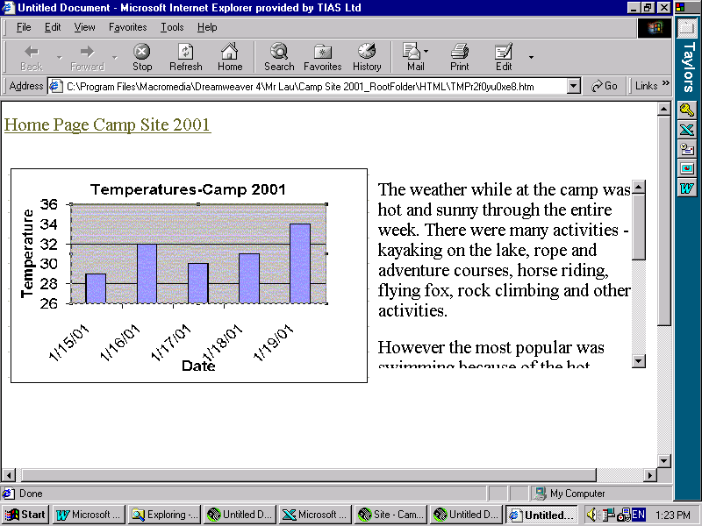
- Remember we need our own hyperlink in the file graph.html.
- You are going to put 2 picture hyperlinks just above the two existing layers.
- Draw a third layer in the desired position.
- Activate the layer.
- Now insert the picture 3 D Diamond.gif found in the G:\Clipart folder.
- Type in the text “Take Me Home” after the picture inside the layer.
- Select the picture.
- Hyperlink the picture by using menu Modify.
- Test the page in the browser.
- Insert another same picture hyperlink after the text “Take Me Home”.
- Format the image and layer until the browser view of the page is satisfactory.
- Test the page until you are happy with it.
- Now delete the dummy text hyperlink “Home Page Camp Site 2001”.
- Your final result should look something like this:

19 Putting Content into tyred teacher.html
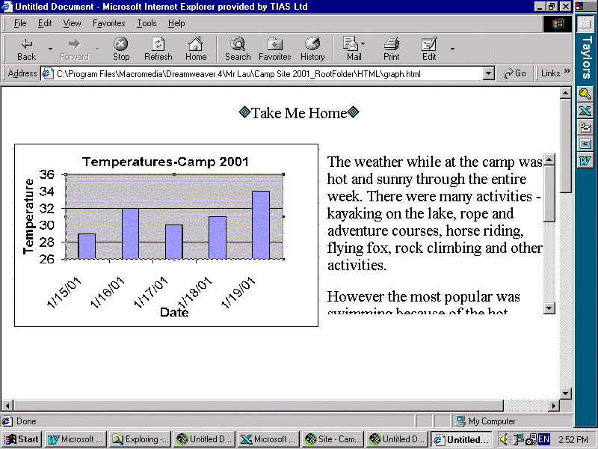
- You are going to create this page as follows:
- Open tyred teacher.html
- Create a layer to hold the picture Tyred Teachers.jpg found in the G:\IT Faculty\…\DreamWeaver folder.
- Insert this picture in the layer.
- Create a second layer with picture hyperlinks and text just above the picture similar to the one in the graph.html. page. You can do this from scratch or copy from graph.html. and paste to tyred teacher.html
- Next we are going to add a new feature called rollovers.
- A rollover is an overlay image as the mouse point passes over text or another image. Its purpose to attract the web surfer’s attention. Let us put a rollover to each of the diamond pictures.
- Select a diamond picture.
- Now add the rollover by using menu Insert, Interactive Image, Rollover Image. This opens the Insert Rollvover Image window like the one below:

- Type in “ROI – Red Swirl” in the Image Name box to replace the default name.
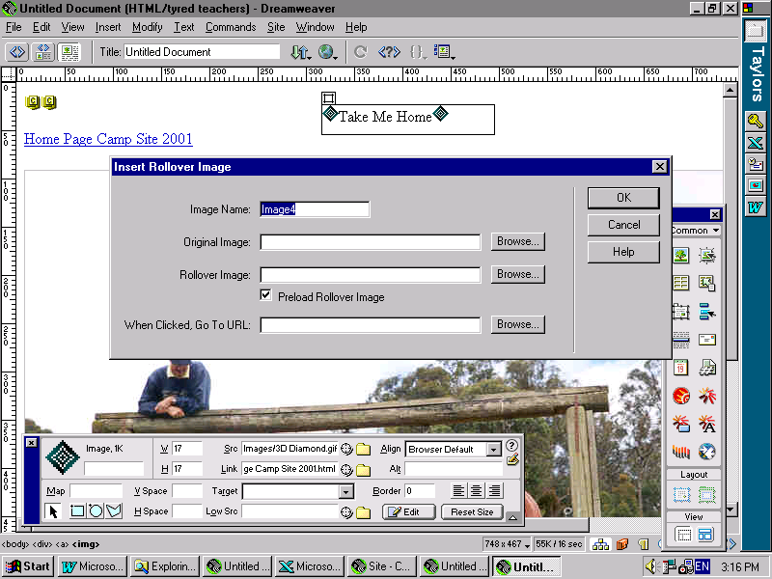
- Browse and find the file 3D Diamond.gif in the G:\… and put it in the box Orginal Image.
- Browse and find the file Red Swirl.gif in the G:\… and put it in the box Rollover Image.
- Browse and find the file Home Page Camp Site 2001.html in the folder H:\…\Images and put it in the When Clicked, Go To URL box.
- Finally Press OK.
- The final result is shown below. You can see the rollover on the left of “Take Me Home” when the mouse pointer(not shown) was over it.

You have now completed all the web pages in the web site.
