Creating PowePoints Efficiently
PowerPoint is one of the easiest software tools to learn and use. On the other hand, it can also be one of the most tedious to use. The purpose of these notes is to show you to create an effective (easy to read, engaging to the audience) PowerPoint efficiently (minimising time & effort).

Effective Reminders
The following points are meant as brief reminders of the do’s and don’ts of a PowerPoint presentation.
- Don’t fill screens with lots of small text. Main points only with bulk text in the notes.
- Do use large font sizes that can be read at a distance.
- Do ensure that your text colour is a good contrast with your background.
- Do have a consistency in appearence across all slides,
using the Master Slide will help with this.
- Don’t overdo sound effects, transitions and animations

Content with Outline View
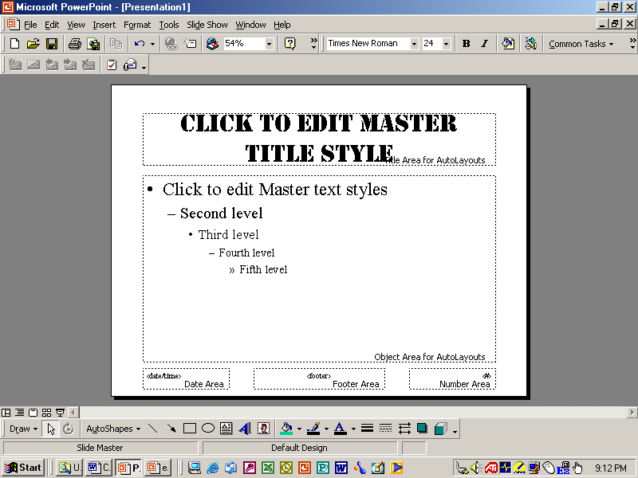
Outline View is a feature found in Word as well as PowerPoint. It works by using different levels of headings, called “Heading 1” up to “Heading 7”, to create a plan which can be fleshed out with “Body Text”. The names used are quite specific and are Styles, which can be defined via Format > Styles... in Word. Outline View can be turned on via the View menu in Word or using the buttons in the bottom left corner of the work area.
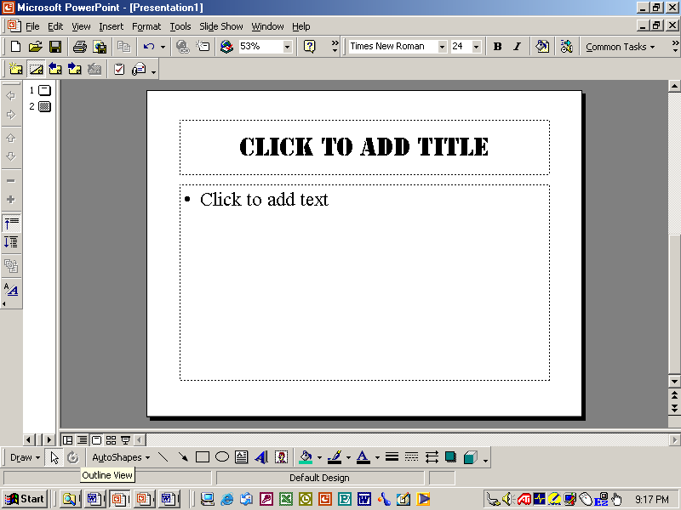
In PowerPoint, Normal View and Outline view are essentially the same and can be accessed via the View menu or the buttons in the bottom left corner of the work area.
A Level 1 heading in PowerPoint is the heading of a new slide. Levels 2 should be used for major subheadings, with level 3 for text on the slide. Body text should be on the notes page, which is found immediately below the view of the slide.
After each Heading press Enter, you will stay in that Heading level, but a new one will be created. To move between levels use the Arrow buttons on the left side or use the keyboard short cuts of Ctrl+Alt+ the left or right arrow.
So at the end of a slide press Enter, then Ctrl+Alt+ Left Arrow (possibly twice) until a new slide appears. Type in its heading, then Ctrl+Alt+ Right Arrow for the major subheadings.
Enter the content of your slides this way until completed. Don’t forget to periodically save the presentation. The order of slides can rearranged in this view, subheadings can be elevated to new slide headings as well as slide headings demoted to subheadings.
Word documents created in outline View can be easily copied across to PowerPoint.

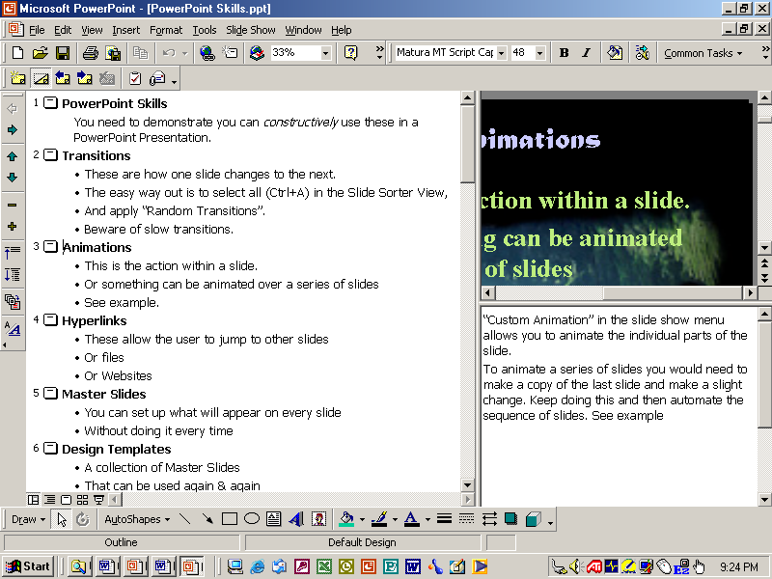
This will not be formatted until later
This is the notes area for any text that can be read out or distributed to the audience
Level 1 Heading / Slide title
Level 2 Heading
The Outline Toolbar which has the buttons for Promoting or Demoting Heading levels.
When complete the Outline part of the presentation will look something like this.

Formatting with Masterslide
You now have a PowerPoint which is just content on a white background.
Open View > Master > Slide Master. This enables you to format every slide at once and place common objects like graphics and buttons on every slide.
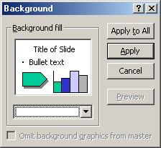
Click on each text style and you will be able to change its font, size and colour.
Through the format menu the background can be set.
Clicking here opens a menu which allows you to change the background colour and explore the various Fill effects. These include inserting a picture as a background.
Close the Slide Master when completed. Individual slides can still have the format changed and have objects added. Objects on the Master Slide, however, cannot be deleted from indivual slides. you need to put something in front of them.

Bulk Transitions & Animation
This is best done in the Slide Sorter View. Press Ctrl+A and every slide is selected.
The two drop down boxes at the left end of sorter toolbar are for Slide Transitions (from one to the next) and Custom Animations (within the slide). Select from the available options, but avoid slow ones.

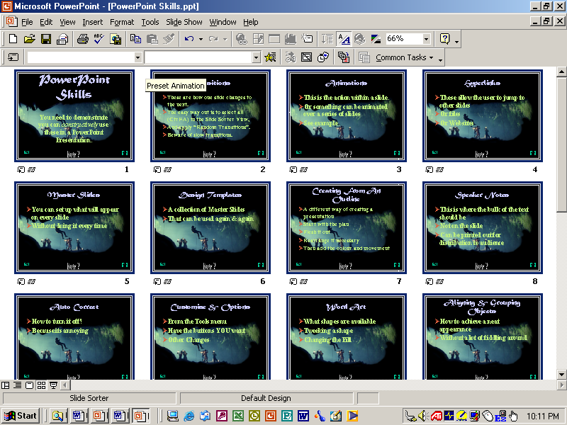
Click here for Slide Transitions
Click here for Animations

Individual slides can be changed, if necessary, later.
Good I.T.
should
free up your time!
not make work

