Website question

You have been asked to create a website for a school. Mockup one page for the staff section. This page will be the template for all of the homerooms. The homeroom section will have navigation that is global throughout and feature the school logo.

1 Import the buttons, homeroom image and school logo into a graphic editing program and manipulate them so that they fit your intended design in size and colour. (6 marks)

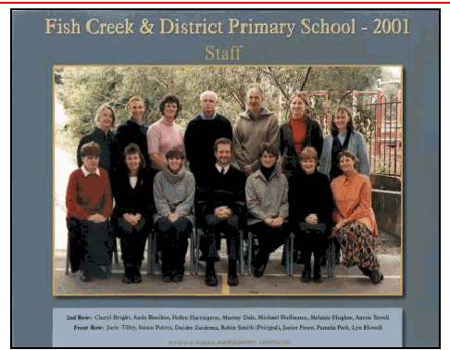

2. Use a web authoring program and create an html document. Using the principles of good design, lay out the staff page with the global navigation including the buttons. ( 1 mark for visible document, 3 marks for good design good navigation (readability, consistency 3 marks) 3 marks for including logo, photo and buttons..

3. Using efficient web-authoring techniques enable the user to select homeroom from a list. 1 mark for mechanism, 1 mark for an input or drop down menu, 1 mark for the form)

