IS CAT 3 - 1993 1
IS CAT 3 - 1994 7
Sample INFOSYS CAT 3 11
IS CAT 3 - 1995 15
IS CAT 3 - 1996 19
IS CAT 3 - 1997 23

IS CAT 3 - 1993

Case study A: Bogus Book Bazaar
Jim, and Lyn own and operate a suburban book shop. They bought a personal computer in 1988 when they set up the business. It has a 20 Mbyte hard disk, 640 Kbyte RAM, with a 31/2 inch disk drive and a dot-matrix printer. It is situated in the back room and runs a specially written stock control program. Using a stock file, this program can provide

- information about the title, author, publisher and supplier of all books in stock.
- book lists sorted by title, author, publisher or supplier.
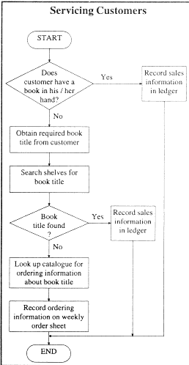
At the front desk there is a cash register and an ordinary exercise book which Jim and Lyn use as a sales ledger. Customer sales and orders are processed manually according to the flow diagram to the right.

At the end of each week Jim and Lyn must process customer orders and send these to the appropriate suppliers.
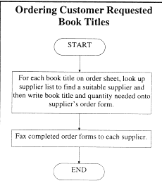

The flow diagram to the right represents the procedure for completing this task.

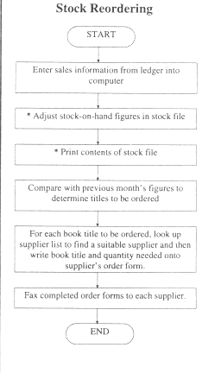
In addition to this they must transfer all the sales recorded in the ledger at the front desk into the computer using the stock control program. This helps them keep track of stock and is part of the monthly reordering process for replacing books that have been sold off the shelves.

The flow diagram to the right represents this process.

Note: The steps marked with an asterisk (*) are carried out by the existing computer system.

When Bogus Book Bazaar first opened it had about 10 000 books in stock. During the first year they sold an average of 4000 books per month and ordered about 50 books per week at the request of customers.

Now, five years later, Bogus Book Bazaar has around 15 000 books in stock. They sell approximately 6000 books each month and order 120 books each week to satisfy customer requests.

Jim and Lyn no longer have time to perform the manual procedures, so they have decided that they need a new computer system which will do as much of each manual procedure as possible.

Question 1
The flow charts show that the stock file is already computerised.
- Look at the flow charts and write down what other data files will have to be created.
- What kinds of data should each of these new files contain?

Question 2
Data storage will be an important consideration. From the advertisements below select a suitable component for each of the following. Give clear reasons for your selections.
- storing all the software and data files used everyday in the business
- making backups
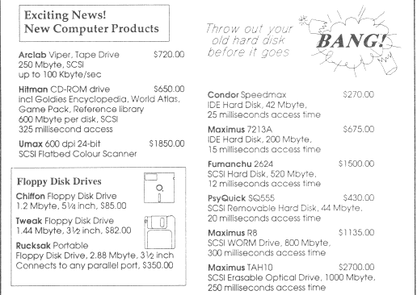

Question 3
It is anticipated that there will be a computer terminal at the front desk and that the data files will be accessible from this terminal.

What measures should Bogus Book Bazaar take to ensure that the data in these files is kept secure when the service counter is left unattended?

Question 4
Explain how Bogus Book Bazaar could ensure that the data files are not lost or accidentally altered through human or machine malfunction?
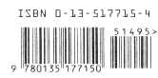

Question 5
On the right is an example of an International Standard Book Number (ISBN). ISBNs are printed on the back cover of all books and uniquely identify each book title. The new computer system will use ISBNs to locate data about books.
a. List three input devices which could be used to enter the ISBN into the new computer system.

b. Of these input devices, choose the device which you consider to be the most suited to Bogus Book Bazaar's needs, justifying your choice.

Question 6
Outline a validation technique appropriate to the input device you have chosen in question 5b. that can be used to ensure that the ISBN is entered correctly.

Question 7
The flow charts show that the new system will need to produce orders which have to be sent to each supplier. Describe two different ways in which the order can go from the system to the supplier.

Question 8
Jim and Lyn will move the existing computer to the front desk, where it will become the computer terminal referred to in question 3. They will purchase a new computer for the back room. These two computers will form the basis of the new system.

Draw and label a diagram showing the new system. Include the devices you have discussed in your previous answers and any other devices you think will be necessary. Indicate on your diagram where the main files will be stored.

Question 9
The new computer system will require an operating system. Describe three different functions that this operating system will need to perform.

Question 10
When Jim and Lyn first opened their book shop, software was not readily available. The stock control program they now use was specially written for them by Sam who worked for Supersoftware. This program has worked very well as Sam was able to tailor it to their needs.

As a result they decide to go back to Supersoftware to ask Sam to update their program. They find that Sam has left but they are assured that John will be able to complete the update within two months.

It is now six months later. Jim and Lyn are puzzled and disappointed that the new system is still not working in the way they had requested.
- Discuss some of the reasons why the new program may not be working.
- What other alternatives should Jim and Lyn have considered before deciding to return to Supersoftware?

CASE STUDY B

Questions 11 to 14 relate to this case study. Students should spend approximately 6 minutes on each question. Students should spend approximately 30 minutes on this case study Students should answer questions 11 to 14 in order.

Case study B: Fourex Oil Company
The Fourex Oil Company is about to build a new crude oil distillation plant in Smellbury, an outer suburb of Melbourne. Before the crude oil is fed into the distillation column, where it is separated into different components such as LPG, petrol, and kerosene, it must be heated in a furnace to a temperature of 350°C.

The furnace consists of a large chamber, through which runs a series of pipes. At the bottom of the furnace there are burners which bum gas to heat the crude oil as it passes through the pipes.
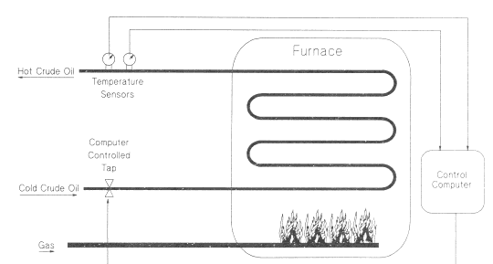
As shown, the furnace will have a tap which can be controlled by a computer to increase or decrease the flow of crude oil entering the furnace. Two temperature sensors will be used to measure the temperature of the crude oil leaving the furnace.

A control system is needed to ensure that the crude oil leaves the furnace at a temperature that is within 1°C of 350°C. To maintain this temperature the control system will need to be able to decrease the flow of crude oil into the furnace if the temperature falls below 349°C, or increase the flow of crude oil if the temperature rises above 351°C. (If the flow of crude oil is slowed down it will spend longer in the furnace, so will get hotter!)

It is assumed that the flow of gas to the burners heating the crude oil is constant.

You are a computer engineer at the Fourex Oil Company, and you have been asked to design the control system. As part of this design process you have written the following algorithm

BEGIN
shutdown~ FALSE

REPEAT
read temperature sensor 1
read temperature sensor 2
IF difference between readings > 1 THEN
sound alarm
shutdown = TRUE

ELSE
temperature * (temperaturel + temperature2)/2
IF temperature < 349 THEN
decrease flow of crude oil a bit

ELSE IF temperature > 351 THEN
increase flow of crude oil a bit

END IF
{Comment: need to include code for safety checks here}
END IF
UNTIL shutdown = TRUE
shut down furnace
stop crude oil flow

END

Question 11

If the flow of crude oil stopped for any reason, the system would overheat, and could explode.

Choose one additional input device and one additional output device from the following lists that you think could be connected to the control system to prevent the furnace overheating. For each device chosen indicate how it would be used by the control system, and why you think it would be useful.

Input devices | Output devices
- temperature sensor  - crude oil chemical composition analyser .  - mouse .  - pressure sensor  - flow rate meter | - flow control tap for crude oil  - flow control tap for gas to burners  - pressure release valve  - crude oil pump

Question 12
Carefully examine the first IF statement in the algorithm. Indicate why you think there are two temperature sensors used to measure the temperature of the crude oil leaving the furnace.

Question 13
State, with reasons, which of the three computers listed below you would choose to operate the control system. In answering this question you should take into account the processing requirements, security, cost, or any other factors that you think are relevant.

A. A single board, 8 bit computer with 16 Kbyte RAM, 16 Kbyte programmable ROM, no keyboard, no disc drives, digital and analogue input/output channels built in, and costing about $500.

B. A desktop personal computer with 4 Mbyte RAM, 80 Mbyte hard disc, 31/2 inch floppy disc drive, digital and analogue input/output card installed, and costing about $2500 (for example an IBM PC compatible with an 80386 processor, or an Apple Macintosh with a 68030 processor).

C. A mini-computer with 16 Mbyte RAM, 1000 Mbyte hard disc, cartridge tape drive, digital and analogue input/output facilities connected, and costing $25 000 (for example an IBM AS/400 mid-range computer).

Question 14
What factors would you need to consider when you connect the various input/output devices to the control computer?

IS CAT 3 - 1994

CASESTUDY

The Organisation
The Sports Science Institute of Wyilykit is a centre for sport and physical education research and coaching. It aims to provide up-to-date information about how to improve sporting performances.

Over the last few years the Institute has developed a process for matching young athletes to the sport they are most likely to be good at. In 1993 about 500 young athletes were taken to the Institute for testing. The 1993 process involved two stages:

Stage 1 (data gathering) A young athlete was put through a series of tests. The results were measured by hand-held instruments such as stop watches and tape measures, and then recorded on the data sheet shown in Figure 1.

Figure 1 The data sheet
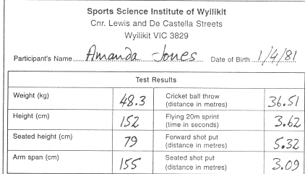
Stage 2 (data analysis) A data entry operator keyed each athlete's results into a spreadsheet program running on one of the Institute's old desktop computers. The spreadsheet used the data to produce an 'ability chart' for the young athlete. The athlete's chart was then compared with the standard charts of 50 different sports, and so the athlete's 'ideal' sport was identified.

The Situation
The Institute has been asked to undertake a Talent Identification Project throughout Australia during 1995. The aim is to test all the Year 7 girls and boys in Australia to establish their sporting potential. Talented youngsters identified by the program will be asked to join a special training squad for the Sydney 2000 Olympics. If the program is successful it will be continued in future years.

The Problem: Stage 1
The Institute has begun an investigation into how it could carry out the Talent Identification Project and has already made two decisions about Stage 1 of the process.
- The first is that the Institute's staff must go to the schools because it would be impractical to bring 300 000 students from all around Australia to the Institute. Therefore portable testing equipment is needed.
- The second decision is that Stage 1, the data-gathering stage, must be computerised; that is the measurements must be made and recorded by a computer without the need for human input.

This approach will be necessary because
- up to 300 students may be tested in a single 6-hour session
- recording the data by hand on sheets of paper will create too much delay in the testing process
- collecting 300 000 sheets of paper from around Australia and then transferring the results to a computer would be costly, prone to error, and take too long.

Because of these decisions, the data-gathering system will use notebook computers, each one controlling a different set of tests, as shown in Figure 2 below.

Figure 2 Arrangement of testing stations at a typical school
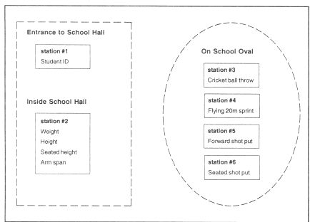

Question 1
To start the testing process, each Year Seven student will report to station # 1 where his/her name will be typed in, and the computer will give him/her a unique identity number.
- Outline a method that could be used to enter this identity number into the computer at each of the other stations. Include relevant equipment in your answer.
- Briefly describe a method of ensuring that the correct identity number is entered.

Question 2
When the data-gathering system is working in a school the Institute staff operating it will need a break from testing so that they can have lunch. Briefly outline two different ways that can be used to keep the system and its data secure from interference by students during this time. Justify your choices.

Question 3
At station #4 students will be asked to sprint a distance of 30 metres, one student at a time. The notebook computer used for this test will have to be able to directly measure the time taken for each student to sprint the last 20 metres. See Figure 3.

Figure 3 Flying 20-metre sprint test
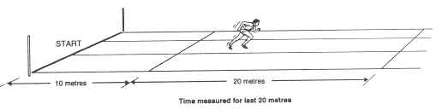
From the following list choose one type of input device that could be used by this computer and describe how this device could be used to measure the time taken for each sprint:
- mouse
- light sensor
- pressure pad
- keyboard

Question 4
The data collected at each station will be stored in a file. At the end of each day's testing the data stored in the files on each of the notebook computers will be combined into a single data file called SCHOOLDATA on the computer at station # 1.
- List the fields required in the flies on the notebook computers at station #2 and station #3.
- List the name, type and size of the fields required in the combined file SCHOOLDATA. A table may be appropriate.

Question 5
- Referring to the previous question, estimate the approximate size of the combined data file stored on the computer at station #1.
- The notebook computers will have their operating system software in ROM. It is estimated that the application software will occupy 500 kilobytes of storage space. The particular notebook computers that are being evaluated are available with the disc sizes listed below.
State, with reasons, which one of these storage devices you would choose for the notebook computer at station #1. In answering this question you should take into account the cost, storage capacity, the fact that the computers will need to be transported all over Australia, or any other factors you think are relevant.
- 1 Mbyte floppy disc drive
- 2 Mbyte floppy disc drive
- 20 Mbyte hard disc drive
- 40 Mbyte hard disc drive
- 200 Mbyte hard disc drive
- 40 Mbyte tape drive

End of Stage 1

The Problem: Stage 2
Stage 2, the data-analysis stage, will be carried out by a new central computer at the Institute. The SCHOOLDATA file from each school will need to be transferred to this central computer.

Question 6
Sometimes the testing unit will be interstate, and a long way from the Institute. Two ways of transferring the SCHOOLDATA file are being considered:
- using the telephone network and modems operating at 9600 bits per second
- copying the file onto a floppy disc and sending it by post
Discuss the advantages and disadvantages of the two alternatives, taking into consideration at least two of the following: cost, speed, file size, and compatibility.

Question 7
In 1993 the standard charts for 50 sports were drawn as bar graphs on sheets of clear plastic and kept in a folder. When an individual was tested, his/her ability chart was printed as a bar graph, and each of the standard charts was laid on top of it, one at a time. In this way the individual's most suitable sport was identified.
However, this method will not be suitable with data from 300 000 students to be checked. Therefore data to create the standard charts will be stored on the central computer's hard disc. The procedure for matching sports to students will be as follows.
Staff in the Finance Department at the Institute want to save money. They are objecting to the purchase of a new central computer and are suggesting that the existing desktop computer would be suitable. This computer has an 8-bit processor, only 64 Kbytes of RAM and a monochrome text monitor. Explain why this equipment will not be suitable, and indicate what capacities and capabilities the new equipment will need in order to carry out the above procedure.

Question 8
The new central computer will be used by other departments within the Institute at the same time. When this new computer is purchased the Institute will also have to obtain an operating system for it. Whichever operating system is chosen, a special device driver may be needed to allow it to read the discs from the notebook computers. From the table of operating systems shown choose one that would be suitable by considering which functions are important. Give reasons for your choice.

Operating System Comparison Table
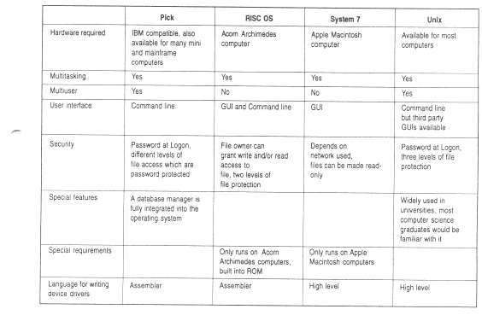

Question 9
The final year students in the Computer Science department at the Wyilykit University are required to undertake a major programming project. The University has offered the services of a programming team free of charge to write the programs required for Stage 2, the data-analysis stage, of the project.

- Give one other alternative that is available to the Institute for obtaining programs for Stage 2 of the project.
- Discuss two factors that need to be considered before making a decision about where the programs could be obtained your answer.
- Should the programming students be given this task? Give two reasons to explain your answer.

Question 10
After the raw data has been collected right through until the final analysis of the results, there will be many opportunities for the data to become lost or corrupted.

- On a diagram of the whole system, show two places where such data loss or corruption could occur, and describe the way in which it could happen at each place.
- For each of the two places you identified in part a., describe measures that could be taken to minimise the problem. Where appropriate suggest suitable equipment that could be used.

END OF QUESTION BOOKLET

Sample INFOSYS CAT 3

Magrathea Examination Board

Examinations for all subjects in Magrathea are set by the Magrathea Examination Board (M.E.B.). The markers write their marks on marking sheets similar to this:

Subject: | Information Systems
Candidate: | 94 021375 X
Question | Mark
1 | 6
2 | 4
3 | -6
4 | 2
5 | 0
6 | 6
7 | 3
8 | 0

There is a marking sheet for each candidate for each exam. The data flow diagram shows how the marks recorded on these mark sheets are processed. The dotted line indicates the boundary between manual and computer operations. The processes shown in the diagram are described here:

1st entry of marks A team of data entry clerks key the marks into a computer which then
stores them in the 1st mark file.
2nd entry of marks The marks are keyed in again but each sheet is keyed by a different clerk.
The computer stores these marks in the 2nd marks file.
Compare mark files The computer compares the two marks files with each other, either
accepting or rejecting the marks. Accepted marks records are stored in
the Main marks file. Rejected marks records are printed out on a sheet of
paper. Marks records are rejected if
a. a candidate's marks for a particular exam do not match.
b. a candidate's record in one file cannot be found in the other file.
C. a candidate's record in one file is found to have more than one
match in the other file.

Correct rejected marks The data entry clerks use the data on the sheet of rejected marks to find the original marks sheet. The clerks then key in the corrections. The computer stores the corrected marks in the Main marks file.

Produce reports Once all the marks have been finalised, a program is run on the computer
which reads all the marks in the Main marks file and processes them to
produce three reports:

1 .Each student's own set of marks which are printed on a pre-printed

A4 sized form. These are folded, placed in individual envelopes
and mailed out to students by a group of mailing clerks.

2. Each student's Tertiary Score is calculated and written on to a

magnetic tape. This tape is then sent to the Tertiary Entrance Board.

3. The marks for all the students from each school are printed and

mailed to the appropriate school by the mailing clerks.

Data Flow Diagram showing how the Magrathea Examination Board (M.E.B.) processes exam marks.
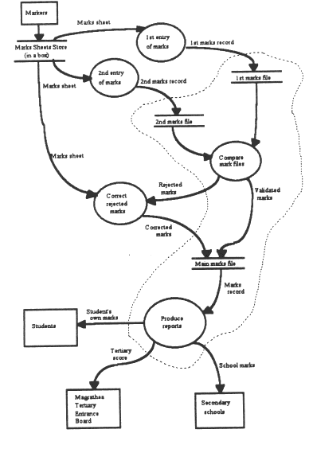

Question 1
- Apart from the CPU and internal memory, list four items of hardware used in this information system and briefly state the purpose of each.
- All computer systems need systems software and application software. List one example of each used in this information system and state what they are used for.
- List the people involved and briefly describe their roles.
- Briefly state the main purpose of this information system.

The current information system was designed eighteen years ago to deal with about 9000 students. Magrathea now has about 50000 students sitting exams, each of whom does an average of six exams. Ibis means that there are about 300 000 marking sheets to be processed. A data entry clerk can enter 300 marking sheets per hour and it takes about four minutes to correct a rejected mark sheet.

Since the system began operation the percentage of rejected marks has remained constant at about 2 per cent of the total marks. This was acceptable in the early years of the system.

Question 2
- Approximately how many mark sheets will now be rejected?
- Why would this number of rejected mark sheets be of concern to the Examination Board?
- Name a component of the existing system that needs to be replaced to overcome this problem. Explain why it needs to be replaced.

The new system
The Examination Board is investigating a new system that will allow the markers to use any personal computer they have access to (at home or at school) to record their marks, instead of using the marking sheets. They will also be able to transmit the data from their personal computer directly to the central computer system at the Examination Board.

Question 3

Describe any additional hardware component(s) that will be required, and indicate how they will be used.

Question 4
- Describe the functions of a program that would be suitable for the markers to use to record their marks.
- What kind of software will the markers need to control the process of transmitting the data from their personal computer to the central computer system at the Examination Board? Why is this software necessary?

Question 5
Outline three possible technical problems that might interfere with the proper transfer of data from the markers' personal computers to the central computer system.

Question 6
- Marks for each question will be in the range zero to six. Design a procedure that will ensure that the data that ends up in the Main Marks File is as accurate as possible.
- Redraw the data flow diagram to reflect the changes made to the system.

Question 7
Describe three ways to minimise data loss from the modified system. Explain how these measures will improve the security and indicate why they would be necessary.
(Note: data loss can be through technical difficulties as well as from unauthorised access.)

Question 8
From the following list of types of people, select three that would be affected by the change in the system and describe the way their roles and functions would change: students, exam supervisors, couriers, markers, data entry clerks, mailing clerks, computer system operator, school office staff. teachers. systems technician, the exam setting panel.

Question 9
One of the reasons for making these changes is to improve the efficiency of the system. Identify areas where the efficiency would be improved and indicate how these improvements can be measured.

Question 10
The modifications to the information system at the Magrathea Examination Board (M.E.B.) are made possible by developments in personal computing and communications technology.

Described below are four situations relating to the new M.E.B. system. Choose one, discuss the issue raised in broad terms and then say how this issue applies to the situation you have chosen.

Situation A raises the issue of the effects of new technology on employment:
Marvin is an experienced data entry clerk and has been working for M.E.B. for the past six years. He has just heard that the new system will need forty fewer data entry clerks although three new technician positions will be created.

OR

Situation B raises the issue of the effects of new technology on privacy:
Trillian is a student who has just completed her M.E.B. exams. She has applied for entry into the Bachelor 'of Fjord Engineering course at the University of Magrathea. Much to her surprise the Vogon Institute in New Zealand contacted her, congratulating her on her excellent examination results, and offering her a place in their Civil Engineering course.

OR

Situation C raises the issue of people's attitude to new technology:
Ford has been a Mathematics examination marker for seventeen years. He uses a typewriter quite often, but he has never made much use of computers because he has always been afraid of them. This week he received an application form from M.E.B. and a letter asking if he was interested in marking next year's Mathematics examination. The letter also explained that M.E.B. was introducing a new computer-based method of marks entry which Ford would have to use.

OR

Situation D raises the issue of ethics relating to the use of information technology:
M.E.B has received a letter from Beeblebrox Educational Publishers, a leading supplier of books and CDROMs for tertiary students. The letter is offering M.E.B. $5000 in return for a list of the names and addresses of all students sitting next year's exams. Beeblebrox claim that new tertiary students would benefit greatly from knowing about the products it sells.

IS CAT 3 - 1995

Catmandoo passport office

Last September, in the far away country of Gatland, Alison Ng applied for a passport at the passport office in the capital city, Catmandoo. She went through the following steps:
- waited in a queue for 45 minutes at the photo section before Polaroid photos were taken and processed
- took the developed photos to the application desk
- waited in a queue for 15 minutes to receive an application form
- filled out the application form waited in a queue for two hours at the 'new applications' counter
- waited for 30 minutes while the applications clerk completed a passport form using a typewriter
- checked details on the typed form and returned it to the applications clerk.

The applications clerk then told Alison that her personal details would need to be checked. He also said that this process would take a week and that her passport booklet would be posted to her.

The data flow diagram below shows how the Catmandoo passport office processes passport applications.
The processes shown in the diagram are described below.

Take photograph

A photographer takes a Polaroid photo of the applicant and gives it to him or her.

Create passport form

A passport applications clerk types the information given on an application form on to a passport form and attaches a photograph of the applicant to it. The data is validated by showing the completed form to the applicant. Any errors on the form are corrected straight away. The applicant then signs the passport form. The clerk places the completed passport form into a box labeled 'applications file'.

Check record

A filing clerk takes each new application and searches through the microfiche records to see if that applicant is already in the file. The clerk then uses a terminal connected to the police department computer to see if the applicant has a criminal history. In either case, if a discrepancy is found, the application is stamped rejected and sent back to the applicant. Otherwise it is accepted and placed in a box marked 'approved applications file' .

Produce passport

A clerk takes a completed passport form from the approved applications file and produces a passport booklet. The clerk then sends the booklet to the applicant.

Create microfiche record

A microfilm technician takes a batch of application forms and photo-reduces them to produce a single microfiche record. This record is placed in the microfiche store.

Question 1
- List three items of equipment involved in this system, and briefly state the purpose of each.
- Briefly describe three different roles of people employed at the passport office.

Question 2
Judging by Alison's experience, which item of equipment in the existing system is the least effective? Give reasons for your answer.
A new digitised system is to be installed. Ten personal computers with digital cameras on top will be connected to a local area network. Each applicant will have his or her photograph taken by a digital camera which transfers the image directly to the personal computer's secondary storage. At the same time the computer operator will key the applicant's personal details into the computer. The personal details will be printed to allow the applicant to check them.

When the computer operator is satisfied that all the details are correct he or she will initiate a criminal record and previous-existence checking program. If no problems are found, the data, including the digitised image, will be transferred to the network fileserver, otherwise the application will be rejected. The fileserver will then send the data to a purpose-built passport printer which produces the finished passport.

Question 3
The previous-existence checking program will not be very effective unless it can access all the existing passport data. Explain why it will be difficult for the new digitised system to access this data.

Question 4
A computer operator starts the criminal-record and previous-existence check by clicking on the 'start check' icon. The criminal record check involves connecting to the police computer and checking the applicant's details against approximately five million criminal records stored on the system. Describe two appropriate types of software that could be used to carry out this task. Include the important features of the software and indicate why you think these features will be necessary.

Question 5
Design a procedure to be followed by the computer operator when dealing with an applicant. The procedure should cover all the steps from when the applicant arrives to when his or her data is stored on the fileserver. Represent your design in an appropriate form.
The light-sensing chips in the digital cameras referred to on page 4 will have a resolution of 512 x 512 pixels. Each pixel will occupy three bytes of storage so that a complete digitised image will be approximately 800 000 bytes. When the data is stored on the fileserver it will be compressed by a ratio of 10 to 1.

The number of digital images to be processed per day can be found in the following table which shows how the number of applications and the number of clerks has increased since 1989.

Year | Number of applications per day | Number of clerks
1989 | 700 | l0
1995 | 2500 | 20
2000 | 4000 (expected) | 10 *
* The new system will need only ten computer operators to operate the new PCs.
All points of entry into Gatland will have terminals connected to the network. Information about any passport will need to be available at these terminals within a few seconds.

Question 6
Using the amount of data to be stored for each passport and the number of applications per day, calculate the approximate size of storage space required to hold passport data. Taking this calculation into account, and the speed of access required, suggest a suitable type of secondary storage. Give reasons for your choice.

Question 7
With the previous system it was comparatively easy to gain unauthorised access to passport data and hence forge passports. Clearly describe three things that could be done as part of the new system to prevent unauthorised access to the passport data.

Question 8
The new information system will involve many changes. Identify two people with different roles who will be affected by the changes. Compare what these people did under the old system with what they could possibly do in the new system.

Question 9
It is anticipated that the new system will make improvements in the areas listed below. For each area indicate one kind of improvement that might be expected and how it could be measured.
- applying for a passport
- criminal record and previous-existence check
- passport data storage

Question 10
This proposed new system is a very ambitious project for the Gatland Government and there are many issues which need to be sorted out to ensure a smooth transition and a better service for the public. Choose one of the following, answer the question posed and discuss the issue in general terms, as well as its relevance to the Catmandoo passport office.

- Computer crime and privacy Susan enjoys the challenge of attempting to access company computer systems. She does this by using her modem and the tele phone lines. One night to her amazement and delight she stumbles on to passport information being sent from the Catmandoo passport office to the Gatland Embassy in Melbourne. She finds she is able to download it into her system and examine the contents. She does not do anything with the information. Has she done anything wrong?

OR

- Attitudes to information technology and employment. Chan is a photographer with the Catmandoo passport office. He hates the idea of the new digitised system and is concerned about the jobs that will be lost (see table in question 5). Mayling, however, is an applications clerk, who is very excited about the proposed changes because of the career opportunities it offers her. Why would two employees have such differing views?

IS CAT 3 - 1996

Keyside Shopping Centre Car Park
The existing system
The Keyside Shopping Centre, in an outer suburb of Melbourne, has an underground car park for 450 cars.
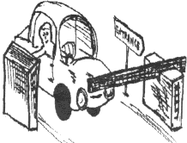
When a car enters the car park it activates a machine which prints a serial number and the current time onto a ticket. The car driver reaches out of the car window and takes the ticket, which causes a boom gate to rise, allowing the car into the car park. The serial number of the ticket and the time are recorded by the car park's central computer.

On leaving the car park the driver gives the parking ticket to a car park attendant. The attendant types the serial number shown on the ticket into his computer terminal. The central computer uses the serial number to look up the time the car entered the car park. It then calculates the parking fee, which depends on how long the car has been in the car park, and displays this amount on the attendant's terminal.

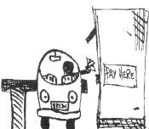
The attendant collects the fee from the driver and presses a button to raise the boom gate so that the car can leave the car park.

This system automatically stores data about the number of cars using the car park each day, how long each car stays in the car park, and prints weekly reports of these statistics.

At the moment the car park has two entrances and two exits, with one attendant at each exit.

Question 1

From the above description of the car park system
- draw and label a diagram showing how the boom gates, terminal, central computer and any other necessary items of equipment are connected
- label your diagram to clearly show the flow of data.

The Problem
The Keyside Shopping Centre is about to increase in size. This means that the car park will need to hold another 2000 cars. Rather than employing another 6 to 10 car park attendants, the Board of Management of the Keyside Shopping Centre has decided to investigate the installation of a new, fully automatic, computer-controlled car perking system. This system will record the date and time that each car arrives and leaves the car park and provide regular data on car park use.

The proposed new system
To use the proposed new system, car owners would need to install transponders in their cars. Each transponder would be used as follows.
- As the car enters the car park, a car detector will cause a 'Who are you?' signal to be transmitted from a signal and camera station near the entrance.
- The transponder will receive this message and respond by sending an identifying code to a receiver in the station.
- The computer would then read the code from the station and store this code with the time of entry.
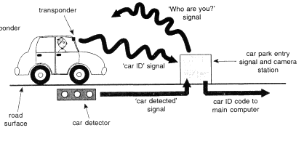

A car fitted with a transponder entering the car park.

As the car leaves the car park it would again be identified and the car parking fee would be calculated. The fee would then be automatically transferred from the car owner's bank account to Keyside Shopping Centre.
To obtain a transponder, car owners would have to agree to provide their personal details, including a bank account number, so that the parking fee can be automatically transferred from their accounts. The transponders would be fitted free of charge by Keyside Shopping Centre.

This new system would no longer need boom gates, ticket printing equipment or car park attendants. However, it would need some way of detecting and charging car owners who do not have transponders. A digital camera put at each of the car park's entrances and exits would automatically photograph the numberplates of cars that do not have transponders, as they enter and leave the car park.
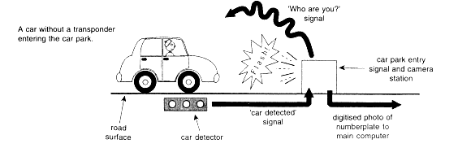
These photographs would be analysed by pattern recognition software, which would be able to identify the letters and digits on the numberplates.
The Board of Management of the Keyside Shopping Centre will arrange with Vicroads (the car registration organisation) to allow them to automatically obtain the names and addresses of the owners of photographed cars. Keyside could then send an account for the car-parking fee to the car owner's home address. To cover the extra costs involved, the car-parking fee for car owners without transponders will be double the fee charged to those who have fitted transponders.

Question 2
From the management's point of view, briefly describe three advantages and three disadvantages of the proposed new system compared with the existing system.

After an investigation of the proposed new system Keyside has stated that
- the old central computer will not cope with the increased data-processing load
- even on a powerful computer system the pattern recognition software can take up to 30 seconds to analyse a numberplate photograph
- about 300 KB of data about car movements needs to be stored every day. At the end of each month this data will be archived
- the system must be able to store permanently on line the personal details of all the car owners with transponders. This data will occupy about 50 MB
- another 85 MB of storage space will be needed by the new system to store the operating system and application programs.

Question 3
Select two important features from each column of the following table that need to be considered for the new system. Briefly explain each of the features you have selected and why they are important for the new system.

Processor features | Operating system features
16 bit data bus | multi-tasking
32 bit data bus | graphical user interface
high clock speed | web browser
RISC processor | range of device drivers
internal memory cache | command line interface
parallel processor | virtual memory support
parallel processor | mirrored hard drive support

Question 4
The following table shows some of the peripheral devices available for purchase. From each column select the minimum number of items necessary to allow the new system to perform as described on pages 3 and 4. Briefly explain why each item you have selected is required.

Storage devices | Other peripheral devices
1.2 GB fixed hard disk drive | laser printer
1.44 MB floppy disk drive | modem
120 MB tape drive | mouse
200 MB removable hard disk drive | colour laser printer
540 MB fixed hard disk drive | digital camera
600 MB CD ROM drive | flat bed scanner
600 MB writable CD drive | 24-pin dot-matrix printer

Question 5
The Board of Management of the Keyside Shopping Centre is worried that some people may decide not to visit the shopping centre. These people may not want to install transponders or have their numberp1ates photographed. One suggestion to overcome this problem is to install a manual pay booth at one of the exits.

Describe a procedure that could be used in this manual pay booth for dealing with people who want to pay when they visit the shopping centre. You may need to include some additional equipment to support your procedure. You may use a diagram to answer this question.

Question 6
Keyside Management is concerned about the car park attendants losing their jobs. Suggest two different positions they could be retrained for in the proposed new system, and describe their roles in these positions.

Question 7
System planners have set the following goals:
- during the first three years of operation, the average time between system failures should be more than 100 days
- no more than 0.2 per cent of cars per month passing through undetected
- no more than 0.05 per cent incorrect identifications of numberplates per month
For each of these goals, describe an evaluation technique that could be used to measure whether or not each goal has been achieved.

Question 8
During the analysis, design and development stages of a new system mistakes can be made, the effects of which do not appear until later. For each of the following problems choose the stage (analysis, design or development) at which a mistake is likely to have occurred and describe what this mistake is likely to have been.

Problems
- When the new digital cameras arrived the technicians found that they could not connect them to the new central computer.
- Soon after the new system was put into use, Keyside Management began to receive complaints from people who had never been to the car park saying that they had received a bill for parking. Investigation showed that numberplates of many cars without transponders were not being recognised correctly.
- After the new system had been in use for a month, Keyside Management received complaints from customers saying that they were being overcharged.

Question 9

Answer either Part A or Part B

Part A
Soon after the plans for the new car parking system were made public the following appeared in a newspaper article about Keyside Shopping Centre car park.
The Privacy Protection Association (PPA) has serious concerns about the plans to anew a private organisation use of Vicroads' records. The PPA says that Keyside could give out information about a car park user without the user's permission, even if the user has not fitted a transponder. The PPA also claims that Keyside could sell the data it collects about its customers to other organisations. This would allow these organisations to direct their advertising to selected individuals or groups in the community.

How concerned should the public be about these claims? Discuss - making sure you include at least four relevant points in your discussion.

OR

Part B
The following paragraph appeared in a publicity pamphlet released by Keyside as part of their campaign to win support for the new car park.
Not only will the new parking complex offer car owners the benefits of 21st century technology, the new technology will also help our fragile environment. By removing the need for parking tickets we will be able to greatly reduce our paper use. This will not only save trees but will help reduce landfill problems by cutting down on waste paper disposal. also, no more long lines of cars waiting at boom gates means reducing air pollution, a bonus for everyone!
How true are these claims? Discuss - making sure you include at least four relevant points in your discussion.

IS CAT 3 - 1997

CASE STUDY

Paint Spot System

The existing system

Colourful Paints (Aust) Pty Ltd own and manage a chain of shops called The Paint Spot, which sell house paints to the general public.
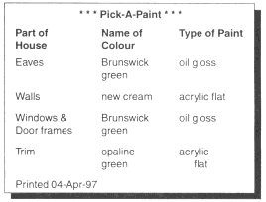
In each of the stores Colourful Paints have installed the Pick-A-Paint system. This is a computer system which helps customers choose paint colours for their houses. It is designed to be used by customers without any assistance from the shop's staff. Except for a touch screen, all the other parts of the system are hidden from view.

At the start of a session the system displays a number of house styles, such as Federation and Colonial, from which the customer selects the style that is most like their own house. This is done by touching the appropriate place on the touch screen. The customer can then select indoor or outdoor views of the house. For each view, they can ask the computer to colour various parts of the house in any colours they choose. They then tell the computer which colours they want. The colours presented to the customer are all taken from the Colourful Paints range of paint colours. At the end of the session a ticket is printed. The ticket printer is built into the touch-screen unit. A ticket similar to the one shown on the right is printed.

Question 1
The Pick-A-Paint system has most of its hardware components hidden from view. Describe the hardware components it must have if it is to operate as indicated above.

Question 2
The Pick-A-Paint system uses a Graphical User Interface (GUI).
- What is the main hardware component of the GUI in the Pick-A-Paint system?
- Why would the designers of the system have decided to include a GUI rather than a Command Line Interface (CLI)?

The problem

Colourful Paints regularly conducts surveys of its customers. For the past three years the surveys have shown an increasing dissatisfaction with the Pick-A-Paint system. Customers say that the houses displayed by the system are not similar enough to their own houses. This means that customers still have to use their own imagination, so the system is not very helpful. Many customers also report that the colours of the paint they buy do not exactly match the colours they saw on the screen.

So far this dissatisfaction has not affected sales. This is because Colourful Paints has a policy that all of its stores should have at least one qualified and experienced painter serving customers. However, in recent times, such people have been harder to hire. Also, some managers in the company want to change this policy. They think an enormous saving can be made in wage costs by hiring ordinary shop assistants instead of 'costly' expert painters. These managers argue that technology can be used to replace the lost expertise.

Therefore the problem is to design an information system which helps customers choose paint colours for their houses and correctly mixes the paint they need, without the assistance of a qualified and experienced painter.

The proposed new system
The General Manager of Colourful Paints has asked Lemon Computers, the computer consultancy who designed the Pick-A-Paint system, to solve the problem. Two of the design specifications provided by the general manager are listed below

Specification 1
The system must allow customers to select colours by:
- manipulating an image of a particular house style (this happens with the existing PickA-Paint system)
- choosing from a Colourful Paints colour chart displayed on a screen
- manipulating a scanned photographic image of their house.

Specification 2
Once all the colours have been chosen, the system must be able to:
- print a copy of the screen showing the colours chosen by the customer
- store personal data about the customer and the colours they have selected for future reference
- calculate the amount of paint required
- mix the required paints.

Question 3
One of Lemon Computer's design engineers has quickly written down a basic dataflow diagram of the new system, as shown above. The General Manager of Colourful Paints is concerned that the dataflow diagram may not meet all the requirements in design specification 2. For each of the four dot points, explain whether the dataflow diagram meets the specification.

To minimise the costs of the new system, Lemon Computers proposes to upgrade the existing system by adding a second computer. The new system will control a paint-mixing machine and any other necessary equipment, such as a scanner.

Question 4
Draw and label a diagram showing how all the existing and new equipment will be connected together.

Question 5
Colour printers with the following specifications are available for the system. Which type should Lemon Computers recommend? Justify your answer

Type | Cost of  printer  $ | Dots per  inch | Colour  quality | Warm up  time | Pages per  minute | Cost per  page(cents)
Dot matrix | 250 | 180 | fair | 0 | 0.33 | 12
Ink-jet | 400 | 360 | good | O | 1 | 60
Thermal transfer | 950 | 360 | very good | 60 | 0.5 | 80
Laser | 8000 | 600 | very good | 90 |  | 25

Di Hugh & Sons manufacture a paint-mixing machine. Lemon Computers will supply the new computer and scanner. The specifications for these items are given on page 5.

Question 6

Using the information presented on page 5, describe three possible compatibility problems.

The Lemon computer
Feature | Specification
RAM | 16 Mbytes
Hard disc | IDE 1.6 Gbytes
Floppy disc drive | 31/2 inch 1.44 Mbytes
Parallel port I/O connector | 25-pin D-connector (12 volt signals)  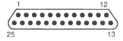
Serial port I/O connector | 25-pin D-connector (5 volt signals)
Serial port I/O connector | 9-pm D-connector (5 volt signals)
Keyboard connector | 5-pin DIN (5 volt signals)
Monitor connector | 15-pin D-connector (5 volt signals)

The Lemon scanner
Feature | Specification
I/O connector | 50-pin SCSI connector
Colour system used | RGB (Red, Green, Blue - as used in computer monitors)
Resolution | 1200 dpi
Time per page | 30 seconds

The Di Hugh paint mixer
Feature | Specification
I/O connector | 45-pin D-connector (-20 volt to + 20 volt signals  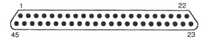
Colour system used | CMYK (Cyan, Magenta, Yellow, black - as used in high quality colour printers)
Paint bases | Able to select one of four varieties (matt, semi-matt semi-gloss and high gloss)
Paint-mixing time | 300 to 600 seconds

A special interface card has been designed for installation in the new computer. This interface card will overcome the problems of connecting the paint-mixing machine to the new computer.

The I/O lines on the interface card have been mapped (connected) to memory locations in the new computer, as indicated in the table below.

Symbolic memory address | Data stored at this address | Connected to pin(s) | Purpose
CYAN | Cyan colour value | 1 -8 | Sends the amount of cyan needed to mixer
MAGENTA | Magenta colour value | 9-16 | Sends the amount of magenta needed to mixer
YELLOW | Yellow colour value | 17-24 | Sends the amount of yellow needed to mix
VOLUME | Volume of paint in ml | 25 - 40 | Sends the volume of paint needed to mixer
TYPEOFBASE | Type of base | 41 -42 | Sends type of base to mixer  0 - use matt base  1 - use semi-matt base  2 - use semi-gloss base  3 - use high gloss base
STARTMIXING | Start mixing signal | 43 | Changing this value from 0 to 1 sends a signal to the mixer to start mixing. If the mixer is busy this signal is ignored
FINISHEDINGMIXING | Finished mixing signal | 44 | Signal from mixer sets memory location to 0 if mixer is busy, or to 1 if mixing has finished.

Question 7
To allow the computer to control the paint-mixing machine, you are required to provide a 'Device Driver' procedure called MixPaint to drive the interface card. The following parameters will be passed to the MixPaint procedure: red, green, blue, CanSize and BaseType. The procedure should monitor and/or set appropriate pins to mix a batch of paint. It should not end until the batch of paint has been mixed. Represent your procedure using an appropriate format.
To assist you in this task, two procedures named ConvertColour (Figure A) and ConvertVolume (Figure B) have already been written, as described on page 7.

The existing Pick-A-Paint program uses the following values for the BaseType parameter: 1 for malt, 2 for semi-matt, 3 for semi-gloss and 4 for high gloss. The driver procedure should take this into account.

Procedure ConvertColour (red, green, blue)
This procedure uses the parameter values red, green and blue to calculate the equivalent cyan, magenta and yellow values. It then stores these new values in memory locations CYAN, MAGENTA and YELLOW.

Figure A

Procedure ConvertVolume
(CanSize)

This procedure takes the parameter value CanSize and calculates the equivalent volume of paint in ml. It then stores this new value in memory location VOLUME. The existing paint-mixing data table uses 1 to represent a half litre can, 2 to represent a one litre can, 3 to represent a two litre can, and 4 to represent a four litre can. As an example this procedure is listed below.

Procedure ConvertVolume (CanSize)
Begin
VOLUME  0
If CanSize = 1 Then VOLUME  500
If CanSize = 2 Then VOLUME  1000
If CanSize = 3 Then VOLUME  2000
If CanSize = 4 Then VOLUME  4000
End ConvertVolume

Figure B

Question 8
It will be very costly for Colourful Paints to implement the new system in all of its stores. Therefore they want to trial the system in three stores and then evaluate the success of this trial. Propose and explain a strategy to measure the success of the new system in meeting each of the following goals.
- to increase paint sales
- to increase customer satisfaction and loyalty
- to decrease staff costs

Question 9
During the trial of the new system, staff at the three Paint Spot stores were surprised to find that many
Customers needed to ask for assistance when using the system.
Describe two possible measures that the management of Colourful Paints could take to solve this problem.

Question 10

Answer either Part A or Part B

Part A
Until two years ago Brian was a painter with about 30 years experience in the industry. He felt that he was becoming a bit too old to go around climbing ladders and when he was offered a job at 'The Paint Spot' as the store's painting expert he took it. Brian's cheerful manner and expert advice to customers has earned 'The Paint Spot' the reputation of being the best paint shop in the Warrego district. However, if the new system is installed in all stores the customers will be able to get all the advice and information that they require from the computer, and Brian's experience will no longer be needed.

Can a machine really take the place of a human being with 30 years experience? Discuss this in detail. At least four points should be mentioned in your answer.

OR

Part B
Colourful Paints want as many customers as possible to use the computer system to help them choose paint colours. To make sure that this happens, Colourful Paints will instruct all stores to:
- install the touch screens so that adults must stand up to reach them. This will prevent small children from playing with the system
- display signs strongly encouraging the use of the touch screens before any discussions take place with staff.
What issues might Colourful Paints have to deal with when these instructions are carried out? At least four points should be included in your answer.

