Computers at Esc
Monday, 13 June 2016
9:55 AM
Summary
This session aims to introduce the students to the way computers and associated systems are used at Epping Secondary College. As well as to establish proper file naming conventions habits

Integration Friendly
EAL Friendly
High-Achiever Friendly

Background Knowledge
There is no specific prior knowledge required for this lesson

Fundamentals of this Lesson
Learning Intention | Success Criteria
- To be able to use the school portal to submit work, view timetables and current news.  - Understand learn how local network drives and compare with the cloud storage system.  - To be able to print at ESC | - Students are able to login to the school network  - Students are able to submit work via the portal  - Students should be able to print.
Core Content | Activities / Assigned Questions
Computer Studies Introduction  This video helps students understand how central computing science is to our society, being the next Industrial Revolution of our age.  Computer Science Introduction Video  https://youtu.be/xJqSu1IbcHg  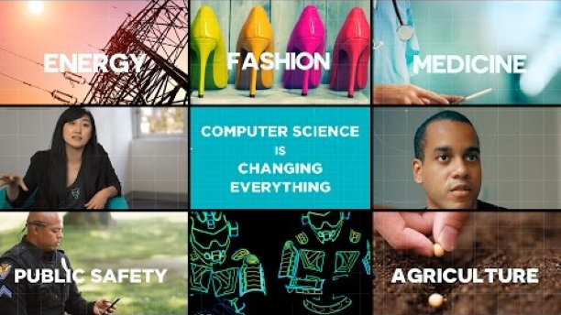  How to use computer system at ESC  - How to sign on  - What to do when something doesn't work  - How to get more printing credit  - How to get a password reset  - Who is responsible if your User ID does something wrong (Don’t tell anyone your password)  - Saving Work (Network Drive, Cloud Storage, USB, etc.)  Year 7 Minimum Skills discussed. First week we should cover  - Network  - Path/Directory Refer to drive letter but advise it can change  - USB Keys Take home work  - Backing Up Work  - Have more than one copy of the file - otherwise the file may be lost  - Saving & Opening Documents  - Username & Password - How they work, etc.  Privacy - e.g. locking your computer when not using, keep password private | Additional Core Tasks  Integration Tasks  EAL Support Tasks  Vocab  - Example Description  Activity  Refer to Integration Task  Extension Tasks  No extension tasks exist for this content
Helpful Teacher Resources | Staff Feedback

Victorian Curriculum Links
Manage, create and communicate interactive ideas, information and projects collaboratively online, taking safety and social contexts into account
(VCDTDI039)
- organising the instructions and files in readiness for the development of a solution, for example applying a file name convention such as author initials, version and date to all data files that are going to be used to create solutions
- devising and applying protocols to manage the collaborative creation of solutions, for example planning to use cloud computing to store common files and establishing virtual meetings that acknowledge time zone differences

