Creating a form in a database

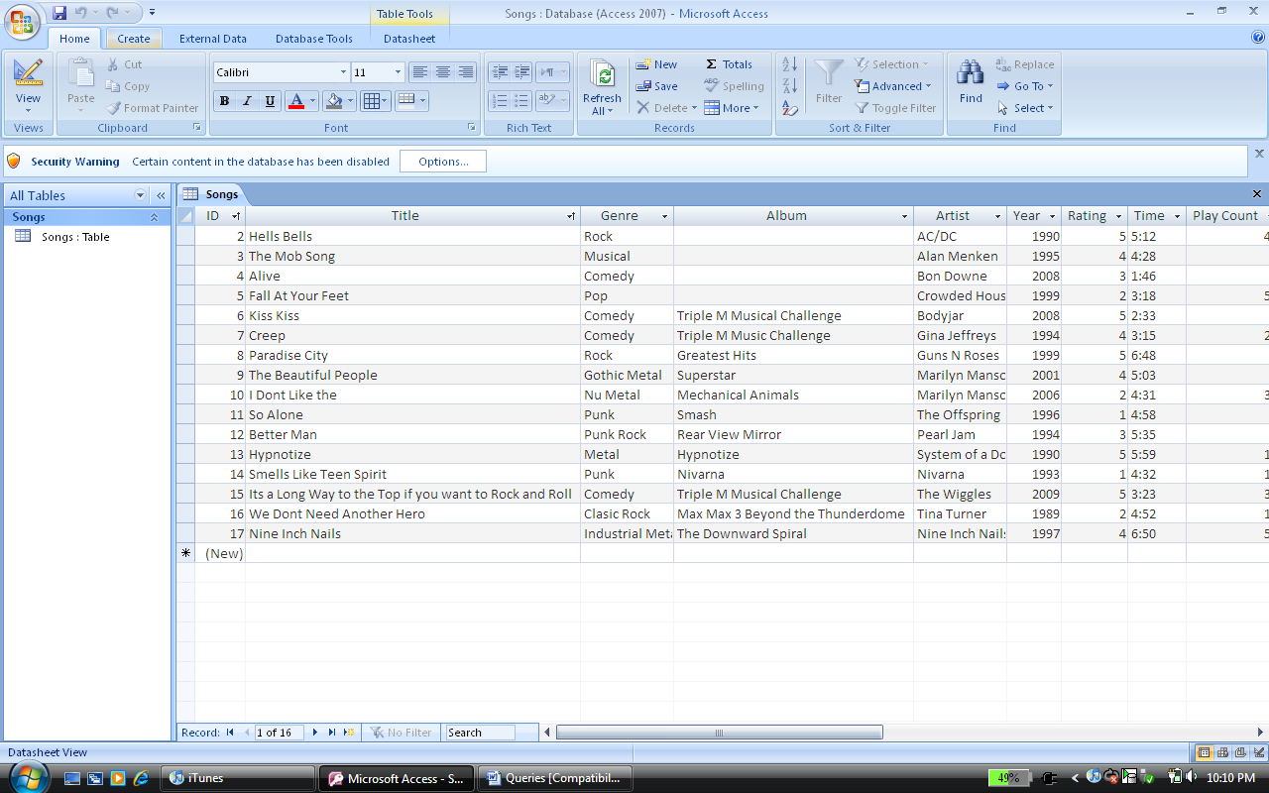
Open the songs table in access and select create

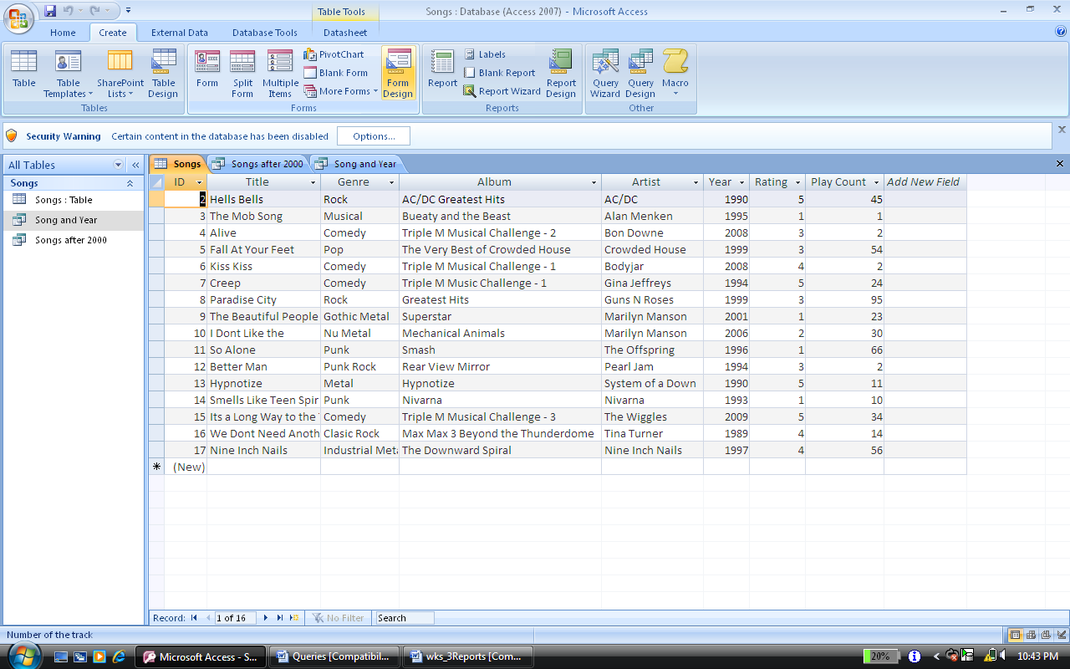
Select FORM DESIGN

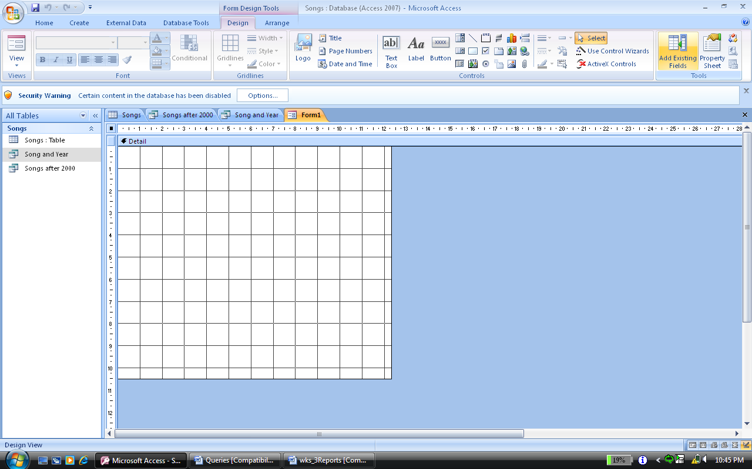
Select Add Existing Fields

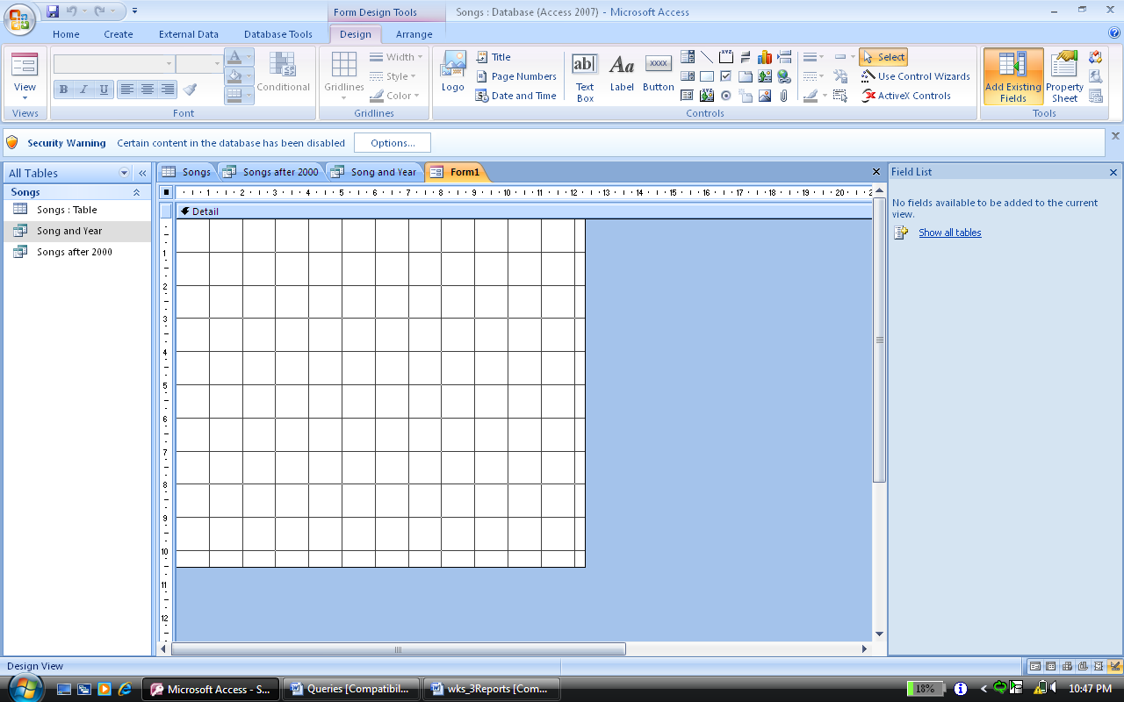
Select Show All Tables – on the left hand side of the screen

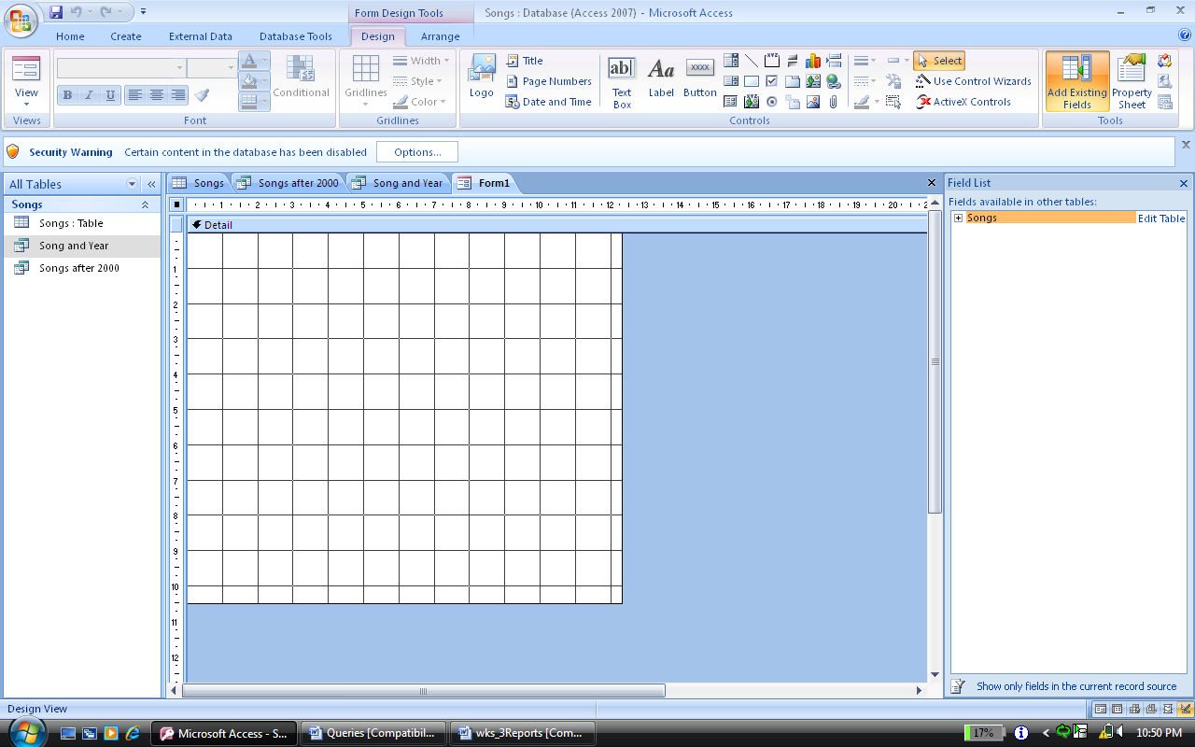
Select the + sign and drag all fields into the form.

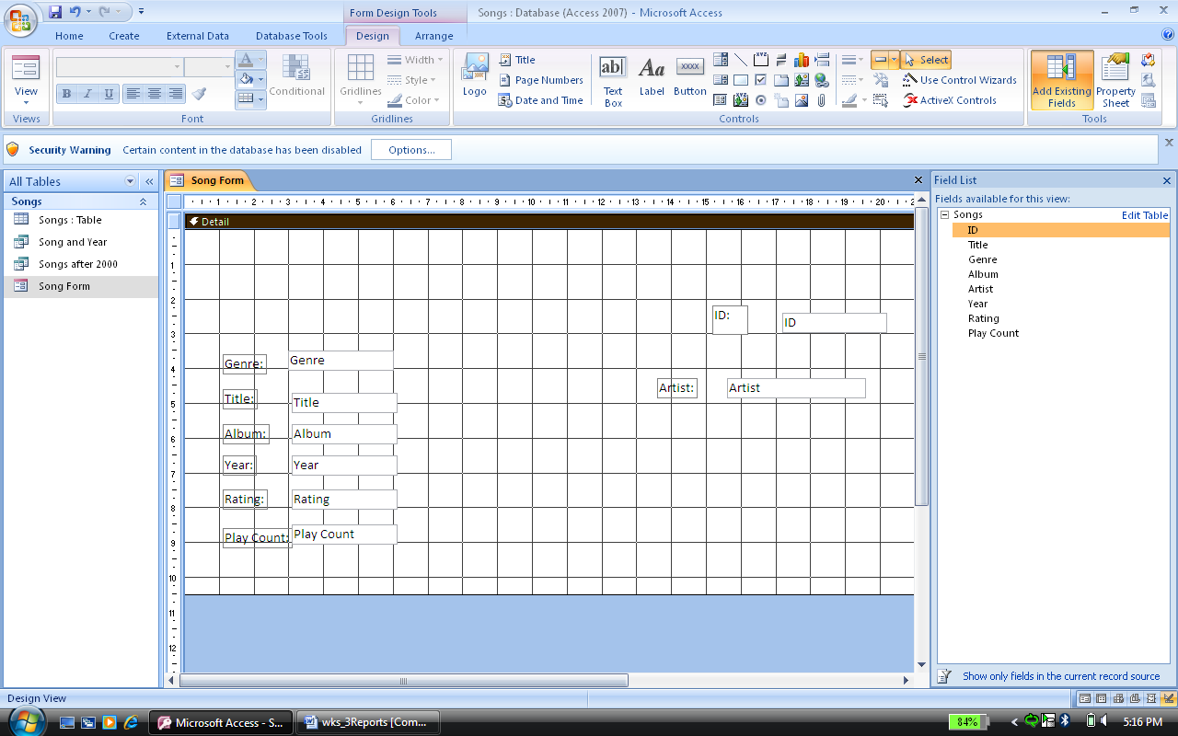
Drag the field names
Drag the fields into the form

To view what the form looks like so far:
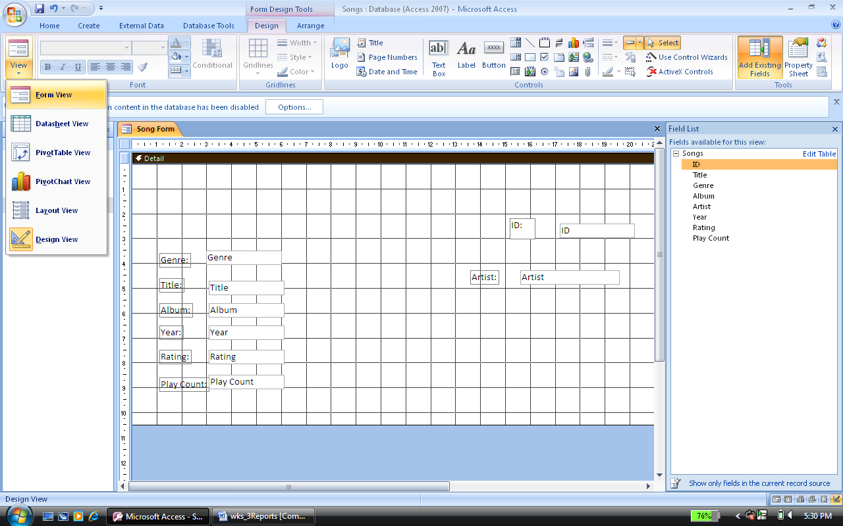
Select VIEW
Select FORM VIEW

This is what you should see:
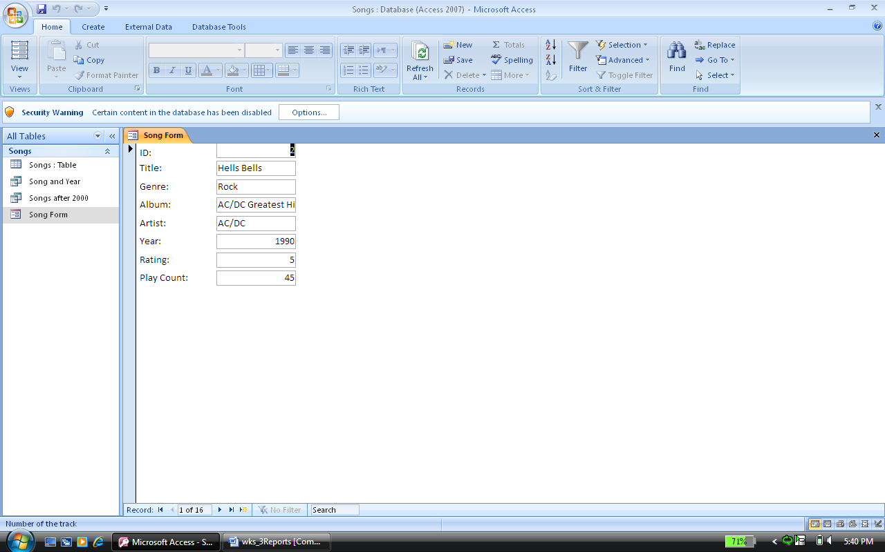

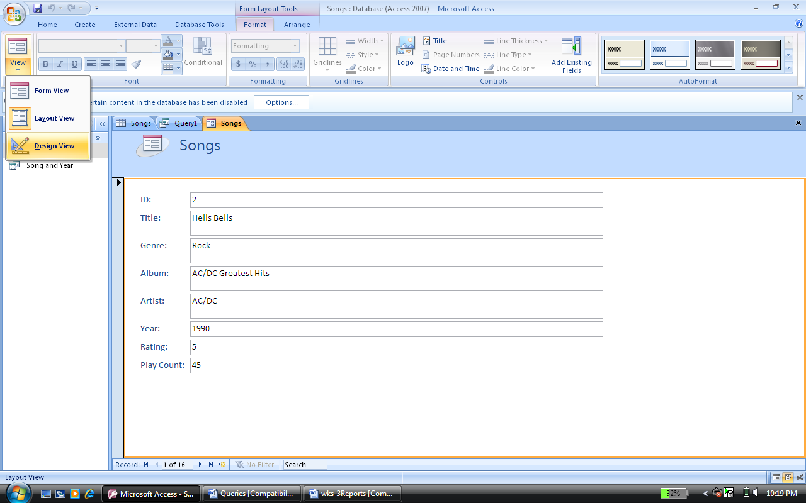
To return to the DESIGN view: (where you can change and design the form)
Select Design View
Select VIEW

Anything you can do in Microsoft Word – you can do in Microsoft Access.
To change the form:

Select ‘Select All’
Select DESIGN tab
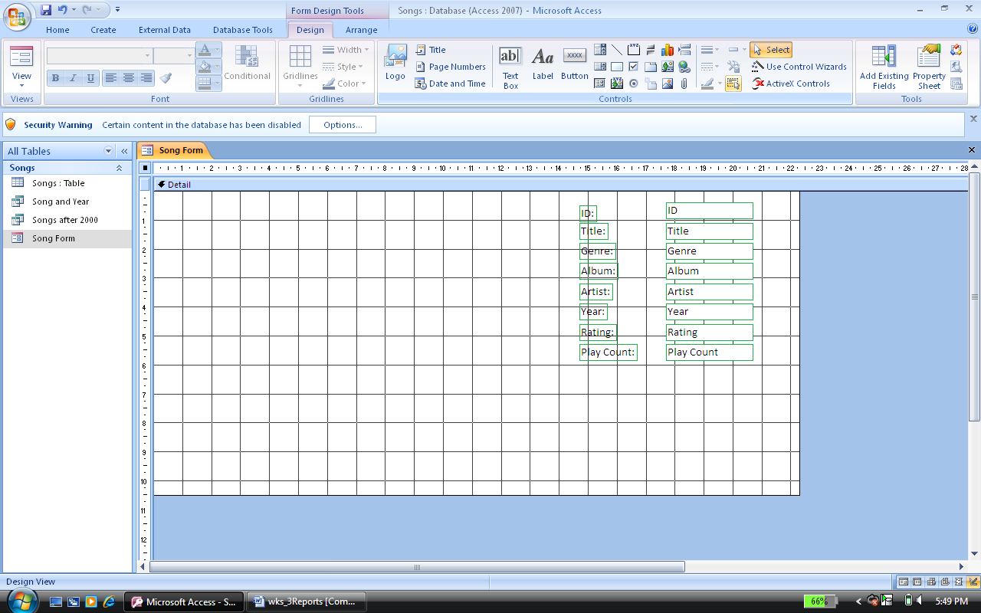
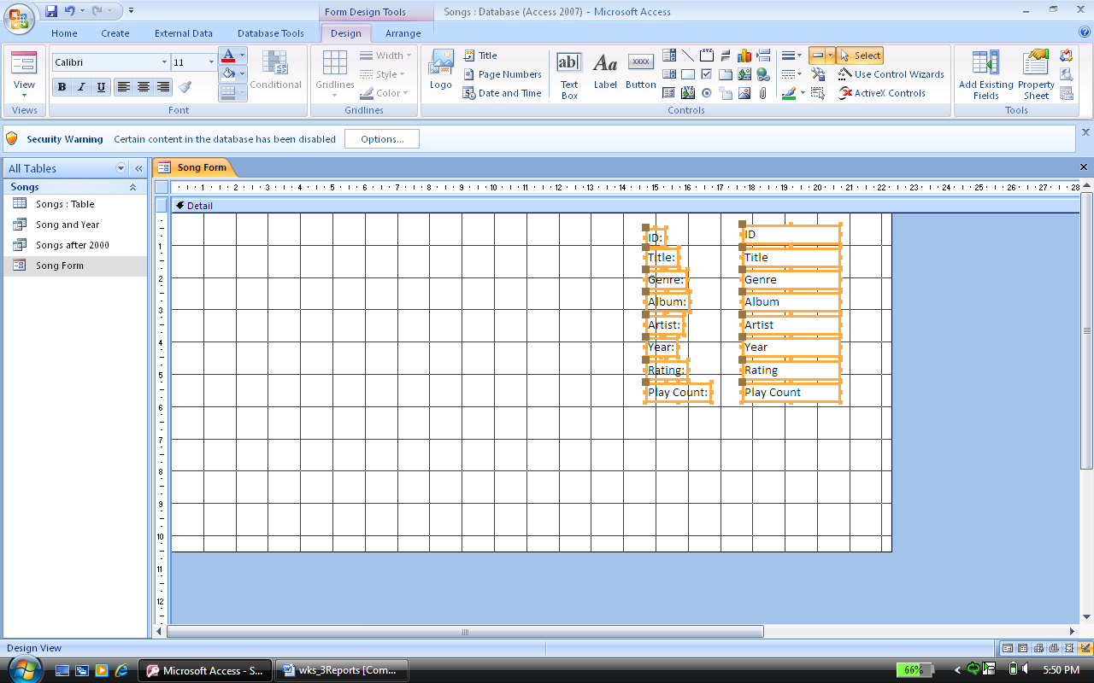
Your screen should look like this – it has all fields selected

Continued over the page

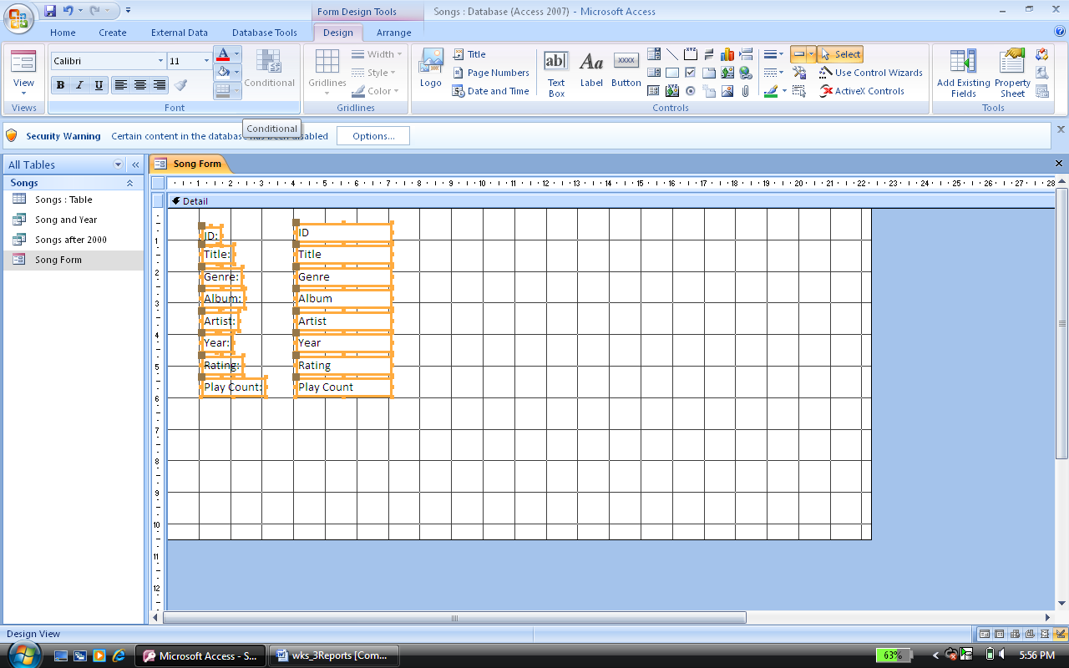
The ‘A’ to change the font colour
The’ bucket’ to change the background in the field

Continued over the page

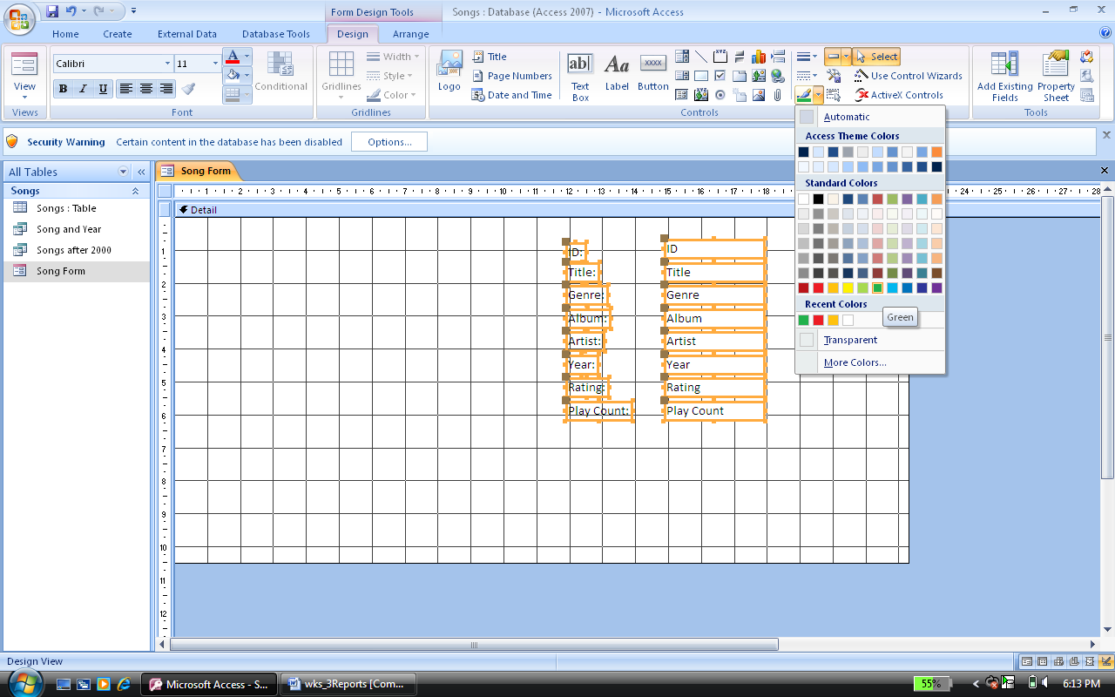
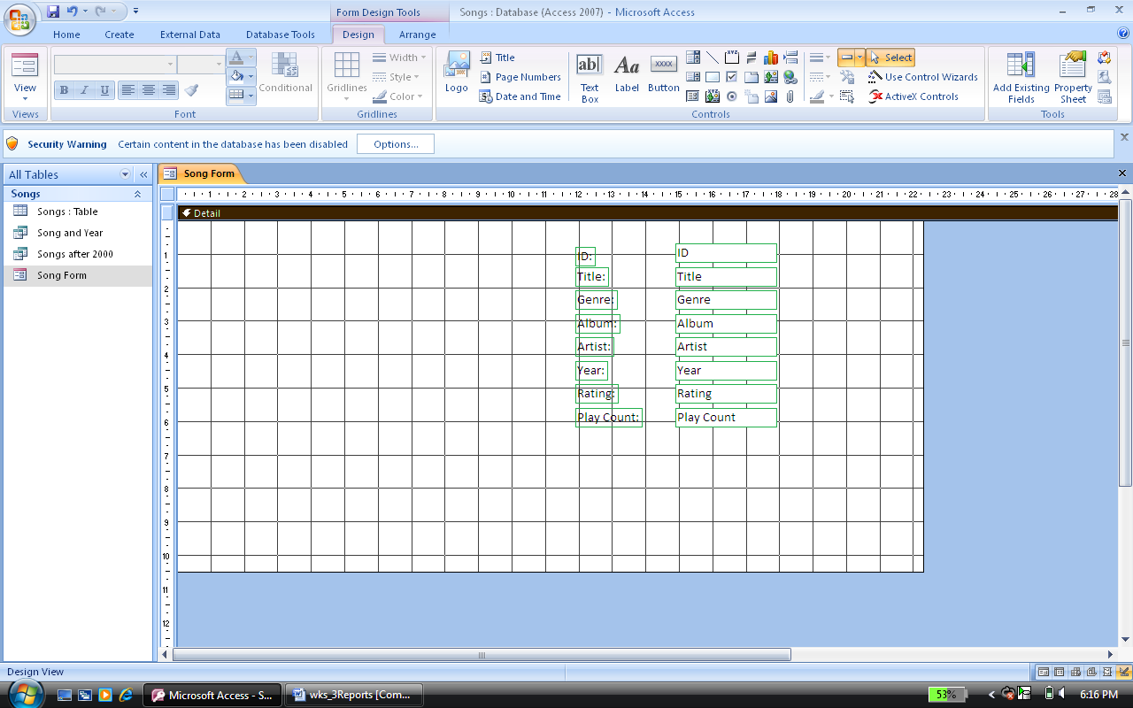
The paintbrush allows you to change the line colour
The colour change is shown below

Continued over the page

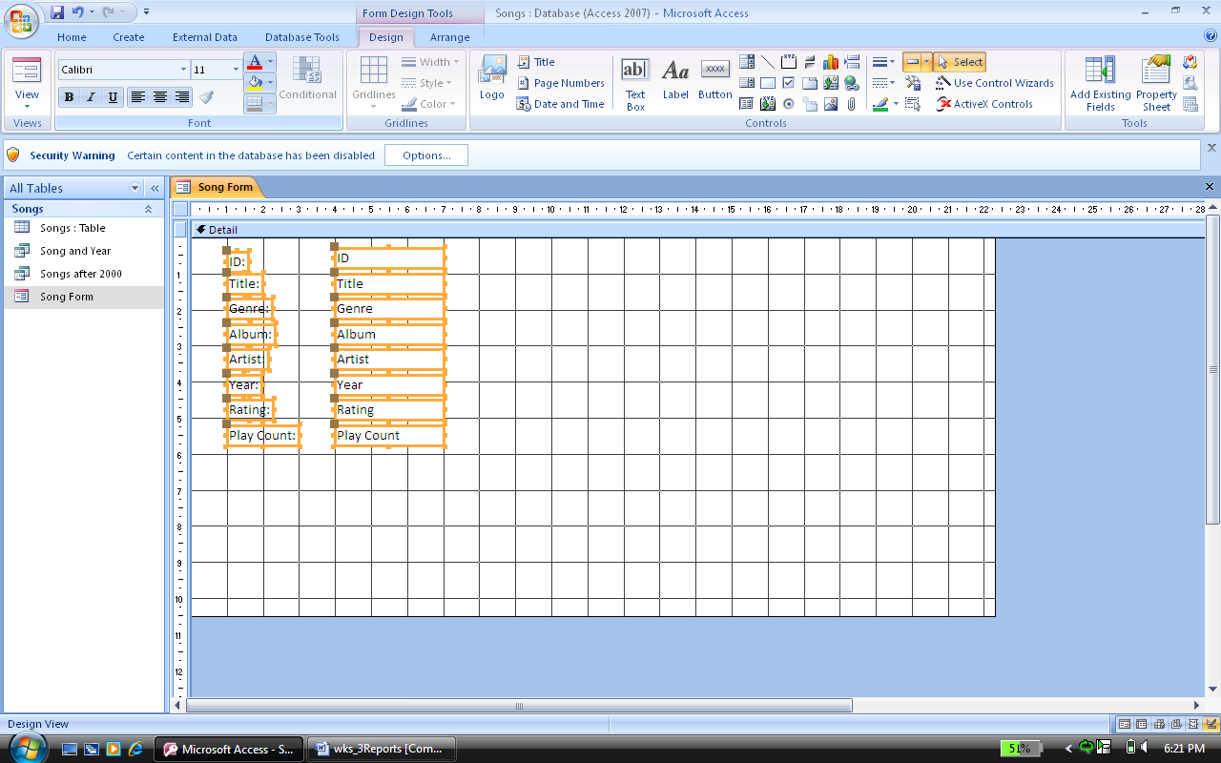

When the field is selected you can change the font size, style and colour

Time to make your own mark on the form: - using the Songs Table
1. Create a form with an appropriate image to represent the form.
2. Find out how to insert the time and date into your form
3. Add in a label for the form (make it appropriate)
4. Change the following in the form:
a. Font colour, background colour of the field, Font size, background colour of the form and change the line colours.

