Creating a report in a database

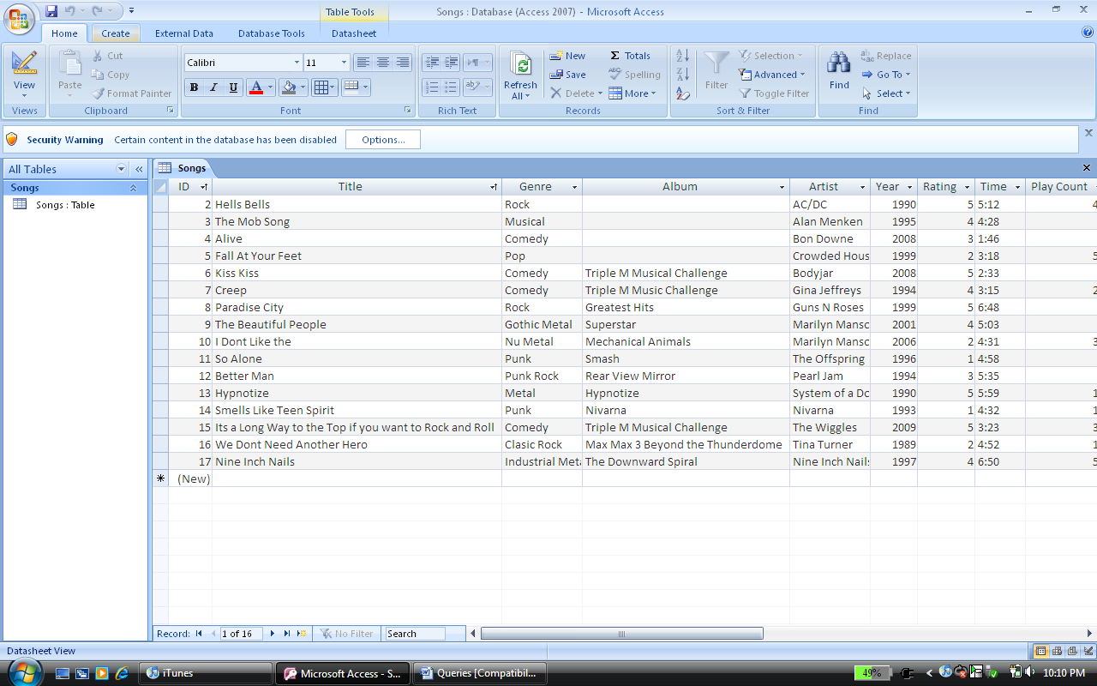
Open the songs table in access and select create

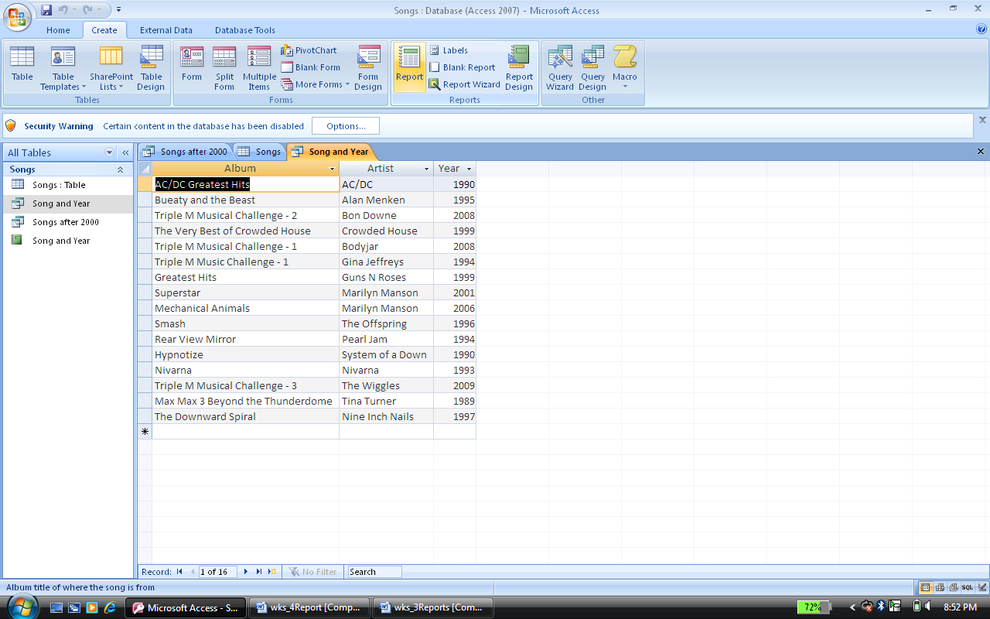

Select Report and it will be instantly created

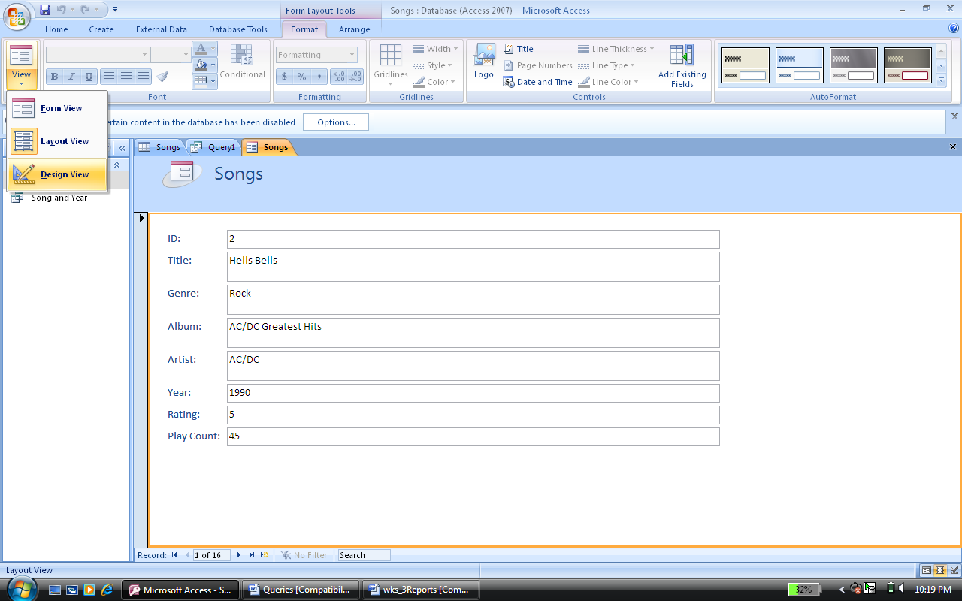
How to change the Report:
Select Design View
Select VIEW

Anything you can do in Microsoft Word – you can do in Microsoft Access.
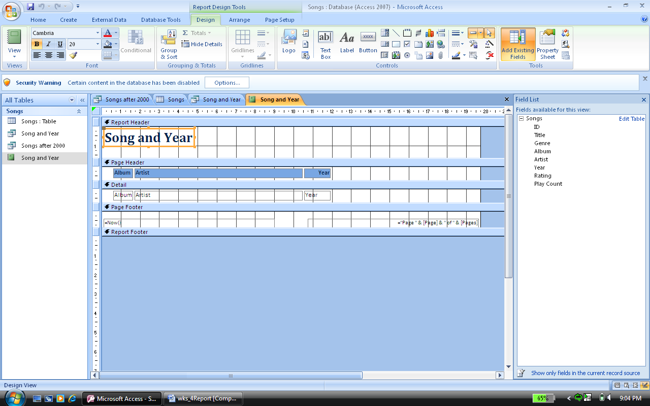
You can change the font size, type.

Allows you to change the font colour
Allows you to change the background colour of the label and text boxes. You can change the background colour of the form by clicking on the background of the form and selecting a colour
Find an appropriate image to include as the logo for the song list.

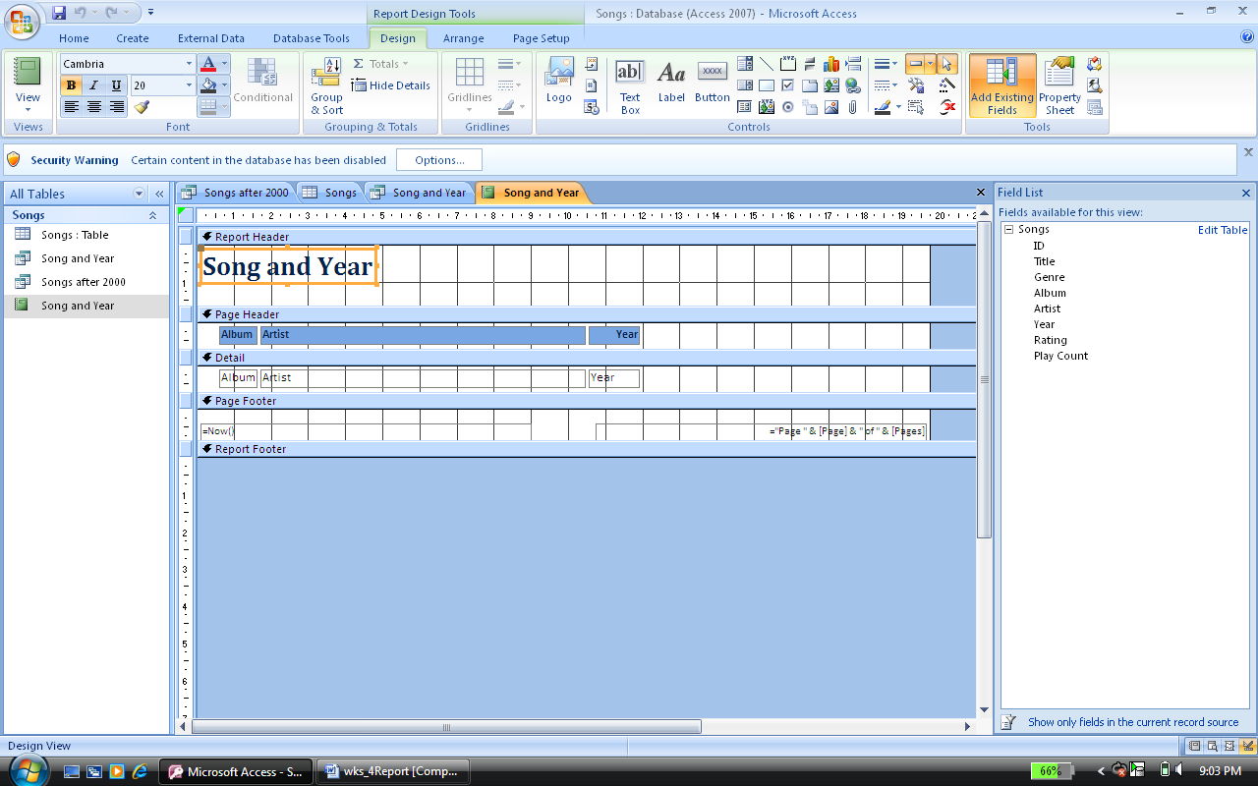

You can add in a text box or a label (label is a heading)
In this box you can change the thickness style, colour and type of line.

Remember to select what you want to change before you change things.
Your task:
To create a report for each query
To create a report for the overall song list
Change the following areas of the report:
- Background colour
- Add in an appropriate logo
- Change the font colour
- Change the font size
- Change the font style
- Different line colours
- Have different line styles

