How to search in Databases

What is a query?
Questions in a database – e.g. looking for a particular song or type or artist.
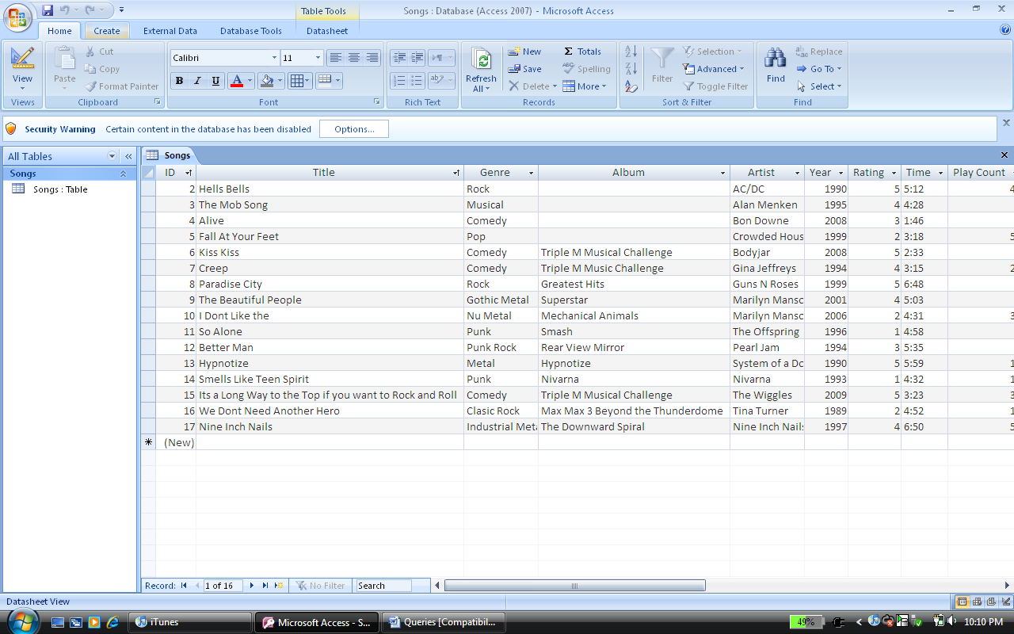
Open the songs table and select create

Now select Query Design at the top of the page on the right hand side of the screen.
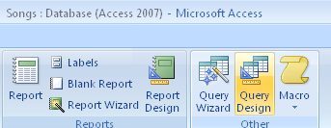
Select the SONG TABLE and select add
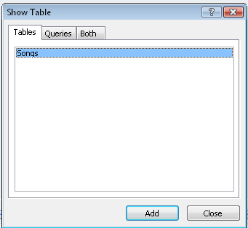

Once the table is added select CLOSE
Add all fields into bottom table by double clicking on each field

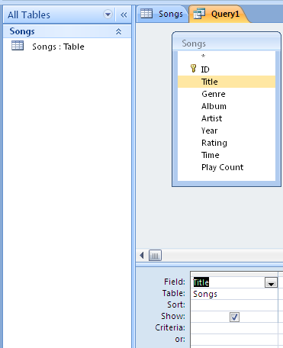

Double click on each field and it will appear below

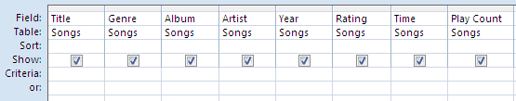
The query you are creating will show all details for the title, genre, album, artist, year, rating, time and play count. It will look like below:

To show the query select run – this will show your query
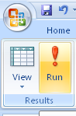

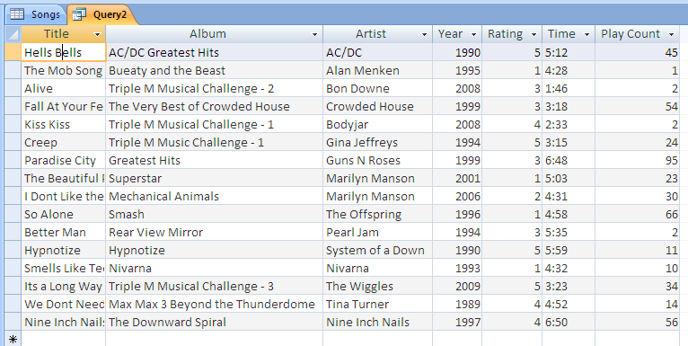
The Song table is the first tab and the query is the second tab: Below is the query you just created.

To go back to the design of the query:
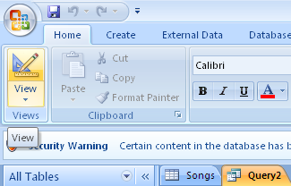

Select the QUERY
Select view

2nd practice of a query:
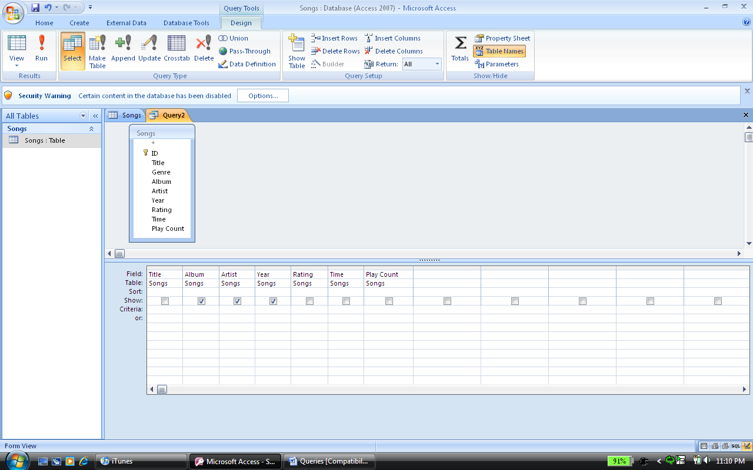
Show: The field selected will appear in the query
Criteria: what specifically you are looking for a list of requirements.
Tick: Means it will appear in the finished query

Create the following queries:
- Show all fields with songs created before 2000
- Play count above 20 and any song past year 2000 – show only album, title and artist
- A query showing on the Title and Album of anything during the year 2000
- Explain why a query would be completed

