Creating a Music Database

Open Access – select Blank Database
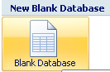

Save the file as Songs List, save into your account browse to find your account.
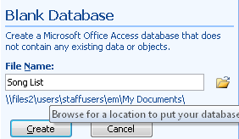

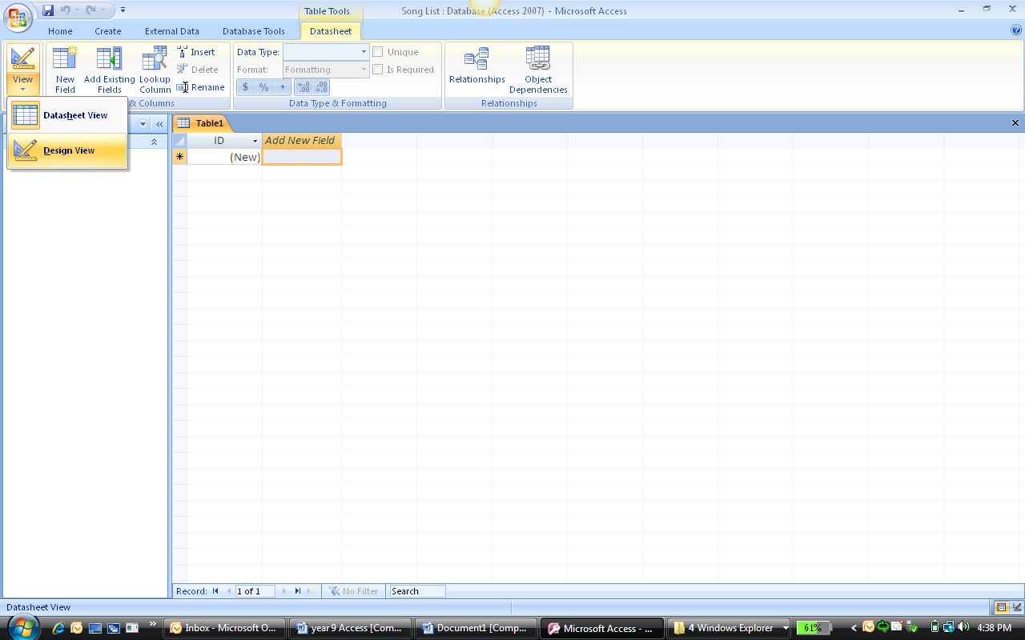
You need to make some field names so click on VIEW
Choose DESIGN VIEW

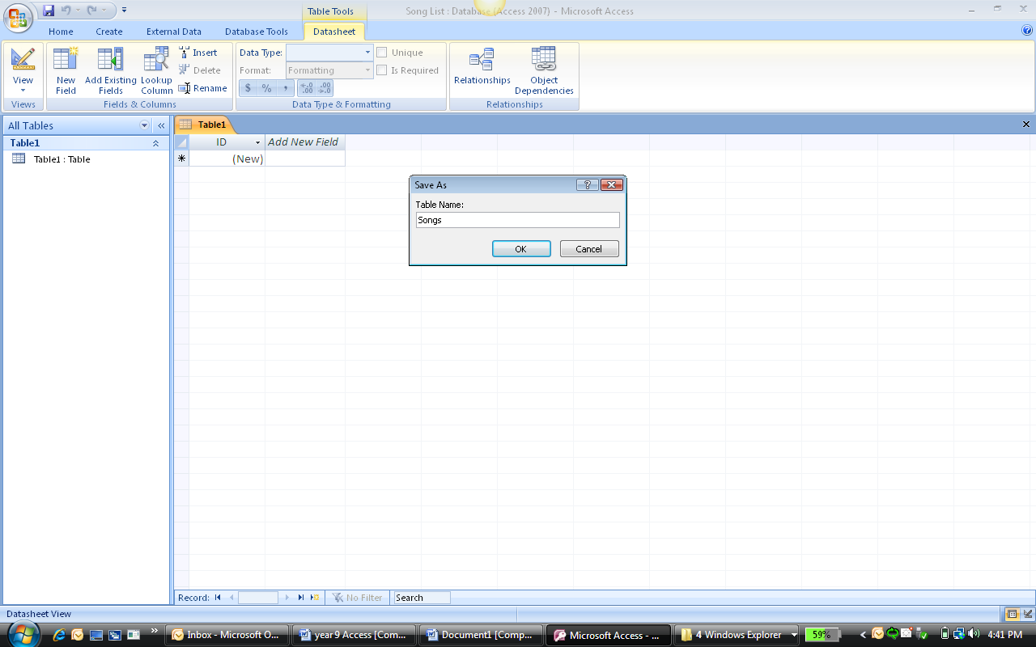
Save the table as SONGS

Below is a list of songs, artists, and other relevant information. Your task is to work out appropriate field names or headings for the information to be put in Access.
You MUST have 6 appropriate field names.
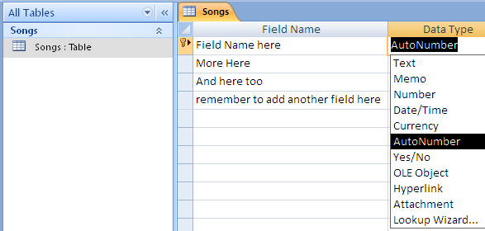

Add your field names. Remember to have one field name per line.
Change data type to suit field names.

Once you have added the field names
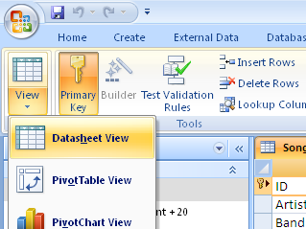

You have created the field names Select VIEW… and then select
Datasheet

Now add the songs to the table
Hells Bells | AC/DC | AC/DC Greatest Hits | Rock | 2000 | 45
So Alone | So Alone | Smash | Punk | 2001 | 35
Creep | Bob Downe | Triple M Music Challenge – 1 | Comedy | 2000 | 67
Teenagers | My Chemical Romance | Black Parade | Alternative | 1999 | 23
Spinning Around | Kylie Minouge | Kylies Greatest Hits | Pop | 1998 | 25
Hit That | The Off Spring | Smash | Alternative | 1995 | 67
Come Undon | Robbie Williams | Very best of Robbie Williams | Pop | 2008 | 89
Bette Man | Pearl Jam | Rear View Mirror | Punk Rock | 2009 | 65
Little Queen of Spades | Eric Clapton | Little Queen of Spades | Blues | 1999 | 43
Population Control | Exile | Exile Radio | Punk | 2009 | 24
I don’t like the… | Marilyn | Mechanical Animals | Nu Metal | 1994 | 57
Only By the Night | Kings of Leon | Only By The Night | Rock | 1996 | 67
One foot wrong | Gina Jeffreys | Beauty and the Beast | Musical | 1999 | 75
Shake It | Metro Station | Seventeen for Ever | Rock | 2002 | 6
Time | Pink Floyd | The Wall | Rock | 2001 | 78
Little Things | Good Charlotte | Good Charlotte Greatest Hits | Alternative | 1996 | 32
Let It Rock | Kevin Rudoph | Let It Rock | Punk | 2003 | 21
Circus | Brittany Spears | Circus | Pop | 1996 | 89
Burn | Jessica Mauboy | Burn | Rock | 1994 | 98
Gotta Be Somebody | Nickleback | Gotta Be Somebody | Pop | 2005 | 32
Tomato In the Rain | Kaiser Cheifs | Off With their Heads | Alternative | 2001 | 56

Once all the songs above are added you need to add another 15 songs to the list with all the detailed information as above.
The assessment task is a cumulative one in which all areas of the database will be assessed. This is what will be assessed:
- Field names and data type in the Table
- Queries
  - Appropriate headings and correct queries
- Reports
  - Ability to produce correct reports with the correct information
- Form
  - Ability to design a form which is appropriate for the audience and has appropriate information in the database.

