Downloading files to use in class from Youtube.

Youtube may be blocked at school – or you may not be able to connect to the Internet when you want to show the file.

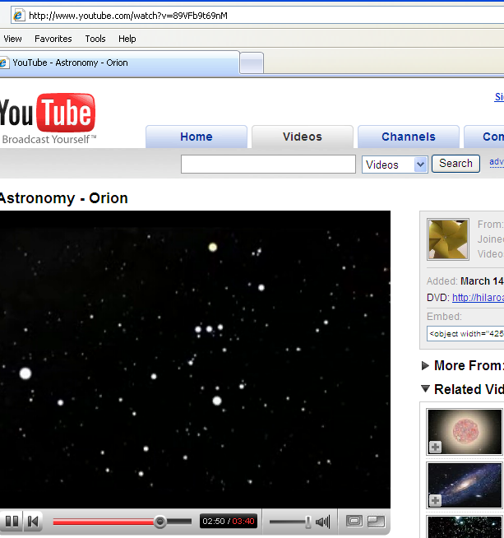
Here’s a solution to save any Youtube file to your computer. It can often get a high quality version. These HQ versions take up more space, use up more of your home broadband allowance and take longer to download.

Find the Youtube video you want.

Copy the URL (address)

Select the address line (it goes blue).
Use Edit + Copy or ^C (ctrl C).

Add a new tab in Internet Explorer and type: http://keepvid.com in the address bar.
(Put this on your Favourites so you never have to type this address again.)


Edit + Paste or ^V (ctrl V) to paste the Youtube address in the green rectangle.
Click button.

Select the link you want – Low-res or HiQuality.

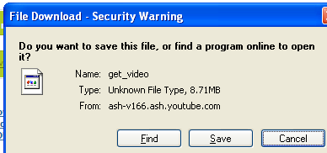
Click .



Navigate to a folder to save the file – it’s best to use subfolders eg Science, Business, English.

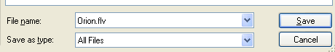

Change name to your guru!!u!
Save using a meaningful filename AND the appropriate file extension eg orion.flv
flv for Low-Res OR mp4 for HiQual
- The extension depends on the quality YOU selected.
The file can be edited/cropped if you want – see ?????????? if you need help doing this.

Keepvid generally ONLY works with Youtube and a limited number of other sites.

If you’re a bit technical there are other solutions for Youtube and lots of other sites which are (once installed) even easier and more automatic:
RealPlayer, CyberFlash, Orbit Downloader and Firefox “Download helper” are other possible ways.
Colin Sutton Monty SC May 2008
oz.sutton@gmail.com

