Year 7 – Information & Communications Technology

Listed overleaf are the menu items that you will make most use of throughout your experience with MS-Word, MS-Publisher & MS-PowerPoint. There is also a brief description to help you remember the main uses of these items. With time, you will become familiar with the shortcut keys and will not necessarily go to each menu every time you need a specific feature.

As you learn these shortcuts, write / type them in the column at the end of each table. Please note that not all menu items have associated shortcuts.

- With experience, you will make more use of other features available throughout these applications.

Good Luck & Have Fun…


Year 7 – Information & Communications Technology
MS-Word Menu Items

FILE | Description | Shortcut???
New | When you start a new document from scratch
Open | To open a file previously created
Save | To update changes to your file
Save As | To save file for the very first time or to rename a file
Page Setup | Modify page margins, orientation, etc. of your page
Print Preview | To view your document as it will print - do this every time before printing
Print | To print your file

EDIT | Description | Shortcut???
Undo | Reverses the last command
Cut | Cut selected object
Copy | Copy selected object
Paste | Paste the cut / copied object

VIEW | Description | Shortcut???
Toolbars | Activates the required toolbar, eg. Standard, Formatting
Header and Footer | To insert headers and footers on each page of your document

INSERT | Description | Shortcut???
Break | Insert a picture (not clip art)
Page Numbers | Inserts the current page number
Date and Time | Inserts the current date and/or time
Footnote | Inserts a footnote within the document
Picture | Inserts images, Clip Art, WordArt

FORMAT | Description | Shortcut???
Font | Formats the font, style, size, color, etc. of the text
Paragraph | Formats indentations and line spacing
Bullets and Numbering | Inserts graphic bullets or sequential numbering/lettering
Borders and Shading | Applies borders and shading to selected text or entire page/s
Columns | Formats text into predefined columns
Tabs | Set tab stops
Drop Cap | Modifies the first letter of the sentence

TOOLS | Description | Shortcut???
Spelling and Grammar | Checks spelling and grammar

TABLE | Description | Shortcut???
Insert | Inserts Table; Rows & Columns to an existing table
Delete | Deletes Table; Rows & columns of an existing table
Merge Cells | Merges cells
Split Cells | Separates cells
Table AutoFormat | Modifies appearance of table
Sort | Sorts text in ascending or descending order

WINDOW | Description | Shortcut???
When clicked | Identifies which documents are opened and active with a tick

What you need to do:

- Copy the file from the network: Student Shared \ Year 7 IT \ ICT Skills \ Xsaction.doc

- Edit the document using the features listed below.

- Use a different font type, size and color for each of the paragraphs
- XSACTION and Camping Tours (the heading) should be in Word Art

- Insert a page border
- Insert a header with the current date
- Insert a footer with your full name
- Both the header and the footer must be size 10 and centered

- Insert an image that reflects the theme of the letter
- Format the image to allow text wrapping
- Place numbered bullets or dot bullets on all the activities, ie. Abseiling, Rock Climbing, etc.
- Divide the paragraph that starts with “Imagine being paid for” into 2 columns
- Divide the paragraph that starts with “We urgently need” into 3 columns
- After all the above features are included, ensure that the document fits on one page.

- Save your document in your Year 7 ICT\Word folder.

- Print your document.

- Hand your document to your teacher.

Please Note: If you finish early, go through the Menu Items table and complete the shortcuts.

Year 7 – Information & Communications Technology
MS-PowerPoint Menu Items

FILE | Description | Shortcut ?
New | When you start a new document from scratch
Open | To open a file previously created
Save | To update changes to your file
Save As | To save file for the very first time or to rename a file
Print | To print your presentation

EDIT | Description | Shortcut ?
Undo | Reverses the last command
Cut | Cut selected object
Copy | Copy selected object
Paste | Paste the cut / copied object
Delete Slide | Deletes the current slide

VIEW | Description | Shortcut ?
Normal | Displays “slide” & “notes” pages” (mini)
Slide Sorter | Displays all slides in miniature size – click and drag slides to rearrange the order
Notes Page | Displays the slide with the notes page on a full sized page
Slide Show | Activates the slideshow
Master-Slide Master | Exposes the background design of the slide – can be edited
Black & White | Displays the slides in black and white – for printing purposes, to see what it would look like printed with a black and white printer
Toolbars | Activates the required toolbar, eg. Standard, Formatting

INSERT | Description | Shortcut ?
New Slide | Adds a new slide
Duplicate Slide | Copies a slide
Picture – Clip Art, From File, Autoshapes, Organisation Chart, Word Art | Inserts images, shapes, hierarchy charts, WordArt
Text Box | Inserts a text box
Movies & Sounds – From Gallery or File | Inserts movies and sounds
Chart | Inserts a chart once you have entered data into a spreadsheet
Table | Inserts a table with columns and rows

FORMAT | Description | Shortcut ?
Font | Formats the font, style, size, color, etc. of the text
Bullets and Numbering | Inserts graphic bullets or sequential numbering/lettering
Background | Background design of individual slides or all slides
Apply Design Template | Background template for all slides

TOOLS | Description | Shortcut ?
Spelling | Checks spelling

SLIDE SHOW | Description | Shortcut ?
Custom Animation | Order & timing and effects of objects on slides
Slide Transition | Effect, timing and sound of each slide transition

WINDOW | Description | Shortcut ?
When clicked | Identifies which documents are opened and active with a tick

What you need to do:

- Create a presentation for a group of kindergarten children.

You need to represent the digits from 0 – 9.

Each slide must be dedicated to one digit. There must also be a heading slide.

You must include the right number of images for each slide. For example, for the digit 3, you need to include 3 images; for the digit 5 you need to include 5 images.

The following features must be incorporated:

- Master Slide Template
- Custom Animation for each object on the slide
- Slide Transitions for each slide – either the same or various transitions
- Automatic Timing – either the same or various times

- Save your document in your Year 7 ICT\PP folder.

- Print your document with 4 slides to a page.

- Hand your document to your teacher.

Please Note: If you finish early, go through the Menu Items table and complete the shortcuts.
Year 7 – Information & Communications Technology
MS-Publisher Menu Items

FILE | Description | Shortcut???
New | When you start a new document from scratch
Open | To open a file previously created
Save | To update changes to your file
Save As | To save file for the very first time or to rename a file
Page Setup | Modify page margins, orientation, etc. of your page
Print | To print your file

EDIT | Description | Shortcut???
Undo | Reverses the last command
Cut | Cut selected object
Copy | Copy selected object
Paste | Paste the cut / copied object
Delete Page | Deletes the current page

VIEW | Description | Shortcut???
Go To Page | Takes you to a specific page number
Go To Background | Takes you to the background of the document to apply a consistent template/design to each page (left and right)
Hide/Show Boundaries and Guides | Makes boundaries and guides visible/hidden
Toolbars | Activates the required toolbar, eg. Standard, Formatting
Rulers | Shows the ruler guides to help with measurement

INSERT | Description | Shortcut???
Picture | Inserts images, Clip Art, Drawing
Object | Inserts special features, ie. Equation, Chart
Date and Time | Inserts the current date and/or time
Page Numbers | Inserts the current page number
Page | Inserts a new page/s into the document

FORMAT | Description | Shortcut???
Fill Color | Applies a color/pattern/gradient to a selected shape
Line/border Style | Applies line and border styles to a selected shape
Shadow | Places a shadow on a selected shape

TOOLS | Description | Shortcut???
Spelling | Checks spelling
Snap to Ruler Marks | Moves an object to ruler marks
Snap to Guides | Moves an object to guides
Snap to Objects | Moves an object to other objects

TABLE | Description | Shortcut???
Insert Rows or Columns | Inserts Rows & Columns to an existing table
Delete Rows or Columns | Deletes Rows & Columns from an existing table
Merge Cells | Merges cells
Cell Diagonals | Separates cells in a diagonal slice
Table AutoFormat | Modifies appearance of table
Grow to Fit Text | Allows the cell to grow as text is being typed in

ARRANGE | Description | Shortcut???
Bring to Front | Brings the selected object in front of all other objects
Send to Back | Sends the selected object behind all other objects
Bring Forward | Brings the selected object in front of the next object
Send Backward | Sends the selected object behind the previous object
Align Objects | Aligns the sides of each object
Rotate or Flip | Allows object to be flipped or rotated

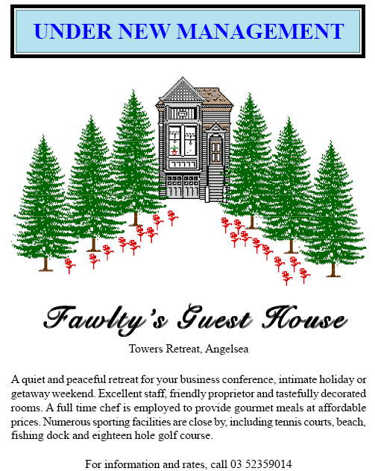

What you need to do:

- Create the publication on the right. You may use your own style of house and trees.

- Ensure you change the font type, size and colour.
- Use the entire page.
- Add two extra features of our choice.

Save your document in your Year 7 ICT\Publisher folder.

- Print your document.

- Hand your document to your teacher.

- If you finish early, go through the Menu Items table and complete the shortcuts.

(Resource: Bowden, G., Maguire, K. Practice IT – Book 2, 2nd Edition,
Cambridge University Press)

