HYPERLINKS

- Select the shape to receive the hyperlink
- This will bring up the Action Settings menu. Select “Hyperlink to” and choose which slide to hyperlink to.

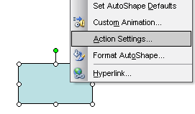
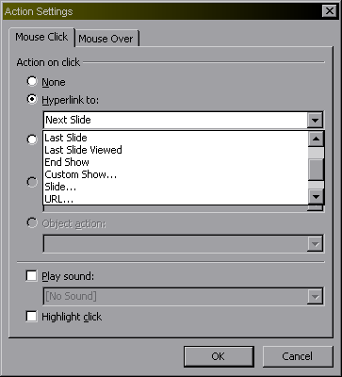

ACTION BUTTONS
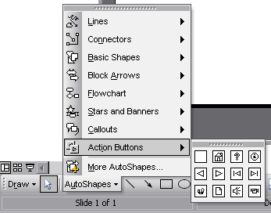
- Go to drawing toolbar.
- Go to autoshapes menu.
- Select the action button you want to use.

GROUPING/UNGROUPING PICTURES

1. Select the picture you want to ungroup. Right click and select grouping. Click ungroup – this will ungroup your picture.

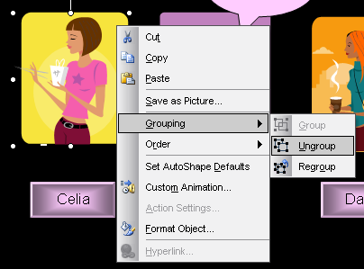
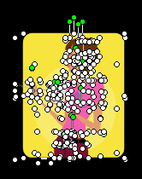

2. Now click and drag away the parts of the picture you don’t want.
3. Once done, group the picture again so that you can move the whole picture around.
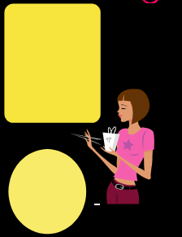
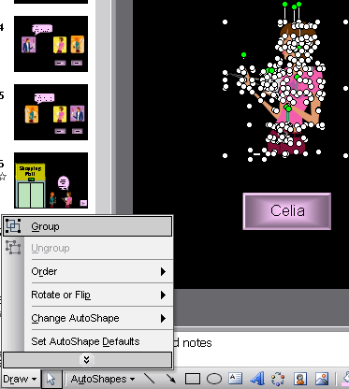
FLIPPING/ROTATING A PICTURE

1. Select the picture.

2. Go to the draw menu, select rotate or flip. Choose which way you want to rotate or flip your picture. This picture has been flipped horizontally.



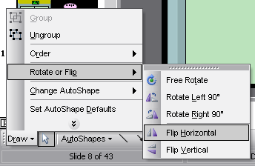

ORDERING THE DIFFERENT PARTS OF YOUR PICTURE

1. Select the part of your picture you want to move either forwards or backwards. Right click and select order. Choose where to place the select part. In this picture I am moving the coffee table to the front of the girls.

