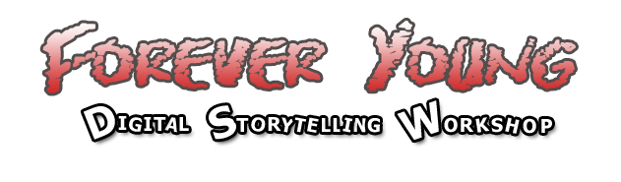
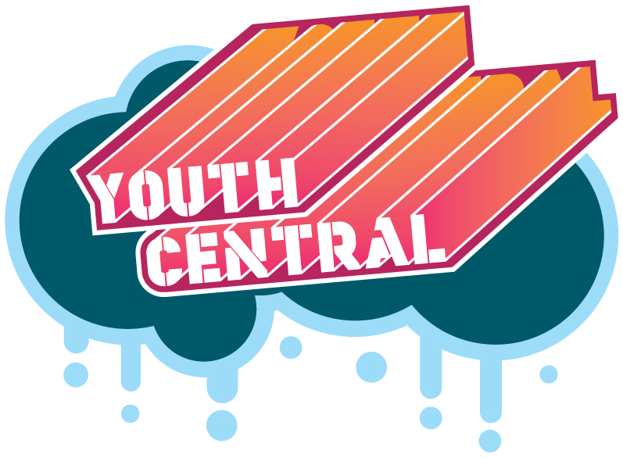
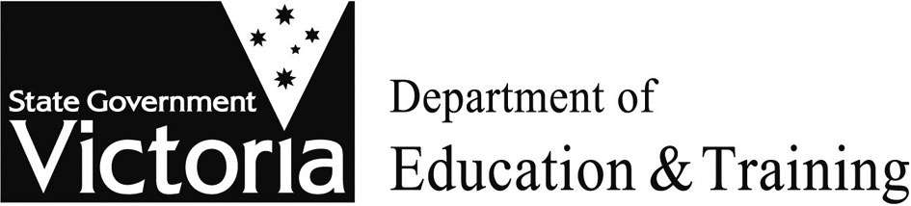



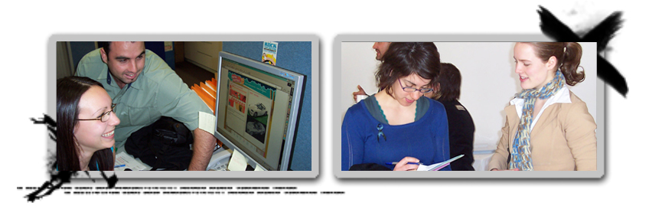
This challenging and inspiring workshop gives you the opportunity to present your story in an exciting format using images and sound called a ‘digital story’.

Your story will be personal and written from your own point of view. It could be about school, friends, family, a treasured memory, the best day of your life, your greatest fear, your hopes for the future…..

Just for 12-18 year olds, you will develop your own 1-2 minute digital story on a topic of your choice. You get to choose the images, the music and write the script. Once your story is ready to go you will then learn to use all the technology that will assist in editing your story and producing the final product.



Dates  Thurs 23rd Nov and Friday 24th Nov.  Location  BLX (Ballarat Learning Exchange)  Cost  FREE! | What else do I get?  The course is catered for.  You will also have access to state of the art equipment and editing studio.

The completed stories will be presented on Fri 7th December at BLX, and will also be presented through the www.youthcentral.com.au <http://www.youthcentral.com.au/> website.
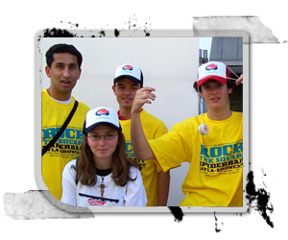


Simply tell us a about yourself and your story by Tuesday 14th November. You can choose to do this as a written piece, as a picture story board, or as a short film …and don’t forget to include your contact details! 10 lucky people will be selected to attend the workshop.

Vivienne Browne  youthcentral Website Initiative  Office for Youth, DVC  Level 5 Nauru House Collins Street  Melbourne Vic 3001  email: vivienne.browne@dvc.vic.gov.au | Jillian Brown  Innovations Branch, DE&T  L 2, 33 St Andrews Place  East Melbourne 3002  t. 03 9637 2163  email: brown.jillian.k@edumail.vic.gov.au
This workshop is delivered in partnership with the Department of Education & Training and the Department of Victorian Communities.

