Visualising data from a Big Data Set using Charte.ca:
How healthcare spending affects life expectancy in our part of the world
This is one of the questions we can find data about on the World Bank database.

Download Data from the World Bank
- Open the World Bank data portal: it lives in http://data.WorldBank.org
- Select Data Catalog from the menu on the top right.
- In the List of datasets click on “World Development Indicators”
(it should be near the top of the Most Popular tab)
- Click on the data button
Now you can select what data you want to see from which countries for what period of time.
- Expand the Country panel
- Click on the filter and select East Asia & Pacific
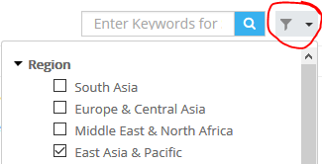
- Click the filter icon again to close the drop down
- In the filtered list below, click on the next to each of the following countries:
Australia, China, Indonesia, Japan, Malaysia, New Zealand, Papua New Guinea, Singapore, Thailand, and two other countries of your own choice from anywhere in the world – 11 in total (NOTE: there is more data available for larger countries than for smaller ones).
- Click on the Series panel. Now you’ll see a long list of data series you can export. We’ll need a few of them.
- First we are interested in healthcare expenditure so type “Health” in the little search box on the top of the list and click and select the “Health expenditure, total (% GDP)” dataset.
- To see how healthcare expenditure affects the life expectancy we need to add “Life Expectancy at Birth, total (years)” data set to the data. Type “expectancy” to search for that one.
- Last one: search for “Population”, Click on “P” to find “Population, total”.
We now have 3 datasets selected on the Series panel
- Click on Selected and drag Population to the top. Your selection should now look like this:
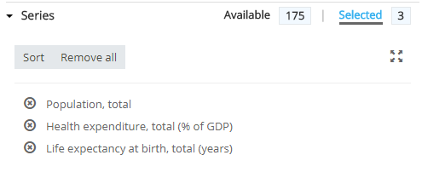
- Expand the Time panel to select the years we are interested in.
- To keep things simple, select the years since 2000 and here is a quick way:
- Click on View Recent Years – 20
- Deselect the years prior to 2000
- Click on the Preview panel on the right
We need to arrange the series in rows and columns that will work for import into charte.ca
- Click on the Layout tab and expand the Orientation panel
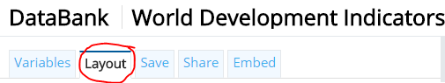
- Click on Custom
- Select the Column, Row or Page as shown below and click Apply Changes
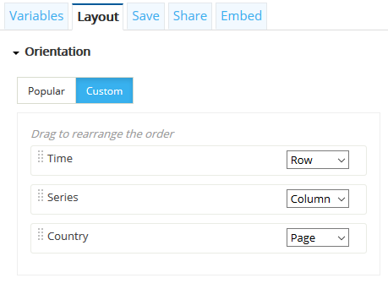
(feel free to switch these around to see what happens to the data in the preview, but return to these settings before exporting.)

Your Preview should look like this:
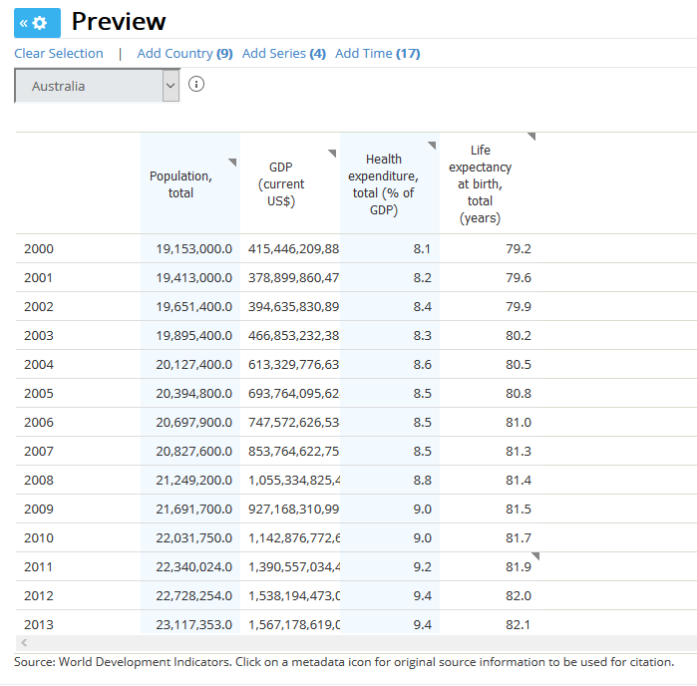
We now need to download the data
- Now click on Download Options to Export the data
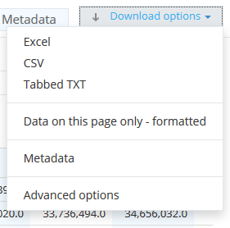

- We have a number of options for the format. Select Excel and Save File.
- Name the file “Health_Expendature_vs_Life_Expectancy.xlsx” and save it in Computing -> U2O2 Visualisations so you remember what it is.
- Open the file.
The file needs some cleaning up before importing to Charte.ca
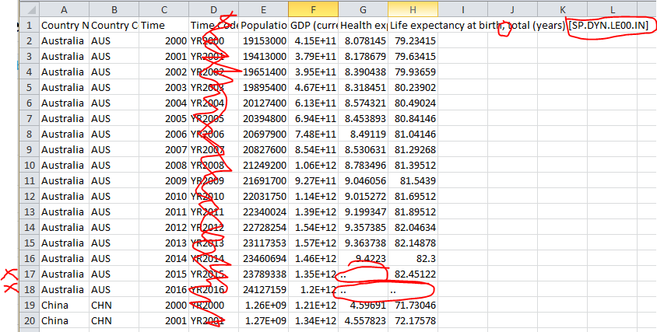
- Delete Column D
- Use a filter or sort to check every column for non-numeric values.
The “..” indicate missing data. They are not numbers. They will cause Charte.ca to crash.
Remove the entire row where you find “..”Health E
- Edit the column headings to remove punctuation as follows:
Original heading | New heading
Time | Year
Population, total [SP.POP.TOTL] | Population - total
GDP (current US$) [NY.GDP.MKTP.CD] | GDP (current US$)
Health expenditure, total (% of GDP) [SH.XPD.TOTL.ZS] | Health expenditure - total
Life expectancy at birth, total (years) [SP.DYN.LE00.IN] | Life expectancy at birth - total

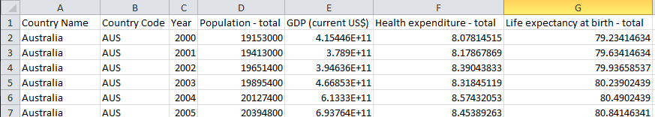

- Select all of the data from A1 (the first heading) right down to the last row of data ready to copy it shortly…
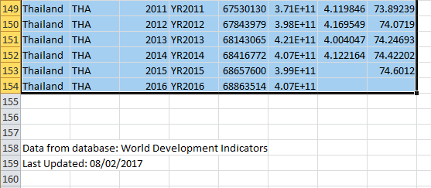

Upload Data to Charte.ca
Start a new chart
- Open Firefox OR Chrome
- Go to https://editor.charte.ca
- Click (top right) and log in with the personal account of your choosing
- Click on Create Chart 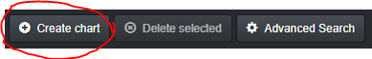
- Type "Health Expenditure vs Life Expectancy" as your chart title and click XY (Scatter, Bubble, Motion)
- Charte.ca shows you a default chart data. We want to replace that. It is possible to paste data from Excel, but we want to import our .csv file instead, Scroll down past all of the data and click the Import button below.
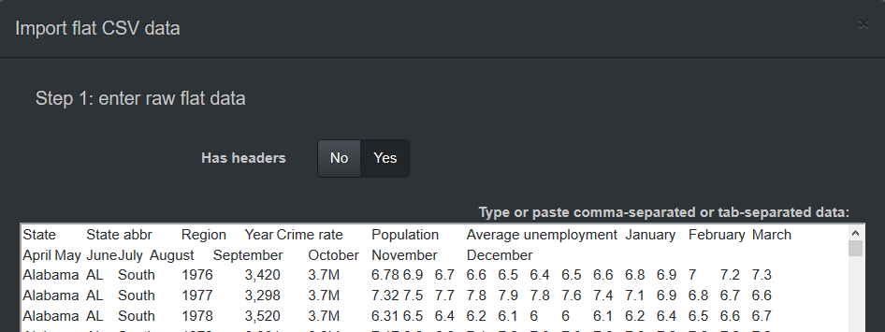
- Click in the data area, type Ctrl+A to Select All and then press delete to clear out all of the data
- In Excel, press Crtl+C to copy the data you have selected
- Back in Charte.ca, click in the data box and type Ctrl+V for Paste
- Click Next
- Specify the data for the chart as shown below. (If you can’t choose the correct options for X, Y and Z you have not correctly formatted your data as described above.)
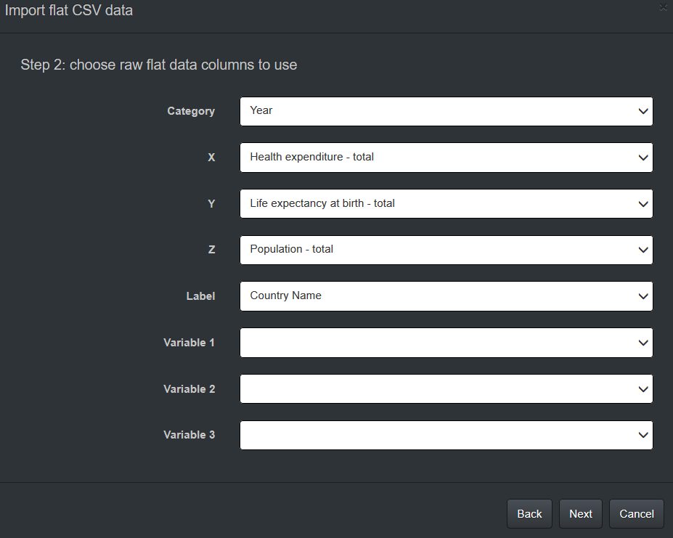
- Skip through the next couple of dialog boxes by clicking Next, Next, Done.
Now your motion chart will appear!!
You have just a few more changes to make
- Click on the Data Panel header to close it
- Click on the Title / Subtitle panel to open it
- Edit the title to “Health Expenditure vs Life Expectancy”
- Edit the subtitle to “Circle size shows state population”
- Click on Categories panel and move the Position to Right
- Close the panels and return to the main menu.
- Click on Save
- Click on Export and save as “Health Expenditure vs Life Expectancy.svg” in your folder.

