Section A: Multiple choice questions

Question 1

What is the Function Key shortcut to run a Visual Basic program?
- F1
- F5
- F8
- F12

Question 2

A student makes a button in Visual Basic. The button will clear a text box when clicked. The student names the button “btnClear” and the button displays the word “Clear” on it. Which 2 Properties of the button has the student changed?
- Visible and Name
- Tag and Text
- Tag and Name
- Name and Text

Question 3

Data visualisation can be evaluated in terms of efficiency and effectiveness. Which factors describe efficiency?
- Cost, time, effort
- Effort, time, quality
- Clarity, effort, relevance
- Quality, timeliness, accuracy

Question 4

The main purpose of data visualisation is to
- increase the time taken to comprehend the data.
- reduce the effort required to analyse the information.
- reduce the comprehension and effectiveness of the information.
- increase the manipulation of the data set so it is unrecognisable.

Question 5

A constraint on a solution can be described as
- a reserved word.
- a dataset found in programing languages.
- a phase of the problem solving methodology.
- a limiting factor that influences the nature of the solution.

Question 6

As part of evaluating a solution, it is important to gather
- feedback from the client about how well the solution meets their requirements.
- the scope of the solution, as well as how the users will benefit.
- notes for the developer to show what the solution will look like.
- documentation allowing users to interact with the solution.

Question 7

The purpose of analysis is to
- show how the data is structured using data dictionaries.
- evaluate the solution’s success once it has been implemented.
- ensure that it has been successful and met the user’s requirement.
- establish the needs of the organisation involved.

Question 8

Typically, a test plan states the type of tests used, identifies the test data to be used and states the:
- name of the file used.
- expected and actual results.
- category of range checking used.
- information processing steps used.

Use the information below to assist in answering questions 9 and 10.

Anushka recently completed a registration form online to sign up to a social networking site. She entered the details into the form as shown below.

She checked to see if all the details were accurate before she submitted the form – which they were!

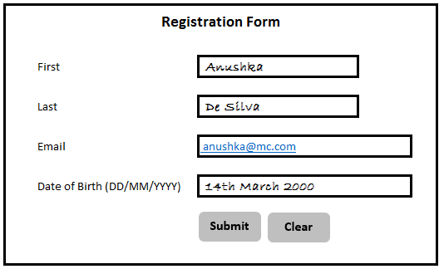

Question 9

Explain the factor that is affecting the integrity of data that Anushka is submitting
- accuracy
- correctness
- completeness
- reasonableness

Question 10

By including a clear button to clear the details if required, the characteristic of effective user interfaces that is being improved is:
- visibility
- legibility
- tolerance
- accessibility

Question 11

A programmer is creating a variable to store part numbers, for example A343.6. What would be the most appropriate data type for this variable?
- Floating point
- String
- Integer
- Boolean

Question 12

Which design tool would be most appropriate to use to plan the appearance of a form within a database?
- Data Dictionary
- Input process output chart
- Entity Relationship diagram
- Mock up

Question 13

Which of the following is the most appropriate name for a form for entering member information?
- members form
- form members
- members_form
- frmMembers

Question 14

Which statement is accurate regarding primary keys:
- A primary must be the first field in a table.
- A primary key is unique within its table.
- A primary key must be created using auto numbering.
- A primary key must not link to any other tables.

Question 15

Which of the following is an example of a non-functional requirement?
- The solution must be able to record orders.
- The solution must be able to calculate costs.
- The solution must be easy to use.
- The solution must print invoices.

Question 16

Primary sources of data include:
- Surveys, questionnaires and interviews.
- Questionnaires, websites and interviews.
- Surveys, newspapers and books.
- Questionnaires, newspapers and interviews.

Question 17

Problem-solving methodology consists of:
- Analysis, design, development and evaluation.
- Analysis, design, development and implementation.
- Analysis, documentation, development and implementation.
- Analysis, documentation, development and evaluation.
Use the following screenshot to answer Questions 18, 19 and 20

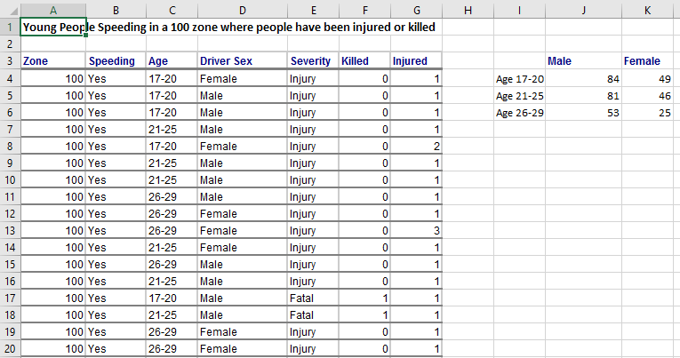

Question 18

The screenshot contains sample data for young people speeding in a 100 zone where there have been injuries or fatalities. The formula in K4 counts how many of these drivers were Female and aged between 17 and 20. Which of the following formulas would correctly give you this answer?
- =SUMIF(C4:C20,”17-20”, D4:D20,”Female”)
- =SUBTOTAL(C4:C20,”17-20”, D4:D20,”Female”)
- =COUNTIFS(C4:C20,”17-20”, D4:D20,”Female”)
- =COUNT(C4:C20,”17-20”, D4:D20,”Female”)

Question 19

You have been asked to create a chart that shows only the data for the female drivers. Which of the following would be the correct cells range(s)?
- K4:K6
- I4:I6 and K4:K6
- K3:K6
- I3:I6 and K3:K6

Question 20

You want to be able to quickly view subsets of this data such as all the Males in the age range 21-25 or all Female drivers where the Severity has been Fatal. Which Excel feature would best help you do this?
- Naming
- Filtering
- Sorting
- Copying

(20 Marks)
Section B: Short answer questions

Question 1 (4 marks)

Complete this diagram with the correct Stages and Activities of the Problem-Solving Methodology.
Question 2 (4 marks)

List the correct Problem Solving Methodology stage associated with each of these actions.

Example | Problem Solving Methodology Stage
- Drawing a flow chart to show the steps in a program.
- Analyse client feedback
- Investigate what the organization’s problem actually is and what they want.
- Click on all the navigation buttons on your website to see if they are working.

Question 3 (3 marks)

- Describe the purpose of a Data Dictionary. (1 mark)

- Identify 4 items you would expect to be included in a data dictionary (2 marks)

Question 4 (8 marks)

- What is the purpose of a database? (2 marks)

- What is the difference between a record and a field in a database? You may give examples to better explain your answer. (2 marks)

- When creating a database solution, it is important that Validation is taken into account. Explain the difference between the Validation Rule and the Validation Text when using Microsoft Access. (2 marks)

- All Victorian postcode start with the number 3. Your database asks that the user enters a valid postcode for Victoria which. Give a suitable validation rule for this. (1 mark)

Question 5 (3 marks)

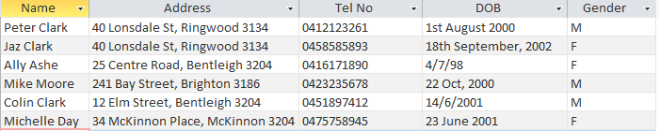
The president of a domestic junior basketball club is concerned about the data in the club records. He has decided to contract a database designer to build a RDBMS. Some of the data is listed below.

List three changes that need to happen so that the data is in a better format. (3 x 1 = 3 marks)

Question 6 (10 marks)

“Toys 4 Fun” uses a relational database management system to record all stock and sales of their products. An example of an entry is below:

Supplier | Part No | Unit Price | Quantity in Stock
Mattel | B345 | $15.40 | 10

- List the most suitable data types for each of these fields. (4 marks)

Field Name | Data Type
Supplier
Part No
Quantity
Unit Price

- Tables should generally have a suitable Primary Key. What is the purpose of a Primary Key? (1 mark)

- Which of the fields above would be a suitable Primary Key? (1 mark)

- How does a listbox improve the efficiency of entering the data into the Category field? (1 mark)

Below is an example of data contained in a Relational Database Management System.

- Using the data above, how many records would be returned for each of these queries? (3 marks)

Field | Manufacturer | Model | Category
Table | Toys | Toys | Toys
Sort
Show
Criteria |  |  | “Outdoor Play”
or

Answer:

Field | Manufacturer | Model | Category
Table | Toys | Toys | Toys
Sort
Show
Criteria | “Disney” |  | “Dress Up”
or

Answer:

Answer:
Field | Manufacturer | Model | Unit Price
Table | Toys | Toys | Toys
Sort
Show
Criteria | Like “T*”
or |  |  | >=90

Question 7 (4 marks)

- Data Visualisation is about making your data more meaningful. When presenting your data in an infographic, you could make the data bold for emphasis. Give two other formatting techniques you could apply to your data to make it stand out visually. (2 marks)

- Outline 2 advantages of representing data visually. (2 marks)
Advantage 1
Advantage 2

Question 8 (10 marks)
- Data Integrity is the correctness of the data. Explain the difference between correctness and accuracy. You may use an example to better explain your answer. (2 marks)

- The following factors should be taken into consideration when measuring the quality or integrity of data. Explain each term giving an example. (8 marks)
Accuracy
Timeliness
Authenticity
Relevance

Question 9 (3 marks)

Describe each of the following data types. Give an example of each.
Integer
String
Floating Point

Question 10 (8 marks)

A student has been asked to create a Visual Basic program to help some young children with maths. Below is a picture of the screen. The program will generate 2 numbers at random between 1 and 10 and the user has to type in their answer to the multiplication sum. If the answer is correct, a “tick” is displayed. If the answer is wrong, a “cross”’ is displayed.

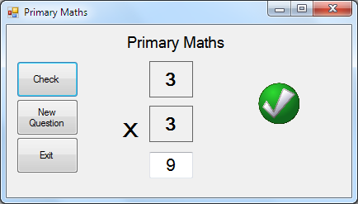

- A button is one type of object which can be used in Visual Basic. Name 3 other object types that have been used in this program. (3 marks)

- What is the difference between a text box and a label? (1 mark)

- txtNum1 is an example of a good object name. Give appropriate names for the following objects:
(4 marks)
Object | Object Name
The object with the word “Exit” on it
The object displaying the number 9
The object displaying the words “Primary Maths”
The object with the tick symbol in it

Question 11 (7 marks)

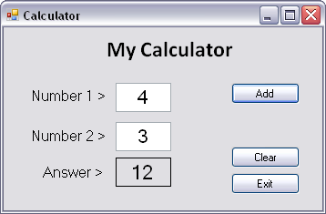

- When the student tests the above program it gives the wrong answer. It should add the numbers together. In the above example the actual answer given is 12. What type of error is this? (1 mark)

Type of Error:

The student looks at the code for this program.
number1 = Val(txtNumber1.Text) 'get value for number 1
number2 = Val(txtNumber2.Text) 'get value for number 2
If (number1 < 0 or number1 > 10) or (number2 < 0 or number2 > 10)
MsgBox("You have not entered both numbers correctly")
txtNumber1.Text = ""
txtNumber2.Text = ""
txtNumber1.Focus()
Exit Sub
End If
answer = number1 * number2 'calculate answer
lblAnswer.Text = answer 'display answer

- What is the name for the text after each of the single quotes (‘)? For example, ‘calculate answer (1 mark)

- What is the purpose of the IF statement? (1 marks)

- Describe 3 things that will happen if a number greater than 10 is entered. (3 marks)

- Re-write the line of code which is causing the error in the program. (1 mark)

Question 12 (4 marks)

Samir is planning on creating a chart showing the cost of petrol over the last five years. He has collected the following data:

Year | Average Price
2012 | 131.0
2013 | 148.9
2014 | 149.4
2015 | 143.4
2016 | 125.5
Source: Caltex Australia

Draw a mockup diagram showing how this data could be best represented in a chart. Include in the mock-up diagram:

- a heading
- the source of the data
- the graphic solution
- identify any colours and contrast used throughout the chart

Question 13 (5 marks)

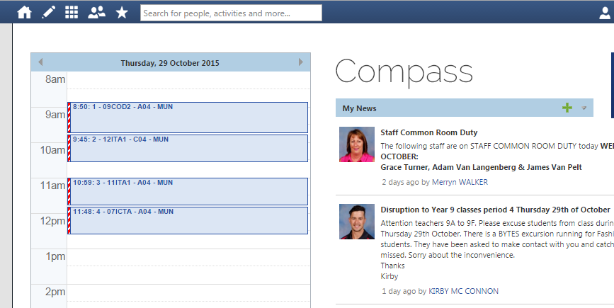
McKinnon Secondary College wants to evaluate the introduction of Compass2, an updated school organisation system used for day to day school activities and learning management.

- List 2 evaluation criteria that could be used to determine if the introduction of Compass2 is meeting the needs of the McKinnon Secondary College community. (2 marks)

- As part of the evaluation strategy, when should the evaluation occur? (1 mark)

- Explain two methods or techniques that could be used to evaluate the introduction of Compass2.
(2 marks)

Question 14 (7 marks)

You have been presented with a spreadsheet file showing the rainfall for Victoria across the years

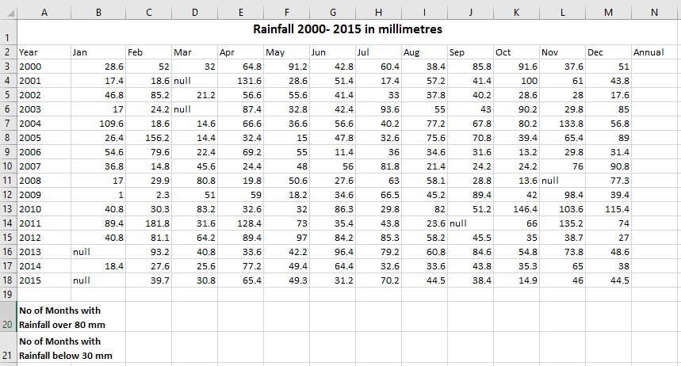

- Write the formula that would be in Cell N3 that would total the Rainfall for the year 2000. (1 mark)

- Write a formula that would count the number of months across all years where Rainfall was over
80 mm and display this in cell C20. (2 marks)

- Some of the cells are showing null values. What impact would this have on the effectiveness of the data. Give 2 statements. (2 marks)

You have been asked to prepare a chart that compares Annual Rainfall Totals across all years. Provide the steps necessary to complete this task ensuring that you include the cell addresses. (2 marks)
Step 1
Step 2
Step 3
Step 4

END OF PAPER

