U2O2: EXAMPLE Data Visualisation
- Collect Data: Here I chose some temperature data from the Bureau of Meteorology.
http://www.bom.gov.au/climate/data/index.shtml
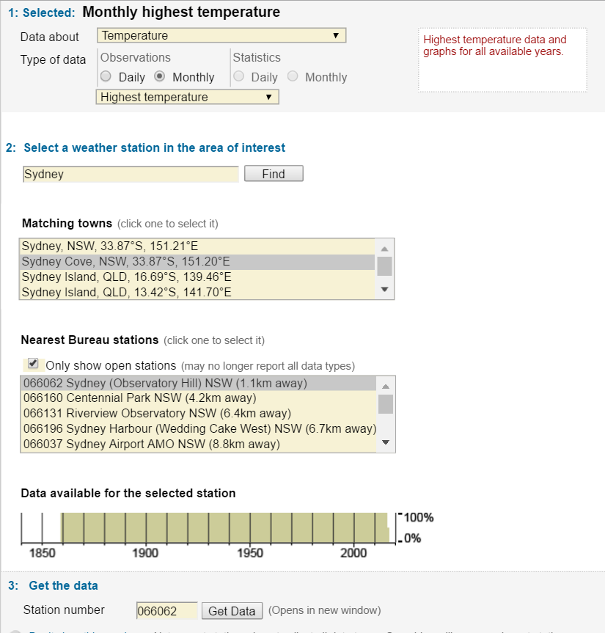
Set the parameters of your investigation.

Here I selected all the highest temperatures of each month collected from the Sydney Cove weather station from 1859 to 2016.

The raw data does back to 1859. However, the data cells not only contain the highest temperature for each month, also the date it was collected.
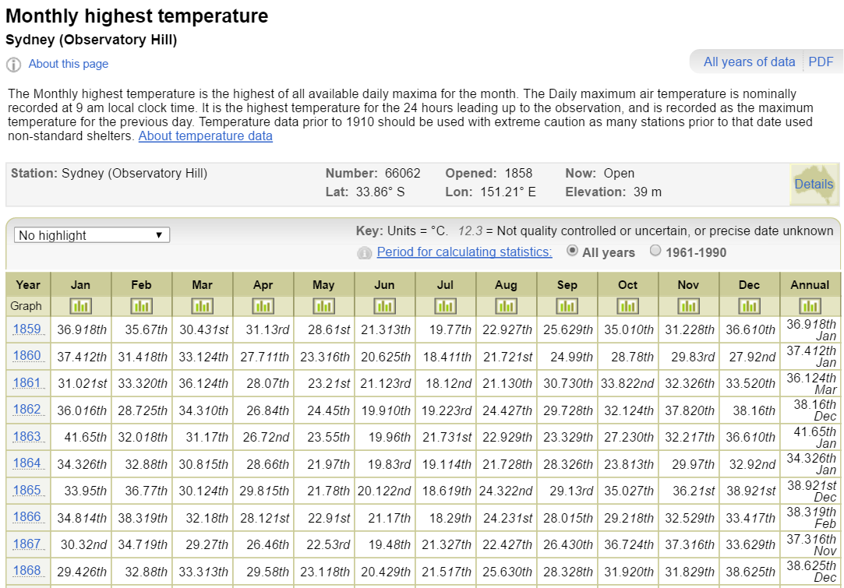
You can download all the data as a zip file – so you can analyse and manipulate the data.

Here is my Raw Data downloaded in a zip file:
A lot of data is not going to inform your investigation such as Column A: Product Code or Colum B Station Number – since they are all the same.

The columns we need to use are: Year, Month and Highest Temperature.
(Columns C, D E)

We can remove the columns we don’t need and start sorting each record by Year and Month to see if there is a pattern emerging over time (160 years).
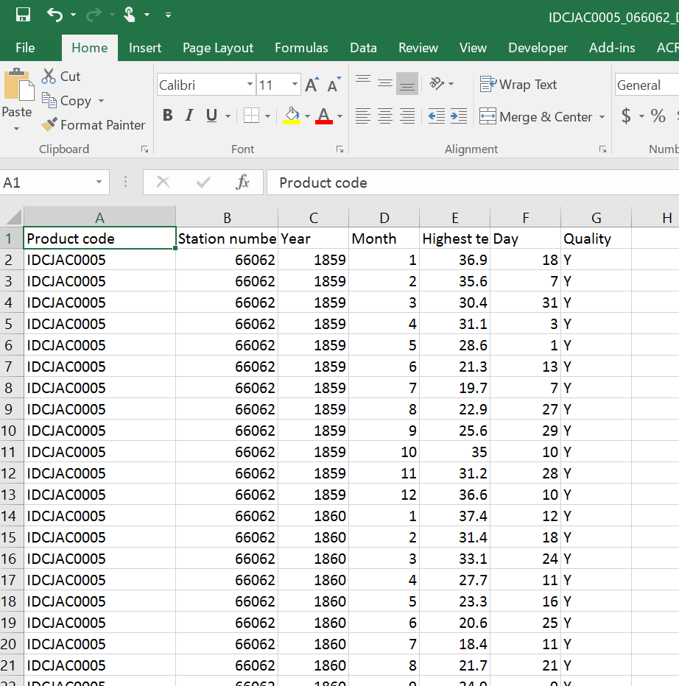

There are 1891 records!!
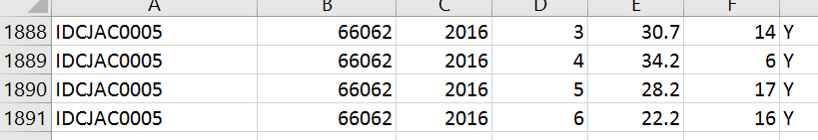
Now we can start grouping records according to Year/Month:
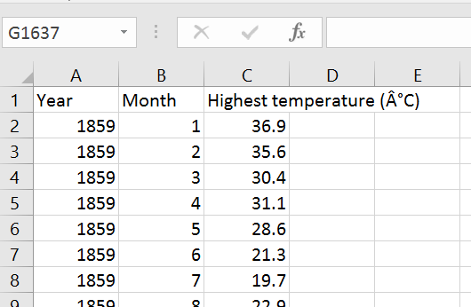

First I copied all the raw monthly temperature data and placed it in order using a FillDown count. I wanted to see if my data has any overall pattern between 1859 and 2016.
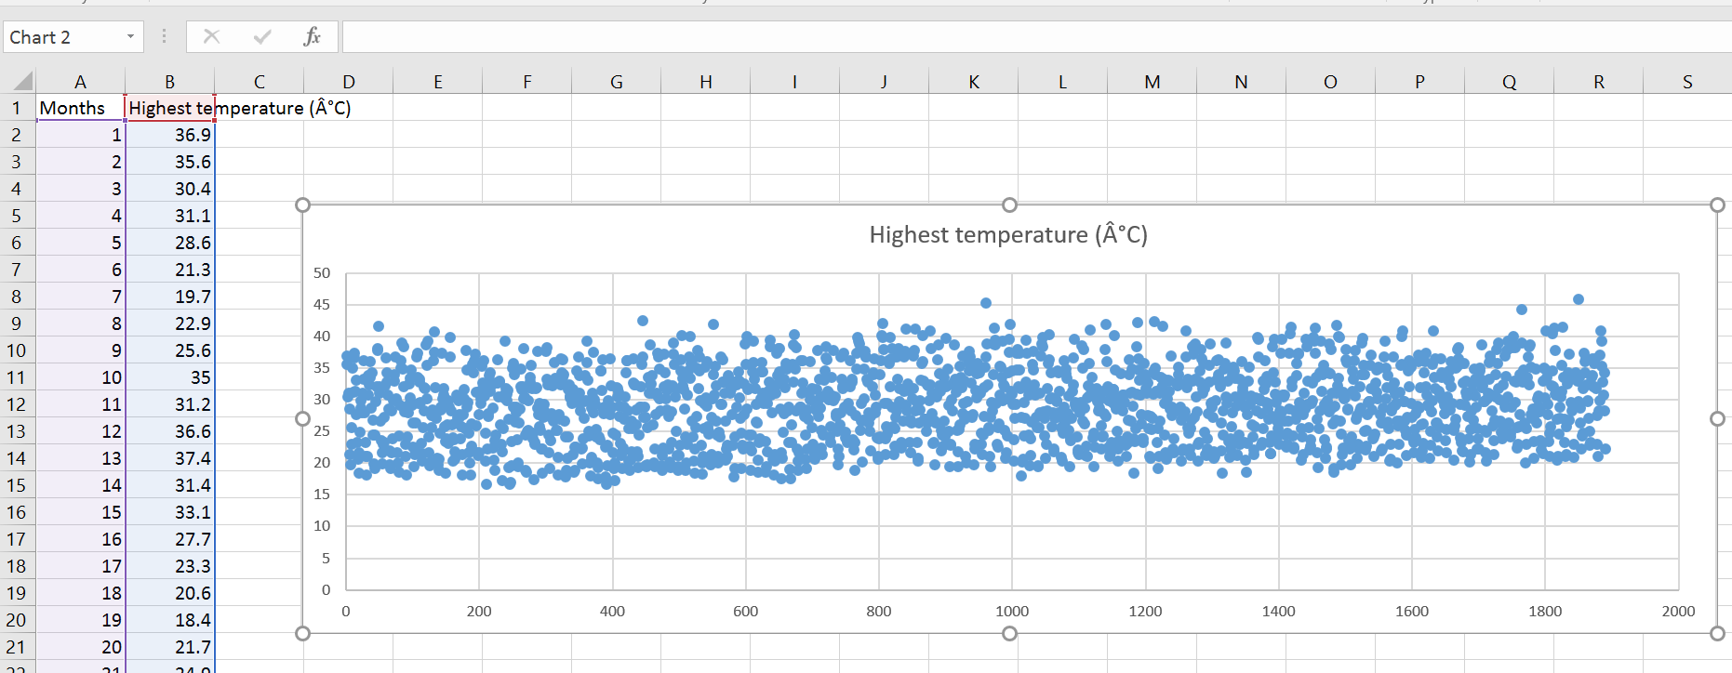
Line of best fit
You can see that the data shows a slight increase over the 1890 months.
We can also condense this data into annual average temperatures which will give us one data point for each year.
The other zipped excel file downloaded from the site has the monthly data arranges according to year making it easier to sort by annual averages:
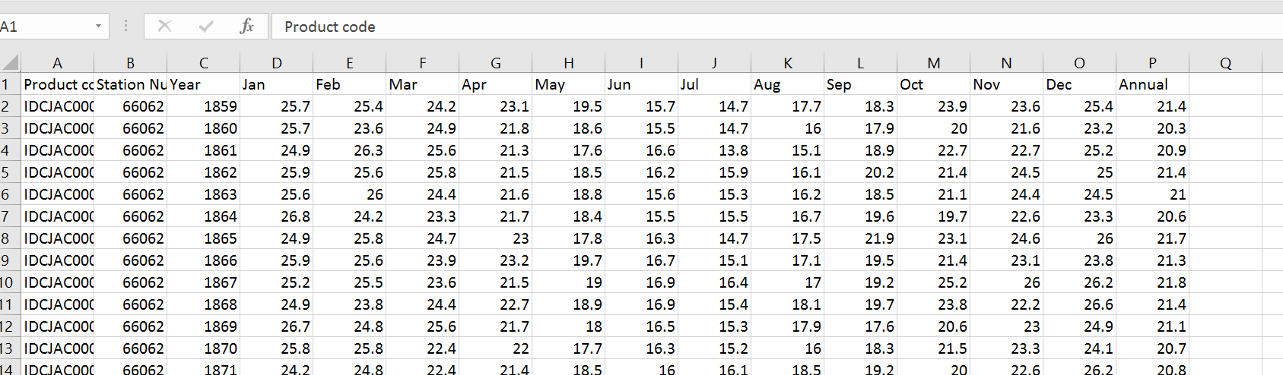
Annual highest temperatures are provided per year
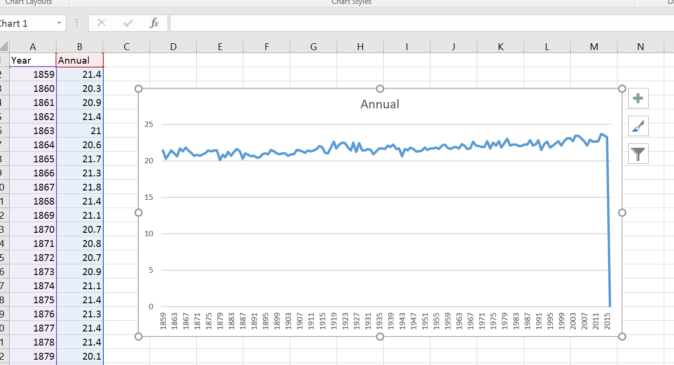
Now we can see there is defiantly an increase in average highest temperatures. We might have to remove 2016 data as it is not complete.
(This data was downloaded at August 2016)

So we have now found a trend. Let’s see if there is a reason for this increase in Sydney temperatures. This means we are going to treat the temperature data as a DEPENDENT variable. We just need to find out what it may be dependent on.
We know that there are scientific findings that show climactic changes in temperature are due to increased fossil fuel use that produces more carbon to be released into the atmosphere.
Let’s look at the Australian Bureau of Statistics to see if we can find an independent variable that could be responsible for the temperature change in the Sydney area.
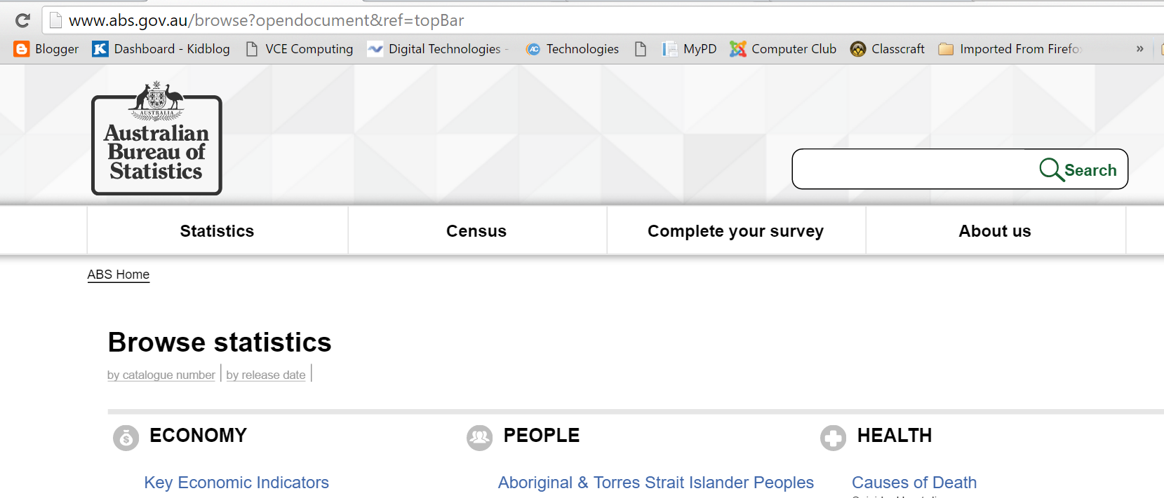
I looked up the increase in the population in Australia over time.
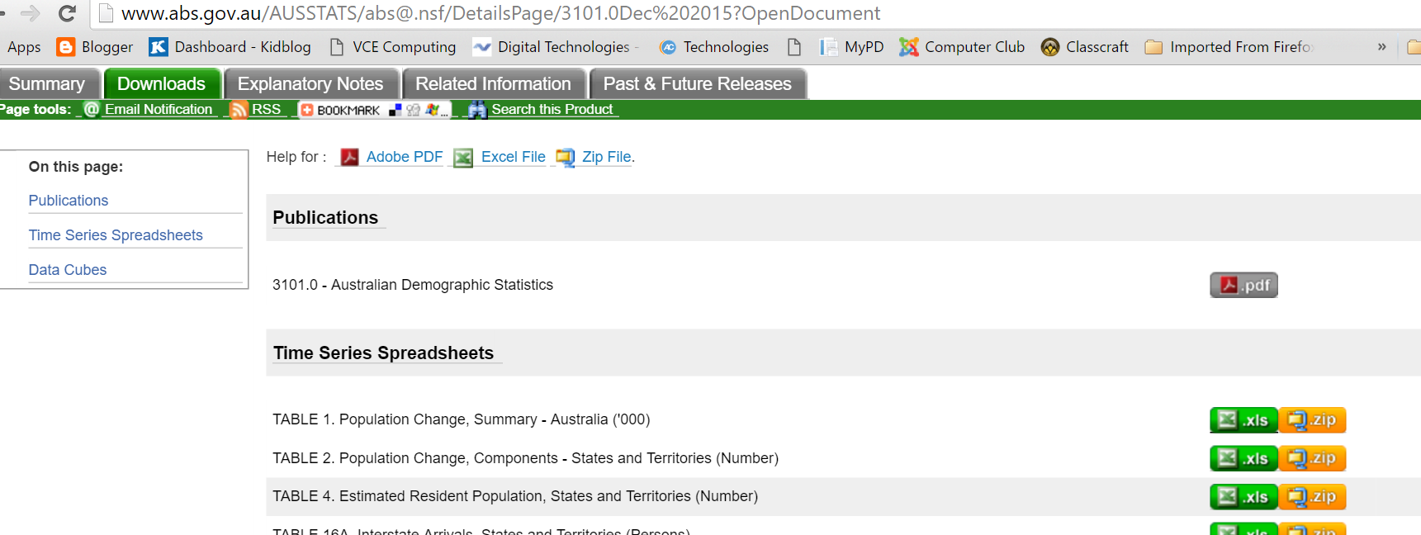
Unfortunately, the population data does not go beyond 1981. There is a steep increase over 34 years.
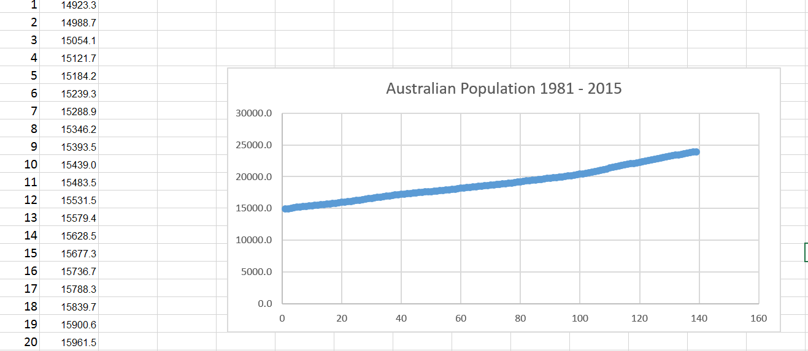
Let’s look for other trends that increase the risks to climate change.
I did some research online and found the EPA (Environmental Protection Agency) www.epa.gov/ and the Carbon Dioxide Information Analysis Centre http://cdiac.ornl.gov/ were reliable sources of government collections of data concerning carbon emissions.
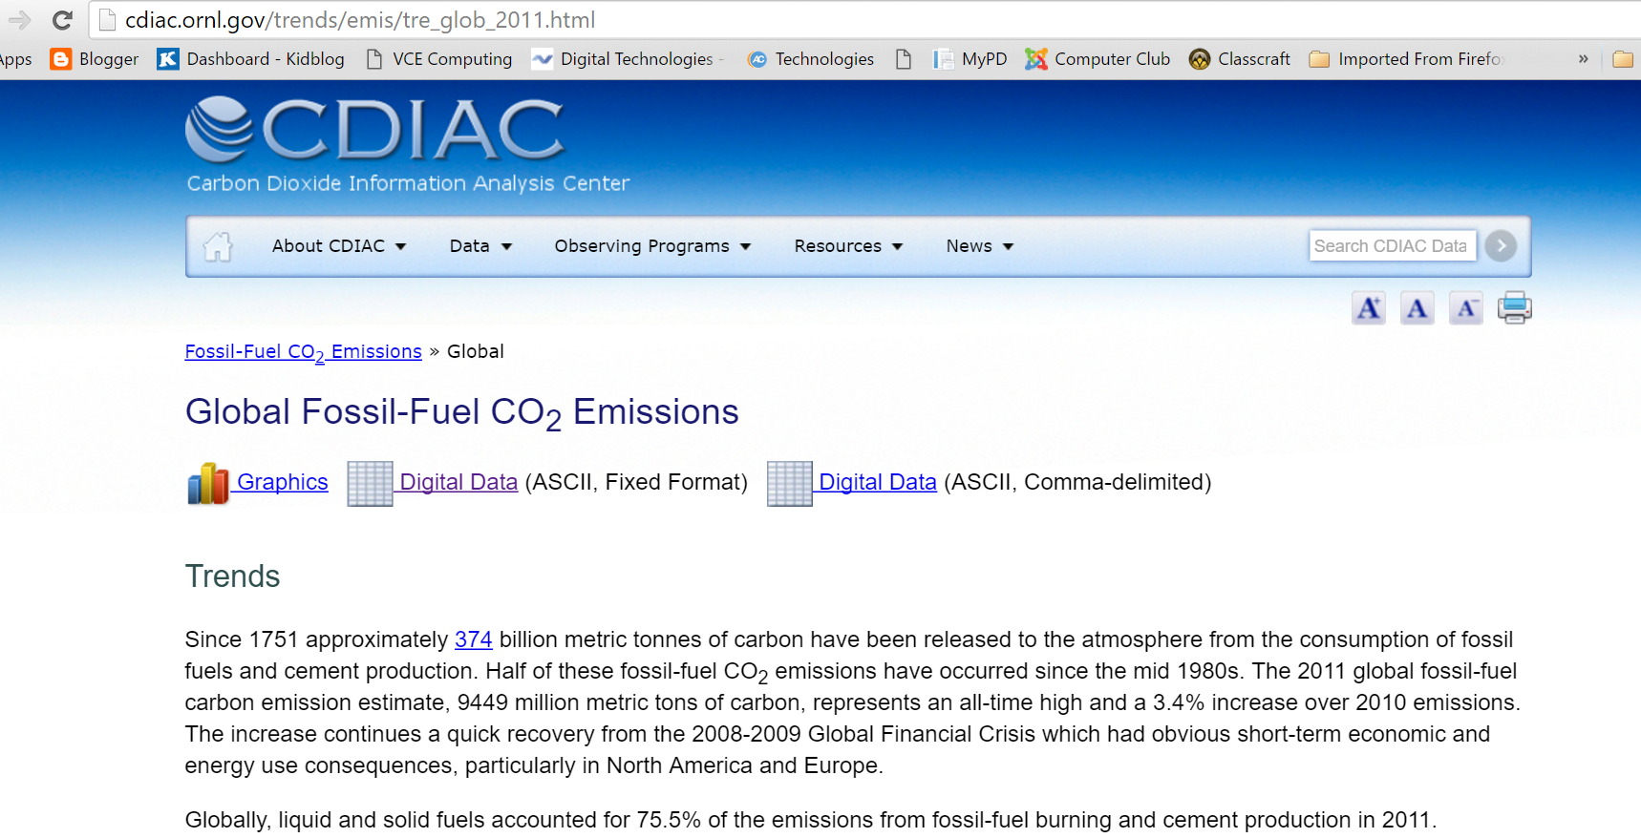
This data spans 1751- 2011.
Adding up the full carbon emissions is as easy as a =SUM() formular for each year – use fill down and you have data to graph over the 260 years.
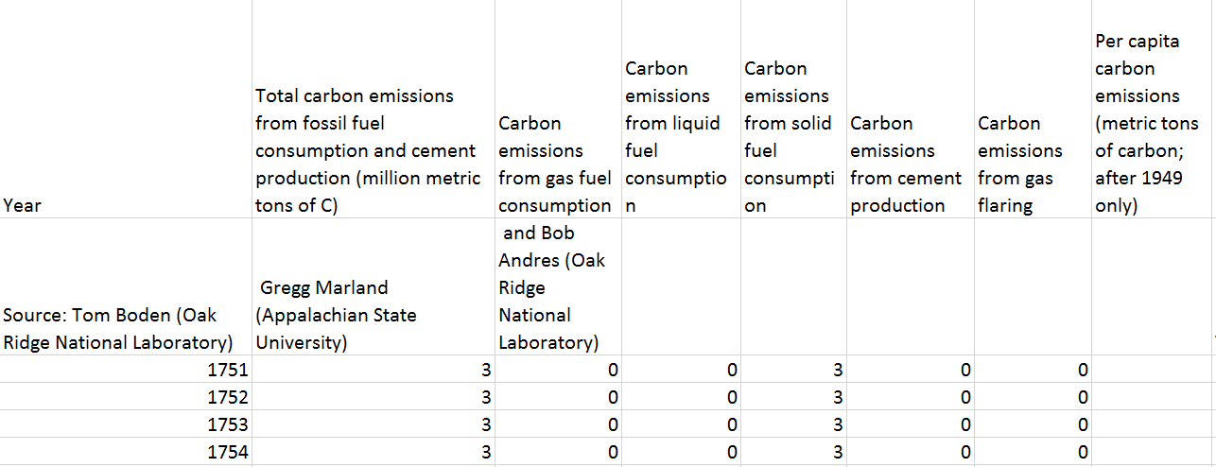
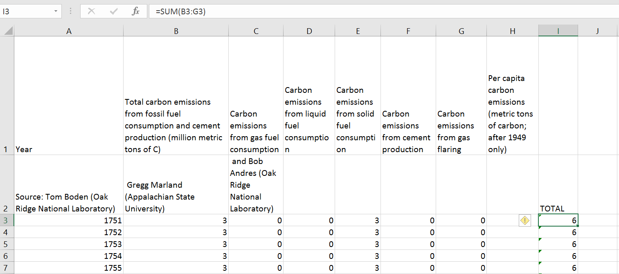
Once we copied I copied the years and the TOTAL emissions onto a new sheet I could plot the results.
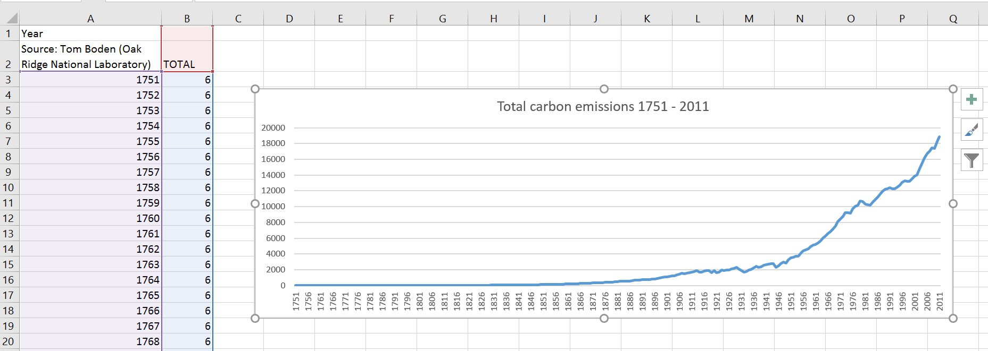

- Analyse Data: We can now start forming a clearer investigation question: “How has the increase of the Australian Population and the Global Increase of Carbon emissions impacted on temperature in Sydney?”

How can we visually compare these three data sets?
Don’t forget to include your SOURCE!
Source: www.bom.gov.au/ August 2016

Source: www.abs.gov.au/ August 2016

Source: cdiac.ornl.gov/ August 2016

I looked at a range of different online visualisation tools and thought dipity.com had a great way of displaying data across a timeline
