St Joseph’s College Geelong

VCE Computing

Unit 1 Outcome 1

Data and graphic solutions

Name: _________________________________________________

~ Suggested Solution ~

Acquire, secure and interpret data, and design and develop a graphic solution that communicates the findings of an investigation.
Add your name to this file and save it as: U1O1_SAT_Lastname_Firstname

Period 1 – Part 1

Topic: Phone apps usage
Many people like to use apps on their phones. You have been asked to investigate the most frequently used phone apps by staff and students at your school.

The topic of inquiry
- Describe the topic you are going to investigate and the sample group for your research. (2 marks)
Phone apps enable us to easily perform tasks which we find useful or interesting. I am going to investigate the issue of which phone apps are most used by people of different ages. I will confine it to students and staff at St Joseph’s College Geelong.

- What is your main focus question? (1 mark)
My focus question is: What phone apps categories are used most frequently by people of different ages?

- What are two other related questions you will gather data about? (2 marks)

Other issues which may be related to this is are:
- Do different genders show different app usage?
- What apps do people pay for?

- Method of data collection
- Describe the method to be used to collect the data. (2 marks)
The method I will use to collect my data will be through a survey contained in a Google Form. The Google Form allows for input to the questions by the candidate and is recorded in a Google Sheet.

Describe how you will legally and ethically acquire the data from your primary source. (3 marks)
I will provide a Participation Information Statement which explains the details of the survey on the email linked to the survey. The survey which will be anonymous, will have a Consent Section. If they agree to do the survey, the participant must agree to the terms of the consent form otherwise the Google Form will close.

Provide a copy of the Participation Information Statement and the consent form. (5 marks)
A copy of the Participation Information Statement and the consent form is shown below.

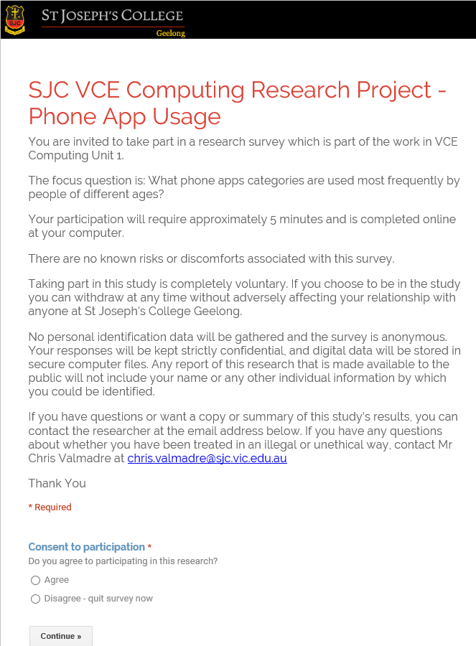

- Describe two ways you will ensure the privacy of the participants? (2 marks)
The survey collects no information that can be attributed to the participant. Data will be summarised

- Where will any original or manipulated data be stored? (2 marks)
The original data will be stored in my school Google Drive as it is saved from Google Forms to Google Sheets. The data from the input form will be transferred automatically to a Google Sheet which is able to be manipulated online or downloaded as a CSV file and manipulated in a spreadsheet program. I will use Excel to manipulate my data. I will store manipulated data on my laptop.

- How will you ensure the security of the data? (2 marks)
My Google drive is password protected and only accessible with those I choose to share. The Google Form is governed by secure restrictions and cannot be edited by anyone who has not been given permission. The responses to the survey are contained in a Google Sheet which is also securely locked so that only I have access to the data. All data is anonymous and cannot be traced to a participant, thereby fulfilling the conditions of the consent form.

My laptop is password protected.

END PART 1
Upload this file to Assessment Tasks

Periods 2-3 – Part 2
- Draw up a table showing the questions, the data type (quantitative or qualitative) and how the choice will be made on the form. Use the following table as a guide: (15 marks)
Question | Data type | How the choice is made in the form
What is your gender?  What is your favourite primary colour? | Quantitative  Quantitative | Pull down list - Choose between ‘male’, ‘female’ or ‘intersex’  Multiple choice buttons - Choose between 8 primary colours

SJC VCE Computing Research Project - Phone App Usage
Question | Data type | How the choice is made in the form
What is your gender? | Quantitative | Multiple choice button - Choose between ‘male’, ‘female’ or ‘intersex’
How old will you turn this year? | Quantitative | Pull down list - Choose between <12, 12, 13, 14, 15, 16, 17, 18-19, 20-29, 30-39, 40-49, 50-59, >59  Redirection if over 19 – App Usage
How much pocket money do you get each week? | Quantitative | Pull down list - Choose between range of answers  Only for respondents <20 yrs
How much do you earn each week from an employer? | Quantitative | Pull down list - Choose between range of answers  Only for respondents <20 yrs
For how many minutes per week would you use the following app categories? Social or business Networking – like Facebook, Snapchat, Instagram, LinkedIN; Games; Health, fitness and wellness; Entertainment – like music, movies; Education – like libraries, schools, TED talks, museums; Productivity applications – like OneDrive, Google Drive, notes, editing documents, editing videos, editing photos; Travel – like locations, accommodation, flights, taxis; Utilities – like calculator, converting units, torch, compass; Commerce – like banking, shopping, paying for items; Being informed – like Newspapers, magazines Weather, Twitter, Maps, fire warnings; Sports;  Voice and video communication – like Skype, Viber, Vine; Gambling | Quantitative | Pull down button - Choose between time categories – 0, 1-10, 11-30, 31-60, 60-120, 120-240, >240  For all respondents
Not including the phone’s default apps, name the 3 apps that are most important to you? | Quantitative | Text input
Do you have any paid apps? | Quantitative | Multiple choice button - Choose between ‘Yes’ or ‘No’  Redirection if ‘No” – submit form
What paid apps do you have? | Quantitative | Text input

Marking Criteria:
Suitability of questions – 5
Data type – 5
Description of question response method – 5

- Create the survey in Google Forms – send to your teacher (10 marks)

Marking Criteria:
Consent section – 1
Logical organisation of pages - 4
Clarity of questions and use of validation techniques in questions – 5

END PART 2
Upload this file to Assessment Tasks

SEND YOUR GOOGLE FORM TO YOUR TEACHER
Period 4 – Part 3

- Data Collection
- Provide a screen shot of a sample of your data (1 mark)

Periods 4-6

Results – Analyse your data; describe conclusions
- Use Excel to select and apply functions, formats, conventions, data validation and testing techniques to manipulate your data to help identify any patterns. (20 marks)
Save this file as: U1O1_Analysis_Lastname_Firstname

Marking Criteria:
Addition of an index column - 1
Use of formulas and functions - 5
Manipulation of data to produce summary tables - 5
Chart production including formats and conventions - 9

- Copy and paste your summary tables. (1 mark)

- Copy and paste any charts you developed. (1 mark)

- Briefly describe your conclusions. (3 marks)
Conclusions need to be related to the issues they were investigating
END PART 3
Upload this word file to Assessment Tasks
Upload the excel file to Assessment Tasks

Period 7 – Part 4
- Infographic Production
Select and apply appropriate design tools to represent the functionality and appearance of your inquiry.
- Draw some annotated sketches of what elements your Infographic should display to help you develop your infographic solution. Hand in to your teacher. (7 marks)

Marking Criteria:
Message development – 2
Layout features – 3
Annotations - 2

END PART 4
Hand in your annotated sketches to your teacher

Periods 8-9 – Part 5
- Develop your final graphic solution – save this as a pdf – U1O1_Infographic_ Lastname_Firstname (20 marks)

Marking Criteria:
Functionality: accuracy of data depiction, clear message, readability – 8
Appearance: alignment, repetition, contrast, space, balance – 10
Referencing: reference of data sources, images and text – 2

- Paste an image of your final graphic solution below. (1 mark)

END PART 5
Upload this word file to Assessment Tasks
Upload a pdf of your Infographic Solution to Assessment Tasks

Submission Requirements
- This file: U1O1_SAT_Lastname_Firstname
- Your survey in Google Forms
- Your Excel file: U1O1_Analysis_ Lastname_Firstname
- Annotated sketches
- A pdf of your final graphic solution: U1O1_Infographic_ Lastname_Firstname

-----------------------------------------------------------------------------------------------------------

Suggested marking scheme

 | Outcome | Mark
Frame an investigation inquiry
- The topic of inquiry
 | - Describe the topic you are going to investigate | 2
 | - What is your main focus question? | 1
 | - What are two other related questions you will gather data about? | 2
Identify, legally and ethically acquire, and reference data and information from primary sources
- Method of data collection
 | - Describe the method to be used to collect the data | 2
 | - Describe how you will legally and ethically acquire the data from your primary source. | 3
 | - Provide a copy of the Participation Information Statement and the consent form | 5
Devise and implement controls and techniques to minimise risks to the security and privacy of data and information
 | - Describe two ways you will ensure the privacy of the participants? | 2
 | - Where will any original or manipulated data be stored? | 2
 | - How will you ensure the security of the data | 2
 | - Draw up a table showing the questions, the data type (quantitative or qualitative) and how the choice will be made on the form | 15
 | - Create the survey in Google Forms – send to your teacher | 10
Interpret selected data, identifying relationships and patterns  - Data Collection |  | 0
 | - Provide a screen shot of a sample of your data | 1
- Results – Analyse your data; describe conclusions
 | - Select and apply functions, formats, conventions, data validation and testing techniques to manipulate your data to help identify any patterns. Save this file as: U1O1_Analysis_Lastname_Firstname | 20
 | - Copy and paste your summary tables | 1
 | - Copy and paste any charts you developed | 1
 | - Briefly describe your conclusions. | 3
Select and apply appropriate design tools to represent the functionality and appearance of graphic solutions for particular purposes
- Infographic Production
 | - Draw some annotated sketches of what elements your Infographic should display to help you develop your infographic solution | 7
Use software, and select and apply functions, formats, conventions, data validation and testing techniques to efficiently manipulate data and create graphic solutions
 | - Develop your final graphic solution – save this as a pdf – U1O1_Infographic_ Lastname_Firstname | 20
 | - Paste an image of your final graphic solution | 1
TOTAL |  | 100

