Information Technology Unit 1 Name: ________________________
Test – Networks

What do the following terms mean in networking? How are they defined?
LAN:
WAN:
Peer-to-peer:
Client-server:

What are five advantages of using a network over standalone computers?
1.
2.
3.
4.
5.

What are two disadvantages of using a network?
1.
2.

What are four tasks of a network operating system?
1.
2.
3.
4.

List five different types of transmission media. At least two must be physical and at least two must be wireless:
1.
2.
3.
4.
5.

In regards to Ethernet, explain what the following terms mean:
Carrier Sense:
Multiple Access:
Collision Detection:

List and describe four threats to network security.
1.
2.
3.
4.

Explain the function of a firewall in a network.

For each of the following protocols, state their full name and what they are used for:
Protocol | Full name | Used for
TCP/IP
FTP
HTTP
WAP
SMTP/POP/IMAP

In the network diagram below, identify the items labelled A through to E.
D:
B:
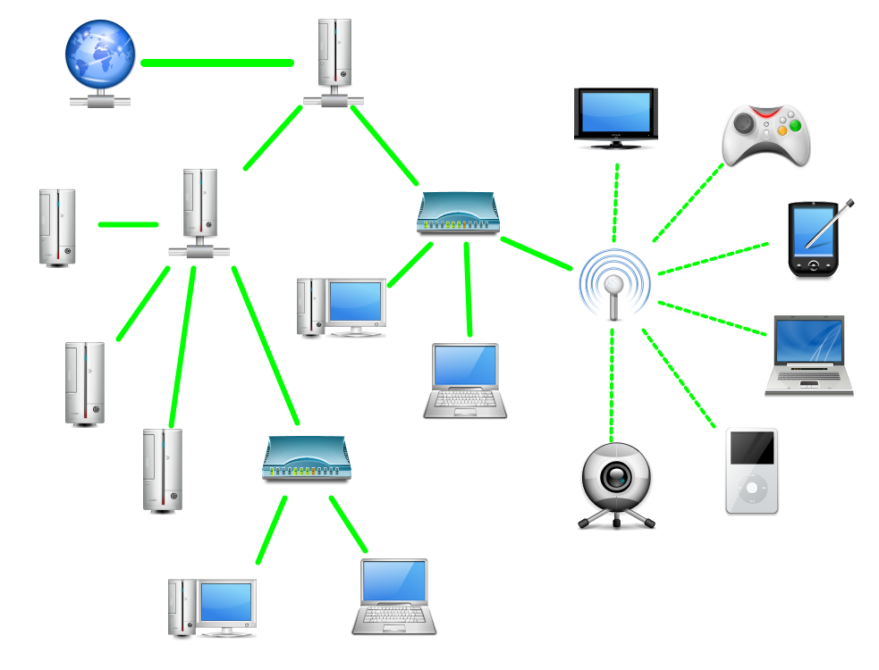
C:
E:
A:

Mark: /40
0-10 | 11,12 | 13,14 | 15,16 | 17-19 | 20-22 | 23-25 | 26-28 | 29-31 | 32-35 | 36-40
UG | E | E+ | D | D+ | C | C+ | B | B+ | A | A+

