‘Create Your Own Apps’ - Unit plan for App Inventor, 4 week lesson plan
(Written by Gail Casey, version 27th July 2012 – gcas@deakin.edu.au)

Possible Classroom Subjects: Information Technology, Multimedia, Programming and other across curriculum units

Year Level: Year 7 to 11

Class Timetabling Per Week – approx 3 x 40 min + 1 x 80 min

Unit Overview – This is a flexible unit of work which takes a student centred approach to learning.
Teachers should use this document as a guide only.
Unit Title: ‘Create your own Apps’

Unit Summary:
This four week unit of work will help students understand the way in which mobile phones operate through the use of Apps. They will research the programming software ‘App Inventor’ before writing their own apps using an Android mobile phone (or simulator). App Inventor fosters creativity through technology and is programmed through an Internet browser where students can design their own mobile phone apps. The program uses a series of blocks, like pieces of a puzzle, where students build a series of behaviours that when put together can appear live on an android phone.
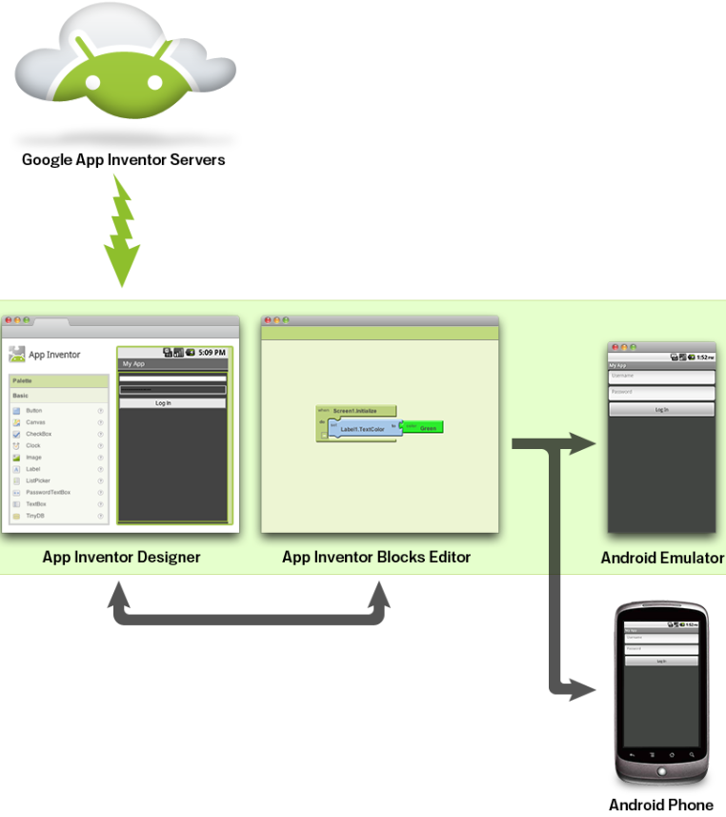
Figure 1: What is App Inventor | Explore MIT App Inventor
http://explore.appinventor.mit.edu/content/what-app-inventor
Screen clipping taken: 15/07/2012, 8:06 AM

Things to note:
- App Inventor is a Web based application. It runs by browsing to the App Inventor website, http://appinventor.mit.edu.
- More resources for each of the tutorials can be found at http://www.appinventor.org/projects
- The App Inventor Setup Installer software is something you need to install beforehand so that your computer can talk with the android phone or in the android emulator.
- Many video tutorials have been created by David Wolber and links to his YouTube channel is given at http://www.appinventor.org/projects after clicking on the appropriate chapter, but for High school students, video tutorials made by Chris Groff should also be considered. Chris Groff’s YouTube channel can be found at http://www.youtube.com/user/cgroff17
- Some tasks involve students taking screen clips of websites to share with their peers. These could be done using the 'prt sc’ key on the keyboard then using a picture editor or by using more specific screen clipping programs such as OneNote.
- It is assumed that good Internet access is available.
- Don’t use spaces when naming files
Possible areas for assessment could include:
1. Skills - ability of students to learn, design and create using App Inventor
2. Communication – ability to share one’s knowledge & communicate through the software.
3. Research & Investigation.

Assessment could be linked to VELS ICT for Visualising Thinking, Creating and for Communicating. It could also be linked to a range of other VELS such as Personal Learning, Communication, Interpersonal skills, Thinking as well as VELS Design Creativity & Technology.

Assumptions:
- App Inventor software is loaded and runs on the school network.
- The school has good internet access.
- If the teacher does not have some form of online sharing space for this project then it is assumed that students have individual email addresses so they can email their shared resources to their peers.
- Students have a Google account

In preparation for lessons:
During this first week, students use the Internet to research the App Inventor software. They should be encouraged to explore the software in a personal manner - they should identify what App Inventor might offer them. (It is helpful if teachers appear to know very little about App Inventor at this point in time.)
- All Lessons: Early in each lesson, discussion on the problems students have encountered in previous classes should be encouraged (as a tips and hints for others) – this could come from a student-centred discussion.
- Week 1, Period 1: The first task does not require the students to actually program with App Inventor. This task focuses on finding resources and information from websites that will provide a greater depth of understanding of the software - this should lead students to discover App Inventor’s ‘POTENTIAL’.
- Week 1, Period 1: It may be necessary for the teacher to explain the difference between an example and a tutorial – an example being something made using App Inventor while a tutorial has step-by-step instructions showing how something is made.
- Week 1, Period 1: The teacher will need to make some decisions on what medium students will use when writing up Task 1. (Students will present their Task 1 in groups of 3 or 4 during period 2, each group sharing one computer.) Students could use a word document then email this to their group members. It may be valuable if students were given other choices. For example, the school may have online publishing options through their Intranet or some students may already have their own online blog or website. Students may be comfortable using Google docs or other online tools where they could publish their task and more easily share with peers. It is important that students can access to Task 1 documents from their peers.
- Week 1, Period 3 or 4: Students are asked to take their own photo and record their own sound. The teacher may need to have some of these available for students to use if they are not able to obtain their own. The teacher could take photos and record sounds during the first two periods, for students to use in Task 2 part 2 - this could add interest in the task.
- Task 2 part 2, it may be useful to discuss the media formats suitable for Android these can be found at http://developer.android.com/guide/appendix/media-formats.html
- Week 4 student worksheet answers - http://www.appinventor.org/post-intro-discussion-solution the teacher should go through these at a convenient time – perhaps one or two questions per lesson.
- Week 3 Task 4 contains some computer terms and concepts (theory), more of this type of background theory can be found for by clicking on the desired chapter page at http://www.appinventor.org/projects
- Downloaded copies of the App Inventor video tutorials, from YouTube, and the PDF hard copy tutorials should all be available for students 24/7.
- It is important that students do view the PDF versions of the tutorials at some point in each task (rather than only watch the video tuts) because they do offer a range of variations to the tutorials as well as useful information and hints.
- Students should bring their own headphones to class – these are needed when watching video tutorials.
- Students will need equipment to take their own picture and sound for their version of the ‘Hello Purr’ app – this is best done with their own phones for homework where possible.
- Answers to Post Intro discussion questions can be found at http://www.appinventor.org/post-intro-discussion-solution

Note:
- It is important not to rush or push the weaker students during week 1 or 2. Some students will need to spend more time simply watching and learning from others.
- The peer and self assessment activity within Task 1 provides students with scaffolding for other tasks; hence, it is important to spend time on this with the students.
- As students become confident they should be encouraged to choose their own tutorials from those found in Task 1. These students should then be encouraged to show their work on the projector – once they have shown their work; any student interested in learning the particular app could be invited to the front of the class to be shown by their peer. (The teacher is not expected to have a complete understanding of the tutorials and skills.) The activities are written to be student centred & students solving student problems. If the tutorials chosen by students are too hard then they need to follow the recommended weekly tutorials in the order given.

Helpful Websites:
- Note that http://appinventor.googlelabs.com/ is the old address for App Inventor. This no longer exists (this may need to be pointed out to students at an appropriate time). The correct App Inventor site is at http://www.appinventor.mit.edu/ - click on ‘Invent’ to start programming.
- There are many helpful videos available on YouTube (See, http://www.youtube.com/watch?feature=player_embedded&v=VTbyqDCK3A0). Many of these can be downloaded prior to class for students to access from their school Intranet. Some are also available from Vimeo (See, https://vimeo.com/search?q=App+Inventor)
- Useful resource
  - Getting Started with Android App Inventor is http://www.i-programmer.info/programming/mobile/1789-getting-started-with-android-app-inventor.html, but be careful because it does refer to the old App Inventor site.
  - Many video tutorials have been created by David Wolber and links to his YouTube channel is given at http://www.appinventor.org/projects after clicking on the appropriate chapter, but for High school students, video tutorials made by Chris Groff should also be considered. Chris Groff’s YouTube channel can be found at http://www.youtube.com/user/cgroff17
  - http://en.wikipedia.org/wiki/Google_App_Inventor, http://www.appinventorblocks.com/ , http://www.appinventor.org/
  - Other video tutorials also available at http://www.youtube.com/playlist?list=PLCF2969C390CE87F4
  - Other resources, http://www.appinventor.org/course-in-a-box

Lesson Plan – 4 Weeks
The Week 1 lesson plan, in the following pages, is described in detail. It is during Week 1 that many of the processes of peer and self reflection as well as group work are set up. These continue during the following three weeks but are not provided in the same depth.
Week 1 Period 1: Task 1 – Exploring
The teacher instigates a class discussion by asking questions about mobile phones and apps, teasing out what students know – this is to introduce the topic. (The teacher should not have the answers and should not tell them what App Inventor is or where to find resources.)

Students are then given the Week 1 handout which provides students with a check list for the first two tasks - this will also be used as their instruction sheet. Students should start Task 1 once the teacher has prompted their thinking with the class discussion.

Please explain to students that they do not actually use App Inventor during this first Task. The purpose of the task is to get them to explore and find out more about App Inventor and to think about apps that they might want to write.
Task 1 includes:
- a) What is App Inventor?
b) Who would/should/could use it and what could they do with it?
- a) Find three examples of programs made using App Inventor. Choose three that could be interesting for your peers or that you find interesting.
b) Explain a little about each example and provide both a picture of each app (if available from the website) and each website address for your peers to use at a later time.
- a) Find three tutorials that use App Inventor. These should be for programs that you may like to produce at a later time.
b) Explain each example and provide both a picture of each app and its website (This will allow others to share your work).

Task 1 should be consolidated early in period 2 at which time students will form groups of 3 or 4 to complete the peer and self assessment section of handout 1.

Week 1 Period 2: Task 1 – Learning by sharing
Students are given time to organise themselves into groups of 3 or 4 around one computer ready to present their Task 1 to their group members – they should email their task 1 to each group member so each member can easily use any websites listed after the presentations (or use another distribution method available).
- The teacher will need to help students understand the different standards for peer assessment: ‘High’, ‘Medium’ and ‘Low’, as explained on the student handout 1.
- Each student puts their name at the top of their handout 1. Students complete the peer assessment section by using a different colour pencil and handing it around their group after each member presents their work.
- Peer assessment is an important part of Task 1 both for the task itself and also for the student’s ability to provide peer assessment. (The teacher may need to provide examples of positive feedback and constructive comments throughout the week as scaffolding.)
Once the group presentation, for Task 1, is finished students complete their own self assessment using a different colour pencil.

Handout 1 is not finalised until the end of week 1, but the teacher is advised to collect the handout 1 sheets at the end of each period so that they is not lost. Students have until the end of week 1 to use the advice from their peers as well as their own understandings of Task 1 to improve their responses.

Students spend the rest of the lesson exploring the Task 1 emails provided by the peers in their group and improving their own Task 1.

Week 1 Period 3: Task 2 – Creating
Starting the lesson - the teacher model, on the projector, how to run the ‘Hello Purr’ video tutorial from the school network while having the App Inventor program running in the background. Pause the video tutorial after each step to perform the action in the App Inventor software. (One version of the ‘Hello Purr’ video can be found at http://www.youtube.com/watch?v=nC_x9iOby0g.)

(Students work through their first classroom App Inventor tutorial - some students may have started working on App Inventor at home (if they became keen during their research) in which case they could continue working at their own pace on the tutorials of their choice - it is important to encourage and support advanced students and encourage them to show their work to other students.)

When the teacher has finished modelling how to go about doing the first tutorial, students should be encouraged to also have both the App Inventor program and the video tutorial open on their own computers. Using headphones, students listen to the video tutorial then pause the tutorial after each step. While the video is paused they then work through the same step in the App Inventor software (they should not watch the entire video and expect to remember the steps).

After each tutorial get students to, in their own words, list the skills gained. For example, in the ‘Hello Purr’ skills include:
- Renaming components
- Button properties
- Label properties
- Overlaying a button with a picture
- Adding sound
- Using blocks editor
- Connecting to Android phone

(As students finish they should start Task 2 - create their own ‘Hello Purr’ where they use their own photo and record their own sound. This will consolidate their skills and provide an opportunity for them to take ownership of their work.)

Week 1 Period 4: Task 2 – Creating
At the start of the lesson: Showcase student work. Those students that have finished their own version of ‘Hello Purr’ should have the emulator running on their computer so that students can view these. Students that may have worked through other tutorials should also have these running through the emulator, on their computer, for their peers to view and run.

Students should be given time to work through their tutorials before a group sharing with peer assessment is done during the second half of the lesson. If some students are finished their tutorial and ready to move on then they should be encouraged to start the Paint Pot tutorial from Week 2.
Tutorial – PaintPot part 1 - http://www.youtube.com/watch?v=31bi9tWOLcY
**Students that are not confident could be encouraged to make another version of ‘Hello Purr’ by using ideas they saw in the showcase.

Assessment Week 1:
1. Task 1 & 2 2. Ability to help others.

Week 2 – Consolidation
Distribute the week 2 student handout. The recommended week 2 tutorial is ‘PaintPot’. The teacher or a student should model the first part of one of the PaintPot tutorial at the start of each of the four lessons – have both the video tutorial and the App Inventor software open and pause the video tutorial when working on the software. Also discuss any common issues students have had in previous lessons. The PaintPot video tutorials are available from http://www.appinventor.org/paintpot.

During the second half each lesson students should meet in their groups to provide:
1. Peer feedback & support – get students together to discuss what they have done. They are expected to show the group the work that they have done and discuss any problems they have had. It is up to the other group members to provide support and positive feedback.
2. Discussion of the PDF tutorial - the PDF versions of each tutorial can be very helpful. In their group students should spend 10 minutes looking through the appropriate PDF tutorial. Students should be able to quickly identify the parts that they have done of the tutorial (given it is the same tutorial as the video These PDF tutorial provides more detailed information than the video tutorials. More depth of understanding may be achieved if students are given opportunities to discuss the extra information on these sheets.

Assessment:
1. Task 3 2. Ability to help others.
Week 3 – Knowledge Building
During week 3 and 4, further theory from chapter 14 and 15 may be found useful to support the programming concepts being used.

Distribute the week 3 student handout. Task 4 requires students to discuss a range of terms used – this should be done in their groups although each student should submit their own answers.

The recommended week 3 tutorial, Task 5, is ‘MoleMash’. There are five parts to the video tutorial for this game at http://www.appinventor.org/molemash.
The teacher or a student should model part of a tutorial during each class – this could occur after students have been working on their programming for 15 min or so when a talented student can be identified or when a number of students are having trouble with a section of the tutorial students should be called over to assist.
Demonstrations should be optional for students to watch at this stage because students could be at different stages or they may choose to do different tutorials.

At some stage during each class, there should also be some class discussion of common problems that students have had during previous lessons.
Chapter 14 – Understanding an App’s Architecture
Chapter 15 – Engineering and Debugging an App

Students should meet in their group each lesson to provide peer feedback and constructive advice.

Assessment:
1. Task 4 & 5 2. Ability to help others.
Week 4 – Teaching Others
This week students create an App or a tutorial to help Year 7 students. This may help them with one of their subjects or it may be to teach them how to use App Inventor. It may also involve a fun activity such as the ‘Xylophone’ tutorial at http://www.appinventor.org/xylophone
Distribute the Week 4 handout.
Students should meet in their group each lesson to provide feedback & support.

Assessment:
1. Task 6 2. Ability to help others (peers and Year 7).

