VCE Information Technology
Unit 1

WRITTEN EXAMINATION

Student’s Name:
Teacher’s Name:

Question and Answer Booklet
Reading Time: 10 minutes
Writing Time: 1 hour 30 minutes

Structure of Booklet

Section | Number of Questions | Number of Questions to be Answered | Number of Marks
Multiple Choice  Short Answer | 15  16 | 15  16 | 15  97  Total: 112

- Students are permitted to bring into the examination room; pens, pencils, highlighters, erasers, sharpeners and rulers.
- No calculator is allowed in this examination.

Instructions
- Write your name and teacher’s name on this booklet and in the space provided on the answer sheet for multiple-choice questions.
- All written responses should be in English.

Students are NOT permitted to bring mobile phones and/or any other electronic communication devices into the examination room.

Section A

QUESTION 1
Formats and conventions are:
A guidelines which apply to the presentation of output.
B rules which determine the use of colours.
C correct methods of implementing a website.
D correct methods of setting out a design.

QUESTION 2
Data gathered for processing information should be:
A free of errors and free of bias.
B from a source with a vested interest.
C from a small sample to make it manageable.
D reliable and with a timely format.

QUESTION 3
You should not knowingly publish misleading or false information on a website because of:
A copyright laws.
B privacy laws.
C computer viruses.
D computer ethics.

QUESTION 4
When gathering data, a secondary source is:
A data gathered from the published work of someone else.
B unreliable.
C data which belongs to someone else.
D an electronic source.

QUESTION 5
Which of the following isn’t a purpose of information
A Inform
B Educate
C Persuade
D Evaluate

QUESTION 6
A client–server network:
A is used mainly for serving the needs of customers.
B uses a peer-to-peer system for sharing files.
C stores the database used for sharing information.
D has a host computer and one or more workstation computers.

QUESTION 7
A LAN is a network that connects computers and devices:
A within a limited geographical area.
B covering a large geographical area.
C in a star-shaped layout.
D via a fibre-optic cable.

QUESTION 8
Infra-red is a wireless communications standard that
A requires a direct line of sight between sending and receiving device
B has the fastest data transfer rates of any communication channel
C Is superior to Bluetooth technology
D was invented in 2009

QUESTION 9
When an organisation publishes graphics or photographs on a website, it is important that they follow copyright and privacy guidelines because:
A it is illegal to do otherwise.
B it is unethical to do otherwise.
C if they don’t, they might be sued.
D it improves the credibility of their website.

QUESTION 10
A Gantt chart:
A facilitates the critical path of a project.
B determines the resources needed for a project.
C visually represents tasks involved in a project.
D allows the project manager to create the required invoices.

QUESTION 11
Suitable graphics file formats for websites include:
A .JPG, .GIF, .PNG
B .JPG, .GIF, .MDB
C .PDF, .DOC, .XLS
D .BMP, .PSD, .PCX

QUESTION 12
Which of the following lists is of three types of network topology?
A server, client, peer
B P2P, token ring, hub
C bus, ring, star
D Bluetooth, microwave, broadband

QUESTION 13
Which of the following are not design elements for onscreen output?
A colour and contrast
B clarity and consistency
C proportion and orientation
D modules and iterations

QUESTION 14
One symptom of computer addiction is:
A being overjoyed when not at the computer.
B being overjoyed when shopping at a department store.
C being overjoyed in the company of family and friends.
D being overjoyed when at the computer.

QUESTION 15
Which of the following is not a validation method?
A range check
B spell check
C completeness check
D hyperlink check

Section B

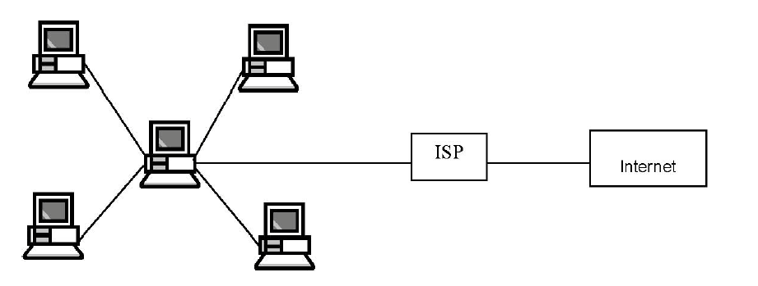
1) The diagram above shows the way the computers are connected at Francis & Francis with the central computer in the diagram representing the Francis & Francis network server.

a What type of network do Francis & Francis have?

_____________________________________________________________________________

(1 mark)

b What network topology is used at Francis & Francis?

____________________________________________________________________________________________________________________________________________________________

(1 mark)

c What is a NOS, and why do Francis & Francis need one?

____________________________________________________________________________________________________________________________________________________________

(2 marks)

d Choose one of the following transmission media that would be suitable for the Francis & Francis computer network, and give a reason for your choice.
• Twisted pair cable
• Coaxial cable
• Fibre-optic cable
• Infra-red
• Broadcast radio
• Microwave radio

Transmission Medium __________________________________

Reason

____________________________________________________________________________________________________________________________________________________________

(2 marks)

e Francis & Francis believe that their business benefits from having a computer network in place. List two advantages for organisations that could result from putting a computer network in place.

Advantage 1

____________________________________________________________________________________________________________________________________________________________

Advantage 2

____________________________________________________________________________________________________________________________________________________________

(4 marks)

f Mr Francis, one of the senior partners of the company, has recently noticed an unexpected rise in Internet usage for the company. He is becoming suspicious that some of the staff are surfing the Internet for personal use rather than using it for work-related purposes. List two reasons why Mr Francis would not want staff members surfing the Internet for personal use while at work.

Reason 1

____________________________________________________________________________________________________________________________________________________________

Reason 2

____________________________________________________________________________________________________________________________________________________________

(4 marks)

g Mr Francis recently read a report from KeaneOnComputing, the company that supports their computer network. KeaneOnComputing made some recommendations for Francis & Francis. One recommendation was that Francis & Francis’s firewall software should be updated every month. What is a firewall?

____________________________________________________________________________________________________________________________________________________________
(2 marks)

h Why should firewall software be updated regularly?

____________________________________________________________________________________________________________________________________________________________
(1 mark)

i Another recommendation from KeaneOnComputing was that staff members at Francis & Francis needed to follow better procedures for their computer network passwords. List and explain two password procedures that could be followed to help ensure that computer network passwords are secure.

Procedure 1
__________________________________________________________________________________________________________________________________________________________________________________________________________________________________________
(4 marks)

Procedure 2
__________________________________________________________________________________________________________________________________________________________________________________________________________________________________________
(4 marks)
2) Define the following terms giving an example

Data

____________________________________________________________________________________________________________________________________________________________

Information

____________________________________________________________________________________________________________________________________________________________

Primary Data Source

____________________________________________________________________________________________________________________________________________________________

Secondary Data Source

____________________________________________________________________________________________________________________________________________________________

Surveys

____________________________________________________________________________________________________________________________________________________________
(2+2+2+2+2) marks)

3) Describe what spreadsheet software is and what it is used for?

____________________________________________________________________________________________________________________________________________________________
(2 marks)

4) Explain a situation where a spreadsheet solution would significantly assist the user and why.

_______________________________________________________________________________________________________________________________________________________________________________________________________________________________________________________________________________________________________________________

(4 marks)

5) Spreadsheet software allows users to complete Mathematical functions. Describe what this means using an example

_______________________________________________________________________________________________________________________________________________________________________________________________________________________________________________________________________________________________________________________
(4 marks)
6) Spreadsheet software allows users to complete Statistical functions. Describe what this means using an example.

________________________________________________________________________________________________________________________________________________________________________________________________________________________________________________________________________________________________________________________
(4 marks)

7) List one advantage and one disadvantage of the following transmission methods

Transmission Method | Advantage | Disadvantage
Twisted Pair
Fibre Optic
Wireless Radio
Cellular Radio
Infra Red
(10 marks)

8) Describe the following threats to network security giving an example

Accidental Threats

____________________________________________________________________________________________________________________________________________________________
(2 marks)

Deliberate Threats

____________________________________________________________________________________________________________________________________________________________
(2 marks)

Power Surge

____________________________________________________________________________________________________________________________________________________________
(2 marks)

9) Explain 3 roles of a network admin

____________________________________________________________________________________________________________________________________________________________

____________________________________________________________________________________________________________________________________________________________

____________________________________________________________________________________________________________________________________________________________
(3 marks)

10) Describe the role the following devices have in a network.

Modem
Network Interface Card
Wireless Access Point
Switches
Server

(10 marks)

11) Why do issues arise with the use of ICT?

____________________________________________________________________________________________________________________________________________________________
(2 marks)

12) Social networking sites are very popular among students as they provide a medium for their friends to communicate and share personal information. However, problems from using social networking sites have emerged. Describe two negative effects from the use of social networking sites

________________________________________________________________________________________________________________________________________________________________________________________________________________________________________________________________________________________________________________________
(4 marks)

13) Society has seen an increase in Robotics and Artificial intelligence in a variety of different industries in recent years. Describe an ethical, legal and social issue that may arise from an ever growing amount of robotic and automated services.

Ethical

____________________________________________________________________________________________________________________________________________________________

Legal

____________________________________________________________________________________________________________________________________________________________

Social

____________________________________________________________________________________________________________________________________________________________
(2+2+2 marks)

Refer to the information from appendix 1 to answer questions 14, 15 & 16

14) Was the PSN Network breach a deliberate or non deliberate threat? Why?

____________________________________________________________________________________________________________________________________________________________
(2 marks)

15) What data has been reported as stolen? Justify which data you feel has the potential to create the biggest problem?

____________________________________________________________________________________________________________________________________________________________
(2 marks)

16) Describe 3 problems that could arise as a result of this breach?

____________________________________________________________________________________________________________________________________________________________
____________________________________________________________________________________________________________________________________________________________
____________________________________________________________________________________________________________________________________________________________
(3 marks)

