Design:
Spreadsheet shows the following:
- Fonts, sizes and colours for all headings, sub headings and body of table
- Validation rule for table 1 – data in B3:C10 will be decimal numbers <20
- Correct formula shown for total born overseas is =SUM(B15:B21) then fill across
- Correct formula shown for if statement =IF(D26<E26, "increased", "decreased") or something similar – eg. =IF(D26>E26, "decreased", "increased")
Charts show the following:
- Clear heading about the data shown in the chart (Not Chart A)
- Fonts, sizes and colours for all headings, sub headings
- X and Y axis labels
- Shape of the chart (eg. pie, line, bar etc.)

Testing of charts: (suggested solution)
Functionality
The first chart fulfills the required purpose of showing the different age groups of males who had asthma in 2011. The second chart shows a comparison between three diseases, asthma, arthritis and deafness for people born in Australia, as compared with people born overseas. The third graph shows n for each disease in 2005 and the final chart shows two diseases that have increased (in terms of numbers) between 2007 – 2011. All figures have been checked and are accurate and show the data in the best possible way.
Usability
I added titles and percentages to the pie chart so that it was easier to understand as we are printing in black and white instead of colour. I made sure all headings clearly reflected what the charts were about. I also renamed all the tabs at the bottom of the spreadsheet so that any new users would find it easy to locate the correct chart quickly and easily. All axes were labeled so that users could clearly identify what the chart was showing.
Presentation:
I made sure that all titles were of a consistent font and colour. The size of the heading font was made larger from my original design so that it stood out and was easy to see. The types of charts were, I believe, the most appropriate, although I could have swapped my column chart for a bar chart. I believe the colours were easy to distinguish and provided a good contrast between the chart and the backgrounds. I also checked the spelling and made sure there were no mistakes in the title. Dates were also included in the title to improve the overall presentation and usability.
Accessibility/Reliability
The charts that were produced were appropriate to the audience, which was VCE students who are familiar with Excel charts. I believe they would have little difficulty in accessing and understanding the data. The data came from a reliable source, which was the Australian Bureau of Statistics.
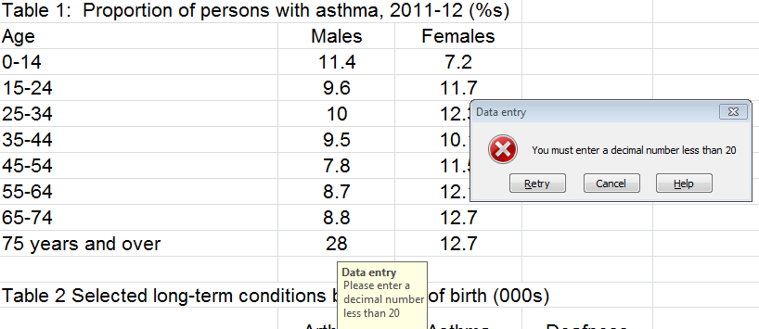
Validation: I set up validation on table 1 so that all values had to be decimals less than 20. Here is my error message:
Evaluation:
1. From chart A, the most prevalent group for asthma in males is boys in the 0-14 age group (11.4%). This decreases as males get older, so by the time they are over 75, the rate is down to 8%.
2. Females show the opposite trend – ie, only 7.2% in 0-14 years, but increasing to 12.7% in later years (over 65)
3. The interesting thing from Chart B is that people born overseas seem to have lower rates of asthma, when compared to the other diseases, eg. deafness and arthritis. In Australian born people, the lowest is deafness then asthma. Both overseas born and Australian born people suffer most from arthritis.
4. Hayfever was the most prevalent disease in 2005, with Diabetes mellitus being the lowest. Chart C shows this very clearly.
5. The biggest increases in the number of people suffering from a long term illness between 2007 – 2011 was hayfever (up by 137,000) and asthma (up by 117,300). Also up were diabetes mellitus and deafness. Arthritis and back pain decreased in terms of numbers.

The main people who would be interested in this data would be health care professionals and government departments such as Medicare, who provide health services for people. The data would allow them to identify trends and therefore better plan for the future.

