IT011 SPREADSHEETS – APPLIED PROCESSING FOLIO TASK 5

LOOKUP TABLES

A LOOKUP table is a way of having all your data in one place (usually at the top of your spreadsheet) and using it to perform mathematical calculations in other parts of your spreadsheet.

Candy’s Lolly shop has a list of all the prices of its products. This is entered into cells A5 – B23. Copy the following onto your new spreadsheet.

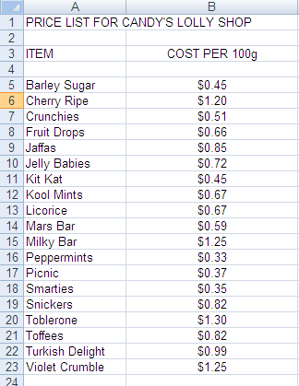
- Format the cells in column B to currency.
- Centre the amounts in Column B.
- Check that you have typed all the items exactly as they appear to the left. Check spelling, also check that you have used the same case (capitals or small letters). Lookup tables won’t work if the item is not spelled correctly.
- It is very important to now sort your spreadsheet, so the lollies are alphabetical. Highlight the data cells from A5 to B 23 and then the sort icon (A-Z) on the top toolbar. Your products should now be in alphabetical order.

- If you forget to do this step, your lookup table won’t work!

- Go to A25 type in the heading: ORDER FOR MRS SWEET TOOTH.

- Type at cell A27 - Item, B27 - Amount ordered, C27 -Price, D27 -Total

- Her order is as follows: Smarties – 500g, Snickers, 200g, Turkish Delight 300g, Mars Bar – 150g, Jelly Babies 1kg. Type this into Columns A & B (row 29). Remember that the prices are per 100g, so 500g = 5, 1kg = 10

- In column C we will use the LOOKUP table to lookup all the prices for these items.

- At C29 type the following formula: =VLOOKUP(A29,$A$5:$B$23,2)

- This formula tells the computer to look up the item in A29 (Smarties) in the lookup table (A5:A23 – with dollar signs to make this an absolute cell reference), then go to column 2.

- Check that the correct price has been identified (0.35). Now you can fill down. Check that all prices are correct, if they are not, check your spelling! Format your column to currency.

- In the Total column, work out how much each item will cost. (Multiply the Price x the Amount ordered). Fill down the rest of the column. Format to Decimal currency.

- Type Sub-Total (B34) and calculate the amount (D34) and then 10% GST (B35) and calculate the amount (D35)

- Finally, type in Grand Total (B36) and the amount (D36). (Add Sub-Total + GST). It should be $15. 89. Check your calculations if you don’t get this figure.

Candy’s Lolly Shop also has orders for the following people:

Mr. Allday Sucker wants: Barley Sugar – 400g, Violet Crumble, 300g, Toffees 1300g, Toblerone – 500g, Licorice - 1kg, Kool Mints – 450 g, and Peppermints – 600g.

Ms. Chocaholic: Jaffas - 700g, Crunchies – 2kg, Kitkats – 500g, Cherry Ripes – 1.3 kg, Picnic – 400g, Milky Bars – 500g and Smarties – 500g.

Dr. D. Kay: Jelly Babies – 300 g, Fruit Drops – 400g, Toffees – 600g, Kool Mints – 3 kg.

- Your job is to show these three customer orders on the spreadsheet (underneath Mrs. Sweet tooth). Don’t forget to add in the GST and the Grand total of each order.

- Make sure your name is on your spreadsheet.

- Print out your work and put it in your folder.

