Name: _________________________________________ 37
Section A – Multiple Choice – 10 marks
- The term quantitative data refers to:
- Graphs and table data.
- opinions data.
- measurable and specific data.
- any data that can be presented in a report.

- The term qualitative data refers to data that is:
- difficult to present visually.
- specific and easy to define.
- easy to measure and categorise.
- often deals with people’s feelings and opinions.

- A text cloud can be used to:
  - visually represent the words from a survey.
  - orally represent the words from a survey.
  - demonstrate the use of phrases and ideas in the sky.
  - illustrate pictorially clouds in the sky.

- A constraint is any factor that:
- influences the nature of the solution.
- limits the usability of a solution.
- causes data sets to be rejected.
- clearly defines what the problem is and what the solution will affect.

- An example of a solution limitation might be:
- effectiveness – is the solution effective?
- completion – will the solution ever be completed?
- timing – does the solution need to be communicated within a timescale?
- efficiency – is the solution efficient?

- Data visualisation can be used in which of the following ways?
- comparing data, distribution of data, relationships between data, and composition of data
- comparing information, distribution of information, relationships between information, and composition of information
- contrasting information, distribution of data, relationships between information, and composition of data
- contrasting data, distribution of information, relationships between data, and composition of information

- A histogram shows how data has:
- not changed over a specific period of time.
- increased over a specific period of time.
- decreased over a specific period of time.
- changed over a specific period of time.

- Scatter charts can be used to show:
- data that only changes against time.
- how various parts comprise the whole.
- composition of data like amount of gases in the atmosphere.
- the distribution of data against a fixed unit, such as time.

- A bubble chart is a variation of:
- a histogram, in which the data points are replaced with bubbles.
- a column chart, in which the data points are replaced with bubbles.
- a pie chart, in which the data points are replaced with bubbles.
- a scatter chart, in which the data points are replaced with bubbles.

- Secondary-source data is gathered from:
- an interview with a person.
- an online survey.
- an observation of a person doing something.
- work published by someone else.

Section B – Short Answer – 27 Marks
- Identify three common constraints that might exist when analysing an information problem.

(3 marks)
- One factor that needs to be taken into account when analysing an information problem is the “scope”. What is meant by “scope”?

(1 mark)

- A local shopkeeper has a laser tracker on the door of their shop. It beeps every time a customer walks through the door to the shop. At the end of the week, the shopkeeper downloads the data from the laser tracker and then spends lots of time looking through the data for patterns.
  - What might this information be used for?

(2 marks)
  - What form of data visualisation might this shopkeeper use to make meaning out of the data set that he has access to?

(4 marks)
  - What other data sets might be readily available to this shopkeeper?

(2 marks)
  - What types of relationships can this shopkeeper create to make business decisions?

(2 marks)
- Provide an example of how you might evaluate a data visualisation to demonstrate efficiency.

(2 marks)

- Explain how you would test for clarity in a data visualisation.

(2 marks)

- In 1786, William Playfair, a Scottish economist, published the image shown in below, a graph comparing exports from England with imports into England from Denmark and Norway from 1708 to 1780
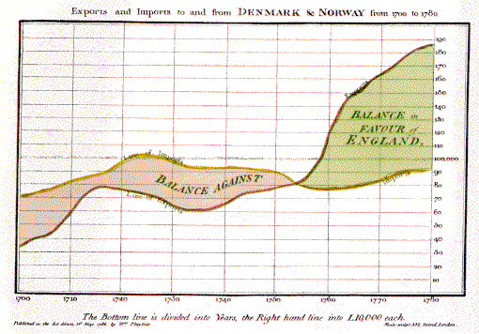
- The graph shows time on the horizontal (x) axis & money in English pounds on the vertical (y) axis.
- The yellow line shows the monetary value of imports to England from Denmark and Norway
- The red line shows the monetary value of exports to Denmark and Norway from England.

Playfair’s graph displayed a powerful message very succinctly. In that at some point in time – something important happened.
    - Approximately what year did the important event happen?

(1 mark)
    - What is the event that happened?

(2 marks)

- Data visualisations can be used to
- compare data,
- show data distribution
- show relationships between data.
Place the type of visualisation (chart) in the list below in the correct location of the Venn diagram.
Note: Some types of visualisations (charts) can be used for more than 1 purpose.

pie chart, comparative map, histogram, scatter chart, bubble chart, word cloud

Charts that show Distribution of Data

Charts that are used to Compare Data

Charts that show Relationships between data

(6 Marks)

