VCE INFORMATION TECHNOLOGY

UNIT 1 OUTCOME 1

DATA TO INFORMATION



REVISION NOTES

**Outcome 1**

Select data from data sets, design solutions and use a range of spreadsheet functions to develop solutions that meet specific purposes.

**Key Knowledge**

1. Stages of the problem-solving methodology

2. Purposes for creating solutions, for example to inform, to entertain, to educate, to persuade

3. Data types, including integer, floating point numbers, character, string

4. Techniques for identifying relevant data

5. Purpose and functions of graphic representations

6. Applications and capabilities of spreadsheet software

7. Design elements that influence the appearance and effectiveness of graphic representations

8. Design tools for representing the functionality and appearance of solutions, including graphic representations

9. Spreadsheet software functions and techniques for efficiently and effectively manipulating and validating data

10. Formats and conventions applied to solutions in order to improve their effectiveness in meeting specific purposes

11. Techniques for testing solutions

|  |
| --- |
| **1. Stages of the problem solving methodology** |

**Required**

**1. Draw** the Problem-Solving Methodology diagram

|  |
| --- |
|  |

**2. Explain** the purpose of the Problem-Solving Methodology

_____________________________________________________________________

_____________________________________________________________________

_____________________________________________________________________

**3. Discuss** why the Design stage occurs before Development

_____________________________________________________________________

_____________________________________________________________________

_____________________________________________________________________

|  |
| --- |
| **2. Purposes for creating solutions for example to inform, to entertain, to educate, to persuade** |

**Required:**

**1.** For each of the following information products, **state** whether the main purpose is to:

1. Entertain

2. Inform

3. Educate

4. Persuade

|  |  |
| --- | --- |
| **Information Product** | **Purpose** |
| Social Network DVD |  |
| World of Warcraft |  |
| Mobile Phone Bill |  |
| Movie Cinema Website |  |
| Year 10/11 Formal Invitation |  |
| Blockbuster Video Online Catalogue |  |
| The Age Website |  |
| Online Driving Simulator |  |
| Vodafone Web Banner Advertisement |  |
| Online Newsletter |  |
| IPhone Weather App |  |
| IT Revision Notes Document |  |

|  |
| --- |
| **3. Data types including integer, floating point numbers, character & string** |

**Required:  
  
1. Define** the term ‘Data Type’. **Give** an exampleto support your answer

_____________________________________________________________________

_____________________________________________________________________

_____________________________________________________________________

_____________________________________________________________________

**2. Explain** what is meant by the term ‘Floating Point Number”

_____________________________________________________________________

_____________________________________________________________________

_____________________________________________________________________

**3.** For each of the following **state** which the most appropriate data type is

|  |  |
| --- | --- |
| **Data** | **Data Type** |
| Nine |  |
| 0.3456 |  |
| 56 |  |
| Y |  |
| Y/N |  |
| YTU 789 |  |
| $4.95 |  |
| Address |  |

|  |
| --- |
| **4. Techniques for identifying relevant data** |

**Required:**

For data to be relevant it must be useable

**1. List** the five elements that data requires to be considered useable

_____________________________________________________________________

_____________________________________________________________________

**2.** For each scenario listed below **identify** the useable characteristic missing

|  |  |
| --- | --- |
| **Scenario** | **Characteristic** |
| The data downloaded was in a format not compatible with the current data |  |
| The column chart was create in a spreadsheet solution where no validation was used |  |
| Peter quoted is his essay economic data from 15 years ago |  |
| The online review of running shoes was written by a sports manufacture |  |
| The data was sourced from a website that nobody had ever heard of before |  |

**3. Describe** how a the design of a spreadsheet may be affected if the audience was mainly made up of and older audience

_____________________________________________________________________

_____________________________________________________________________

_____________________________________________________________________

_____________________________________________________________________

|  |
| --- |
| **5. Purpose and functions of graphic representations** |

**Required:**

**1. Discuss** two reasons why data should be presented in a graphical format

_____________________________________________________________________

_____________________________________________________________________

_____________________________________________________________________

_____________________________________________________________________

**2.** For each of the following types of graphs **explain** when they would be most appropriate

|  |  |
| --- | --- |
| **Graph** | **Appropriate** |
| Column |  |
| Line |  |
| Pie |  |
| Bar |  |
| Area |  |
| Scatter |  |

|  |
| --- |
| **6. Applications and capabilities of spreadsheet software** |

**Required**

**1. Define** the term “Spreadsheet”

_____________________________________________________________________

_____________________________________________________________________

_____________________________________________________________________

**2. List** five applications of Spreadsheets

_____________________________________________________________________

_____________________________________________________________________

**3. Label** the following on the spreadsheet below

Cell Formula Bar Worksheet Active Cell

Column Row Function Wizard Conditional Formatting

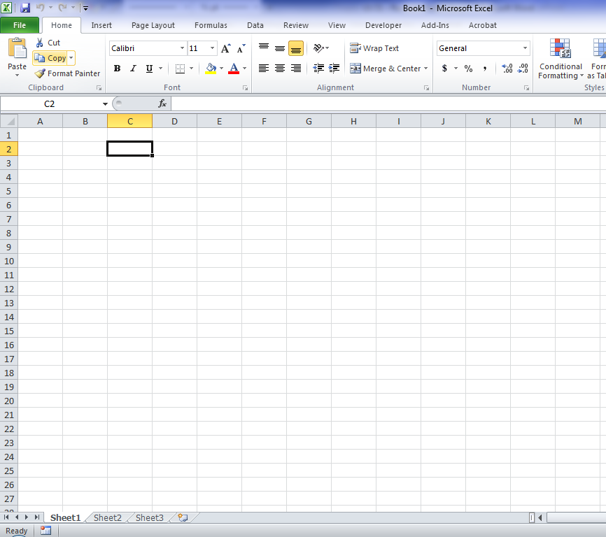

|  |
| --- |
| **7. Design elements that influence the appearance and effectiveness of graphic representations** |

**Required**

**1. Explain** why it is important to incorporate design elements into a solution

_____________________________________________________________________

_____________________________________________________________________

_____________________________________________________________________

**2. List** seven design elements

_____________________________________________________________________

_____________________________________________________________________

_____________________________________________________________________

**3. Describe** how two design elements have been used in the spreadsheet shown

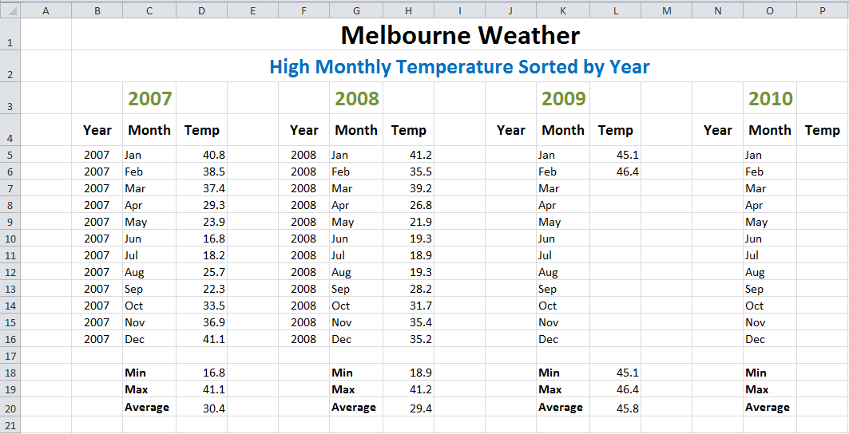

_____________________________________________________________________

_____________________________________________________________________

_____________________________________________________________________

_____________________________________________________________________

|  |
| --- |
| **8. Design tools for representing the functionality and appearance of solutions**  **including graphic representations** |

**Required:**

**1. Identify** the main advantage of completing a design

_____________________________________________________________________

_____________________________________________________________________

_____________________________________________________________________

**2. Explain** the purpose of a layout diagram

_____________________________________________________________________

_____________________________________________________________________

_____________________________________________________________________

Melbourne Car Sales wish to create a graph showing the trend in the number of cars sold over the last 12 months

**3. Create** an annotated layout diagram showing an appropriate solution

|  |
| --- |
|  |

|  |
| --- |
| **9. Spreadsheet software functions and techniques for efficiently and effectively manipulating and validating data** |

**Required:**  
**1. Explain** how a function is different to a formula

_____________________________________________________________________

_____________________________________________________________________

_____________________________________________________________________

**2. Explain** how a workbook is different to a worksheet

_____________________________________________________________________

_____________________________________________________________________

_____________________________________________________________________

A user is about to re-use the spreadsheet shown below

**3. Discuss** how the spreadsheet will help the user in terms of effectiveness and efficiency

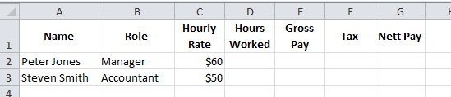

_____________________________________________________________________

_____________________________________________________________________

_____________________________________________________________________

_____________________________________________________________________

|  |
| --- |
| **10. Formats and conventions applied to solutions in order to improve their effectiveness in meeting specific purposes** |

**Required:**  
**1. Define** the term ‘format’

_____________________________________________________________________

_____________________________________________________________________

**2. Define** the term ‘convention’

_____________________________________________________________________

_____________________________________________________________________

**3.** From the spreadsheet below **identify** two formats and two conventions used



_____________________________________________________________________

_____________________________________________________________________

_____________________________________________________________________

_____________________________________________________________________

|  |
| --- |
| **11. Techniques for testing solutions** |

**Required:**  
**1. Explain** the purpose of testing

_____________________________________________________________________

_____________________________________________________________________

_____________________________________________________________________

**2. List** the ten attributes of effective output

_____________________________________________________________________

_____________________________________________________________________

_____________________________________________________________________

_____________________________________________________________________

3. For each scenario **identify** the missing attribute

|  |  |
| --- | --- |
| **Scenario** | **Attribute** |
| The spreadsheet is missing data for 2012 |  |
| The information was based on data that came from a unknown source |  |
| The formula to calculate the total cost of the air ticket was incorrect |  |
| The workbook opens on the wrong worksheet |  |
| The user cannot understand the validation used |  |
| The graph produced is hard to understand |  |
| It takes four weeks to process the data into information |  |