## Bacchus Marsh Grammar



**Semester Two Examination 2011**

**Information Technology**

Name:

Teacher: Mr Pike

Date: ?? /11/2011

Time Allowed: 15 minutes reading

120 minutes writing

Instructions:

**The Paper consists of Two Sections:**

* Multiple Choice Questions Part A
* Short Answer Questions Part B

Answer all multiple-choice questions on the answer sheet provided. Place your answer sheet inside this booklet at the end of the examination.

**Short Answers** are to be written in the space provided under the question.

* Students are to write in blue or black pen.
* A scientific calculator may be used in this examination
* No communication is allowed during the examination.

**Marking Scheme:**

Multiple Choice Questions: 20 Marks

Short Answer Questions: 100 Marks

________

Total: 120 Marks

**Section A.** 20 marks

Answer all questions by marking the correct answer on the multiple choice answer sheet.

**Question** **1**

For which of the following information solutions would a site map be the most suitable design tool?

1. Web site
2. Word Processed document
3. Database
4. PowerPoint presentation

**Question 2**

Which task is NOT part of the **Development** stage when creating a VB program?

1. Producing an algorithm
2. Coding
3. Validation
4. Testing

**Question 3**

I wish to store the number of students at BMG in a VB variable called num_studs. The most appropriate variable type for num_studs would be

1. boolean
2. single
3. text
4. integer

**Question 4**

A new staff member arrives at BMG and they require a login and email account. The person who is most likely to do this task would be a

1. Programmer
2. Network administrator
3. Technician
4. Systems Analyst

**Question 5**

The main purpose of testing a website is to

1. check that the links work
2. check that images load correctly
3. check the spelling on the website
4. all of the above

**Question 6**

I write a VB program to calculate wages for the hours worked. Most people work 7.5 hours per day, but the maximum anyone can work is 16 hours and I need to validate the hours entered. The most suitable set of test data of hours to see if my validation works would be

1. 7.5, 16, 25
2. 15, 24, 25
3. -16, 0, 7.5
4. 16, 24,100

**Question 7**

Which of the following is NOT an example of a convention?

1. Results of a test put into a table
2. Currency in a spread sheet having 2 decimal places
3. A website with links down the left hand side
4. A Word document with page numbers in the footer.

**Question 8**

The most appropriate type of data visualisation to show the change in data over time is a

1. pie chart
2. bubble chart
3. line graph
4. column graph

**Question 9**

In VB I type the following lines of code as part of a procedure to determine whether a student passes or fails a test. Line numbers are not part of the program.

1 IF MARK >50 THEN

2 MSGBOX(“you have failed”)

3 ELSE

4 MSGBOX(“you have passed”)

END IF

When I run the program with some test data, I get the wrong message.

The most likely line containing the error would be

1. 1
2. 2
3. 3
4. 4

**Question** **10**

Which of the following is NOT an outcome of visualising data?

1. Comparing sets of data
2. Showing a distribution of data
3. Showing a relationship between sets of data
4. Producing a spread sheet of data

**Question** **11**

A webpage would be considered to be efficient if

1. It was fast to load
2. It contained accurate information
3. It didn’t take long to develop
4. The information on the webpage was relevant

**Question 12**

I create a checkbox on the form of a VB program to enter the gender of a person. Which of the following would be a **Property** of the checkbox, which I could use in a program to stop a person changing it once they tick the checkbox?

1. .false
2. .enabled
3. .true
4. .hide

**Question 13**

I wish to prepare a data visualisation on the number of people in Bacchus Marsh who drive too fast. A method of data collection which provides a primary source of data would be

1. count the number of cars going past you too fast
2. look up the RACV website and get statistics on cars in Bacchus Marsh
3. ask a policeman how many traffic fines they give out in Bacchus Marsh
4. use the TAC website to see how many road accidents occur due to speeding motorists in Bacchus Marsh.

**Question** **14**

I have been asked to create a school website which will allow parents to see the marks of their students. Due to a lack of testing, parents can see the marks for all students in a particular class. This can be best described as

1. An issue of trust
2. An issue of testing
3. A copy right issue
4. A privacy issue

**Question 15**

A tool which can be used to determine user satisfaction with a program I wrote could be

1. survey
2. interview
3. SMS feedback form
4. All of the above

**Question** **16**

Which of the following is NOT a convention that is applied to data visualisations?

1. Easy to read fonts
2. Heading at the top of the chart
3. Labels on Axes
4. Citing the source of the data

**Question 17**

A Gantt chart can be used for

1. Determining the critical path of a project
2. Determining the resources needed for a project
3. Determining the completion date of a project
4. All of the above

**Question** **18**

Which of the following is NOT a constraint I need to consider when producing a data visualisation?

1. The age of the intended audience
2. The time I have available to produce the visualisation
3. The reliability of the source of the data
4. The software I have available to produce the visualisation

**Question 19**

The information system in an organisation is performing poorly. The person you would get in to make recommendations to improve the situation would be a

1. systems Analyst
2. programmer
3. technician
4. all of the above



**Question 20.** The above data visualisation shows the number of Google searches for bars by region in the USA. The size of the circle indicates the number of searches. The main problem with this visualisation is

1. size of the map
2. overcrowding
3. lack of colour
4. all of the above

**Section B** Answer all questions 100 marks

**Part 1 ICT Terminology**

**Question**1

Give a definition for each of the following ICT terms which clearly demonstrates your understanding of the term.

**a**. Boolean _________________________________________________________

_____________________________________________________________________

**b.** Syntax error _________________________________________________________

______________________________________________________________________

**d.** Validation ___________________________________________________________

______________________________________________________________________

**e**. Data Visualisation _____________________________________________________

______________________________________________________________________

**f**. ICT pathway (used in careers advice)_______________________________________

_______________________________________________________________________

**g**. Dependency ___________________________________________________________

_______________________________________________________________________

**h.** Milestone ____________________________________________________________

_______________________________________________________________________

**i.** Data Validation ________________________________________________________

_______________________________________________________________________

**j.** Data Integrity _________________________________________________________

______________________________________________________________________

**i.** Efficiency ___________________________________________________________

______________________________________________________________________

( 10 x 1 mark )

**Part 2 Programming**

A VB program is shown below to find the smaller of two numbers. The numbers at the start of each line are not part of the program. The code below should be used in questions 1 – 4.

Private Sub btncompare_Click(ByVal sender As System.Object, ByVal e As System.EventArgs) Handles btncompare.Click

1 Dim A, B As Single

2 A = Val(txtA.text)

3 B = Val(txtB.text)

4 If A > B Then

5 MsgBox("A is the smallest number")

6 Else

MsgBox("B is the smallest number")

7 End If

End Sub

**Question 1**

Explain the function of each line of the program.

1 _________________________________________________________________________

2 _________________________________________________________________________

3 _________________________________________________________________________

4 _________________________________________________________________________

5 _________________________________________________________________________

6 _________________________________________________________________________

7 _________________________________________________________________________

( 7 marks )

**Question** **2**

There is a mistake in the program. Identify the mistake and rewrite the line to fix the problem.

___________________________________________________________________________

___________________________________________________________________________

___________________________________________________________________________

(2 marks )

**Question 3**

I want to test the program. Complete the testing table below giving the test data and expected output of the code before you fix the problem in Q2.

|  |  |  |
| --- | --- | --- |
| **Test description** | **Test data** | **Expected output** |
| First number is larger |  |  |
| Second number is larger |  |  |
| The same numbers |  |  |

( 3 marks )

**Question 4**

Assume you are going to use a text box to enter each number and a label to display the output each time you press the calculate button. Design a suitable form for this program.

( 4 marks)

**Question 5**

A programmer has been given the flow chart below to develop a VB program. He first wants to test the flowchart. Identify the output (Print) of the flowchart for the following input.

( 3 marks)

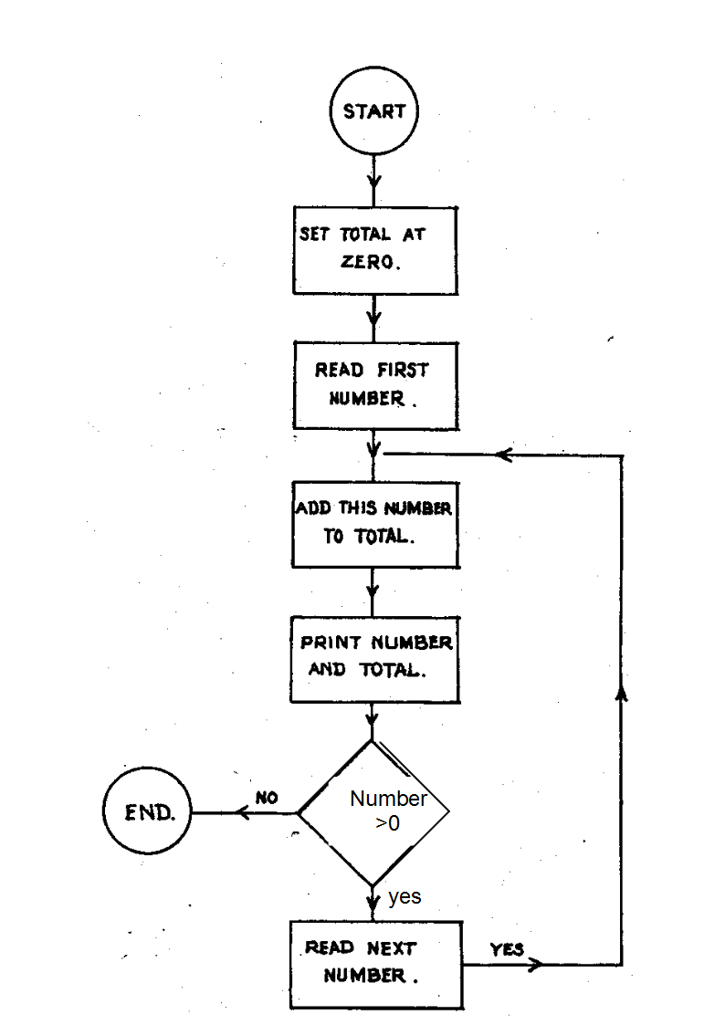**Input numbers**

5, 10, 0

**Output**

Below is a copy of the proposed code for the flowchart in question 5

DIM total as integer

Private Sub Btncalc_Click(ByVal sender As System.Object, ByVal e As System.EventArgs) Handles Btncalc.Click

Dim number As Integer

Number= val(txtnum.text)

Do While number > 0

*******************

lbltotal.text=total

Msgbox(“Please enter the next number”)

Number= val(txtnum.text)

Loop

End Sub

**Question 6**

Why is the DIM total statement above the Private sub line? ____________________

___________________________________________________________________ ( 1 mark)

**Question7**

What should the line *************** be to add the number onto the total?

___________________________________________________________________ (1 mark)

**Question 8**

Both total and number are Integers. Describe a possible problem with this type of variable. __________________________________________________________________________

__________________________________________________________________ ( 1 mark)

**Question 9**

Suggest a better variable type for both total and number _____________________ ( 1 mark)

**Question10**

What would happen to the program if you didn’t enter a zero at some stage?

__________________________________________________________________ ( 1 mark )

A program has been written to calculate the cost of tickets to a fair. Adult tickets cost $15 and children cost $5.

Private Sub Btncalc_Click(ByVal sender As System.Object, ByVal e As System.EventArgs) Handles Btncalc.Click

' calculation of ticket prices

Dim adults, children As Integer

Dim cost, discount As Single

discount =0

adults = val(txtadults.Text)

children =val(txtchild.Text)

cost = adults * 15 + children * 5

End Sub

**Question 11**

It has been decided to give families a 10% discount if the total cost is over $40. Write the lines of code to apply this discount and display the new cost in a label called lblcost.

_______________________________________________________________________

_______________________________________________________________________

_______________________________________________________________________

_______________________________________________________________________

( 4 marks )

**Question 12**

What is the purpose of the line? ' calculation of ticket prices

_______________________________________________________________________

____________________________________________________________ (1 mark)

**Question 13**

Explain the purpose of the VAL command in the line

adults = VAL(txtadults.Text)

_______________________________________________________________________

________________________________________________________________ (1 mark)

**Part 3 Data Visualisation**

Below is a set of data showing two indicators used to compare countries. The first part of the table compares Australia and Mexico’s annual expenditure ( how much they spend each year) per capita ( per person).

The second set of data compares the percentage of the country’s Gross Domestic Product GDP ( how much the country produces) spent on education.

**I would like to know if the amount spent on education has any effect on household expenditure.**

|  |  |  |  |  |  |  |  |  |  |
| --- | --- | --- | --- | --- | --- | --- | --- | --- | --- |
|  | A | B | C | D | E | F | G | H | I |
| 1 |  | **1980** | **1990** | **2000** | **2005** | **2006** | **2007** |  |  |
| 2 | **Household expenditure per capita** |  |  |  |  |  |  |  |  |
| 3 | [Australia](http://hdrstats.undp.org/en/countries/profiles/AUS.html) | 10776 | 12647 | 15287 | 17449 | 17639 | 18024 |  |  |
| 4 | [Mexico](http://hdrstats.undp.org/en/countries/profiles/MEX.html) | 5476 | 5315 | 7026 | 7790 | 8134 | 8393 |  |  |
| 5 | **Expenditure on education (% of GDP)** |  |  |  |  |  |  |  |  |
| 6 | [Australia](http://hdrstats.undp.org/en/countries/profiles/AUS.html) | 5.1 | 4.5 | 5.0 | 4.8 | 4.8 | 4.7 |  |  |
| 7 | [Mexico](http://hdrstats.undp.org/en/countries/profiles/MEX.html) | 4.6 | 3.6 | 4.9 | 5.0 | 4.8 | 4.8 |  |  |

**Question 1**

Explain how data visualisation can assist in answering my question ( in bold).

( 2 marks)

**Question 2**

Createa formula I could use in H3 to find the average household expenditure per captia for Australia.

(2 marks)

**Question 3**

What method should I use in H4to find the average household expenditure per captia for Mexico?

__________________________________________________________________ ( 1 mark )

**Question 4**

Create a formula I could use in H6 that will show the minimum value for the Expenditure on education

(2 marks)

**Question 5**

From Question 4 above, which year was Australia’s minimum value of Expenditure on education?

(1 mark)

**Question 6**

If I wanted to compare Australia’s and Mexico’s household expenditure per captia for 1980 – 2007,

1. Design the graph you would use showing the heading and labels for the axes.

( 3 marks)

1. Describe why you chose this type of graph.

(2 marks)

**Question 7**

If I wanted to show how Australia’s household expenditure per captia has changed over the years 1980 – 2007,

1. design the graph you would use showing the heading and labels for the axes.

( 3 marks)

1. Describe why you chose this type of graph.

(2 marks)

1. Describe how you could produce an animation to show the same data.

(2 marks)

**Question 8**

The chart below compares the per capita expenditure with the % GDP spent on education for Mexico from 1980 – 2007

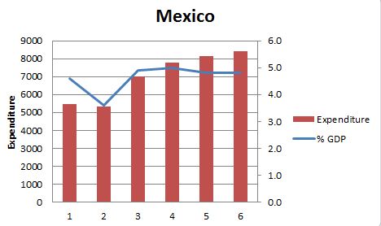

1. Describe what this chart shows in terms of a relationship between expenditure and % GDP in Mexico.

___________________________________________________________________________

___________________________________________________________________________

___________________________________________________________________________

(2 marks )

1. There is a problem with the x axes of this chart. Describe the problem and explain how you could fix this problem.

___________________________________________________________________________

___________________________________________________________________________

___________________________________________________________________________

(2 marks )

1. Describe why I have used two vertical axes on this chart.

___________________________________________________________________________

___________________________________________________________________________

___________________________________________________________________________

(2 marks )

**Question 9**

The data visualisation below shows the number of health professionals in Africa



1. Identify two conventions used in this visualisation

__________________________________________________________________________

___________________________________________________________________________

____________________

1. Identify two formats used in this visualisation

________________________________________________________________________

________________________________________________________________________

(4 marks)

**Part 4 Problem Solving**

BMG senior school is concerned about the Internet safety of their students and has hired you to produce a website about Internet safety. They are concerned about privacy on Facebook, chat rooms and other online identification students give including photos of themselves. This website would be available at school to help our students stay safe online. The school has asked you to develop the website.

**Question 1**

List **two** characteristics of your audience that will affect your design of the site. For each characteristic, explain what effect it will have on how you choose to design and produce the site.

Characteristic 1 _________________________________________________________

Effect on site

______________________________________________________________________

Characteristic 2 _________________________________________________________

Effect on site

_______________________________________________________________________

(4 marks)

**Question 2**

Describe **two** criteria you would use to evaluate the success of the site.

_______________________________________________________________________

______________________________________________________________________

(2 marks)

**Question 3**

Describe what you would do at each of the following stages of the Problem Solving Methodology as you produce the website. ( 4x1 = 4 marks )

|  |  |
| --- | --- |
| Problem Solving Stage | Description |
| Analysis |  |
| Design |  |
| Develop |  |
| Evaluate |  |

**Question** **4**

You decide to use a cascading style sheet (css) in the development of the webpage. Describe one advantage of using a css.

___________________________________________________________________________

___________________________________________________________________________

(1mark)

**Question** **5**

Design a frameset in the space below which could be used on the website and show the contents of each frame for the home page.

( 4 marks)

**Question** **6**

You have asked two of your friends to assist you in building the website. Describe one **collaboration** tool that you could use and discuss how it would help the team work collaboratively?

________________________________________________________________________

________________________________________________________________________

________________________________________________________________________

(2 marks)

**Question** **7**

After viewing your webpage, Mr. Richardson has decided to make it available to students on the web. Explain how the website could be made available on the Internet?

__________________________________________________________________________

__________________________________________________________________________

_________________________________________________________________ (2 marks )

**Question 8**

The production of the website will be managed as a project. The task table below shows the tasks, how long the tasks will take and the predecessors for each task.

Assuming you will not work on Saturday or Sunday and you start on Monday, complete the Gantt Chart for this project. Include any milestones.

|  |  |  |  |  |  |  |  |  |  |  |  |  |  |  |  |  |  |
| --- | --- | --- | --- | --- | --- | --- | --- | --- | --- | --- | --- | --- | --- | --- | --- | --- | --- |
|  | **Task** | **Length** | **Pred** | M | T | W | T | F | S | S | M | T | W | T | F |  |  |
| A | Start Project | 0 |  |  |  |  |  |  |  |  |  |  |  |  |  |  |  |
| B | Project Planning | 1 |  |  |  |  |  |  |  |  |  |  |  |  |  |  |  |
| C | Website design | 3 | B |  |  |  |  |  |  |  |  |  |  |  |  |  |  |
| D | Principal approval | 1 | C |  |  |  |  |  |  |  |  |  |  |  |  |  |  |
| E | Create website | 4 | D |  |  |  |  |  |  |  |  |  |  |  |  |  |  |
| F | Test website | 1 | D |  |  |  |  |  |  |  |  |  |  |  |  |  |  |
| G | Principal approval | 1 | E |  |  |  |  |  |  |  |  |  |  |  |  |  |  |
| H | Upload website | 1 | G |  |  |  |  |  |  |  |  |  |  |  |  |  |  |
| I | Finish project | 0 | H |  |  |  |  |  |  |  |  |  |  |  |  |  |  |

(4 marks)

**Question** **9**

Not counting weekends, how long will the project take? _________ days (1 mark)

**Question** **10**

What tasks are on the critical path? ____________________________________ (2 marks)

**Question** **11**

What will happen to the finish date if the web creation (E) takes 5 days?

_______________________________________________________________ (1 mark)

**Question** **12**

What will happen to the finish date if the Principal approval (G) takes 2 days?

________________________________________________________________ (1 mark)

**Question** **13**

Identify two advantages for a business in using Project Management techniques to manage a project.

1. _____________________________________________________________________

_____________________________________________________________________

2. _____________________________________________________________________

_____________________________________________________________________

(2 marks)

******** End of exam paper *******