Pseudocode and NS representations in SD exams 2007-2010

2007 Question 12
The following IF statement needs to be tested.
IF b > 10 AND b < 20 THEN
PRINT b
ENDIF
The best set of test data for b to test this algorithm is
A. 10, 11, 15, 19, 20
B. 8, 9, 10, 11, 20
C. 9, 10, 12, 20, 21*
D. 8, 9, 10, 20, 21
2007 Q17
Question 17
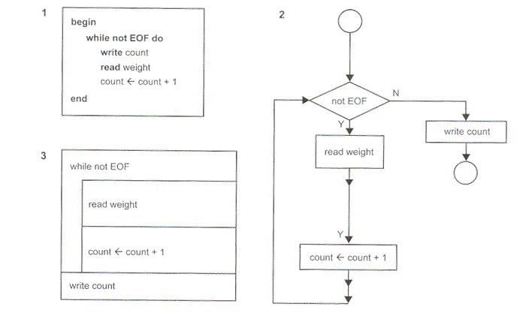
Which statement about diagrams 1, 2 and 3 is true?
A. The algorithm represented by diagram 1 is the same as that represented by diagram 2.
B. The algorithm represented by diagram 2 is the same as that represented by diagram 3.*
C. The algorithm represented by diagram 3 is the same as that represented by diagram 1.
D. All three diagrams represent the same algorithm.
2007 Section C
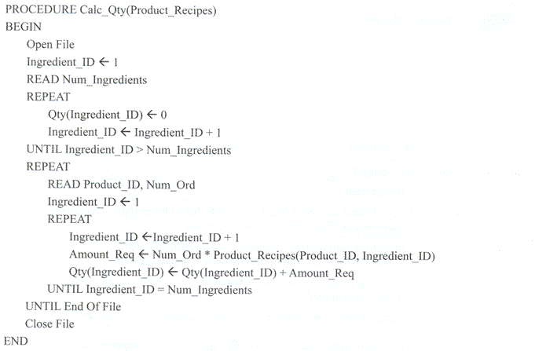

2008
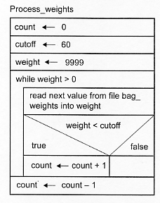
The algorithm Process_weights has been designed to process data contained in a file called bag_weights.
Question 6
The algorithm is to be tested using a pencil and paper. It is assumed that bag_weights will contain the test data: 55, 77, 60, 0, 58.
At the end of the test the final value in variable count will be
A. -1
B. 0
C. 1
D. 2
Answer is D.

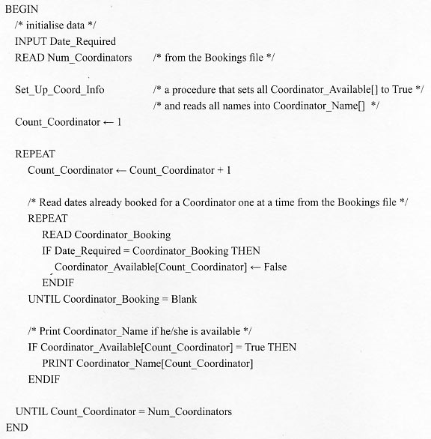

2009
Question 19
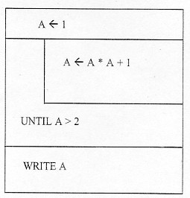
The output for the Nassi-Shneiderman diagram above would be
A. 2
B. 3
C. 5
D. 6
Answer is C.

Function Check_Length(Timber_Length, LengthRequired)
Begin
If Timber_Length > Length_Required Then
Return true
Else
Return false
End if
End

2010
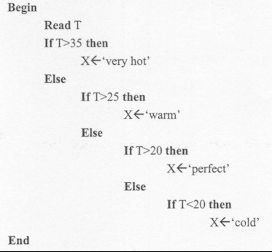

Question 7
Test the above algorithm with the value T=25. The variable X will contain
A. 'cold'
B. 'warm'
C. 'perfect'
D. 'very hot'
Answer is C.

Question 19
Below is part of an algorithm that reads and checks passwords. It is to be represented as a Nassi-Schneiderman diagram.
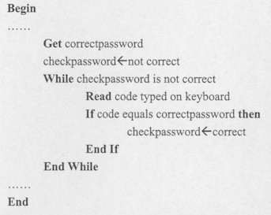
Which diagram shows the correct structure for this part of the algorithm?
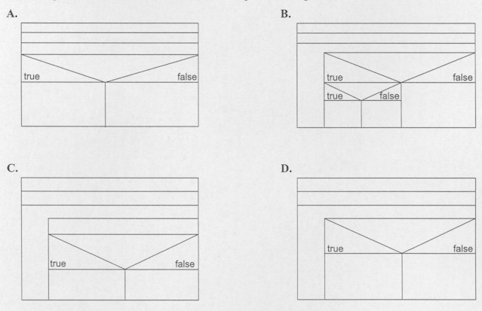
Answer is C.
Question 9
During the trial it was found that when nurses changed their passwords for the portable devices the program failed and they were locked out. Investigation found that entering certain characters caused the problem, so it was decided to limit the passwords to just alphabetic letters and numbers. Suzie has suggested the algorithm below to validate a new password before it is stored in the system. She must now test it.
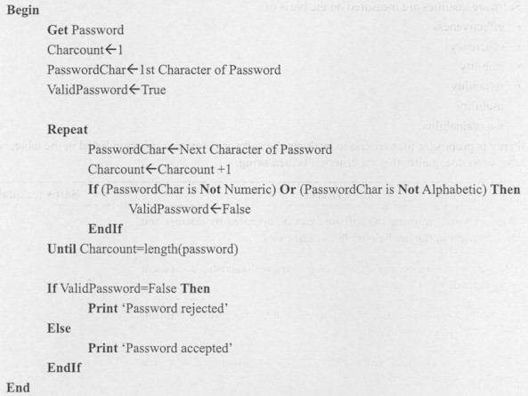
Suzie created the test data shown below.
a. For each item of data, give a reason for why that data was chosen.
Test data | Reason for choosing it
12a | It's a valid password and should be accepted by the program
*la | Finds invalid character at the beginning of the password
l*a | Finds invalid characters anywhere in the middle of the password
la* | Finds invalid character at the end of the password
4 marks
Question 10
a. For the algorithm in Question 9, complete the test table below showing what output is expected from the test data and what it actually produces.
Test data | Expected output | Actual output
12a | Password accepted | Password rejected
*la | Password rejected | Password rejected
l*a | Password rejected | Password rejected
la* | Password rejected | Password rejected
2 marks

