Unit 2 Outcome 1
Data Visualisation SAC

Your school canteen has decided to start serving students a range of healthy breakfast cereals before school. You have been asked to investigate the properties of different breakfast cereals and to make a recommendation as to what would be the best in terms of whole grains, fat, sugar, fibre and salt.

- Analysis - go to http://www.nutritionlabels.com.au/comparisontool.aspx and choose any 10 of the products listed (4 – Sanitarium 1 – Uncle Toby’s 1 - Nestle, 4 – Kellogs). Perform the nutritional analysis on your selected cereals to generate the required information. Copy and paste the information into an Excel spreadsheet (Copy, Paste special, Text). Save your data.

Now print out your data with gridlines (making sure your name is on it)

- Design a series of data visualizations that compare the performances of the different cereals (in all 5 categories). You will need to produce five different visualizations using the following tools. Draw up preliminary designs for b, c and d (below) using an appropriate design tool. This must be completed before it is attempted on the computer.

- A Wordle (available at http://www.wordle.net/) using the names of the breakfast cereals you chose.
- Using Excel – a chart that shows a comparison of wholegrain per 100g for each cereal. (use a median figure if there is a range – ie, 90-100% = 95%)
- A table which rates each cereal in terms of fat, salt and sugar, using the ‘traffic light” system described below. You will have to decide on the software used, as well as the appearance and layout of the table.

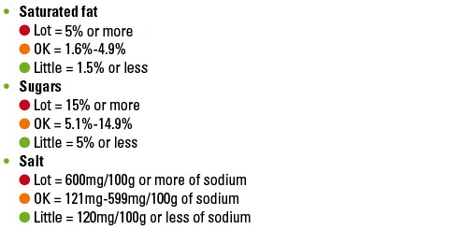

- Many eyes – a comparison of the fibre content in each cereal.
- MS Auto Collage or Freemind – your choice! Use either of these programs to create a suitable visualization which will enhance any aspect of the information.

- Develop your presentation by incorporating your charts into a Powerpoint Presentation. Slides should be as follows:
  - Title slide with your name
  - Wordle slide
  - Excel chart slide
  - Table slide
  - Many eyes slide
  - Free choice slide (Auto Collage or Freemind)
  - Best cereal slide – which of the cereals would you recommend? Give the canteen a list of your top 3 and explain why.
  - Worst cereal slide – which of the cereals would be the worst in terms of nutritional value? Give the canteen a list of your worst 3 and explain why.

Now print out your PowerPoint, one slide per page.

- Evaluate – write your answers to the following questions in full sentences (in Word).

- Which of your data visualizations do you think is the most effective? Explain why.
- Which of your data visualizations was the least effective? Explain how it could have been improved.
- Do you think the use of data visualizations made your task of recommending the 3 cereals any easier (ie, more efficient)? Explain why or why not.
- Give an example of where you could use data visualization in the future for your VCE studies (in any of your subjects) and explain how it could be used.

Now print out your evaluation (making sure your name is on it)

Assessment guide: E = Excellent, H = High, M = Medium, L = Low, VL = Very low

Task | Marks | Comments
1. Analysis & print out of data | H L
2. Designs | H M L
3. Wordle | H M L
4. Excel chart | H M L
5. Table | H M L
6. Many eyes | H M L
7. Free choice | H M L
8. Good cereal | H M L
9. Bad cereal | H M L
10. Evaluation | E H M L

Total: 30 marks

24-30 = A 21-23 = B 18-20 = C 15–17 = D 12-14 = E <12 = N

