Network Revision Booklet
Networks and data communications systems
1 State the advantages of fibre optic cables over coaxial and twisted pair.
- Can maintain signal integrity over great distance.
- Can transfer data at a much faster rate.
2 What are the advantages of networking?
- File, resource, software and hardware sharing.
- Workgroup access, communication.
3 What is the purpose of a network interface card? (NIC)

An NIC enables a computer to connect to a network such as a home network or the Internet using an Ethernet cable with a RJ-45 connector.

4 State what job is done by the server on a network.

A server or host is a computer that ‘serves’ information to other computers, such as common files an programs. Client computers, can connect to a server through either a LAN or WAN.

5 Do some research to find the name of the largest WAN in the world.
The internet is technically the world’s largest WAN

6 List three types of cable used in a network.

Coaxial
Twisted Pair
Fibre Optic

7 What is a client in relation to a client/server network?
A client is a computer or device that makes a service request from the ‘server’.
A client server setup is often used for the STAR network topology.

Network topologies
1 Sketch three diagrams showing a bus, a star and a ring network topology.
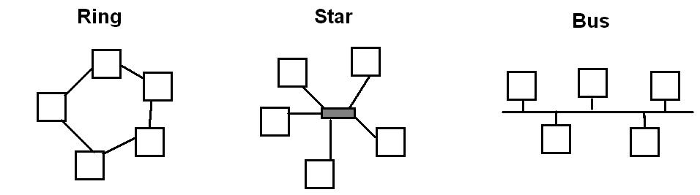

2 Describe the effect of a break in each of the network types in Question 1.
Ring: complete loss of network
Star: loss of network to node that is broken.
Bus: Depending on where the break is, total loss of network or just one node.
3 What does TCP/IP stand for? Briefly describe what it is.
Transmission control protocol/internet protocol: a set of protocols developed for the internet in the 1970s to get data from one network device to another
4 In the context of an Ethernet network, what is a ‘collision’?
When two or more devices send data simultaneously and it ‘collides’ resulting in the data requiring a repeat send.

5 If five computers are all connected together via a physical Ethernet in order to share files and internet connection, how many cables would be required for the whole network?
6
6 Outline a few situations in which a LAN be most suited to operate?
At home when multiple devices need to communicate with each other.
In an office or school “” “” “”
7 What is a WAN and when is it used?
A network that includes computers spread across a large geographical distance, usually involving several cities, states or countries.

Networking (Mixed Questions)
1 What is the purpose of a network operating system (NOS)?
An operating system that contains components and programs that allow a computer on a network to serve requests from other computers for data and provide access to other resources such as printer and file systems.

2 Give the names of two mainstream network operating systems.
Novell
Windows NT

3 Define and explain the term FTP.
File transfer protocol: protocol that allows users to copy files between their local system and any system they can reach on the network

4 Where do wireless access points most commonly get placed and why?
High on walls or on the ceiling
To minimise structural interference with the radio signals being transmitted and received.

3 What is a protocol? Give and en example of a protocol in your answer.
Rules determining the format and transmission of data. eg. TCP/IP

4 Describe a typical home network’s hardware and software.
Computer, modem/router/ UTP Ethernet connections, laptops, Wireless routers.
(Anything involving these key words above)

5 Explain what a Token Ring LAN is. Is it used today? Explain your answer.
Token ring local area network (LAN) technology is a local area network protocol that uses a single “token to designate which computer can transfer information.
It is not really used today as much more efficient and effective methods are widespread.

6 A small desktop publishing business employs a secretary, two salespeople, three editors/graphic artists and four production staff. Write a brief account to explain how networking the office computer might benefit the business.

Students need to include a variety of networking benefits such as File, resource, software and hardware sharing, workgroup access, communication.

Design of networks
1 A university with campuses in various suburbs of Melbourne and Geelong wants to set up a computer network between its campuses. State the type of network it will need, using a classification based on the geography of the campuses.
WAN so that all campuses can be included in the network.

2 You have just setup a wireless internet connection at your home. You are now configuring your router. What sort of security would you install to deter unauthorised access? Why?
WPA or WPA2 with a complicated passphrase to ensure no unwanted users can utilise my connection or hack my network.

3 What would be the most efficient way to physically connect all computers at your home?
Using twisted pair Ethernet cables.

4 Describe what communications software is.
Software that provides remote access to systems and exchange files and messages in text, audio and/or video formats between different computers or users.

5 What is the fastest known physical transmission media? Describe what it is made of.
Fibre optic cable: a cable made of optical fibres that can transmit large amounts of information at the speed of light

6 Describe the most commonly used physical transmission media.
Twisted Pair, which is a relatively low-speed transmission medium consisting of 8 individually insulated wires, grouped into pairs and arranged in a regular spiral pattern.

7 What is a Hub? How is it different from a router?
A hardware device providing the interconnection between networked devices.

It does not provide an internet connection (unless a modem is connected to it) and it does not directly send specific information to a designated device. It mearly repeats the signal to all devices connected.

8 What are the risks of leaving a wireless router unsecured? Give an example of the possible ramifications.
- Unwanted users my waste your designated downloads.
- Private information may be stolen.
- Your computer may be remotely controlled and used for malicious purposes.

9 What is a DFD?
A data flow diagram.

10 Name and draw the 4 key elements of DFDs. Eg. The first has been done for you.
1 Process 2 Data flow

3 Data store 4 Source or entity.

11 Name the 3 levels of DFDs covered in class.
context diagram
level 0
level 1
12 Draw an example of a first level DFD below from the following information.

A business has an online ordering web site for customers to purchase stock.
