Year 11 Visual Basic Programs
Do the “VB Hello Around The World” exercise.
- a) Using radio buttons to select an attraction, write a program to show the location and country of the following tourist attractions. Show appropriate headings.
Attraction | Location | Country
Eiffel Tower | Paris | France
Taj Mahal | Agra | India
Terracotta Army | Xian | China
Hoover Dam | Nevada | USA
Matterhorn | Zermatt | Switzerland

b) Using radio buttons to select a team, write a program to show information about different teams. Select 4 teams. The information to be shown should include: Team nickname (eg Melbourne- Demons); team colours; team captain; team coach. Show appropriate headings.
Team | Nickname | Colours | Captain | Coach
Melbourne | Demons | Blue and red | David Neitz | Neale Daniher
Geelong | Cats | Blue and white | Tom Harley | Mark Thompson
Richmond | Tigers | Yellow and black | Kane Johnson | Terry Wallace
Essendon | Bombers | Red and black | Matthew Lloyd | Kevin Sheedy

2) Write a program to perform the following calculations when the user clicks on a corresponding SHOW ANSWER button.
3 x 7 + 8 ÷ 4
6² x 9
12 ÷ (6 – 4) + 8 x 3
7 - (6 - 3) x 8
5⁶ ⁻ ² – 3⁵

Do the “Temperature Converter” exercise.
3) Write a program to calculate the area and circumference of a circle.

4) Write a program to ask for 4 numbers and to calculate the sum, product (multiply them all), and average of the numbers.

Do the “Calculator Program” exercise.
5) Write a program to perform the selected conversion when the convert button is clicked.
The formulas are as shown:
Number entered (textbox)
Converted result (label)
Fahrenheit to celcius: C = (Fahrenheit – 32) x 0.56
Celcius to fahrenheit: F = 1.8 x Celcius + 32
Inches to centimetres: C = 2.54 x Inches
Centimetres to inches: I = 0.39 x Centimetres
Grams to ounces: O = 0.04 x Grams
Ounces to grams: G = 28.35 x Ounces
Hint: You will only need 2 variables: one for the number entered and one for the result.

Do the “Test Comments” program exercise.
- Create a program to accept a percentage and then tell you the grade using the information below:
A score over 80
B score between 70 and 79
C score between 60 and 69
D score between 50 and 59
E score between 40 and 49
F under 40
You will need to use IF statements as shown below to check between 2 values (in this case 20 and 29).
If score >= 20 and score <= 29 then….

Do the “Coin Toss” program, and the optional extension.
- Write a program to play Rock, Paper, Scissors. The computer’s selection and winner are to be displayed in the labels below the radio buttons (See below).
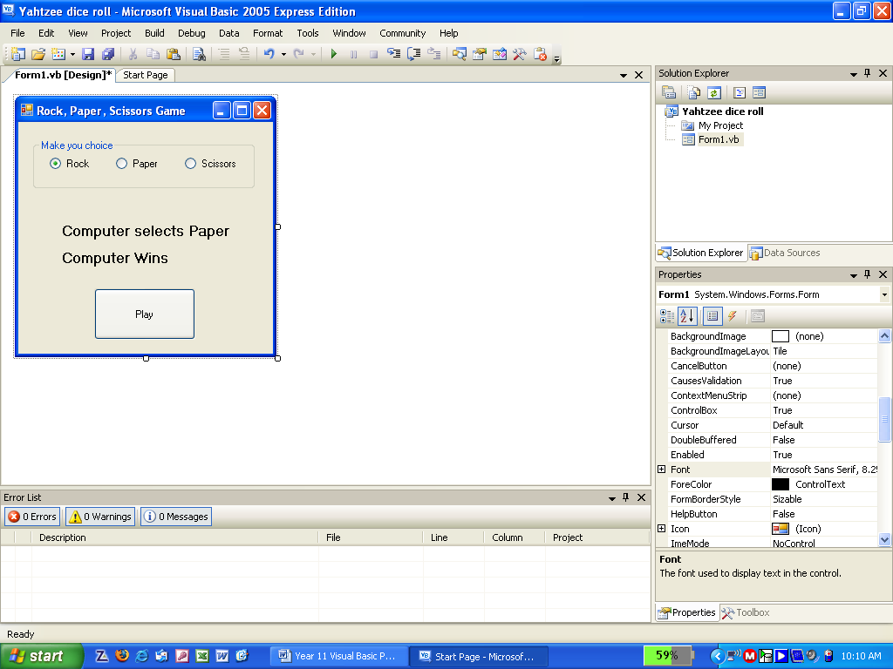
Note:
- Rock beats scissors.
- Paper beats rock.
- Scissors beats paper.

- Write a program to simulate rolling 5 dice, as in the game Yahtzee. The player can select the dice they want to keep using checkboxes (in toolbar). The next time they roll only the unchecked dice should be rolled again.
Note:
- We are only simulating dice rolling, not the entire game.
- They have an unlimited number of rolls.
- Checkboxes work similarly to radio buttons, but you can select as many as you like.

- If you want a challenge ask your teacher about the In-N-Out Burger program.

