VB Hello Around The World
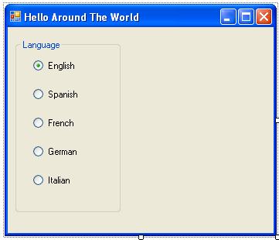
frm_helloworld
grp_language
rdb_english
rdb_spanish
rdb_french
rdb_german
rdb_italian
lbl_helloworld

- Create the form above using radio buttons, labels and group box.
- Name the objects and set the text as shown.
- Change the font for lbl_helloworld.
- Set the text for lbl_helloworld to a blank- you will not see the label on screen after this.
- Set the CHECKED property for rdb_english to TRUE.
- Double click on rdb_english and type the code below:
lbl_helloworld.text = “Hello World”
- Complete the other buttons using the information below:
In Spanish the translation is: Hola Mondo
In French the translation is: Bonjour Le Monde
In German the transltion is: Hallo Welt
In Italian the translation is: Ciao Mondo
- Run the form.

