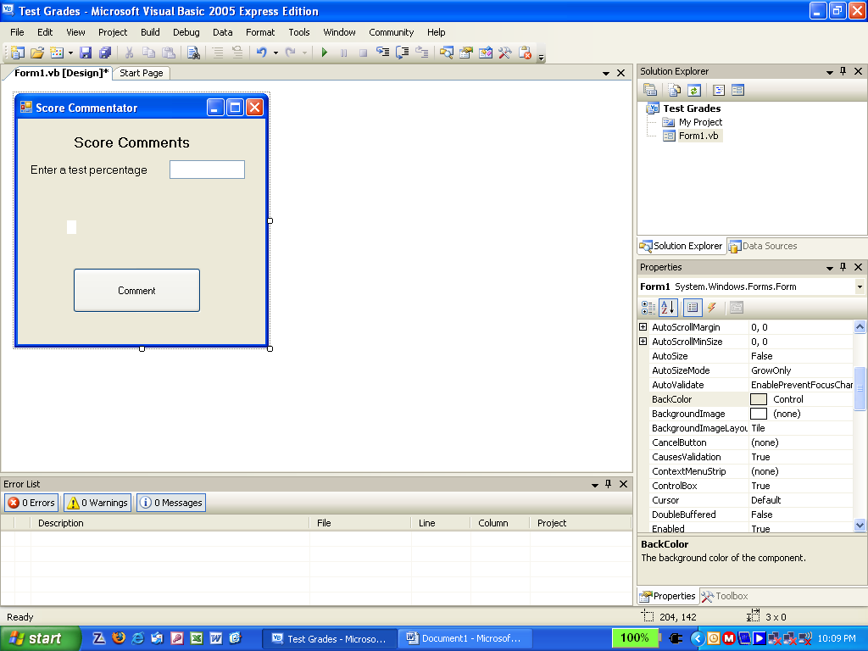
Test Commentator
Txt_score
Lbl_comment
- Create the form shown above, applying appropriate names to objects.
- Type the following code for the comment button.

Dim testnum As Single = Val(txt_score.Text)
If testnum > 70 Then
lbl_comment.Text = "Good job!"
Else
lbl_comment.Text = "Work Harder"
End If

