Temperature Converter
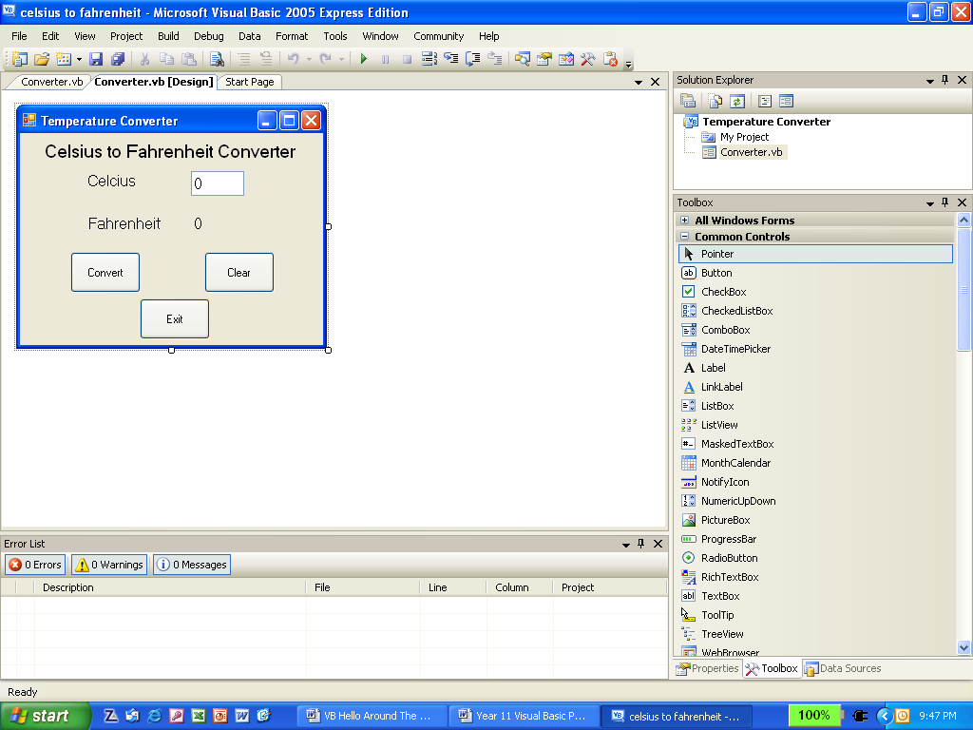
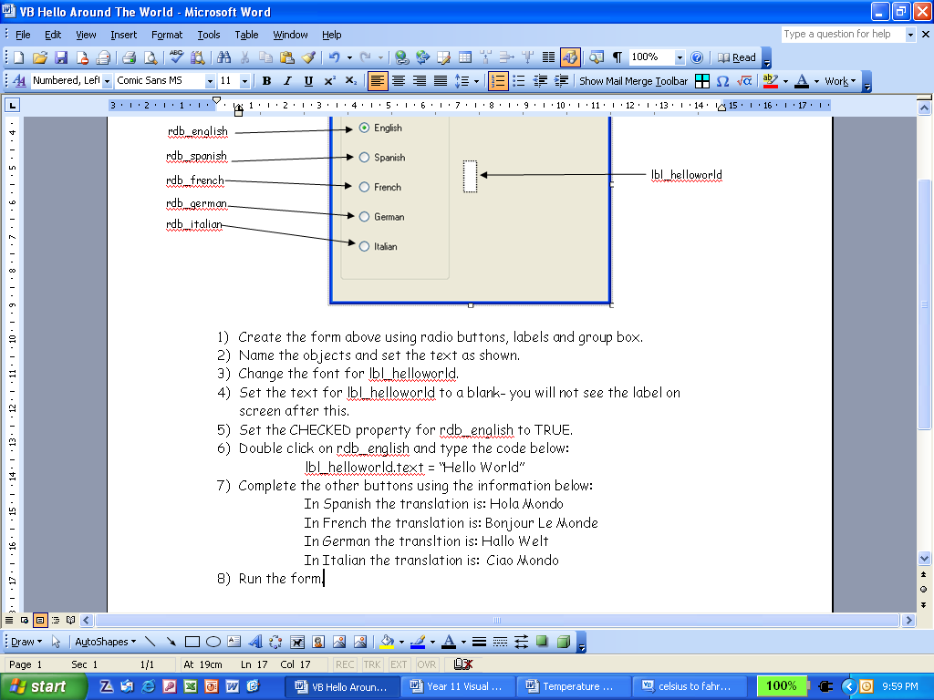
frm_converter
lbl_celcius
lbl_fahrenheit
btn_convert
btn_exit
btn_clear
lbl_heading
lbl_converted
txt_celcius

- Create a form with the objects as shown above.
- Change fonts and colours as needed.
- Double click on the clear button and write the following code:
txt_celcius.text = 0
lbl_converted.text = nothing
- Write the code for the exit button.
Create a variable to store answer
Create a variable to store data entry
Perform calculation
Put answer into label (to 2 decimal places)
- Write the following code for the convert button:
dim fahrenheit As Single
dim celcius As Single = Val(txt_Celcius.Text)
fahrenheit = celcius * 9 / 5 + 32
lbl_converted.Text = Format(fahrenheit, "0.00")
- Run the program.

