Coin Toss
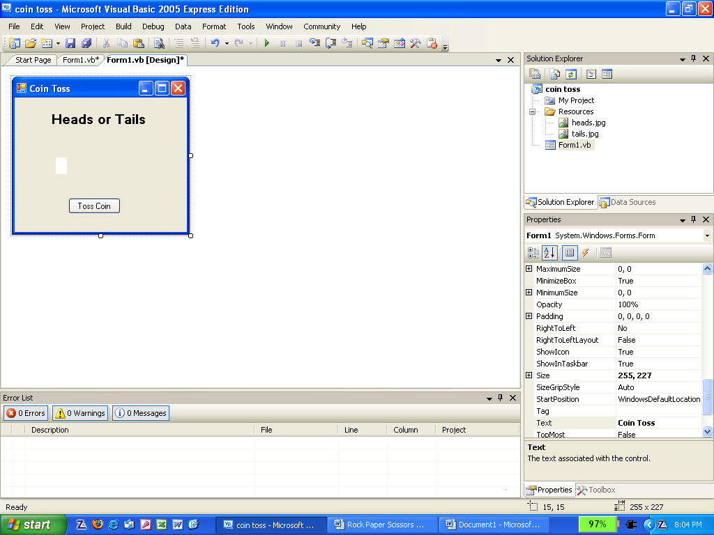
This program is designed to simulate a coin toss using random numbers.
Lbl_toss
- Create the form shown above using appropriate object names.
- The following code for the “Toss Coin” button:
- Uses randomize() to ensure that the number selected is totally random.
- Selects a number between 1 and 2, for heads or tails respectively.
- Displays the result.
Variable for random number
Dim toss As Integer
Randomize()
toss = Int(1 + Rnd() * 2)
If toss = 1 Then
lbl_toss.Text = "Heads"
Else
lbl_toss.Text = "Tails"
End If

Note:
To select a random number use:
Int(Low + Rnd()* (High – Low + 1))
Where High is the highest number wanted and Low is the lowest number wanted.

This means that to select a number between 5 and 20 you will get:
Low = 5
High - Low + 1
= 20 – 5 + 1
= 16
Int(5 + Rnd() * 16)
Extension:
- Copy the heads and tails images to your solution folder for this project.

- Add a picture box to your form and call it pic_coin.

- Add the following code to the beginning of your Toss Coin button:
Dim heads As String = "PATH\heads.jpg"
Dim tails As String = "PATH\tails.jpg"

- PATH needs to be the folder location of your images.

- Use:
pic_coin.Image = Image.FromFile(heads)

to display the heads image at the appropriate time.

- Get the tails image to appear at the appropriate time.

