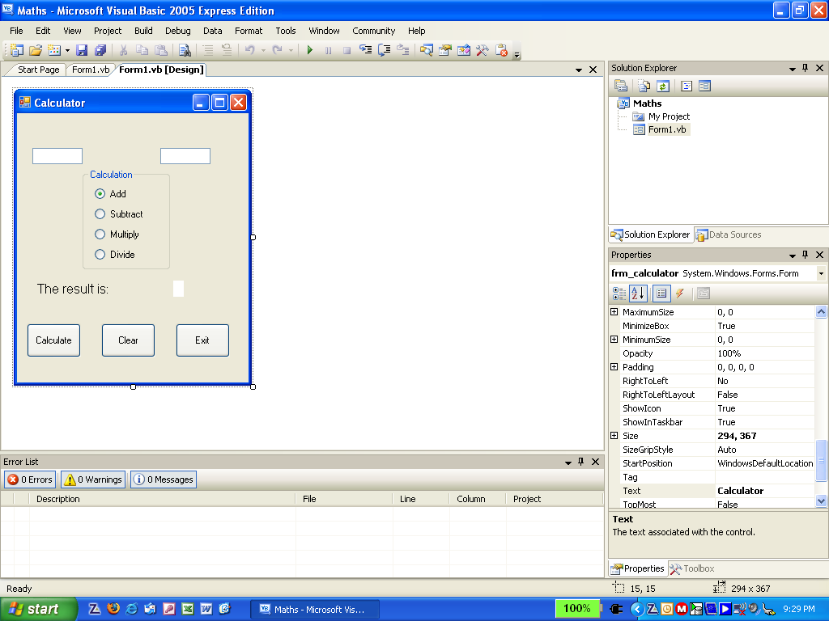
Calculator Program
Txt_num1
Txt_num2
Rdb_add
Rdb_multiply
Rdb_subtract
Rdb_divide
Frm_calculator
Lbl_statement
Lbl_result
Btn_calc
Btn_exit
Btn_clear
Grp_calculate
- Create the form shown above.
- Set the checked property for rdb_add to true.
- Write code to exit the program.
Create variables to store data entry
- Write code to clear txt_num1, txt_num2 and lbl_result.
- Write the following code for the calculate button.

Dim num1 As Single = Val(txt_num1.Text)
Dim num2 As Single = Val(txt_num2.Text)
Create variable to store calculation result
Dim result As Single

If rdb_add.Checked = True Then
result = num1 + num2
Perform addition if rdb_add selected
End If
If rdb_subtract.Checked = True Then
result = num1 - num2
End If
If rdb_multiply.Checked = True Then
result = num1 * num2
End If
If rdb_divide.Checked = True Then
result = num1 / num2
End If
Display final result
lbl_result.Text = result

