Access TUTORIALS

Exercise 1
Steps:
1. Open a blank database and Save As Exercise 1.
2. Click onto the Tables tab → Create Table By Entering Data
3. Double click on Field1, rename this column Name. Then rename the following fields to: Surname (Field2), DOB (Field3), Gender(Field4), IceCream (Field5) AFL (Field6) and Email (Field7).
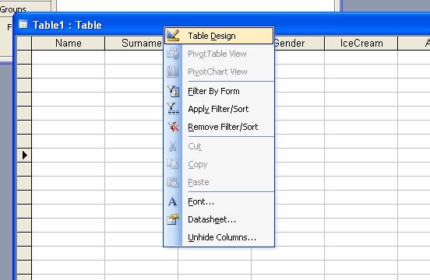
4. Right click on the blue bar of the window (as shown) → Table Design

5. Rename the table Exercise 1.
6. Click Yes to the primary key pop up.
7. Change the DOB field to the data type Number.
In the Input Mask type in: ##\-##\-####
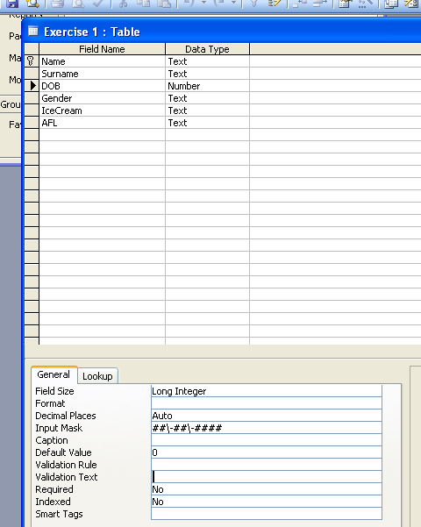

8. In Gender, change the Field Size to 1.
9. For the field name Gender, write in the description: Male (M) or Female (F)?
10. In the Description of the field IceCream, write: Favourite ice cream flavour. Write: Supports which AFL team? for the description of the field name AFL.
11. Save the table.
12. Right click onto the blue bar → Datasheet view

Questions
1.
(a) What is the difference between the data type memo and text?
(b) Give an example of memo data.
(c) Give an example of text data.

2.
(a) What is the purpose of an input mask?
(b) What would be the formula to ensure that the year of birth is in the range 1900’s? (hint: see step 7)

Exercise 2
1. Open Exercise 1 and Save As Exercise 2.
2. Enter in 10 new people to your database.
3. Save and exit the table.
3. File → Get External Data → Import → Subject Groups (G drive) → Year 11 → Info Tech → Unit 1 → Access → exercise 2.xls → Import
4. Another window comes up → Next → Check that the First Row Contains Column Headings is ticked → Next → Select in Existing Table → Find Exercise 2 → Finish.
5. Now go back to the main menu and select Exercise 2 again. You will notice that you have 15 more data entries.
6. Click onto any cell in the IceCream field name with the word Vanilla → right click → Filter by Selection

Questions
1.
(a) What do you noticed when Filter By selection was selected?
(b) Suggest an advantage to using Filter By Selection.
Exercise 3
1. Open postcode.dmb.
2. Using Filter By selection to answer the questions for this exercise.

Questions
1. How many suburbs are there in this database?
2. How many states have the suburb Brighton?
3. What is the postcode for the town Banana?
4. How many suburbs are there in Victoria?
5. How many suburbs have a delivery office in Templestowe?
6. How many PO boxes are there in Sydney?
7. How many GPO boxes are there in Melbourne?
8. What is the postcode for the world trade centre?
9. List the suburbs that share the postcode 3127?
10. How many suburbs share the same postcode as Geneva?
11. What is Filter By Selection?

Exercise 4
1. Open postcode.dmb and Save As Exercise 4.
2. Click onto the Queries tab → Create Query By Using Wizard
3. Move the fields: Pcode, Locality and DeliveryOffice to the selected fields (as shown below) → Finish
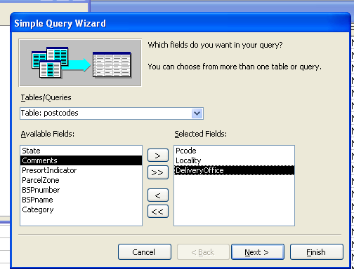

Question
1. What is the purpose of a Query?

Exercise 5
1. Open camp.dmb .
2. Save As Camp.dmb in your folder.

The Camp database contains information for a camp syndicate in America. This database contains information of all the members and employees of the camp.

3. Have a look at the tables that are in the Table Tab. Click onto the Relationships icon (shown below). OR Tools → Relationships…
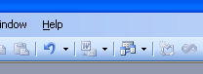

(Answer Q1)
4. Close the Relationships window.
5. Press on the Queries tab → Create Query By Using Wizard
6. Under Tables/Queries, select Table: Members → Bring the following field names across to the Selected Fields: FirstName, LastName, DateOfBirth, EmrgcyContactName and EmrgcyContactPhone.
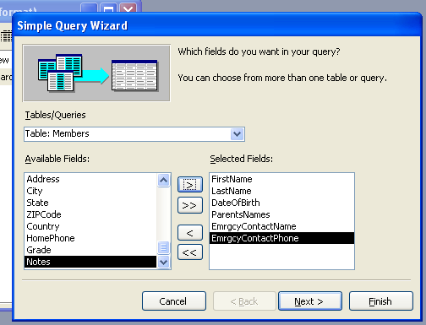

7. Now choose the Registration Table and select MemberID and HealthIssues → Finish
8. Another table is produced, showing all the field names that you have selected.
9. Close this table.
10. Rename the Query to Emergency Contact Info, by clicking once on the Query table.

Question
1.
(a) What is the purpose of the Relationship button?
(b) What is the field name that is linked between the Registration and Employees?
(c) What is the field name that is linked between the

2. Suggest 2 advantages to creating a Query.

Exercise 6
1. Open camp.dmb (the file that you saved in Exercise 5)
2. Create 2 more queries
* One query on the camp member’s T-shirt size
*and the other on the camp member’s personal information
Each Query must have at least 4 different fields.
Make sure they are appropriately labelled.

Exercise 7
1. Open camp.dmb (from Exercise 6)
2. Click onto the Forms tab → Create by Using Wizard.
3. Selected the following field names:
CampID, CampCode, CampName, Location, Price, Description, Notes
4. Once all of the field are found → select Tabular → Choose a colour/style → name the form Camp Info → Finish
5. Right Click any where on the form → Form Design
This is where you can add images onto the form (Eg. Company logo).
6. Move the Detail bar down, so that there are about 3 rows of boxes between the Form Header and Detail section (as shown).
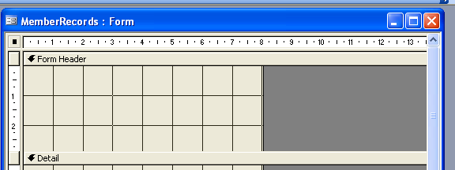

7. Click the Label icon. Draw a rectangular box in between the space of the Form Header and Detail. Type in the text: Camp Information.
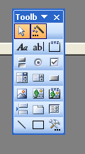

8. (Camp Information will now become the heading for the form).
Choose an appropriate font size and colour.
9. Right Click anywhere on the dark grey part of the page → Form view.
10. Now enter the following information onto your form:
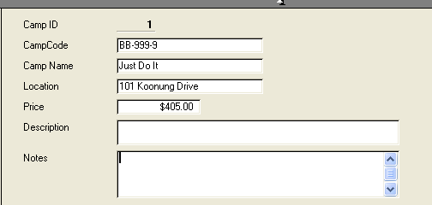

11. Make up a short description of the camp.
12. At the bottom of the form click
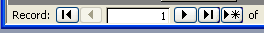

This button adds the new information into the database.

Question
1. Suggest 3 ways that a form could be used.
2. In Access, suggest 3 ways of entering in data.

Exercise 8
1. Open camp.dmb (from Exercise 7)
2. Make 2 more forms.
* One form takes in personal information of the campers
* and another form takes in payment details of the campers
All forms must have at least 5 field names.

Exercise 9
1. Open camp.dmb (from Exercise 8)
2. Click on the Reports tab → Create Report Using Wizard
3. Selected the following field names:
CampCode, CampName, Location, Price, Description, Notes
4. Click Next.
5. Add CampName to the top of the grouping level → Next
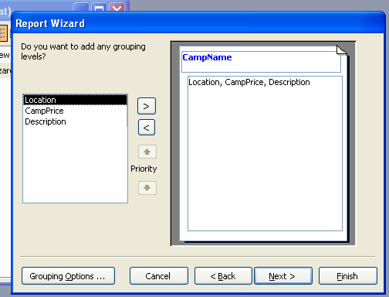

6. Sort the camp prices in Ascending order → Next
7. Stepped layout → Next.
8. Choose a colour/style → Next.
9. Name it Camp Information.
10. Now create a list of camper’s Emergency Contact Details.
Your report must have at least 5 fields

Question
1. What is the purpose of a report.
2. Suggest 3 ways that a report could be used.

