Year 11 Information Technology
Unit 2 Outcome 1

Due Date:

Part A.
1. READ THE FOLLOWING INFORMATION

Lucky Pizza is a take-away pizza bar. TEN standard pizzas are available ($11 each) and customers can choose from a range of extra toppings (50c each topping). Unfortunately too many errors creep into the calculations and the owner requires a program that will calculate the price of any pizza order.
In particular Lucky Pizza wants an interactive program the employees can use easily. Given the basic pizza order, extra toppings required and number of pizzas, the program must calculate the total price.
The prices must be displayed on the screen.

2. TASKS TO COMPLETE

Part A:

Open a new VISUAL BASIC program. You will need to design 3 forms and add the content shown on the adjoining pages. These forms need to be named:
- PizzaIntro
- PizzaMenu
- PizzaOrder
Part B:
**Weighting 40 out of 80 MARKS**
Referring to the ‘PizzaOrder’ form that you have designed, you need to OPEN a new WORD document and DRAW and LABEL each of the following:
- Layout diagram (page 166)
- IPO chart (page 167)
- Data dictionary (page 167)
- Flow Chart (page 170)
- N-S diagram (page 170)
Summary of how you would test your product (referring to your text) and suggestions of changes that you would make as a result.
You should have observed a number of changes to the PIZZA ORDER form IE. OBJECT CHANGES

Part A: DATA

- Each of your 3 forms should involve the objects outlined below:

FORM 1.
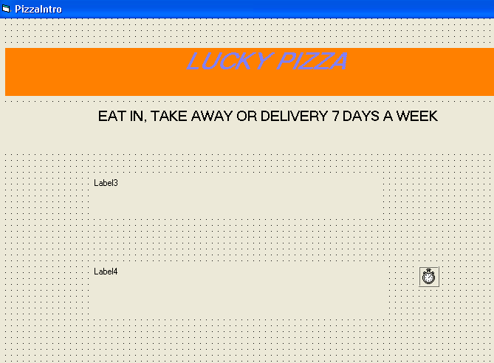
**Name your form PizzaIntro
OBJECTS REQUIRED:
- 4 labels
- 1 Command Button (linked to ‘PizzaMenu’ form)
- Picture/Image boxes (to hold pictures/images)
- 1 Timer (for display of time, day, month & date)

FORM 2.
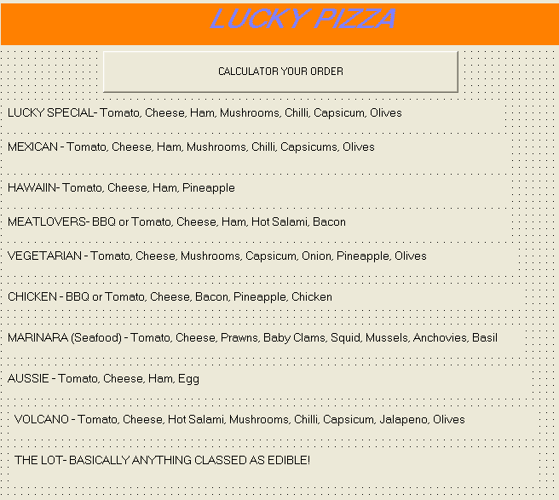

OBJECTS REQUIRED:
- 11 labels
- 1 Command Button (link to ‘PizzaOrder’ form)

FORM 3.
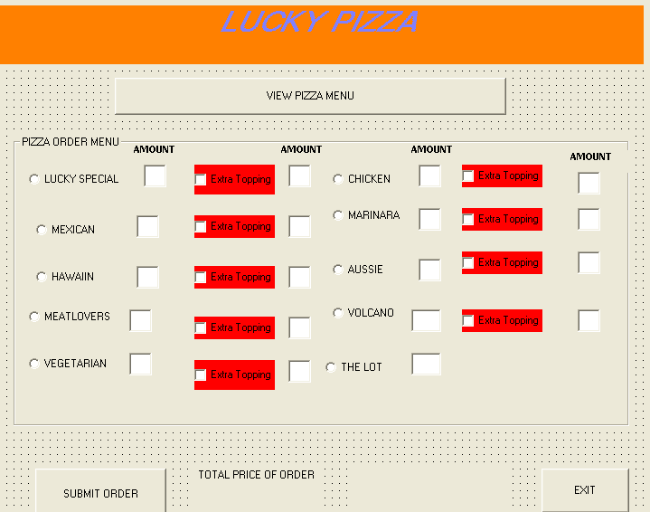

OBJECTS REQUIRED:
- 3 labels
- 10 option buttons
- 9 check boxes
- 3 Command Buttons. NB- These need to (1) Link to ‘Pizzamenu’ form (2) Disable all Option & check boxes (3) ‘End’ the program.

ASSESSMENT CRITERIA
*THEORETICAL – 50% *PRACTICAL (Design of project) – 50%
CRITERIA | Marks allocated | Mark received | COMMENT
Coding/Functions of Project | 20
Inclusion of Objects- textboxes, labelboxes, Checkboxes, Option boxes, timer/s and text from PART A DATA. | 10
Addition of extra functions that address problems involved with customer orders | 10
Layout diagram | 5
IPO chart | 5
Flow Chart | 5
N-S diagram | 5
Data dictionary | 5
Explanation of how you would test your solution (with reference to textbook) | 15
TOTAL /80
GRADE ____________

