IT Unit 2 Outcome 1

Programming Folio

For each of the following tasks, design a solution with pen and paper and then attempt to implement the solution using Visual Basic 6. The tasks begin easily and get more difficult as they continue.

Not everyone is expected to implement all of the tasks. How far you get, and whether you can even design a solution (without actually creating it in VB) are important indicators. Save projects in your home directory in a folder called IT \ U2O1 and name each task appropriately (e.g. task1.vbp)

TASK 1

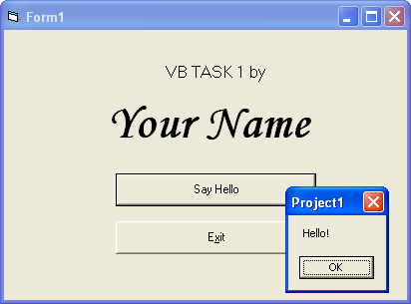
Design, then create a program that looks like the screenshot below. When the button labelled “Say Hello” is clicked, it should say “Hello” as shown. When the Exit button is clicked, the program should end. Save in your home directory.

TASK 2

Design and create a program that shows 3 possible faces. When first run, the face should be neutral (figure 1). When the “Happy”, “Sad” or “Neutral” buttons are clicked, the matching face should appear – and traces of other faces should not be visible!

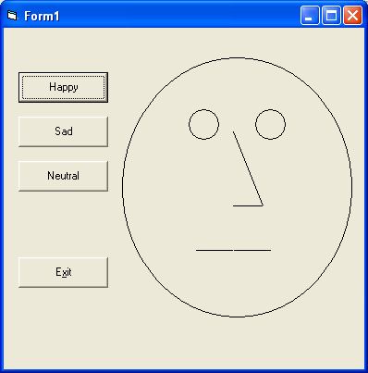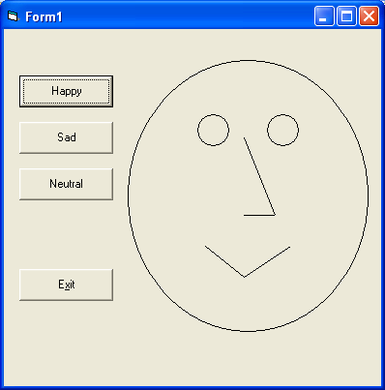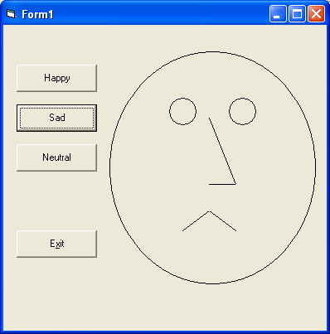

TASK 3
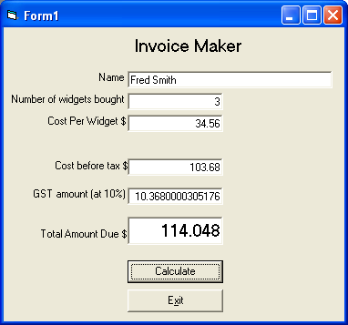
Design and produce a program that lets a user enter a number of items purchased, and a cost per item.
The program should calculate the cost (before tax), the amount of GST (10% of the cost before tax) and the total cost (pre-tax cost + GST).
It should not calculate if the number of items or the cost per item is missing: it should warn the user instead!
Preferably, show dollar amounts as currency (hint: DataFormat property of a textbox).
The exit button end the program.

TASK 4

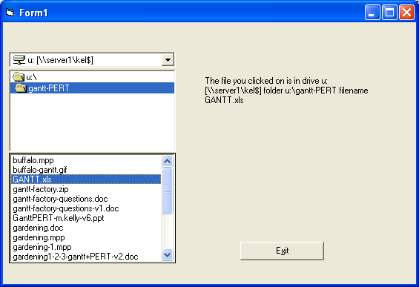
Design and produce a program that lets a user select a drive and subfolder, and then click a filename.
When the filename is clicked, the program announces in a label:
- the drive chosen
- the folder chosen
- the file chosen

The Exit button ends the program.

TASK 5

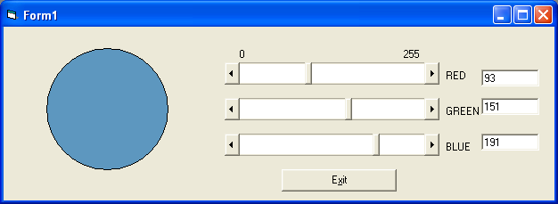
Design and create a program that creates a shape and lets the user adjust its colour (hint: backcolor) by dragging on 3 scrollbars which can set its red, green and blue values between 0 and 255. The values should also be shown numerically beside the scrollbars. The exit button ends the program.

TASK 6

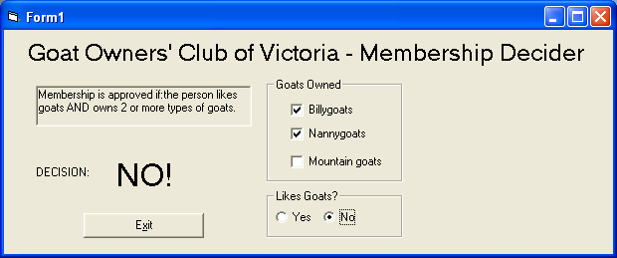
The Goat Owners Club wants an easier way to decide if people should be members. They have decided that membership is approved if a person both likes goats and owns two or more types of goats. Otherwise, membership is refused. Note that there is no “Calculate” button: the decision should be updated whenever any of the relevant data fields are changed!

TASK 7

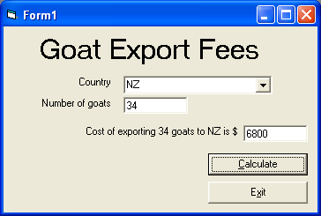
Design and product a Goat Exporting calculator to work out the cost of exporting goats around the world. This data is used to calculate:

Australia = $100 per goat
France = $500 each
NZ = $200
USA = $450.

Use a combo box to select countries. Label the answer to show how it was calculated (as shown).

TASK 8
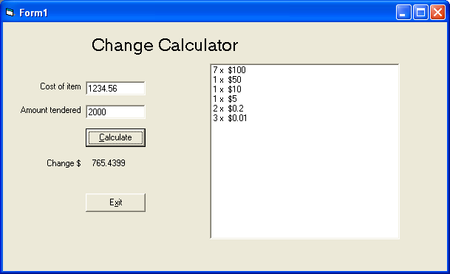
Design and create program that, when given the cost of any item and the amount of money tendered, can tell you the change required and the most efficient way of giving change (i.e. the least number of notes and coins required.)

I’ll let you assume there are 1c coins so you don’t have to round off to the nearest 5c!
For a greater challenge, round the change off before calculating the notes & coins required.

TASK 9 – Are you scared yet?
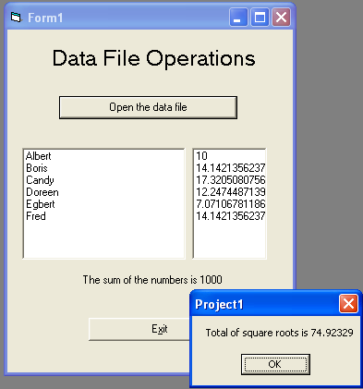
- Design and create a program to read and write from a sequential text file.
- Open the data file r:\it\11it\u2o1\task8data.txt. (Hint - Use CTRL+T to add a commondialog control and use the showopen method to find and open the file.)
- The file contains several lines of data, each one with a name and a number, as shown below.

Albert, 100
Boris, 200
Candy, 300
Doreen, 150
Egbert, 50
Fred, 200

- Read all the lines, add up the total of the numbers and show the answer (it should be 1000).
- Show the names in a list box, and values in a second list box.
- Calculate the square-root each of the numbers and write the names and square roots back to a file called 'task8v2.txt' in your U: drive along with the project for this task. At the end of the file, add your own name and the sum of all the square roots]. It should look like this:

Albert 10
Boris 14.142135623731
Candy 17.3205080756888
Doreen 12.2474487139159
Egbert 7.07106781186548
Fred 14.142135623731
KEL 74.92329

