Robotics Student Guide
Open the “Introduction to Mobile Robotics - Quickstart”.
Using the list of menus under Basics, work through the list.
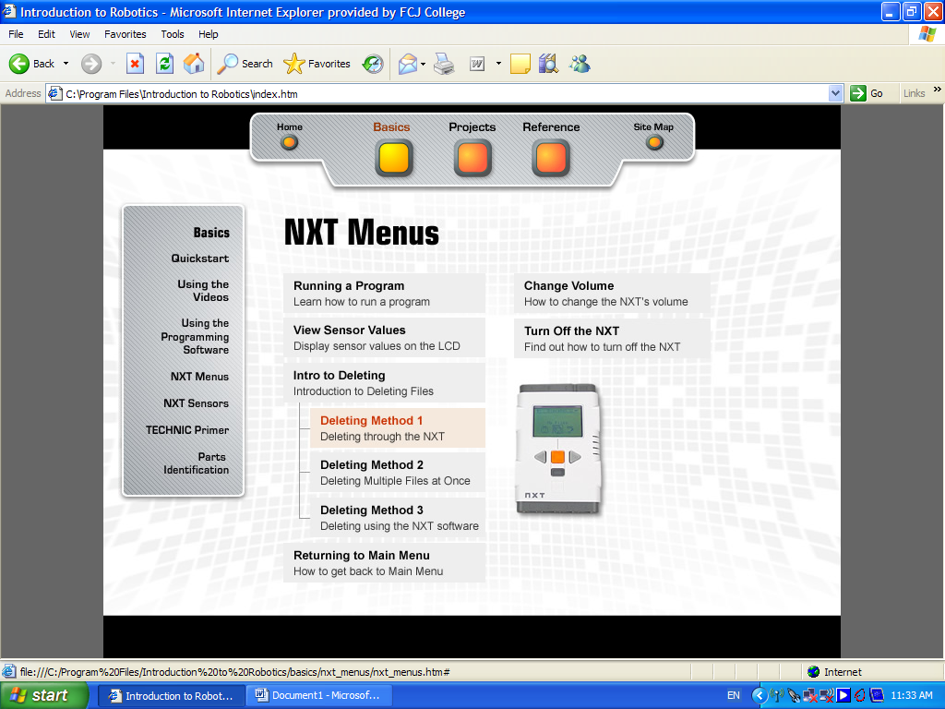

- From Quickstart,
    - How many batteries and what type of batteries are needed?
    - What do the letters S, P, A mean?
    - How are the outputs described on the NXT block?
    - How are inputs described on the NXT block?
    - What are actuators?

- From Using the videos, list the shortcuts to moving around the videos.
- From Using the Programming Software,
i) What does LMS stand for?
ii) What are the naming methods suggested?
iii) Why do you need to use the Complete Palette?
iv) What are the 6 tips given?
- From NXT Menus, write a summary of the six subsections.
- From NXT Sensors, define
i) the Touch, Sound, Light and Ultrasonic sensors
ii) the Servo Motor
iii) the RCX Sensors.
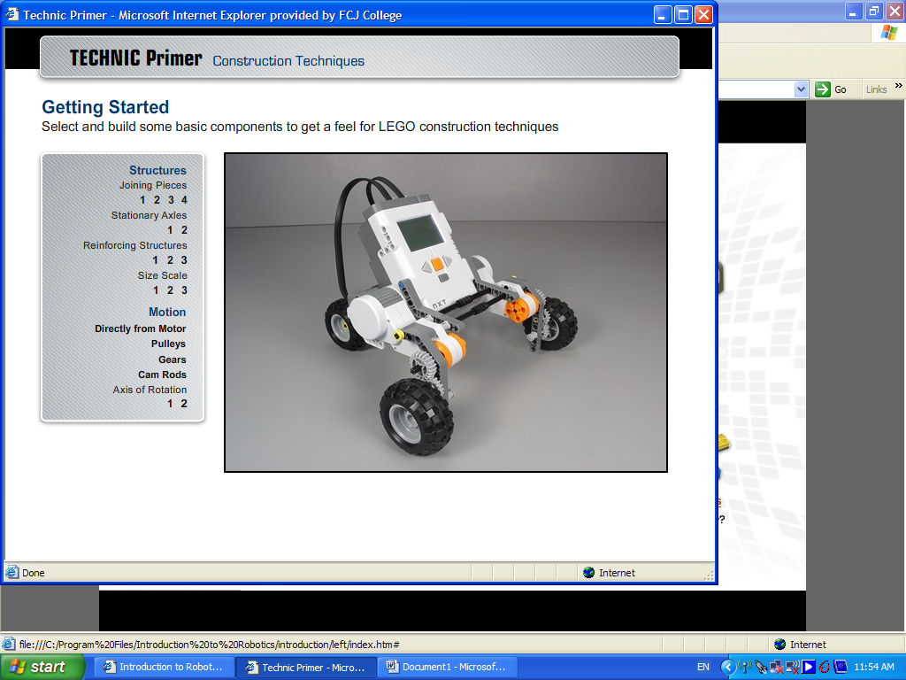

- From the Technic Primer section,
i) What are the joining pieces?
ii) What are the two different axles for?
iii) Draw the reinforcing structures.
iv) Describe the effects of the Motor
v) What is an axis of rotation?
- From the Parts Identification section,
i) Define the five types of parts. Make sure you include a dictionary definition.
ii) What is meant by Multipurpose pieces?

The next section is the Robotics Projects area, from the main menu of the Introduction to Robotics program.

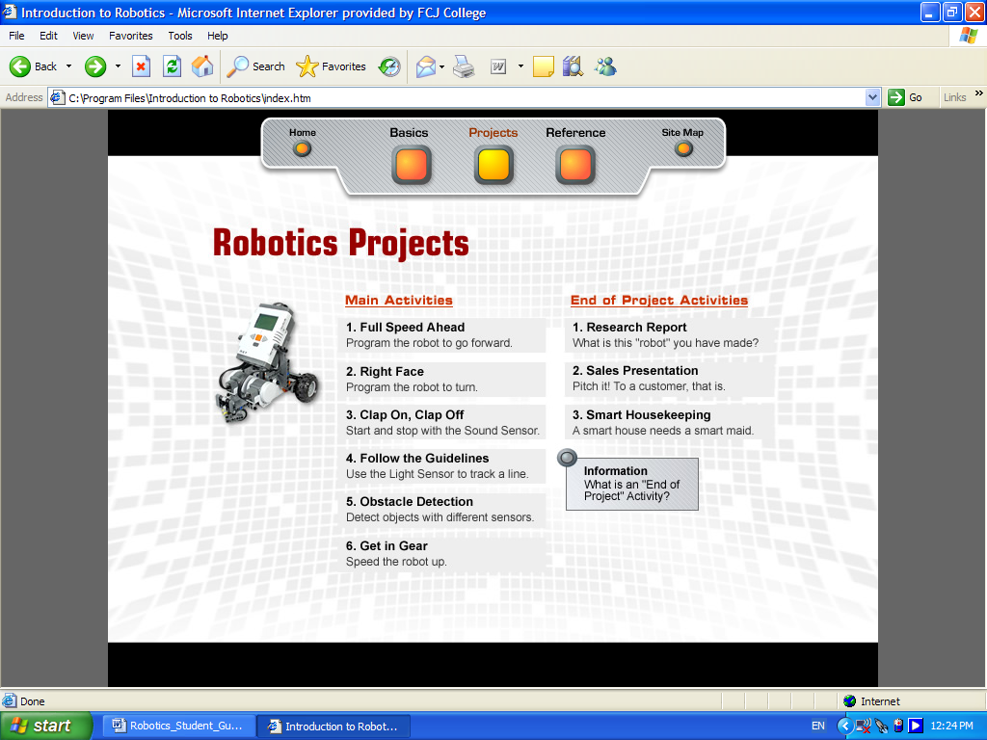

The worksheets have been printed and are part of your work. When you get to the worksheets, please approach your teacher, complete the sheet and hand it back. Then you may go onto the next phase. Each of the Main Activities needs to be completed in sequence. There will be an assignment on Robotics in the first half of Term 1 and a Film as Text Response in the first half of Term 2. There will also be an excursion to Thales Group, ADI Benalla in the first half of Term 2. The final CHALLENGE will occupy the second half of Term 2.

Worksheet | Score | Comment and Teacher Signature
1a. Construct parts 5, 6, 7 questions
1b. Contemplate questions
1c. Continue questions
1d. Full Speed Ahead worksheet
2a. Construct parts 3 questions
2b. Contemplate questions
2c. Continue questions
2d. Right Face worksheet
3a. Connect questions on SPA and Thresholds
3b. Construct part 2 questions
3c. Contemplate questions
3d. Continue questions
3e. Clap On, Clap Off worksheet
4a. Connect questions on Ultrasonic Obstacle Detection
4b. Construct parts 2,3 questions
4c. Contemplate questions
4d. Continue questions
4e. Follow the Guidelines worksheet
5a. Connect questions on Ultrasonic Obstacle Detection
5b. Construct parts 2,3 questions
5c. Contemplate questions
5d. Continue questions
5e. Obstacle Detection worksheet
6a. Connect questions on Gear Ratios
6b. Construct parts 3, 4, 5, 6 questions
6c. Contemplate questions
6d. Continue questions
6e. Get in Gear worksheet

