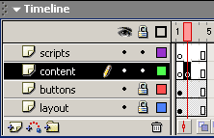
Navigating The Timeline
You will need to dowload the file pagechanging.fla to complete this tutorial
1. Open the fla file. On the timeline you should find 4 layers. Lock the layout
and buttons layer.
2. Click in frame 2 of the content layer and hit F6 to insert a key frame.
3. Click in frame 3 of the content layer and hit F6 to insert a keyframe.
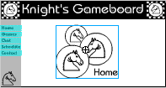
4. Click in frame 4 of the content layer and hit F6 to insert a keyframe. Each of these keyframes on this layer will be different content
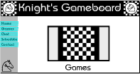
5. Click back in frame 1. This is going to be your home page. Open your Library (F11). Find the graphic symbol called Home. Drag this onto the stage in the blank
area of your stage and position it so it looks decent.
6. Click in frame 2 of your content layer. This will be your Games page. Drag the Games graphic symbol from the library to your stage and position it on the stage.
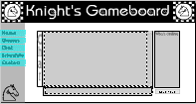
7. Click in frame 3 of your content layer. This will be your Chat page. Drag the Chat graphic symbol from the library to your stage and position it on the stage.
8. Click in frame 4 of your content layer. This will be your Schedule page. Drag the Schedule graphic symbol from the library to your stage and position it on the stage.
9. Now all the basic pages are set, Lock the content layer. It is time to script this. Click in the key frame of the script layer. Open up your action panel.
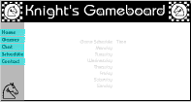
Click the plus sign => Actions=> Movie Control=> stop. The stop will run the length of the keyframe.
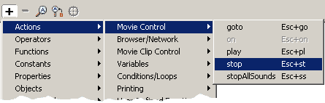
Scripting buttons:
10. Unlock your buttons layer. Click on the home button to highlight the button, not the frame. Open your action panel.
Click Plus sign => Actions=> Movie Control=> goto.
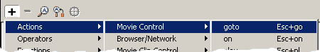
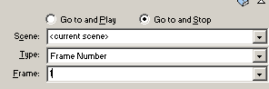
Above the Plus symbol you will have some boxes to fill in.. Select
- Go to and stop
- Frame number
- Frame 1
The resulting script below in the white appears as

11. Click on the Games button to highlight the button, not the frame. Open your action panel.
Click Plus sign => Actions=> Movie Control=> goto.
Above the Plus symbol you will have some boxes to fill in.. Select
- Go to and stop
- Frame number
- Frame 2
The resulting script below in the white appears as

12. Click on the Chat button to highlight the button, not the frame. Open your action panel.
Click Plus sign => Actions=> Movie Control=> goto.
Above the Plus symbol you will have some boxes to fill in.. Select
- Go to and stop
- Frame number
- Frame3
The resulting script below in the white appears as

14. Click on the Schedule button to highlight the button, not the frame. Open your action panel.
Click Plus sign => Actions=> Movie Control=> goto.
Above the Plus symbol you will have some boxes to fill in.. Select
- Go to and stop
- Frame number
- Frame 4
The resulting script below in the white appears as

15. Click on the contact button. Open your action panel.
Click Plus sign=> Actions=> Browser/network=> getURL
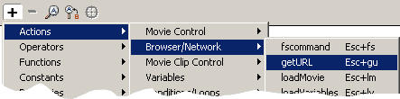
Above the Plus symbol you will have some boxes to fill in. Click in the URL box andtype in
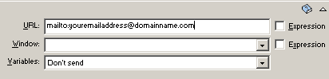
- mailto:
- Follow the colon with your email address, no spaces.
The resulting script below in the white appears as

16. Click control=> Test movie. Navigate your movie frames or pages using your buttons!

