Creative Thinking Techniques:

Sample Exam Questions

BSBDES302A Explore and Apply the Creative Design Process To 2D Forms

Sample exam questions have been removed to avoid any copyright breaches with VCAA.

Creative Thinking Techniques:

 | Definition | Example | Advantages | Disadvantages
brainstorming: | The purpose of a brainstorming session is to discover new ideas and responses very quickly. It is particularly a good way of getting bright ideas. It differs from the buzz groups discussion in that the focus is on generating as many ideas as possible without judging them. In this technique, all ideas are given equal credence.  Participants are encouraged to let ideas flow freely, building on and improving from previous ideas. No idea, however crazy, should be rejected. These ideas are listed exactly as they are expressed on a board or flipchart, or written on bits of paper. The combination of swiftly generated ideas usually leads to a very animated and energising session. Even the more reserved participants should feel bold enough to contribute. The purpose of listing responses is to collect existing experiences and thoughts. | 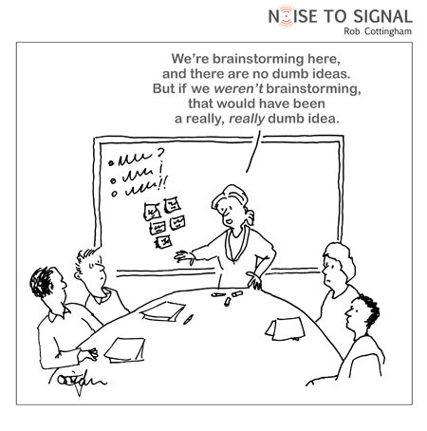  Drag to enlarge | - You don't have to be a highly qualified expert or highly paid consultant to use it  - Easy to understand - it's not a complicated technique  - It is inexpensive  - If controlled properly it is a quick way of generating ideas  - Encourages creative thinking and thinking "out of the box"  - Generates ideas and solutions that can be used elsewhere  - Provides an opportunity for widespread participation and involvement | - Can take too much time if the group is not properly controlled and is allowed to run for too long  - Raising expectations of the brainstorming group by considering ideas that will never be implemented
bulletin board | a board on which messages may be posted, especially one in a public space; a system in which users may send, read and reply to messages of interest to no particular person; an electronic bulletin board | none | - May obtain the ideas or the assistance of person who are not normal contacts  - They create a discussion thread which can encourage the development of ideas  user involvement:  - the interactive nature of a bulletin board means that users can  - have their own say, easing two-way interaction with the company  - and potentially acting as an abundant source of free content | - You may not receive a helpful reply in the time available  - BB’s are sometimes the victims of pransters.
buzz session | Buzz sessions are activities in which learners are divided into small discussion groups. The groups talk about assigned topics and then share their ideas with the others. You can use buzz sessions to give a large number of people the opportunity to participate in a lesson.  At times, the groups may share their ideas by making  posters or charts or drawing pictures. For example, you  might ask them to draw different parts of the same scripture  account or things for which they are thankful. | none | Individuals who are usually hesitant to participate might  share ideas in small groups that they would not express  in front of the entire group. This will help them see that their ideas are important to others. | The main obstacle using buzz sessions lie in unfamiliarity with their use, the time required, the need for leaders or facilitators within each sub-group, and the need to have tables and chairs arranged for quick and easy discussion.
computer-aided
sequencing
stop and go
daydreaming and mental wandering | Relaxed state of thinking where an individual may drift in and out of a thought process | none | May be less stressful and as such encourage free thinking. | May not be helpful if the timeline for producing a solution is short  Does not assist to order or group individual thoughts – would have also use a mind map  There is no guarantee that the process will produce anything worthwhile.
Edward de Bono's six thinking hats | "Six Thinking Hats" is a technique that helps you look at important decisions from a number of different perspectives. It helps you make better decisions by pushing you to move outside your habitual ways of thinking. As such, it helps you understand the full complexity of a decision, and spot issues and opportunities which you might otherwise not notice. | 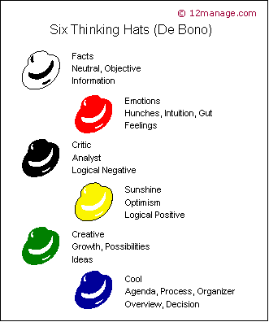  Drag to enlarge | Thinking process is more constructive and faster  Improves the capacity of individuals to “think outside the square” and to consider other perspectives in a less threatening manner | Success of the process often depends upon the capacity of the “facilitator” to encourage people to relax and to understand how to implement that process. E.g. only one hat should be used by a group at any time, not all hats should be used in the one day.
ego alter or heroes  “Alter ego” | Does this mean Dr Jekyll and Mr Hyde?  The assumption may be that by thinking how a hero or alter ego may deal with a situation will promote the capacity to look at a problem differently. | none
graphic organisers: | Are visual methods for recording thinking processes and which are intended to promote the quality and originality of thinking.  They can be computer generated or hand drawn. | none | See organisers below.  Allow the thinker to determine relationships, order, timing or elements of a task or solution. | See organisers below.
concept fans | The Concept Fan is a way of finding different approaches to a problem when you have rejected all obvious solutions. It develops the principle of 'taking one step back' to get a broader perspective.  To start a Concept Fan, draw a circle in the middle of a large piece of paper. Write the problem you are trying to solve into it. To the right of it radiate lines representing possible solutions to the problem. | 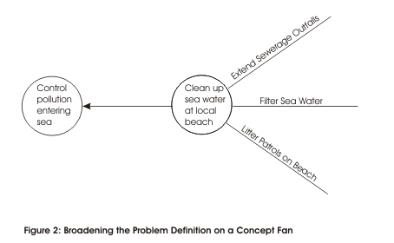  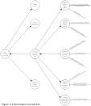 | A useful technique for widening the search for solutions when you have rejected all obvious approaches. It gives you a clear framework within which you can take 'one step back' to get a broader view of a problem.  Encourages the viewing of a problem in a wider context. Sometimes a person does not successfully solve a problem because they do not sufficiently “step back” to identify the cause or related issues  (Johnny printer) | Because a concepts fans encourage the broadest examination of a problem that is possible, this sometimes makes a task appear exceedingly difficult to solve and can frustrate a persons endeavour.
visual maps | Visual maps indicate direct affiliations (associations) between “groups”, funders (supporters, predecessors), and individuals. | 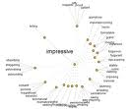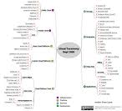 | - Helps to identify the majors steps required for completing a task  - Allows individuals tasks to be grouped so they can be better understood and the relationship between each task is known  - Identifies predecessors which must be completed for the job to move forward. | - If correct associations are not identified, unexpected delays may occur and ideas will not fully develop.
webbing | Use or develop a network: an interconnected system of things or people. (e.g. Social networking)  Using known contacts to obtain ideas and suggestions for tackling a particular problem | none | - Existing networks are likely to be trusted  - May offer criticism to develop ideas that other people are not.  - Many businesses are turning to Social Networking sites to research opinions about their business | Existing networks may have similar thoughts and expertise and may not be able to help to develop an idea to a higher level of sophistication  With some networks, individuals may be afraid to tell you what you need to know.
lateral thinking games | Lateral thinking games are a great way to get you thinking outside of the box. They often involve asking a question that doesn't have a clear answer. It turns out it is the question that is ambiguous and not the answer.  Lateral thinking games often involve puzzles, model building and solving scenarios. | none | Promote team building, build resistance to problems, encourage lateral thinking (thinking outside the box), allow individuals with different skills to receive recognition | Lateral thinking games in the wrong environment can creative competitiveness which hinders team development and problem solving.
making associations
mind mapping | A mind map is a diagram used to represent words, ideas, tasks, or other items linked to and arranged around a central key word or idea. Mind maps are used to generate, visualize, structure, and classify ideas, and as an aid in study, organization, problem solving, decision making, and writing. | 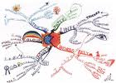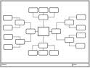 | Online mind mapping tools:  Easier to collaborate with other users  - Easier to publish and share mind maps from online tools  - Platform independent, so only one version of the mind mapping tool needs to be developed.  (See visual maps) | Online mind mapping tools:  - Online mind mapping tools lacks the features of their desktop brethren  - Sometimes you want to work 'off-line' and escape the rat race of the internet  - With some web services closing due to lack of funding and profits, your favourite mind mapping could close down without any notice.  (See visual maps)
morphological analysis | As a problem-structuring and problem-solving technique, morphological analysis was designed for multi-dimensional, non-quantifiable problems where causal modeling and simulation do not function well or at all.  Example  An artist, looking for new ways of creating artwork, identifies two attributes, 'materials' and 'canvas', and then lists the values these can take (e.g. 'ink' is a value of 'materials'). She then brings these together in the table below to explore possible combinations. See Diagram for example | 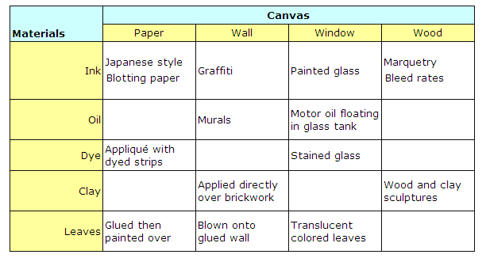  Drag to enlarge | - "It may help us to discover new relationships or configurations, which may not be so evident, or which we might have overlooked by other – less structured – methods.  - It encourages the identification and investigation of boundary conditions, i.e. the limits and extremes of different contexts and factors.  - It also has definite advantages for scientific communication and – notably – for group work. "[source: www.swemorph.com ]  - It allows us to find possible solutions to complex problems characterised by several parameters. | - "One apprehension that has been voiced against morphological analysis is that it is too structured – and that this could inhibit free, creative thinking."[source: www.swemorph.com ]  - Morphological analysis may yield too many possibilities. Human judgments are still needed to direct the outcome. There are no guidelines for making combinations.  - Human error – the development of morphological boxes requires critical judgments. If the underlying thought processes are not insightful, the outcomes of this method will be weak.
storytelling | Storytelling is the interactive art of using words and actions to reveal the elements and images of a story while encouraging the listener’s imagination.  1. Storytelling is interactive.  2. Storytelling uses words.  3. Storytelling uses actions such as vocalization, physical movement and/or gesture.  4. Storytelling presents a story. |  | - encourages the active imagination of the listeners.  1. We connect on an emotional level with people and events in stories and we connect them to experiences in our own lives.  2. Stories let us communicate our perspective and perception.  3. Stories are usually a collaborative effort of stories' characters, their actions and points of view.
sub-culture surfing | Each culture can be broken into sub-cultures where individual develop traits (styles) which separate from the main culture and other sub-cultures. E.g. Goth, Emo’s, First Home Buyers, surfers | none | T | Sub-culture appeal can be very difficult to achieve and one may alienate other sub-cultures in an effort to attract another.  (e.g. consider the use of Colour Theory)
trigger words | They are words that trigger a reaction from your audience. | In one of our projects, we discovered the word “must” has a much stronger impact on users than the word “should”.  Users felt that “should” implies it is “the correct thing to do”, however, if I don’t do it, I can “beg for forgiveness later”.  “Must”, on the other hand, meant they had to do it. | Trigger words are successful when well thought out. If you get a negative reaction, is this the trigger word working or is it a bad trigger word?  Solution: develop multiple trigger words to ensure that the results are not producing undesirable or conflicting information
use of metaphors and analogies | A metaphor is a figure of speech that uses one thing to mean another and makes a comparison between the two. The key words here are “one thing to mean another.” So, when someone says “He’s become a shell of a man,” we know not to take this literally, even though it’s stated directly as if this person had actually lost his internal substance.  An analogy is comparable to metaphor and simile in that it shows how two different things are similar, but it’s a bit more complex. Rather than a figure of speech, an analogy is more of a logical argument. The presenter of an analogy will often demonstrate how two things are alike by pointing out shared characteristics, with the goal of showing that if two things are similar in some ways, they are similar in other ways as well. |  | Metaphors are so powerful because of one simple fact of human psychology—we react more readily to the emotional than the rational.  By using analogies an advertiser can give more examples on the benefits of their products or services in either a witty or more easily absorbed explanation. By causing the reader, listener, or viewer to be intellectually entertained it allows for the message to sink in to the thought pattern more than if you just stated a benefit. An analogy in short encourages participation or amusement that is more memorable when getting an advertising message across.
vision circles | A VisionCircle is a group of up to 25 people who work in turn toward the fulfilment of each other's personal vision.  Initially VisionCircle members are driven by either personal growth or fulfilment (i.e. self-interest), or by the satisfaction of helping others. | none | It has the capacity to harness the skills of others. | Depends upon the willingness of individuals to commit to work to help another regardless of the amount of time and effort this requires.  No guarantee of “payback”
visualisation
wishful thinking | Promoting thinking by thinking positively. The thinker is encouraged to believe that the impossible may not be. This encourages the thinker to develop and take on strategies that they previously would not have considered. | None – “think big” | Encourages someone to think outside the square. | The thinker may not have the capacity to develop the strategies need to solve there wished for solution, becomes disheartened and achieves little.
word salads | a jumble of “seemingly” meaningless or illogical words and phrases  (Note that word salad is a phrase normally used to described speech as sometimes heard in schizophrenia) |   Example of “Wordle” – a word salad.  Size of text relates to the number of times the particular word is inserted into the list that makes up the wordle. | Whilst the image may appear random, it may be possible to identify relationships and to group the words to assist in the production of a solution.  Unusual or standout words may become a trigger for a new idea. (Note in Wordle this would actually be the smaller words.) | Word salads (word clouds) may inhibit the development of a solution if meaningless terms are not disregarded once basic relationships are established.

