VCE VET Interactive Digital Media Unit 3 & 4

SAC 1 Assessment Task – Project
CUFDIG304A Create visual design components
&
CUFDIG301A Prepare video assets

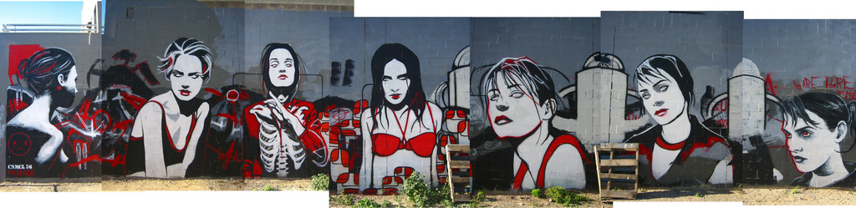
Show reel for Australian Graffiti Group (AGG)
Project - Part | Time Allocation | Due Date
Part A - Video | 10 lessons
Part B - Logo | 6 Lessons
Interview and presntation | 1 /2 – 1 hour | Appointment to be made
Please Note
- Everything needs to be correctly ordered into your A3 visual display book.
- All prints and drawing should be on A3.
- Read EVERYTHING before you begin
The Brief
The Australian Graffiti Group (AGG) is made up of street artists from all over Australia. They formed this group 2 years ago in response to the public outcry calling to ban all graffiti work and the development of legislation that would recognise graffiti as vandalism and therefore be unlawful. AGG has been working very hard to change the stereotypical views held by the general public. They want to be accepted and recognised as true artists. To date this has been done through memberships, promoting using flyers and placing ads in local newspapers of exhibitions and free events where people are invited to watch artists in action. This has had a positive but small impact on their reputation. AGG now feel if they are to be truly accepted as real artists they need to be recognised well beyond their ‘own back yard’ – they want the world stage. Not only do they wish to attract a much wider and diverse group of people but they would also like to grab the attention of those who via their own business or art form, could help to promote graffiti as a legitimate art form- they don’t mind if graffiti art work is used within other businesses provided copyright issues are respected.
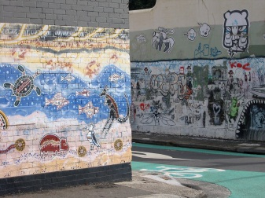
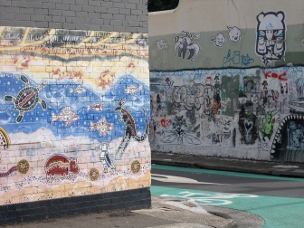
As one of 5 employees in a leading multimedia company they have approached you as the designer, for your advice. They want to use social media and other avenues to reach a greater and more diverse group of people. As already mentioned they want to also try and get the attention of other businesses such as photographers and tour operators to help promote local graffiti works. In other words a tour operator could market a tour of street art or a photographer cold take photos and publish them as his/her own work but would ultimately be promoting the actual graffiti art and artist. They also need a new logo that can be recognised as their branding. They want something that is in line with their general philosophy – ‘graffiti is art made to express, inspire, provoke and entertain’.

Your Response
To begin with you have suggested creating a 2 min video clip which can be posted onto YouTube and their web site, but also a DVD which can be ordered and posted to the tour operators and artists when requested via their web site (you have also offered to create the web site at a later date).
You have also suggested a couple of other things such as
Using still images along with appropriate music -noting that copyright is a constraint
The appropriate atmosphere can be created with the use of transitions and movement
By the creative combination of still images, your own music and text you can create the subliminal messages helping to break down the stereotype.
With regards to the logo you have discussed some ideas with them and they are happy to wait until they see the video clip before you finalise this aspect. They are happy that once the logo is developed and everyone is happy this can be added to the final part of the project.
Now for the tasks.
1. Planning – This needs to be submitted at the end of lesson 2.
A/ Planning Report – (500 – 700 words)
Outline how you have considered the problem and the solution. Write a brief outline of how you intend to meet the requirements of the brief. Your plan should also foresee any problems that may arise and how you may deal with them and discuss the constraints that you will need to consider.
This report should outline your approach from your initial meeting until the final hand over including any additional staff who would usually work on or who can advise you on various aspects of the project. The end is 16 lessons later.

B/ Production Plan List- show the tasks you need to accomplish in order to meet the brief, any resources needed and the estimated time frame

C/ Visual Plan - Gantt Chart – This will be used to outline the estimated time frame and the actual time frame. You will need to spend 5-10 mins at the end of each lesson to review this plan by showing actual time. Make comments on any alterations and how this impacts the project.

2. Research Part A
Research similar projects- analyse what works and what doesn’t according to the principles and elements of design. Use annotations on screen dumps to explain your findings and your thoughts. This should be on A3
3. Storyboard – on A3
Look carefully at all of the images supplied to you by your client in order to decide what you are going to use and how. Complete a detailed storyboard which brings everything together including effects, transitions, timings and text. You can insert screen clippings of the images into the boxes.
4. Production – The video
Using your plan, your understanding of the brief, use the appropriate software and the tools available to create a 2 min show reel. Save it to the appropriate formats once the logo has been added (term 2).
5. Review Questions (1000-1500 words)
1. Describe the design process you used for both the video (part A) and the logo (Part B). Which stages do you think were the most important and why?
2. What problems did you encounter for both the video (part A) and the logo (Part B)? What techniques and processes did you use to resolve these challenges? (Additional problems will be emailed to you)
3. Did you meet the deadlines you set yourself in the timeline for both the video (part A) and the logo (Part B)? If not, why not?
4. What constraints did you identify when sourcing our images and sound for the video? Discuss copyright, image resolution, file formats and file sizes.
5. Discuss how you made the decision on the final exported file formats of your video. How was this appropriate for the output purposes, destination and platform? Make mention of the following terms: File Format, codecs and bandwidth.
6. Given that there are 5 employees working within your organisation, describe the roles and responsibilities each team member might have in relation to this particular project.

At this point all of the above requirements need to be submitted for evalution on wed 28th march.
This includes your folio and the hard drive.

The logo – Part B
2. Research Part B
Create an inspiration page. Use annotations on screen dumps to explain your findings and your thoughts. This should be on A3

3. Concept drawing
Plan your logo design. You should be able to show in at least 4 steps (can do more) the stages from your inspiration page to an end sketch. Along the way you will need to demonstrate design principles and elements through annotations which clearly point to these aspects of your design and why.
4. Creation and Production – Inserting the logo
Using the appropriate software create your logo. Use screen dumps to demonstrate at least 4 stages of the development. Use a screen dump to show how you converted the logo to the appropriate format for the video. Insert this into the video.
Production – The video (part A) Save to appropriate formats as per the brief.

5. Review continued (1000 – 1500 words)
Continue with the review questions addressing the logo aspect of this project.

Files provided by the client.

Specific images to include for Melbourne
http://www.whiterhino.com.au/blog/?p=638
a laneway melbourne
http://www.lanewaymagazine.com.au/wp-content/uploads/2011/06/wreckers_yard1.jpg
http://www.flickr.com/photos/johannahobbs/2582263293/

Specific images to include for Sydney
http://www.flickr.com/photos/agnesscottcollege/5610098757/
http://sydney.localsmile.com.au/LocalTimes/Story/WhenGraffitiIsArtPt2
http://sydneynearlydailyphot.blogspot.com.au/2008/03/green-boy-newtown.html

Adelaide Graffiti
Specific images to include for Adelaide
http://www.flickr.com/photos/stephenliveshere/375429029/in/photostream/
Complete works
http://www.flickr.com/photos/lorenzocolen/3231019872/sizes/l/in/photostream/

You will need to include at least 2 more images per city but remember copyright, image size and resolution (and don’t forget to record copyright issues and constraints such as size and resolution for your report)

